**DEPARTMENT OF COMPUTER SCIENCE AND ENGINEERING**

**SUBJECT CODE: 19CS2107**

**ENTERPRISE PROGRAMMING WORKBOOK**

**XSLT #3**

**Date of the Session: ___/___/___** **Time of the Session: _____to______**

**Prerequisite:**

* **General Idea on HTML Tags.**
* **Idea on XML documents and Tags**
* **Basic idea on XML** Stylesheet Language Transformations

**Pre-Lab Task:**

Create XML document which store the information about Library/Bookstore. more than 5 books.

<?xml version=*"1.0"* encoding=*"UTF-8"*?>

<books>

<book>

<title>Web Programming</title>

<author> Chrisbates</author>

<publisher>P Wiley</publisher>

<edition>3</edition>

<price> 300</price>

</book>

<book>

<title>Python Programming</title>

<author> G.V.Rossum</author>

<publisher>Pypi</publisher>

<edition>3</edition>

<price> 500</price>

</book>

<book>

<title>Java Programming</title>

<author> J.Gosling</author>

<publisher> Oracle</publisher>

<edition>8</edition>

<price> 800</price>

</book>

<book>

<title>Dynamic Programming</title>

<author>Au Cris</author>

<publisher> Aakash</publisher>

<edition> 7</edition>

<price> 750</price>

</book>

<book>

<title> R Programming</title>

<author>A John</author>

<publisher> Crisit</publisher>

<edition>2</edition>

<price> 930</price>

</book>

</books>

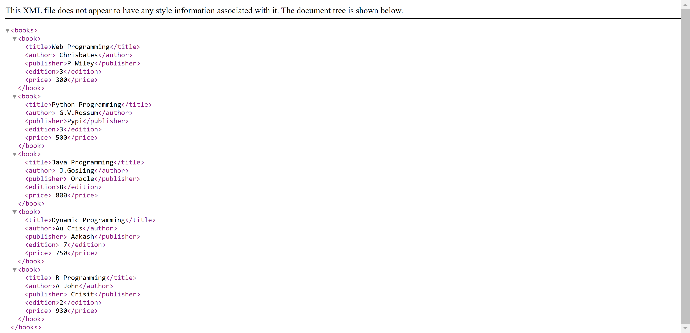

**In Lab Task:**

1.Create XML document which store the information about Library/Bookstore. more than 5

books.to transform XML documents into other formats (like transforming XML into HTML).

**XSL FILE**

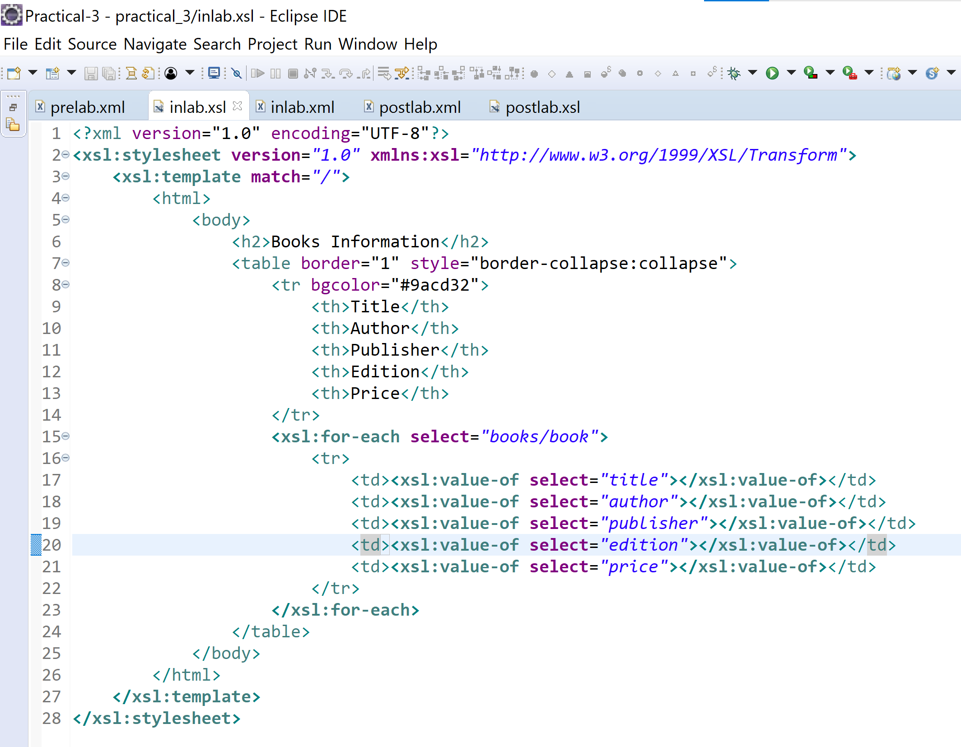

**XML FILE**

<?xml version=*"1.0"* encoding=*"UTF-8"*?>

<?xml-stylesheet type=*"text/xsl"* href=*"inlab.xsl"*?>

<books>

<book>

<title>Web Programming</title>

<author> Chrisbates</author>

<publisher>P Wiley</publisher>

<edition>3</edition>

<price> 300</price>

</book>

<book>

<title>Python Programming</title>

<author> G.V.Rossum</author>

<publisher>Pypi</publisher>

<edition>3</edition>

<price> 500</price>

</book>

<book>

<title>Java Programming</title>

<author> J.Gosling</author>

<publisher> Oracle</publisher>

<edition>8</edition>

<price> 800</price>

</book>

<book>

<title>Dynamic Programming</title>

<author>Au Cris</author>

<publisher> Aakash</publisher>

<edition> 7</edition>

<price> 750</price>

</book>

<book>

<title> R Programming</title>

<author>A John</author>

<publisher> Crisit</publisher>

<edition>2</edition>

<price> 930</price>

</book>

</books>

**OUTPUT**

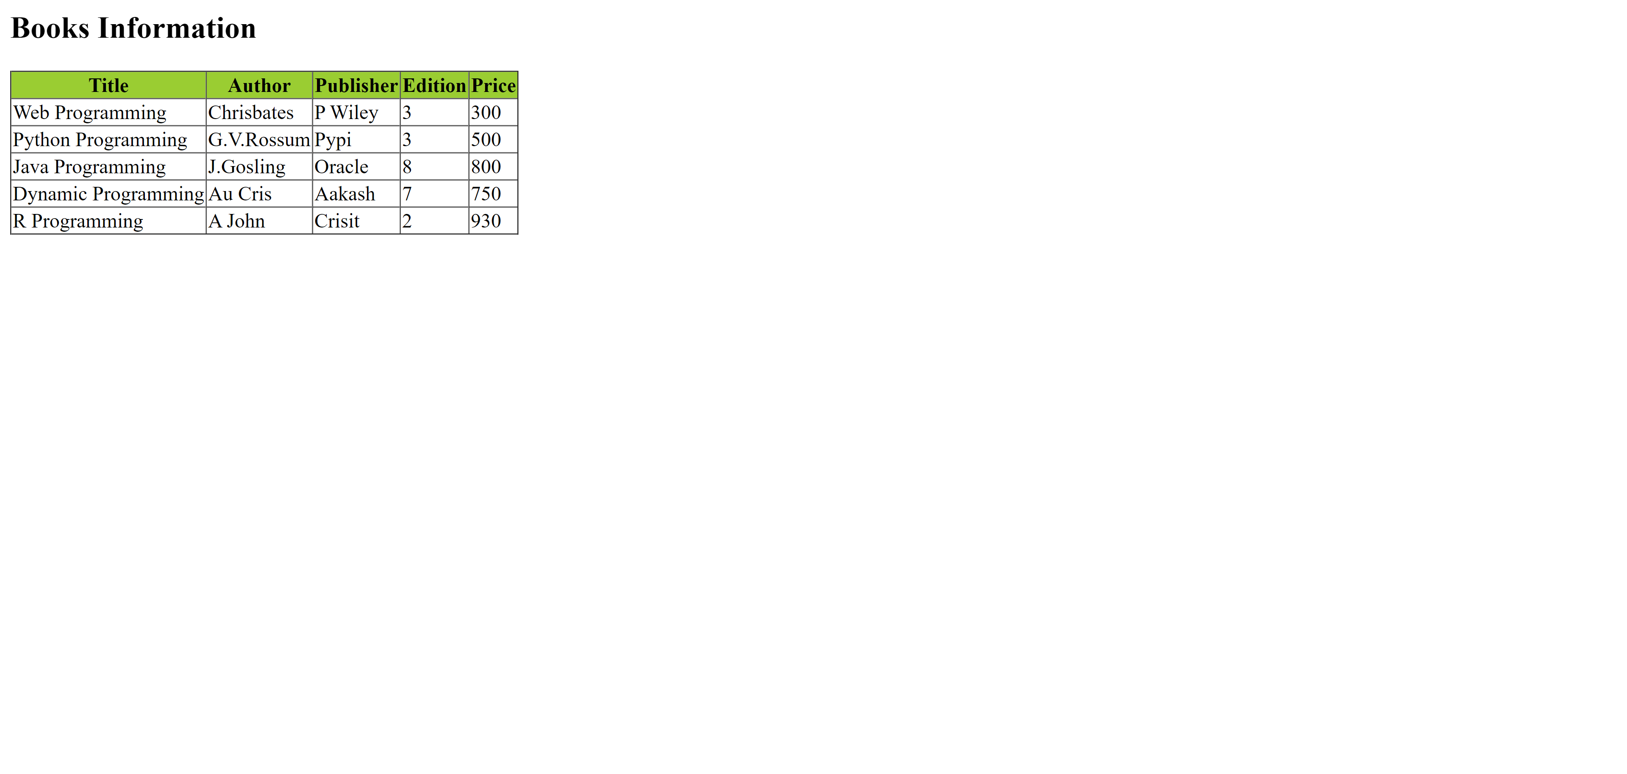

**Post Lab Task:**

1. Creating the XML file that contains the information about five students and displaying the XML file using XSLT.

**XSL FILE**

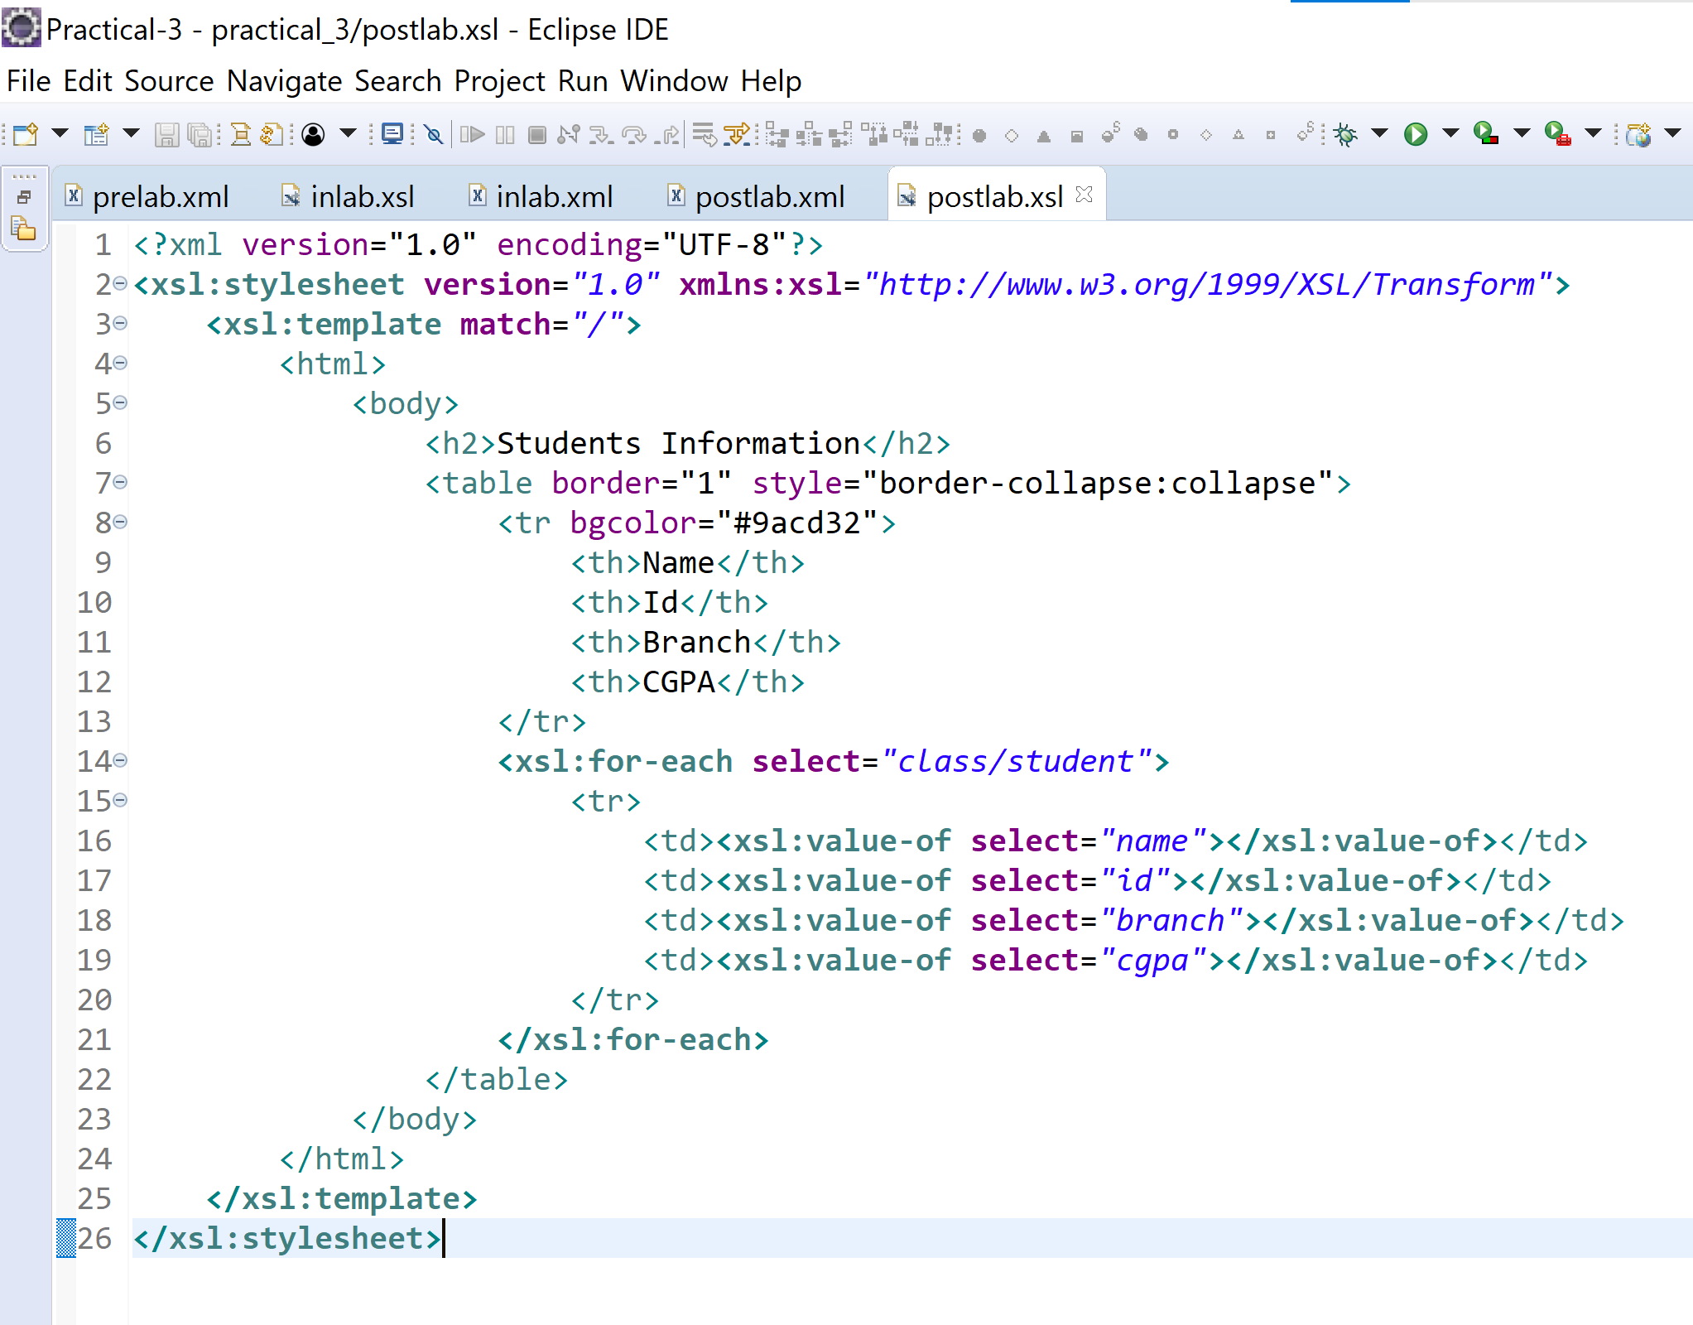

**XML FILE**

<?xml version=*"1.0"* encoding=*"UTF-8"*?>

<?xml-stylesheet type=*"text/xsl"* href=*"postlab.xsl"*?>

<class>

<student>

<name>RADHAKRISHNA</name>

<id>190031187</id>

<branch>CSE</branch>

<cgpa>9.67</cgpa>

</student>

<student>

<name>PAVAN</name>

<id>190031134</id>

<branch>CSE</branch>

<cgpa>9.00</cgpa>

</student>

<student>

<name>MOHITH</name>

<id>190031249</id>

<branch>CSE</branch>

<cgpa>9.00</cgpa>

</student>

<student>

<name>NAVNEET</name>

<id>190031177</id>

<branch>CSE</branch>

<cgpa>9.00</cgpa>

</student>

<student>

<name>KRISHNA VAMSI</name>

<id>190031527</id>

<branch>CSE</branch>

<cgpa>9.00</cgpa>

</student>

</class>

**OUTPUT**

