Tutorial-1

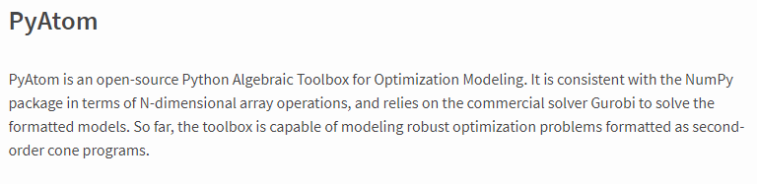

Installing Pyatom:

Step1:Go to Anaconda3 then open Jupyter notebook

Step2: Give the command pip install pyatom

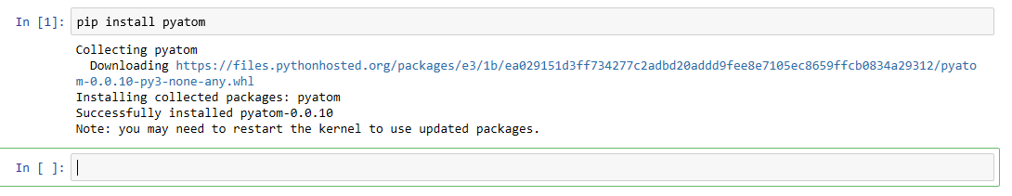

Step3: Give the command pip install -i <https://pypi.gurobi.com> gurobipy

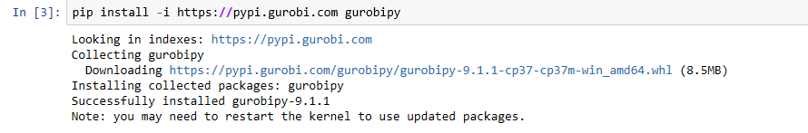

Step4: Give the command pip install rsome

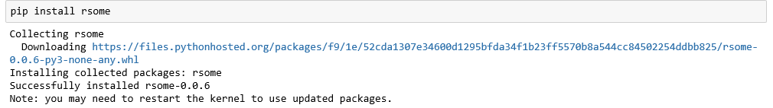

Step4: Restart the kernel to work on pyatom

**Examples 1:**

Maximize objective function 3x+4y

where the constraints are

2.5x+y<=20,

3x+3y<=30,

x+2y<=16,

x<=3,

y<=2

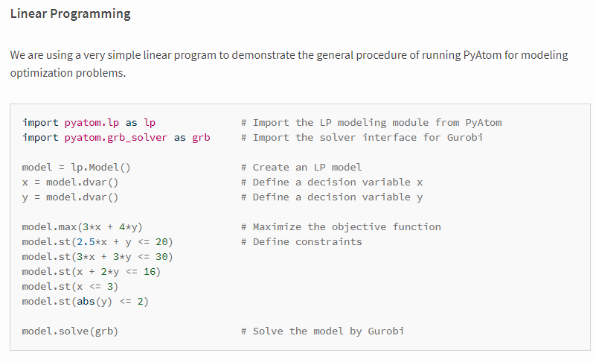

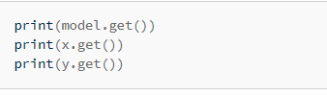



**Example2: Robust Optimization**

