**Mathematical Programming II**

**Tutorial - 2**

Text, letter

Description generated with very high confidence

Text, letter

Description generated with high confidence **Python Code:** 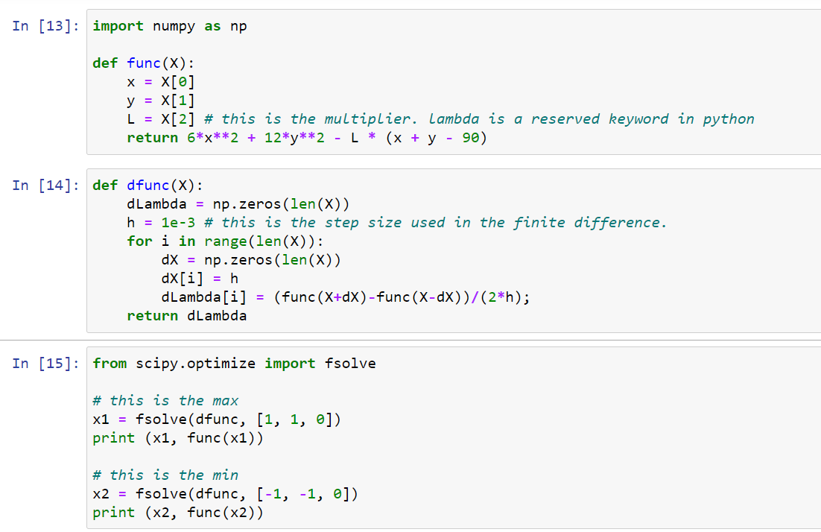

**A knapsack problem is an IP with a single constraint.**

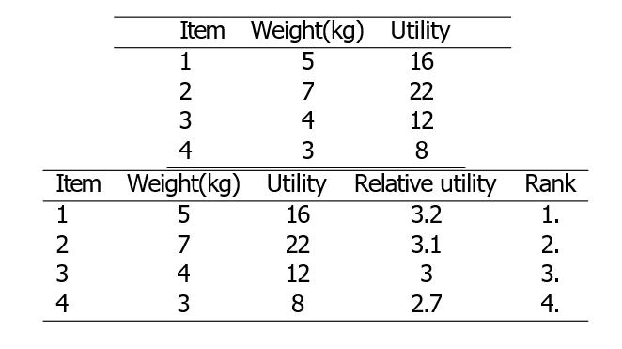**Example:** Josie Camper is going to a 2-day trip. There are 4 items that he wants to pack, but the total weight cannot exceed 14kg. The following table shows the weight and utility of each item.

