**Tutorial- 5: Non linear Programming using Python**

Q: Min x1x4 (x1+x2+x3)+x3

s.t. x1x2x3x4 ≥25

x21+x22 +x23+x24 =40

1≤x1,x2,x3,x4≤5

x0=(1,5,5,1)

This problem has a nonlinear objective that the optimizer attempts to minimize. The variable values at the optimal solution are subject to (s.t) both equality(=40) and inequality (>25) constraints. The product of the four variables must be greater than 25 while the sum of squares of the variables must also equal 40. In addition, all variables must be between 1 and 5 and the initial guess is x1 = 1, x2 = 5, x3 = 5, and x4 = 1.

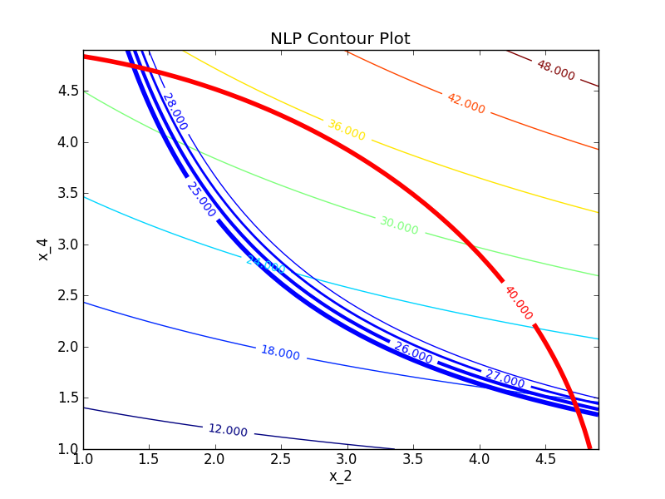

For this problem determine:

1. A potential feasible solution
2. Identify the constraints on the contour plot
3. Mark the set of feasible solutions on the contour plot
4. Identify the minimum objective feasible solution
5. Identify the maximum objective feasible solution
6. Use a nonlinear programming solver to find a solution

Example 2:

maximise 2x1 + x2 - 5loge(x1)sin(x2)  
subject to  
x1x2 <= 10  
| x1 - x2 | <= 2  
0.1 <= x1 <= 5  
0.1 <= x2 <= 3

Here we have a nonlinear objective and nonlinear constraints. Using the package we have the input:

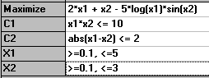

and it clear from this there there are values of x1 and x2 that exceed the supposed maximum objective function value of 8.8166 given by the package.