**PFSD SKILL-1**

**1.** **Create a Python script using OOP concepts with following criteria:**

a) Create a class Name Students with following attributes: Student ID, Student First Name, Student Last Name, Course, Year, GPA,University, Email, Mobile. Create at least 3 instances for the above class.

b) Use appropriate types of Attributes.

c) Use appropriate types of Properties.

d) Use appropriate types of Methods.

e) Create Email based on First Name and Last Name of the Student. (NOTE: If we modify First Name or Last Name it has to reflect in Email.)

f) Find the Count whenever we create a new instance for the above mentioned class.

class Students:

count=0

def __init__(self,id,fname,lname,course,year,gpa,university,mobile):

self.StudentID=id

self.StudentFirstName=fname

self.StudentLastName=lname

self.Course=course

self.Year=year

self.Gpa=gpa

self.University=university

self.Email=self.Gen_Email()

self.Mobile=mobile

Students.count+=1

def Gen_Email(self):

return self.StudentFirstName+self.StudentLastName+'@'+self.University+'.in'

def StudentDetails(self):

out="ID = "+self.StudentID+"\n"+"FirstName = "+self.StudentFirstName+"\n"+"LastName = "+self.StudentLastName+"\n"+"University = "+self.University+"\n"+"Email = "+self.Email

return out

if __name__=="__main__":

st1=Students('190031187','Nerella','Radhakrishna','CSE',2,9.67,'kluniversity',7286009239)

print("count= ",Students.count)

print(st1.StudentDetails())

print()

st2=Students('190031134','Nerella','Pavan','CSE',2,9,'kluniversity',9866341486)

print("count= ",Students.count)

print(st2.StudentDetails())

print()

st3=Students('190031249','Panapakam','Mohith','CSE',2,9,'kluniversity',8328130161)

print("count= ",Students.count)

print(st3.StudentDetails())

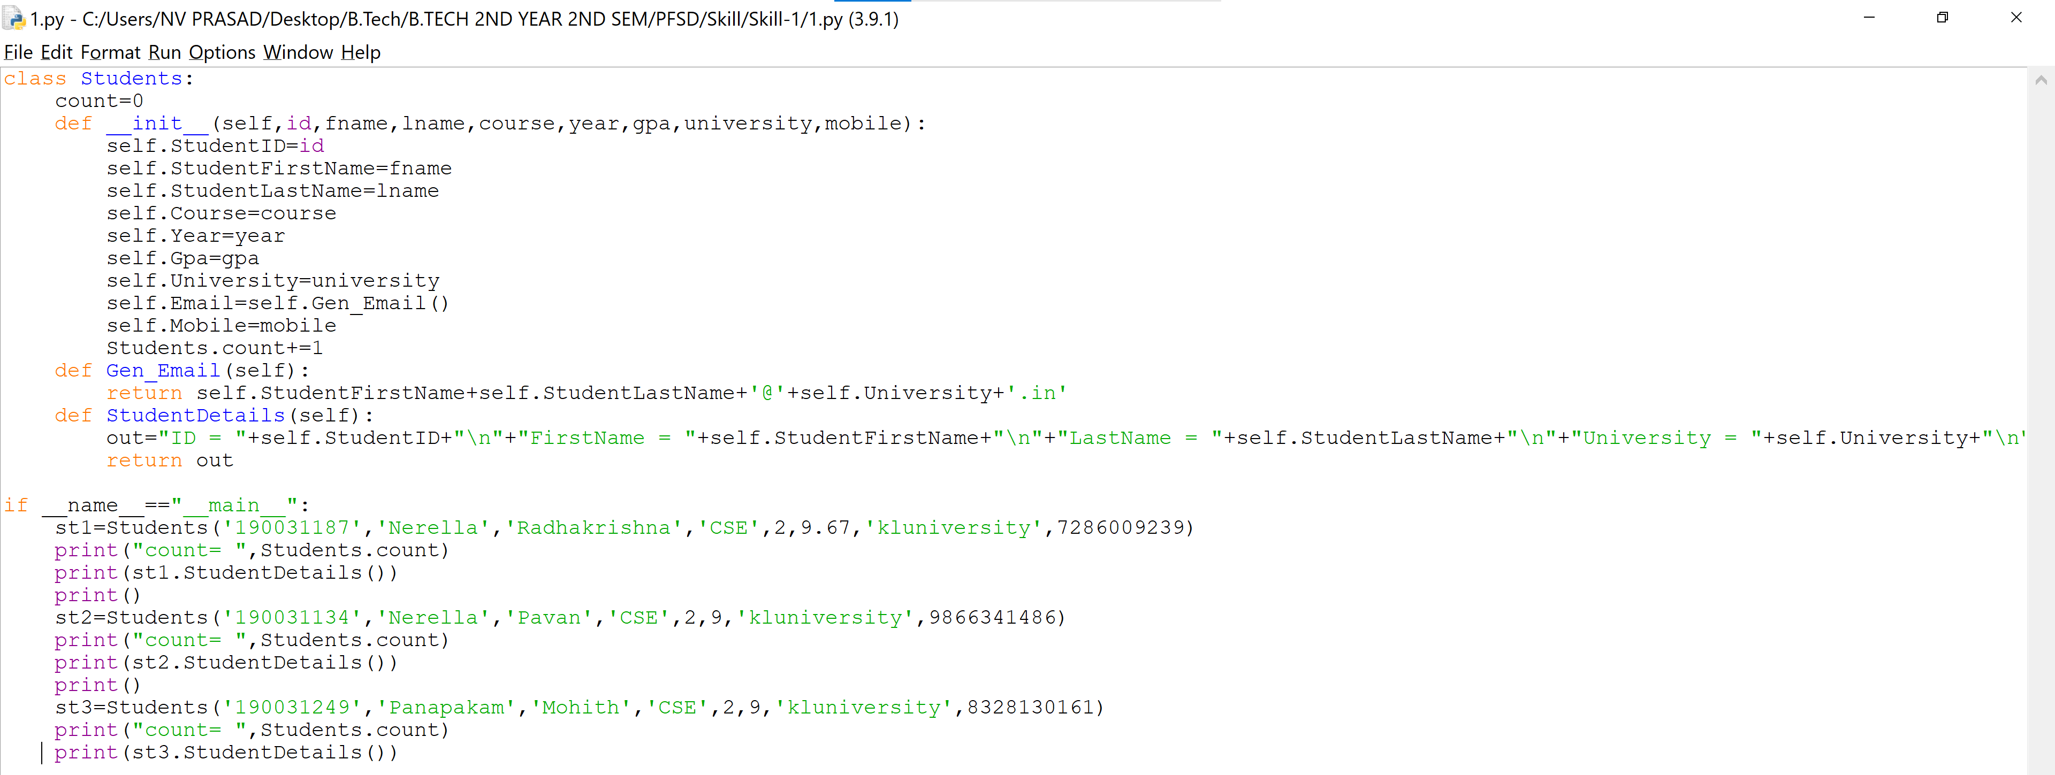

**OUTPUT**

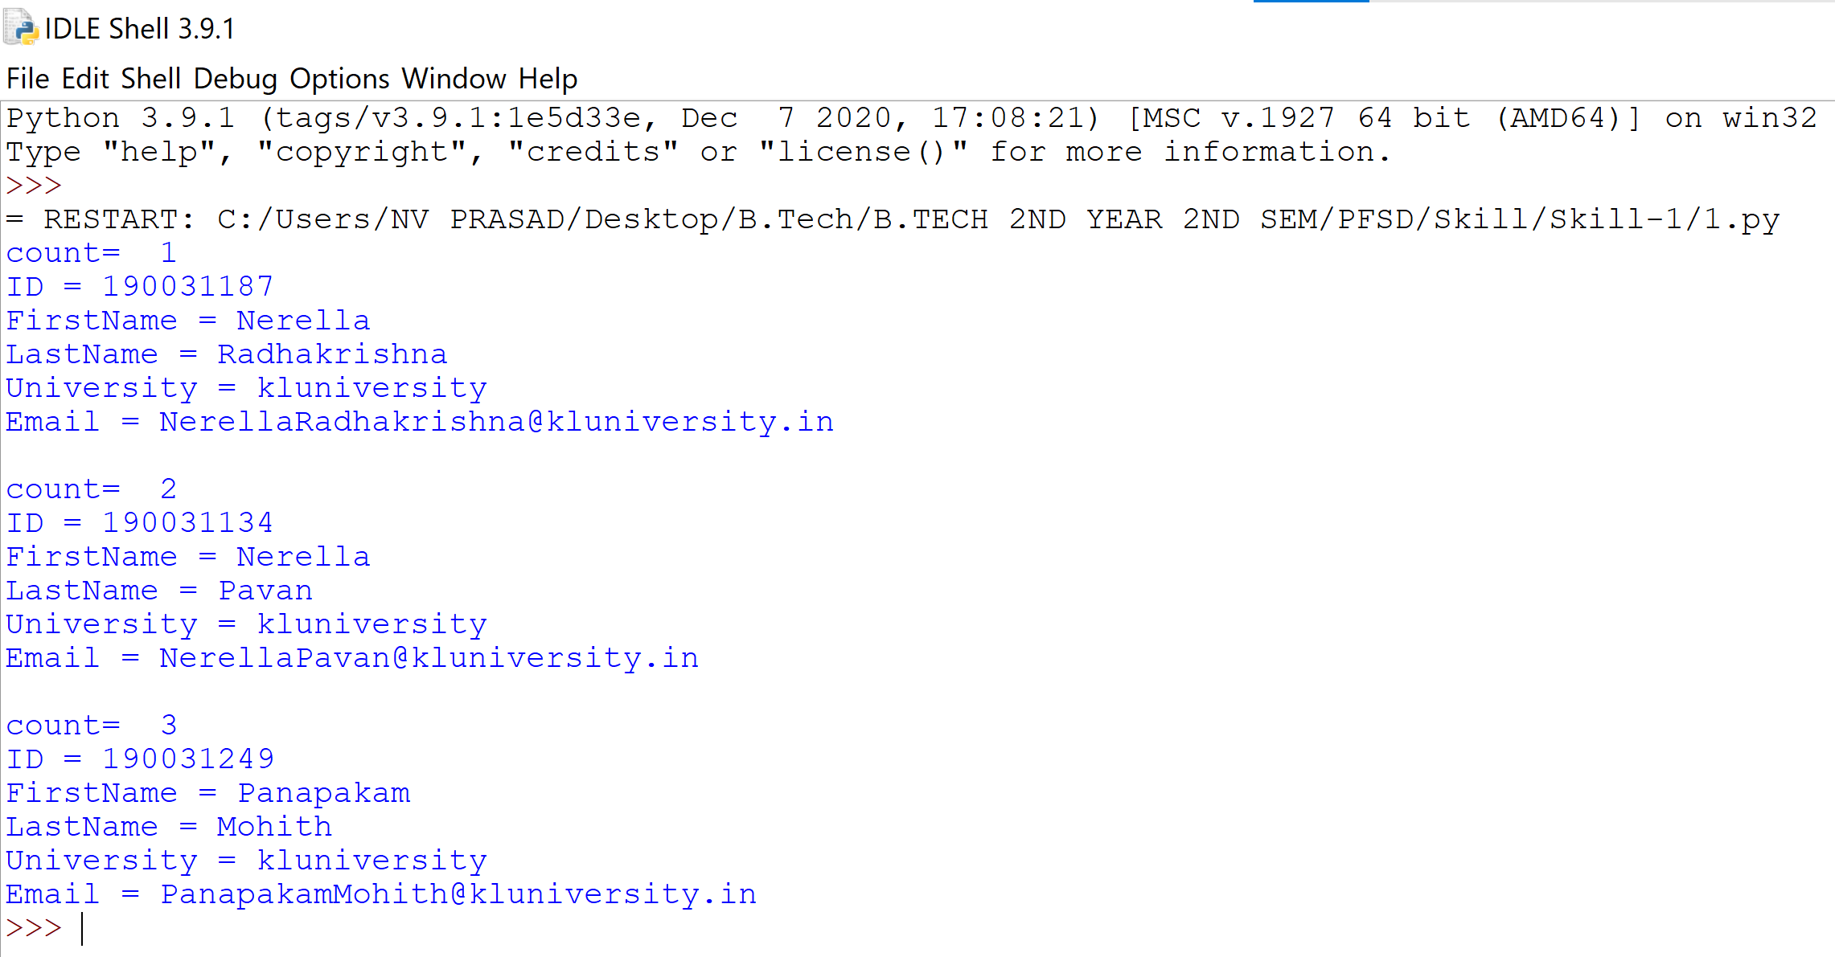

2) Create an BankAccount, MobileBankAccount and InternetBankAccount classes with appropriate Attributes, properties and methods.

a) Use Inheritance among the above-mentioned class.

b) Demonstrate super() mechanism. (NOTE: Use super() at both init() level and methods level.)

c) Work with name or main concept.

class BankAccount:

def __init__(self,accno):

self.accountno=accno

def get_Account(self):

return str(self.accountno)

class MobileBankAccount(BankAccount):

def __init__(self,accno,pin,balance):

super().__init__(accno)

self.pin=pin

self.accBalance=balance

def AccountDetails(self):

return "AccountNo = "+super().get_Account()+"\n"+"Balance = "+str(self.accBalance)

class InternetBankAccount(BankAccount):

def __init__(self,accno,pin,balance):

super().__init__(accno)

self.pin=pin

self.accBalance=balance

def AccountDetails(self):

return "AccountNo = "+super().get_Account()+"\n"+"Balance = "+str(self.accBalance)

if __name__=="__main__":

acc1=MobileBankAccount(123456789,5643,20000)

print("Mobile Bank Account")

print(acc1.AccountDetails())

acc2=InternetBankAccount(987654321,3465,10000)

print("Internet Bank Account")

print(acc2.AccountDetails())

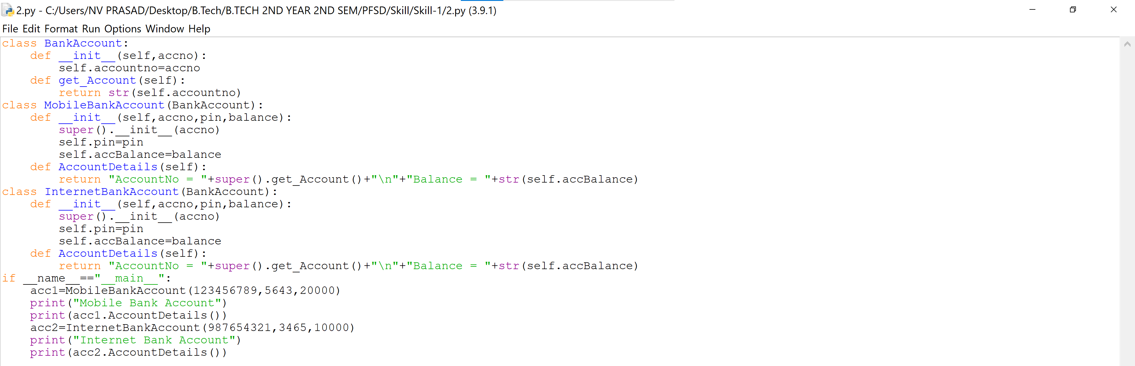

**OUTPUT**

