Session-4

1. For each of the following graph search strategies, work out the order in which states are expanded, as well as the path returned by graph search. In all cases, assume ties resolve in such a way that states with earlier alphabetical order are expanded first. Remember that in graph search, a state is expanded only once.
2. DFS
3. BFS
4. DLS
5. IDDFS
6. Bidirectional search

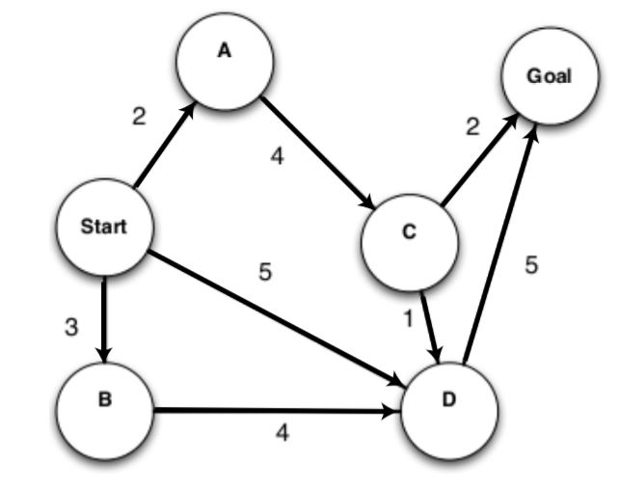

2. Given 3 jugs of capacities 12, 8 and 5 liters. The 12 liter jug is completely filled. Using these 3 jugs split the water to obtain exactly 6 liters.

Initial State: (12, 0, 0)

Goal State :( 6, 6, 0)

Frame the production rules for the water jug problem. Show the specific rule which is applied at each step.