**Session 6**

1. 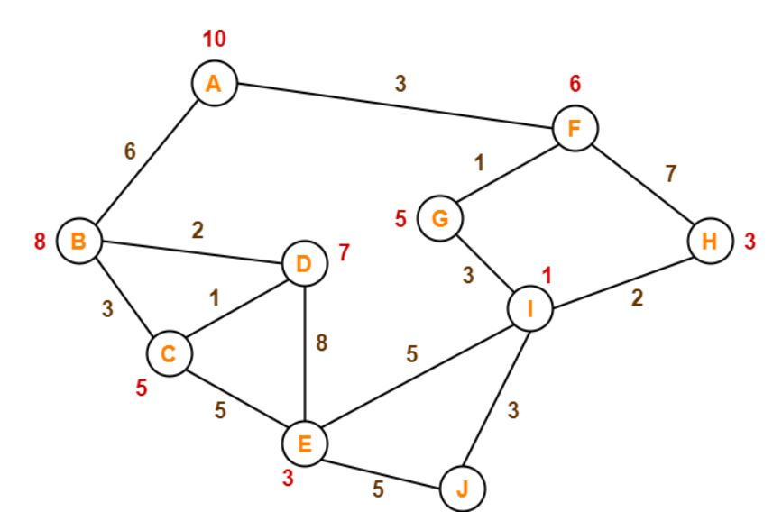Consider the following graph:

The numbers written on edges represent the distance between the nodes. The numbers written on nodes represent the heuristic value. Find the most cost-effective path to reach from start state A to final state J using A* Algorithm.