Lab -1

**PRELAB:**

1)

1a) Write a python program to check whether the given year is a leap year or not?

1b) Write a python program to print the multiplication table of any number up to 12 steps?

1c) Write a python program to check whether the given number is prime or not?

2. Execute the following string operations by writing an efficient python program by using switch case.

1. Convert the input string into upper case.  
2. Convert the input string into lower case.  
3. Check whether all the characters of the input string are in upper case.  
4. Check whether all the characters of the input string are in lower case.  
5. Replace the string "INTELLIgence" by “Neural Network”.  
6. Check whether the given string starts with “T”.  
7. Check whether the given string ends with “e”.  
8. Convert the first letter of the input string into capital letter.  
9. Convert the lower-case characters to upper case and vice versa.

INPUT:” aRTificial INTELLIgence”

OUTPUT: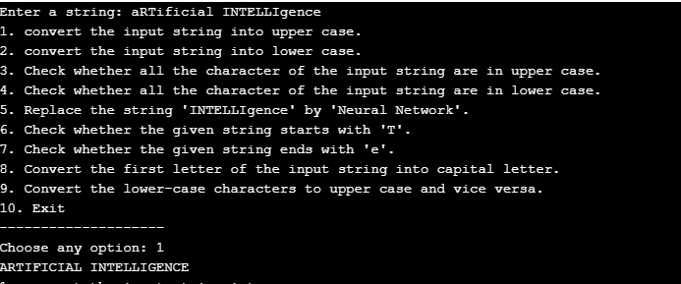

**IN LAB:**

1. Riya is a student at K L University, as she is facing some inconvenience in choosing her courses for specialization and its global certifications in CSE Department, help her find a course and global certification that is required for the specialization she is interested in, by using a simple Chatbot.  
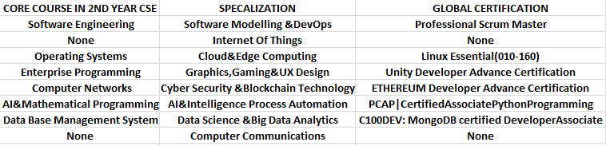

Sample Data: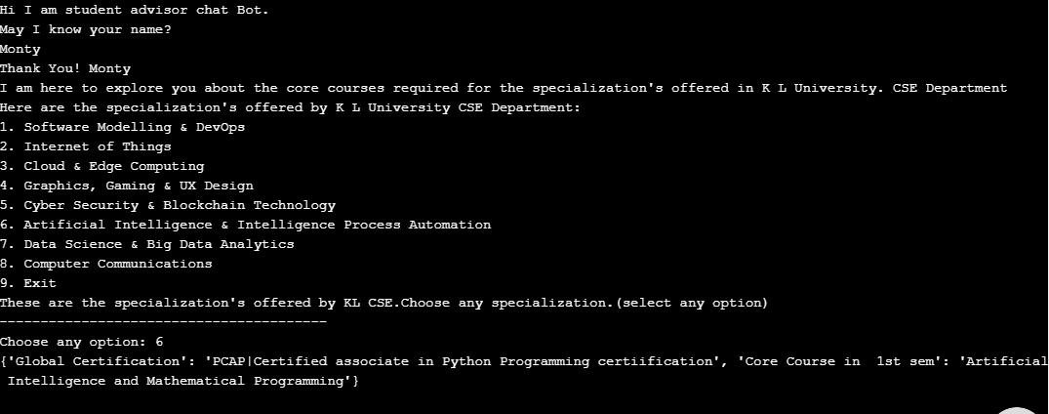

**POST LAB:**

1. Monty is a student. He wants to know his age in years, days, hours, minutes and seconds from his birthdate till date and print a few lines about his favorite color. Create a Chatbot to solve Monty’s Problem.

Output:

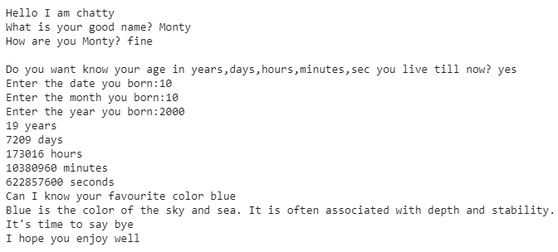

2. MIN AND MAX

You are given a 2-D array with dimensions X.  
Your task is to perform the *min* function over axis and then find the *max* of that.

Input Format

The first line of input contains the space separated values of and.  
The next line contains space separated integers.

Output Format

Compute the *min* along axis and then print the *max* of that result.

Sample Input:

4 2

2 5

3 7

1 3

4 0

Sample Output:  
 3