**LAB-10**

**PRELAB**

1. Write a short note on Knowledge Based agent with its architecture and write the two functions of Knowledge Based agent. Write a simple algorithm on its functionality.

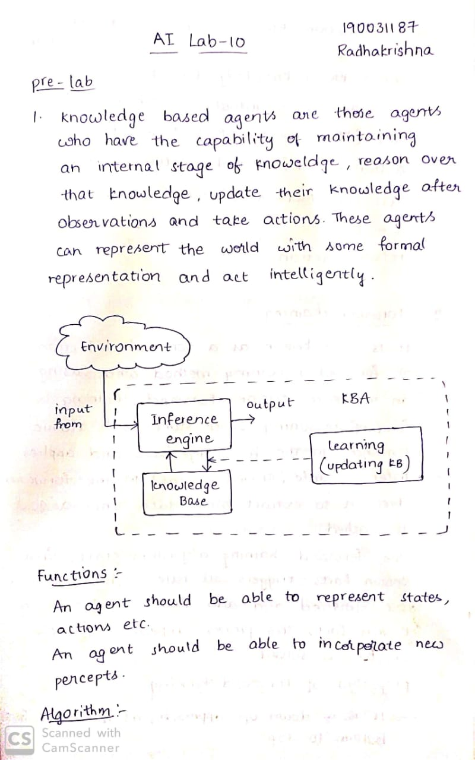

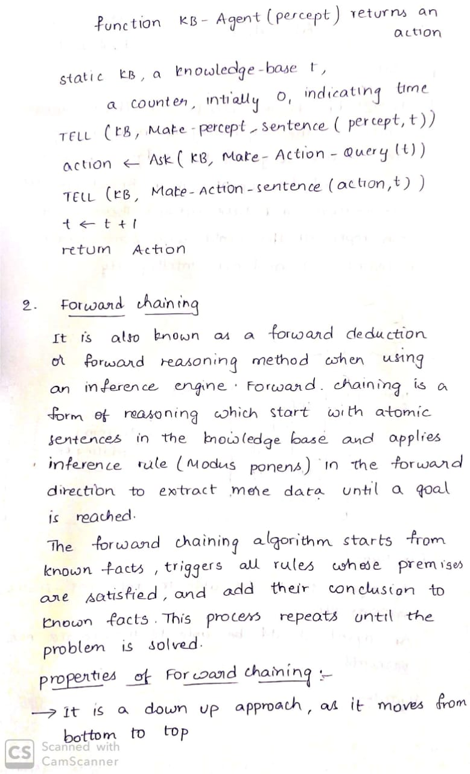

1. State and explain about forward chaining with an example.



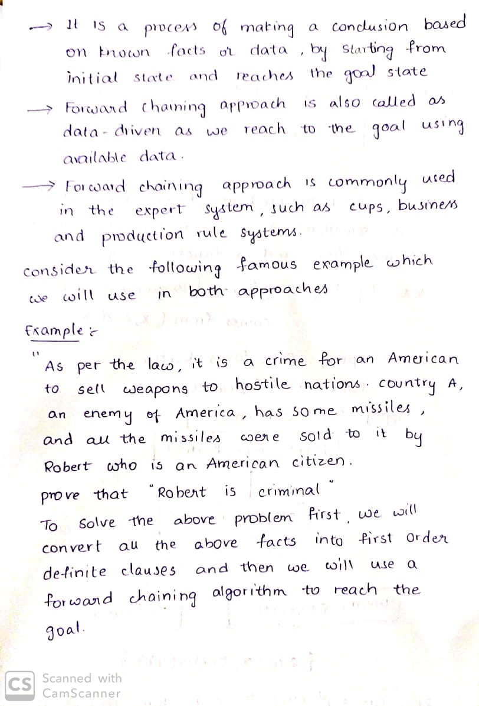

**IN LAB**

1. Write a python code for the following inference rules and facts such that the inference engine generates a list. Implement the code using Forward Chaining.

Seed(A) ==> Plant(A).

Plant(A) ==> Fruit(A).

Plant(A),Eating(A) ==> Human(A).

Plant("Mango").

Eating("Mango").

Seed("Sprouts").

global facts

global is_changed

is_changed = True

facts =[["plants","mango"],["eating","mango"],["seed","sprouts"]]

def assert_fact(fact):

    global facts

    global is_changed

    if not fact in facts:

        facts += [fact]

        is_changed = True

while is_changed:

    is_changed = False

    for A1 in facts:

        if A1[0] == "seed":

            assert_fact(["plant",A1[1]])

        if A1[0] == "plant":

            assert_fact(["fruit",A1[1]])

        if A1[0] == "plant" and ["eating",A1[1]] in facts:

            assert_fact(["human",A1[1]])

print(facts)

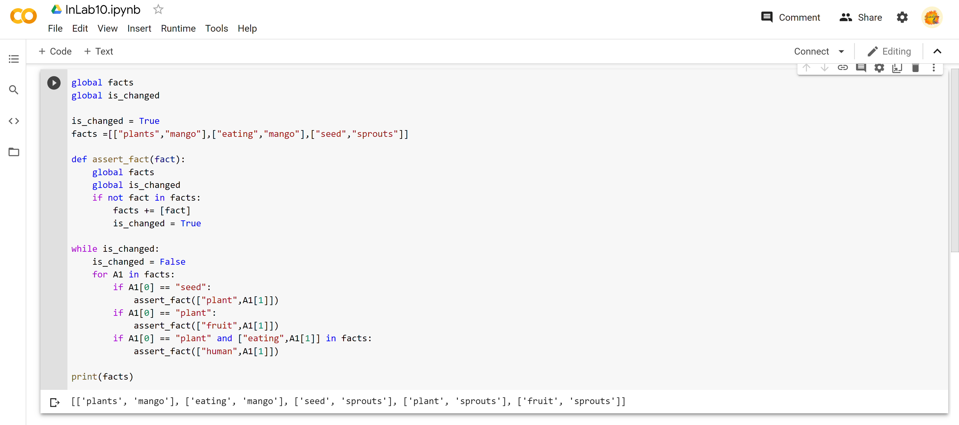

**POST LAB**

1. Translating English into first order logic

1. Every gal in Constantinople lives in Istanbul, not Constantinople.

2. Every new beginning comes from some other beginning end.

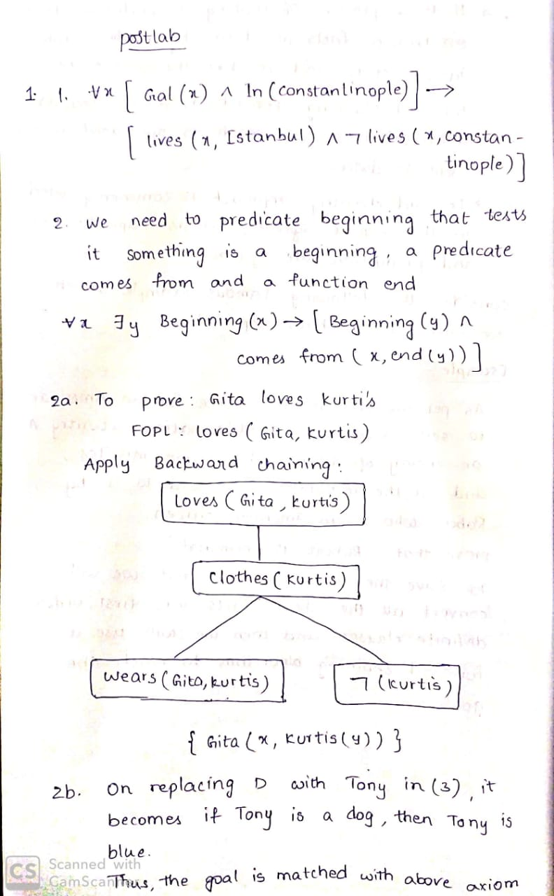

1. a) Apply backward chaining and prove that Gita loves Kurtis.

Ans) Convert the given axioms into FOPL as:

x: clothes(x)→loves(Gita, x).

Suits(x)→Clothes(x).

Jackets(x)→Clothes(x).

wears(x,y)→Ʌ ¬bad(y)→Clothes(x)

wears(Sita,skirt)Ʌ good(Sita)

wears(Sita,x)→wears(Renu,x)



b) Derive forward chaining using the given known facts to prove Tony is blue.

1. Tony barks.
2. Tony eats bone.

