**LAB-2**

**PRELAB:**

1. Write an algorithm to solve the water jug problem?

2- JUG PROBLEM ALGORITM:

STEP1:START

STEP2:Read the initial values of the container a,b

STEP3:Read the container capacities x,y STEP4:Read the goal state of the container g STEP5:

5.1 :While(True):

5.1.1 :READ THE RULE NO

5.1.1.1 :if(ruleno==1): if a<x : a=x

if(ruleno==2): if b<y:b=y if(ruleno==3): if a>0:a=0 if(ruleno==4): if b>0:b=0 if(ruleno==5):

if a+b>x and b>0:a,b=x,b-(x-a)

if(ruleno==6): if a+b>=y and a>0:a,b=a-(x-b),y if(ruleno==7):

if a+b<=x and b>0:a,b=a+b,0 if(ruleno==8): if a+b<=y and a>0:a,b=0,a+b print("A=",a) print("B=",b) if(a==z and b==0):

print("The goal state is reached") break

STEP6:STOP

3- JUG PROBLEM ALGORITHM:

STEP1:START

STEP2:Read the initial values of the container a,b,c

STEP3:Read the container capacities x,y,z STEP4:Read the goal state of the container g STEP5:

5.1 :While(True):

5.1.1 :Read the rule number

5.1.1.1:if(ruleno==1): if a<x : a=x if(ruleno==2): if a+b<x and c>0 :a,b,c=a,a-c,y-a

if(ruleno==3):

if a==x and b+c==0:a,b,c=x-y,y,c if(ruleno==4):

if a+b==x and c==0:a,b,c=a-z,b,z if(ruleno==5):

if a+b==y and c>0:a,b,c=y,x-(b+c),c if(ruleno==6):

if a+b>y and c>0:a,b,c=a+b,y-b,c; if(ruleno==7):

if a+b<y and c>0:a,b,c=a,y,c-b if(ruleno==8):

if a+b<x and b==0:a,b,c=a,c,x-(a+c) if(ruleno==9):

if b+c<=x and c==0:a,b,c=y-2*(x-y),y,x-y

print("A=",a) print("B=",b) print("C=",c)

if(a==g or b==g or c==g):

print("The goal state is reached") break

STEP6:STOP

1. You have two jugs with capacities x and y liters. There is an infinite amount of water supply available to you. Now you need to determine whether it is possible to measure z liters using these two jugs. If z liters of water are measurable, you must have z liters contained within one or both jugs by the end. We can do these few operations − • Fill any of the jugs fully with water.

* Empty any of the jugs.
* Pour water from one jug into another till the other jug is completely full or the first jug itself is empty.

SOLUTION

We have jugs x and y . Now According to Extended Euclidean theorem

if gcd(x, y) = a

then we can write a as

mx + ny = a

now if z % a == 0 then z = ka

mx + ny = ka or m (x/k) + n(y/k) = 1

here x/k and y/k are integers

now m and n according to extended euclidean theorem are integers

lets suppose than when m or n is positive it means adding water to the jug

and when m or n is negative it means removing or emptying the jug

so our requrement is

mx + ny = z

we have already found tha

m(x/k) + n(y/k) = 1

mutliplying both side by z

we have

mz(x/k) + n(y/k)*z = z

which means that we can measure water upto z litres using jugs of size(x/k) and

(y/k)

so we will return true if z%(gcd(x, y)) == 0 of course when gcd(x,y) ==0 we would have to consider certain cases

As a cororolly to the problem we can establish that given x and y such that

gcd(x,y) ==1 or x and y are coprime .In such a configuration we can measure upto any capacity that is any z greater than 0 and less than or equal to x +y.

**IN LAB:**

1. A Water Jug Problem with 2 gallons: You are given two jugs, a 5-gallon one and a 4-gallon one, a pump which can supply unlimited water that can be used to fill the jugs, and a ground on which water can be disposed. Neither jug has any measuring markings on it. Implement a python code to get exactly 2 gallons of water in the 5-gallon jug.

CODE:

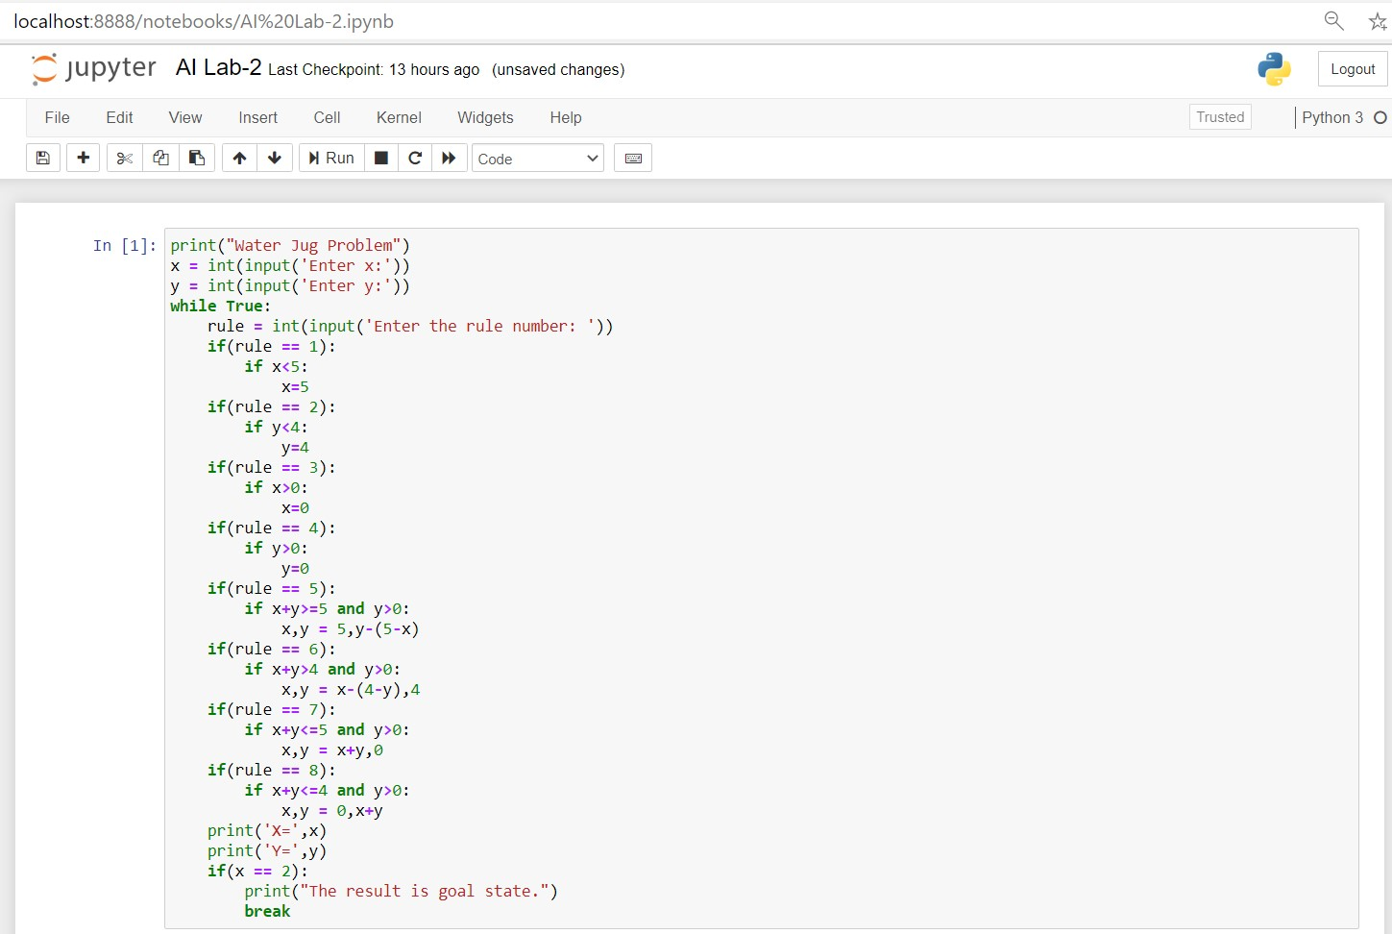

**OUTPUT**

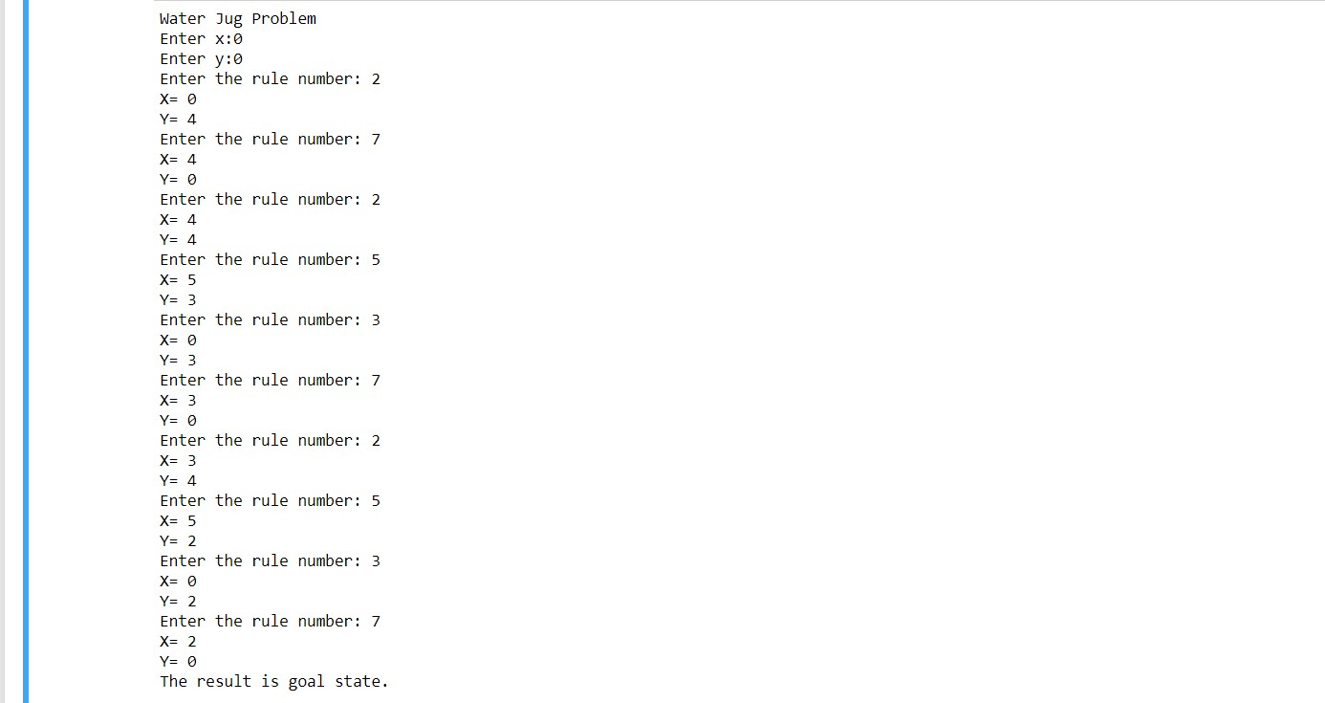

**POST LAB:**

1. A Water jug problem with 3 gallon: You are given three jugs, a 12-gallon one and an 8-gallon one and a 5-gallon one, a pump which can supply unlimited water that can be used to fill the jugs, and a ground on which water can be disposed. Neither jug has any measuring markings on it. Implement a python code to get exactly 6 gallons of water in any of the jug.

CODE:

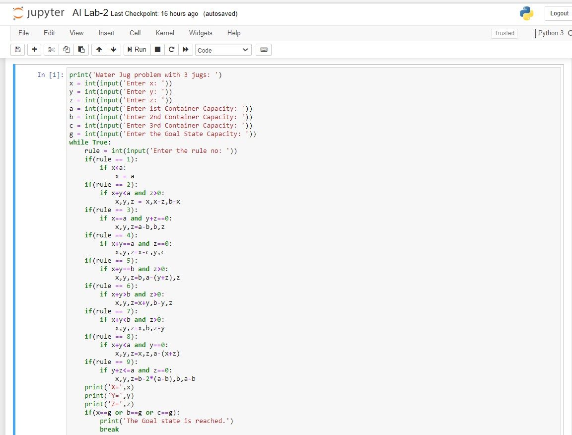

**OUTPUT**

