**Artificial Intelligence**

**LAB-3**

**PRELAB:**

1. Trace out the path using BFS, DFS and IDDFS for the following tree.

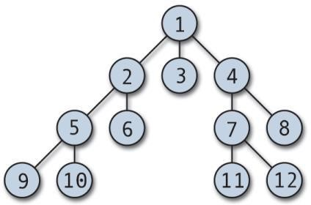

***implement iteration path for each and every level.

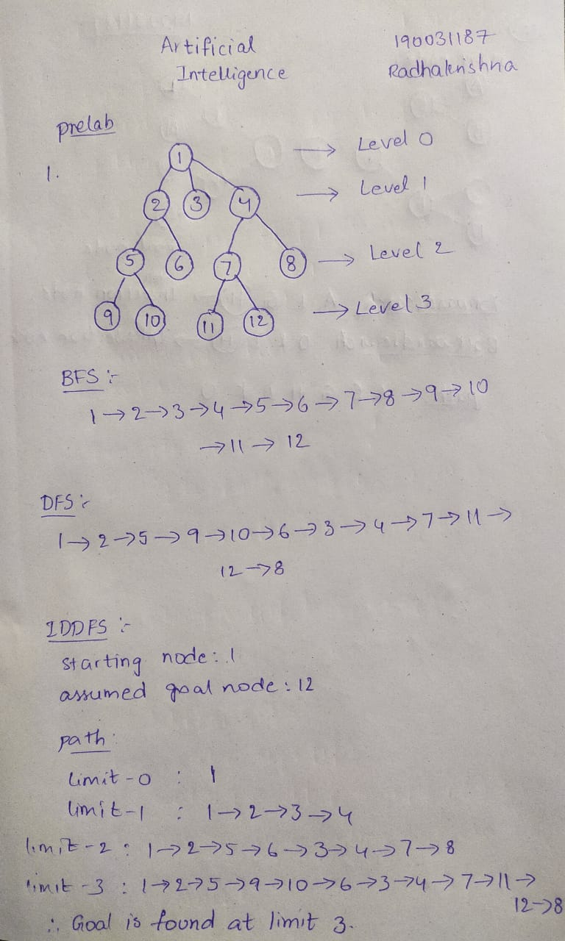

1. Trace out the path using Bidirectional search for the following tree with the given starting node and the goal node.

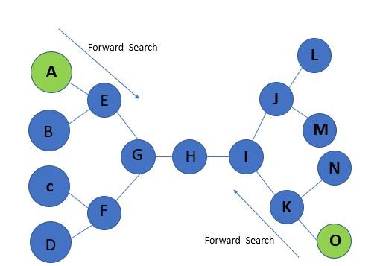

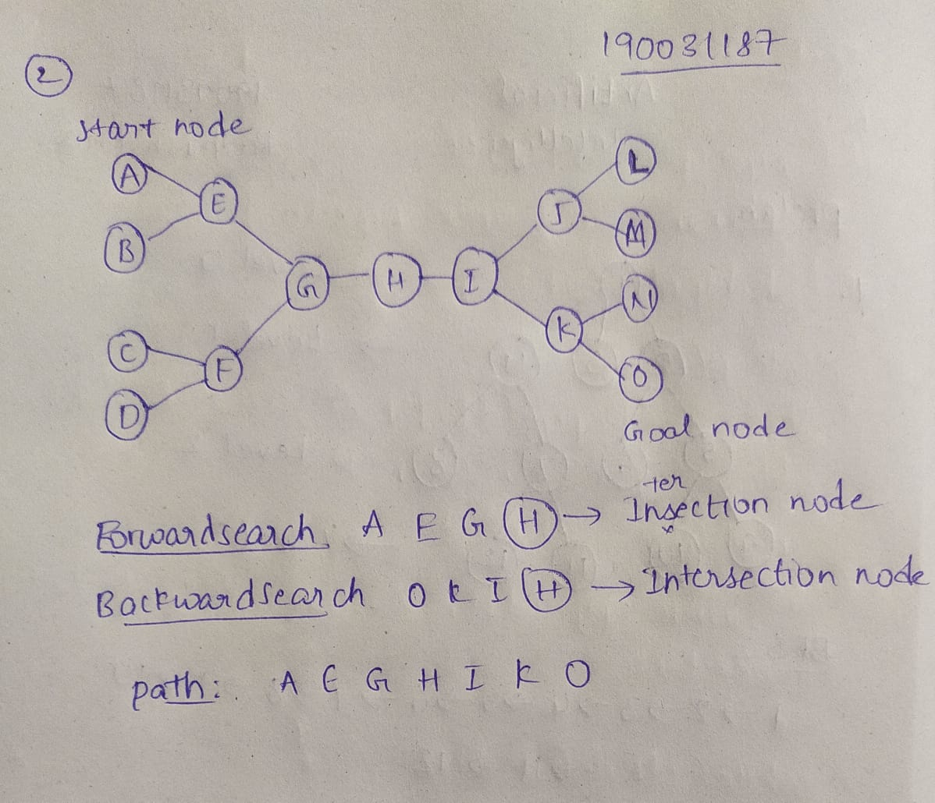

**INLAB:**

1. Write an efficient python program to implement Breadth-First Search by considering the following tree.

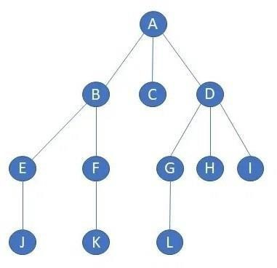

Output:

A B C D E F G H I

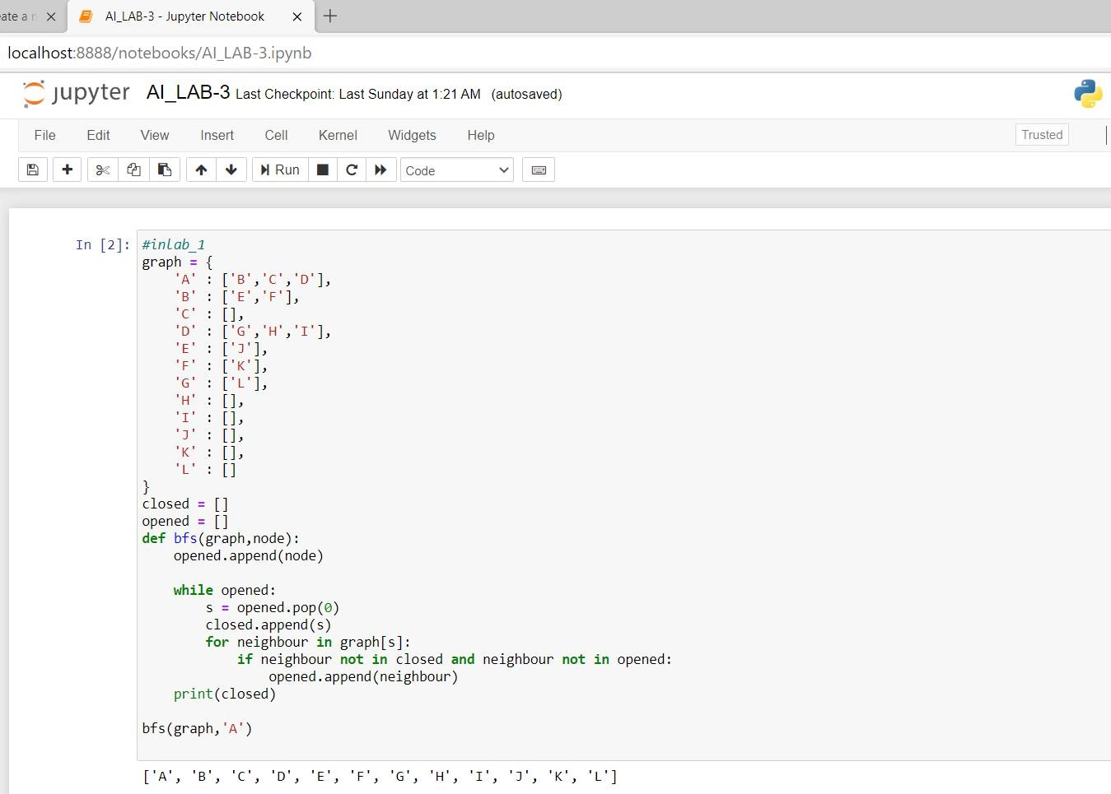

2. Write a python code to implement Depth-First Search by considering the following tree. Your code must satisfy the tree to find the best and shortest path.

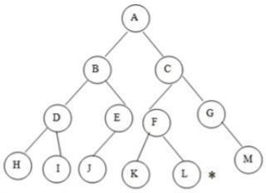

Output:

A B D H I J C F K L G M

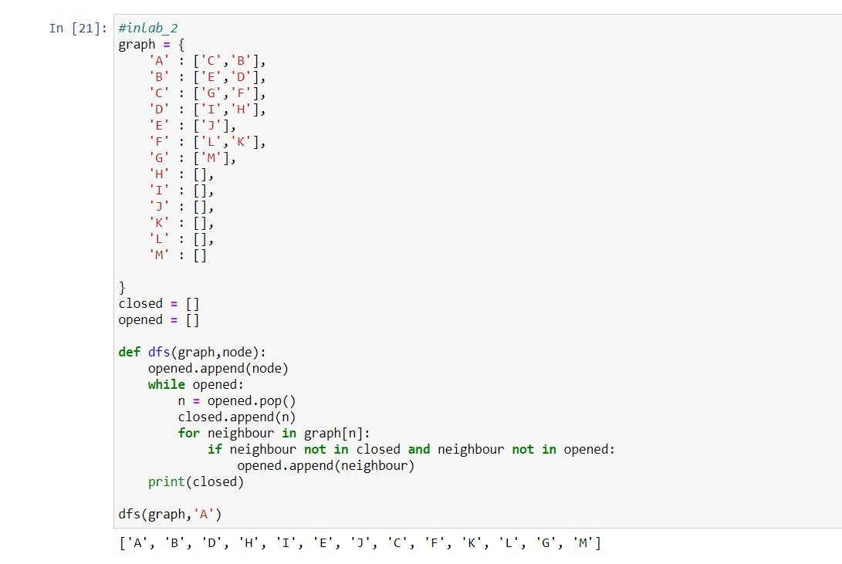

**POSTLAB:**

1. Write an efficient python program to implement Iterative deepening search by considering following tree.

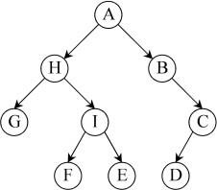

Output:

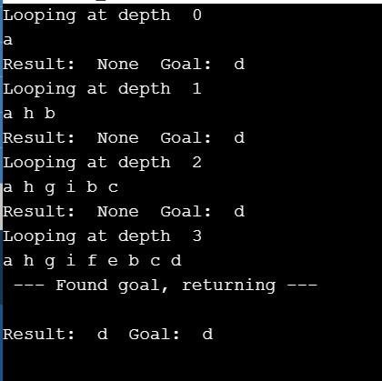

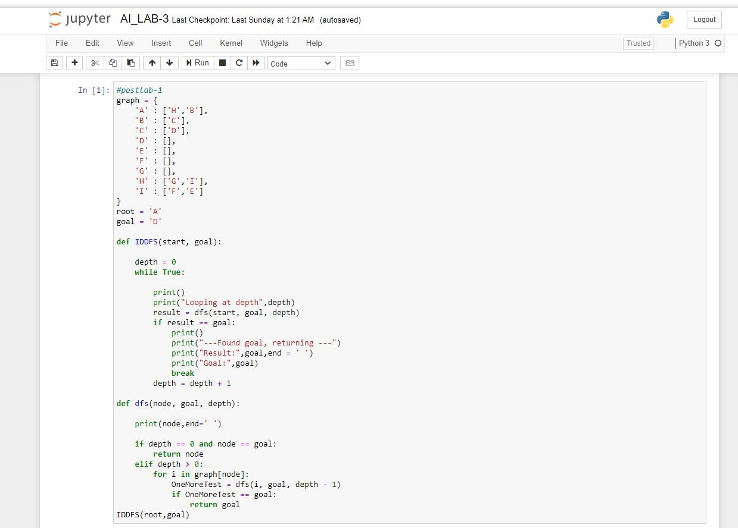

**OUTPUT**

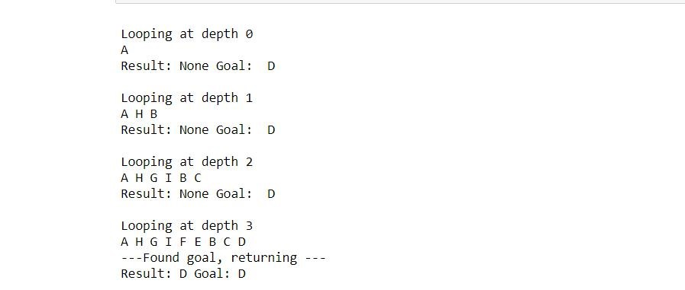

2.Write an efficient python program to implement Bidirectional search by considering following tree and print the path.

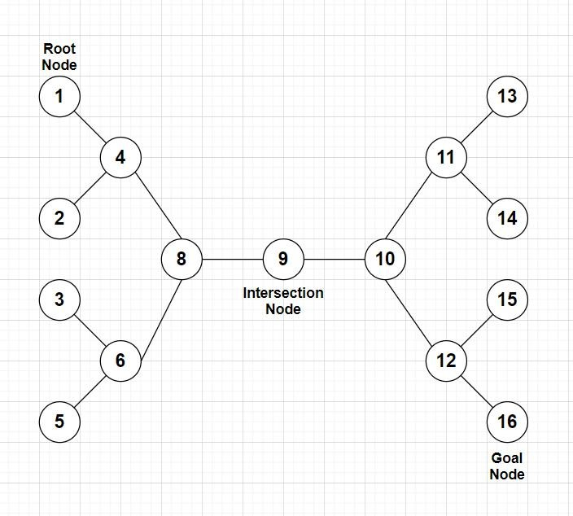

Output:

[1, 4, 8, 9, 10, 12, 16]

