**LAB-3**

**PRELAB:**

1. Trace out the path using BFS, DFS and IDDFS for the following tree.

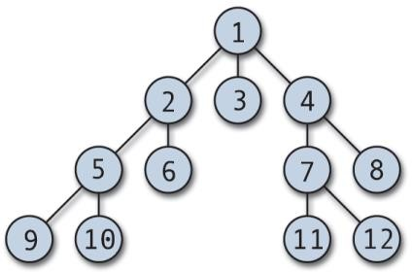

***implement iteration path for each and every level.

2. Trace out the path using Bidirectional search for the following tree with the given starting node and the goal node.

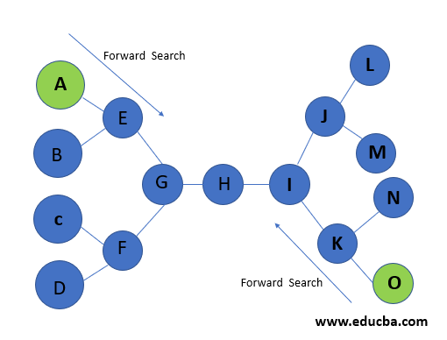

**INLAB:**

1. Write an efficient python program to implement Breadth-First Search by considering the following tree.

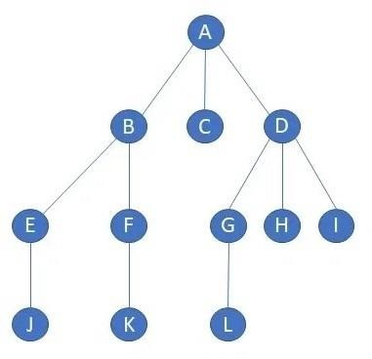

Output:

A B C D E F G H I J K L

2. Write a python code to implement Depth-First Search by considering the following tree. Your code must satisfy the tree to find the best and shortest path.

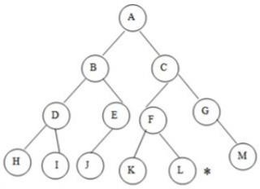

Output:

A

B

D

H

I

J

C

F

K

L

G

M

**POSTLAB:**

1. Write an efficient python program to implement Iterative deepening search by considering following tree.

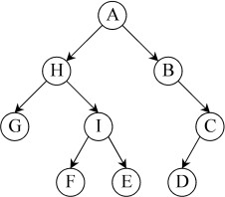

Output:

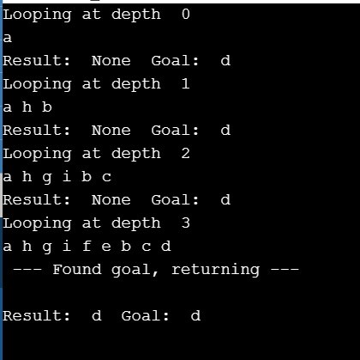

2. Write an efficient python program to implement Bidirectional search by considering following tree and print the path.

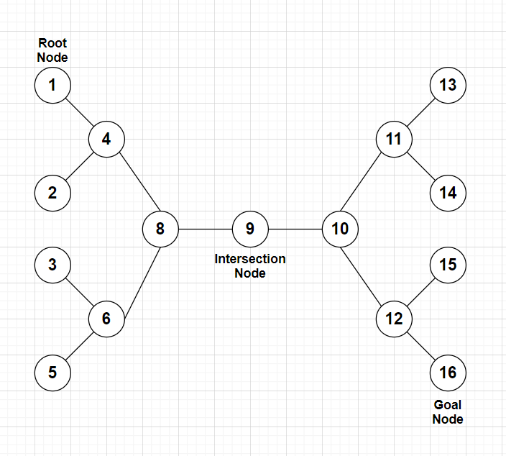

Output:

[1, 4, 8, 9, 10, 12, 16]