**AI Lab-5**

**PRELAB**

1. Describe how AO* algorithm can be used for implementing Travelling Salesman Problem.

(Travelling Salesman Problem - given a number of cities and the distances between each couple of cities, the aim is to find the smallest possible route that goes to each city exactly once and returns to the origin city i.e. find a least cost Hamiltonian cycle.)

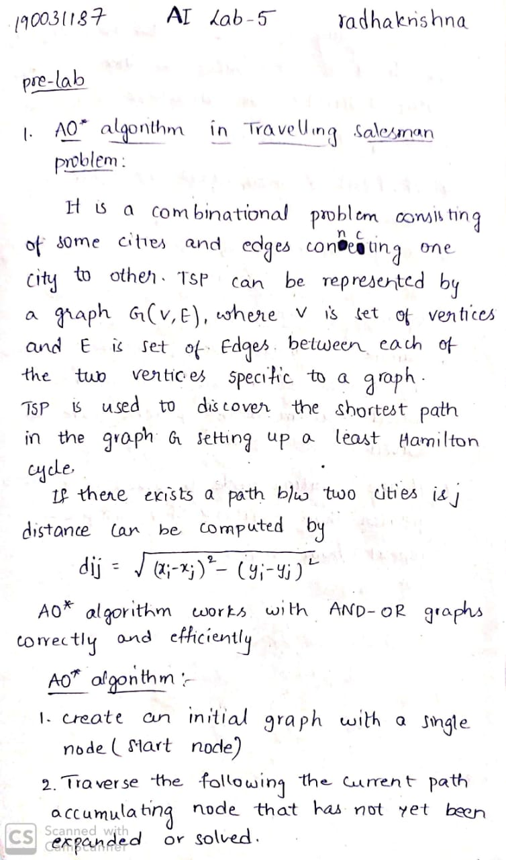

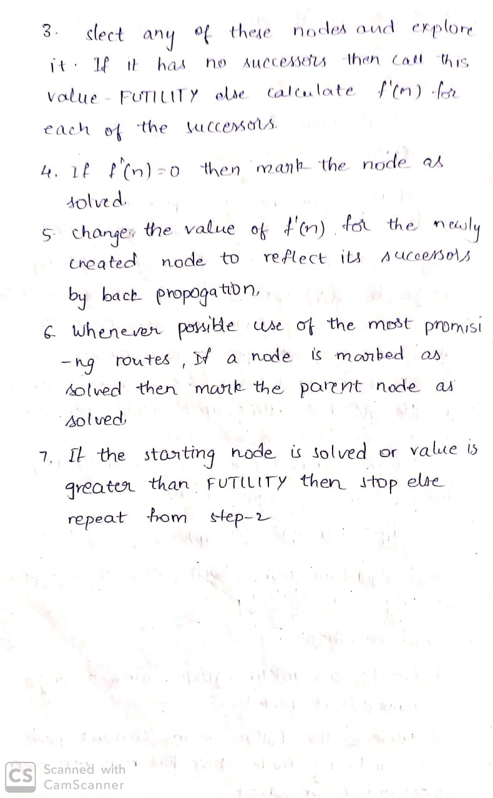

**INLAB**

1. Implement A* algorithm to find the shortest path from 0 to 19.

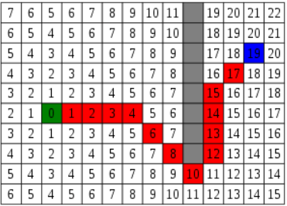

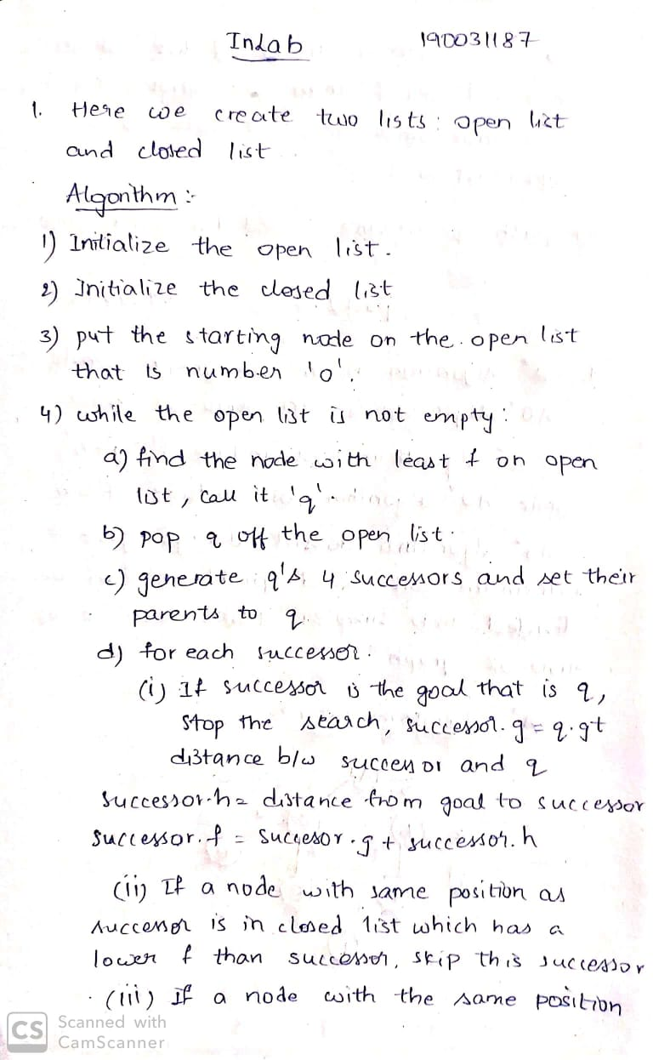

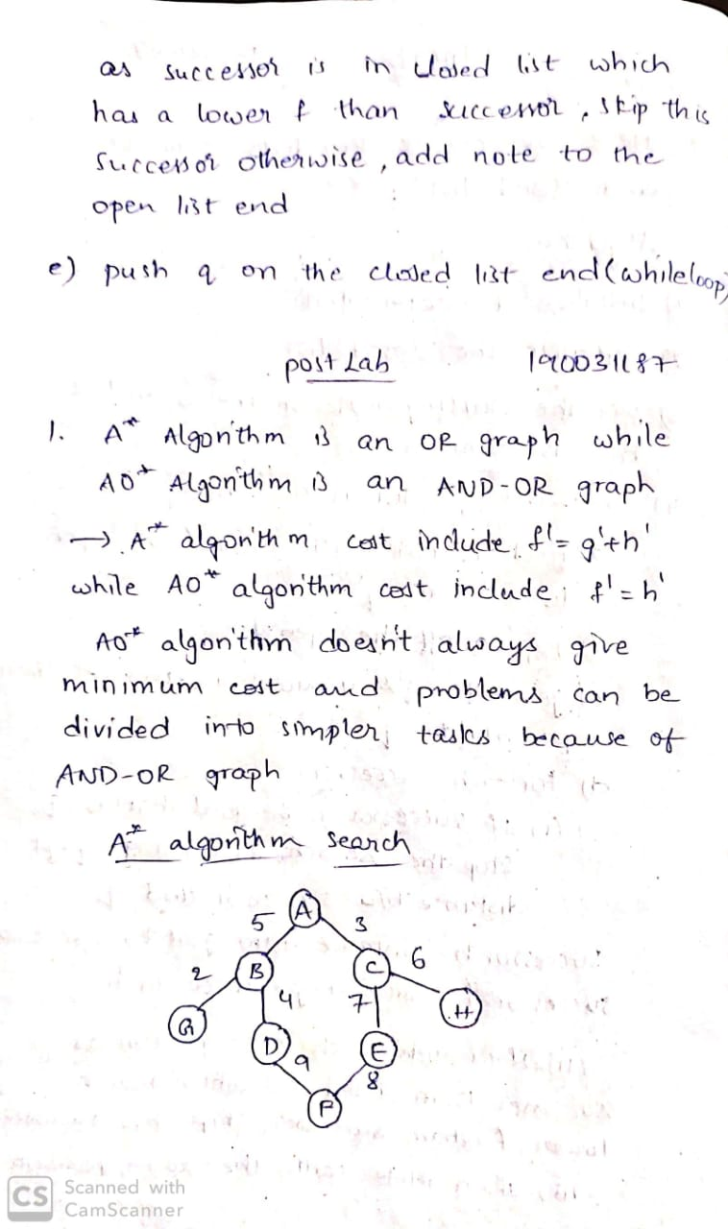

**Postlab**

1. For the given graph implement compare A* and AO* algorithm by implementation and check which one gives the optimal solution?

