**Lab-6**

**PRELAB:**

1. Write the complete workflow of the minimax two player game.

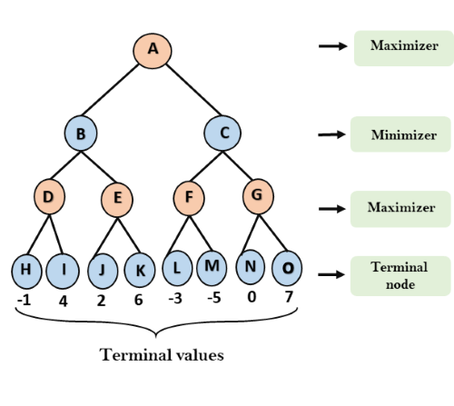

2. Write the complete workflow of the tree using alpha-beta Pruning.

**INLAB:**

1. Write a python code to print the root node using minimax algorithm.

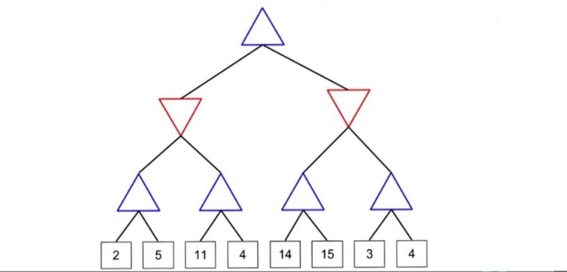

Output:

The Root Node value is: 5

**POSTLAB:**

1. Write a python code to implement the given tree and print the alpha - beta values in the root node and also print the result and time pruned by using Alpha beta pruning.

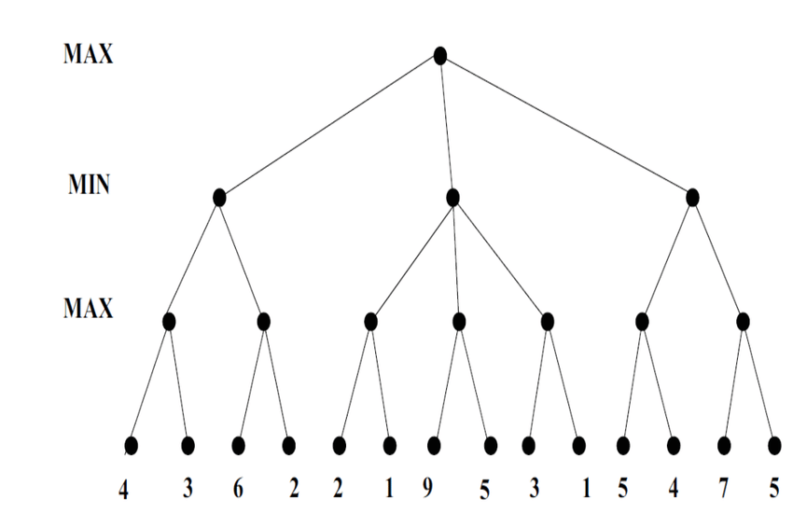

Output:

(Alpha, beta): 5 15

Result: 5

Times pruned: 4