**AI PRACTICAL-9**

Prelab:

**1. What are the techniques of Knowledge Representation? Explain in brief about Logical Representation and write the advantages and disadvantages of Logical Representation?**

A) There are 4 ways of Knowledge representation

1. Logical Representation
2. Semantic Network Representation
3. Frame Representation
4. Production Rules

Logical Representation:

Logical representation is a language with some concrete rules which deals with propositions and has no ambiguity in representation. Logical representation means drawing a conclusion based on various conditions. This representation lays down some important communication rules. It consists of precisely defined syntax and semantics which supports the sound inference. Each sentence can be translated into logics using syntax and semantics

Advantages of Logical Representation:

1. Logical representation enables us to do logical reasoning.
2. Logical representation is the basis for the programming languages.

Disadvantages of Logical Representation:

1. Logical representations have some restrictions and are challenging to work with.
2. Logical representation technique may not be very natural, and inference may not be so efficient.

**2.List the names of inference rules of Propositional logic and write the properties of the Propositional logic?**

A) Inference rules:

**Implication:** It is one of the logical connectives which can be represented as P → Q. It is a Boolean expression.

**Converse:** The converse of implication, which means the right-hand side proposition goes to the left-hand side and vice-versa. It can be written as Q → P.

**Contrapositive:** The negation of converse is termed as contrapositive, and it can be represented as ¬ Q → ¬ P.

**Inverse:** The negation of implication is called inverse. It can be represented as ¬ P → ¬ Q.

**Properties of propositional logic are:**

Satisfiable:

A atomic propositional formula is satisfiable if there is a interpretation for which it is true. In the table 6.1 P v Q is satisfiable for first three propositional formula (statements).

Tautology:

A propositional formula is valid or a tautology it is true for all possible interpretations.

Contradiction:

A propositional formula is contradictory (unsatisfiable) if there is no interpretation for which it is true. For example, Amritsar is the capital of India in table 6.1 P v Q is unsatisfiable for the row 4.

Contingent:

A contingent statement is one which is neither a tautology nor a contradiction.

**IN-LAB**

**1. Given below is the list of inference rules:**

**mammal(A) ==> vertebrate(A). vertebrate(A) ==> animal(A). vertebrate(A), flying(A) ==> bird(A). vertebrate("duck").**

**flying("duck"). mammal("cat").**

**Translate those rules into a python code.**

global facts global is_changed

is_changed = True facts = [["vertebrate","duck"],["flying","duck"],["mammal","cat"]]

def assert_fact(fact): global facts global is_changed if not fact in facts: facts += [fact] is_changed = True

while is_changed:

is_changed = False for A1 in facts: if A1[0] == "mammal":

assert_fact(["vertebrate",A1[1]]) if A1[0] == "vertebrate":

assert_fact(["animal",A1[1]]) if A1[0] == "vertebrate" and ["flying",A1[1]] in facts:

assert_fact(["bird",A1[1]])

print(facts)

**OUTPUT**

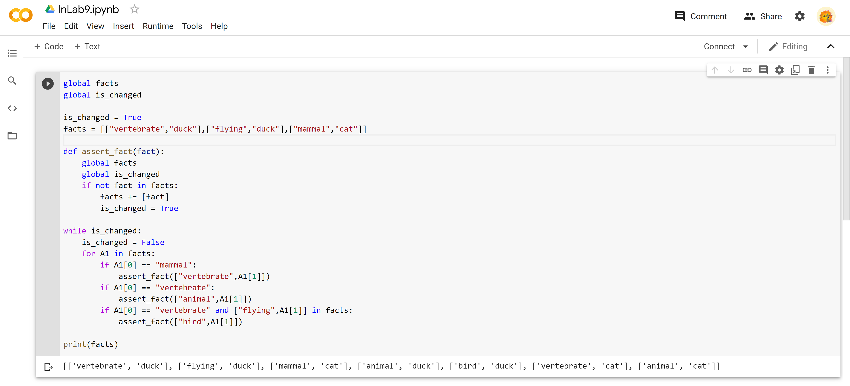

**2. Solve the following**

**Consider the following axioms:**

1. Anyone whom Mary loves is a football star.

A) ∀ x (LOVES(Mary,x) → STAR(x))

2. Any student who does not pass does not play.

A) ∀ x (STUDENT(x) ∧ ¬ PASS(x) → ¬ PLAY(x))

3. John is a student.

A) STUDENT(John)

4. Any student who does not study does not pass.

A) ∀ x (STUDENT(x) ∧ ¬ STUDY(x) → ¬ PASS(x))

1. Anyone who does not play is not a football star.
2. ∀ x (¬ PLAY(x) → ¬ STAR(x))
3. (Conclusion) if John does not study, then Mary does not love John.

A) ¬ STUDY(John) → ¬ LOVES(Mary,John)

**POSTLAB**

**1. After teacher explained about inference topic in Proportional logic topic, Sita gave these problems to her friend to test her capability. Help her solve the problems.**

**i. “If I eat spicy foods, then I have strange dreams.” “I have strange dreams if there is thunder while I sleep.” “I did not have strange dreams.”**

A) A= “I ate spicy food”

D= “I had strange dreams”

B = “It thundered while I slept”

“If I eat spicy foods, then I have strange dreams.” A → D

“I have strange dreams if there is thunder while I sleep.” B→D

“I did not have strange dreams.” ¬D

**ii. “I am dreaming or hallucinating.” “I am not dreaming.” “If I am hallucinating, I see elephants running down the road.”**

D = ‘I am dreaming’

H = ‘I am hallucinating’

E = ‘I see elephants running down the road’

“I am dreaming or hallucinating.” D V H

“I am not dreaming.” ¬D

“If I am hallucinating, I see elephants running down the road.” H → E