**PL/SQL Programs on Case Study 2 & 5**

**(EMERGENCY ROOM INFORMATION SYSTEM) & (TOUR OPERATING SYSTEM)**

**PRE-LAB**

1. Declare  
   fvar number := null; svar number := 5  
   Begin  
   goto << fproc>>  
   if fvar is null then  
   << fproc>>  
   svar := svar + 5  
   end if;  
   End;

What will be the value of svar after the execution ?

**Ans)** Ouput : Syntax Error.

1. What is a stored procedure?

**Ans)** A stored procedure is a prepared sql code that you can save, so the code can be reused over and over again.

1. What are the different datatypes supported in PL/SQL

**Ans)** pl/sql provides many pre-defined data-types like integer, floating point , charcater , Boolean, date , collection,refrence and large object (lob) types.

1. What is the Result of the following 'VIK'||NULL||'RAM' ?

**Ans)** VIKRAM

1. A database is an extensive collection of records. In what form are they stored?

**Ans)** Database is a collection of data and records. They are stored in form of simple tables. Tables are related if they contain common fields.

1. In the index allocation scheme of blocks to a file, the maximum possible size of the life depends on ______

**Ans)** the size of the blocks, the number of blocks used for the index and size of address of blocks.

1. How many Clustered indexes can be created on table and why?

**Ans)** There can only be one clustered index per table , because the data row themselves can be stored in only one order. The only time the data rows in a table are stored in sorted order is when the table contains a clustered index.

**INLAB**

1. **Write PL/SQL program to display doctor appointment fee amount value.**

delimiter $$

create procedure proc_amt()

begin

select amt as doctor_appointment_amount from APPOINTMENT;

end $$

delimiter ;

call proc_amt();

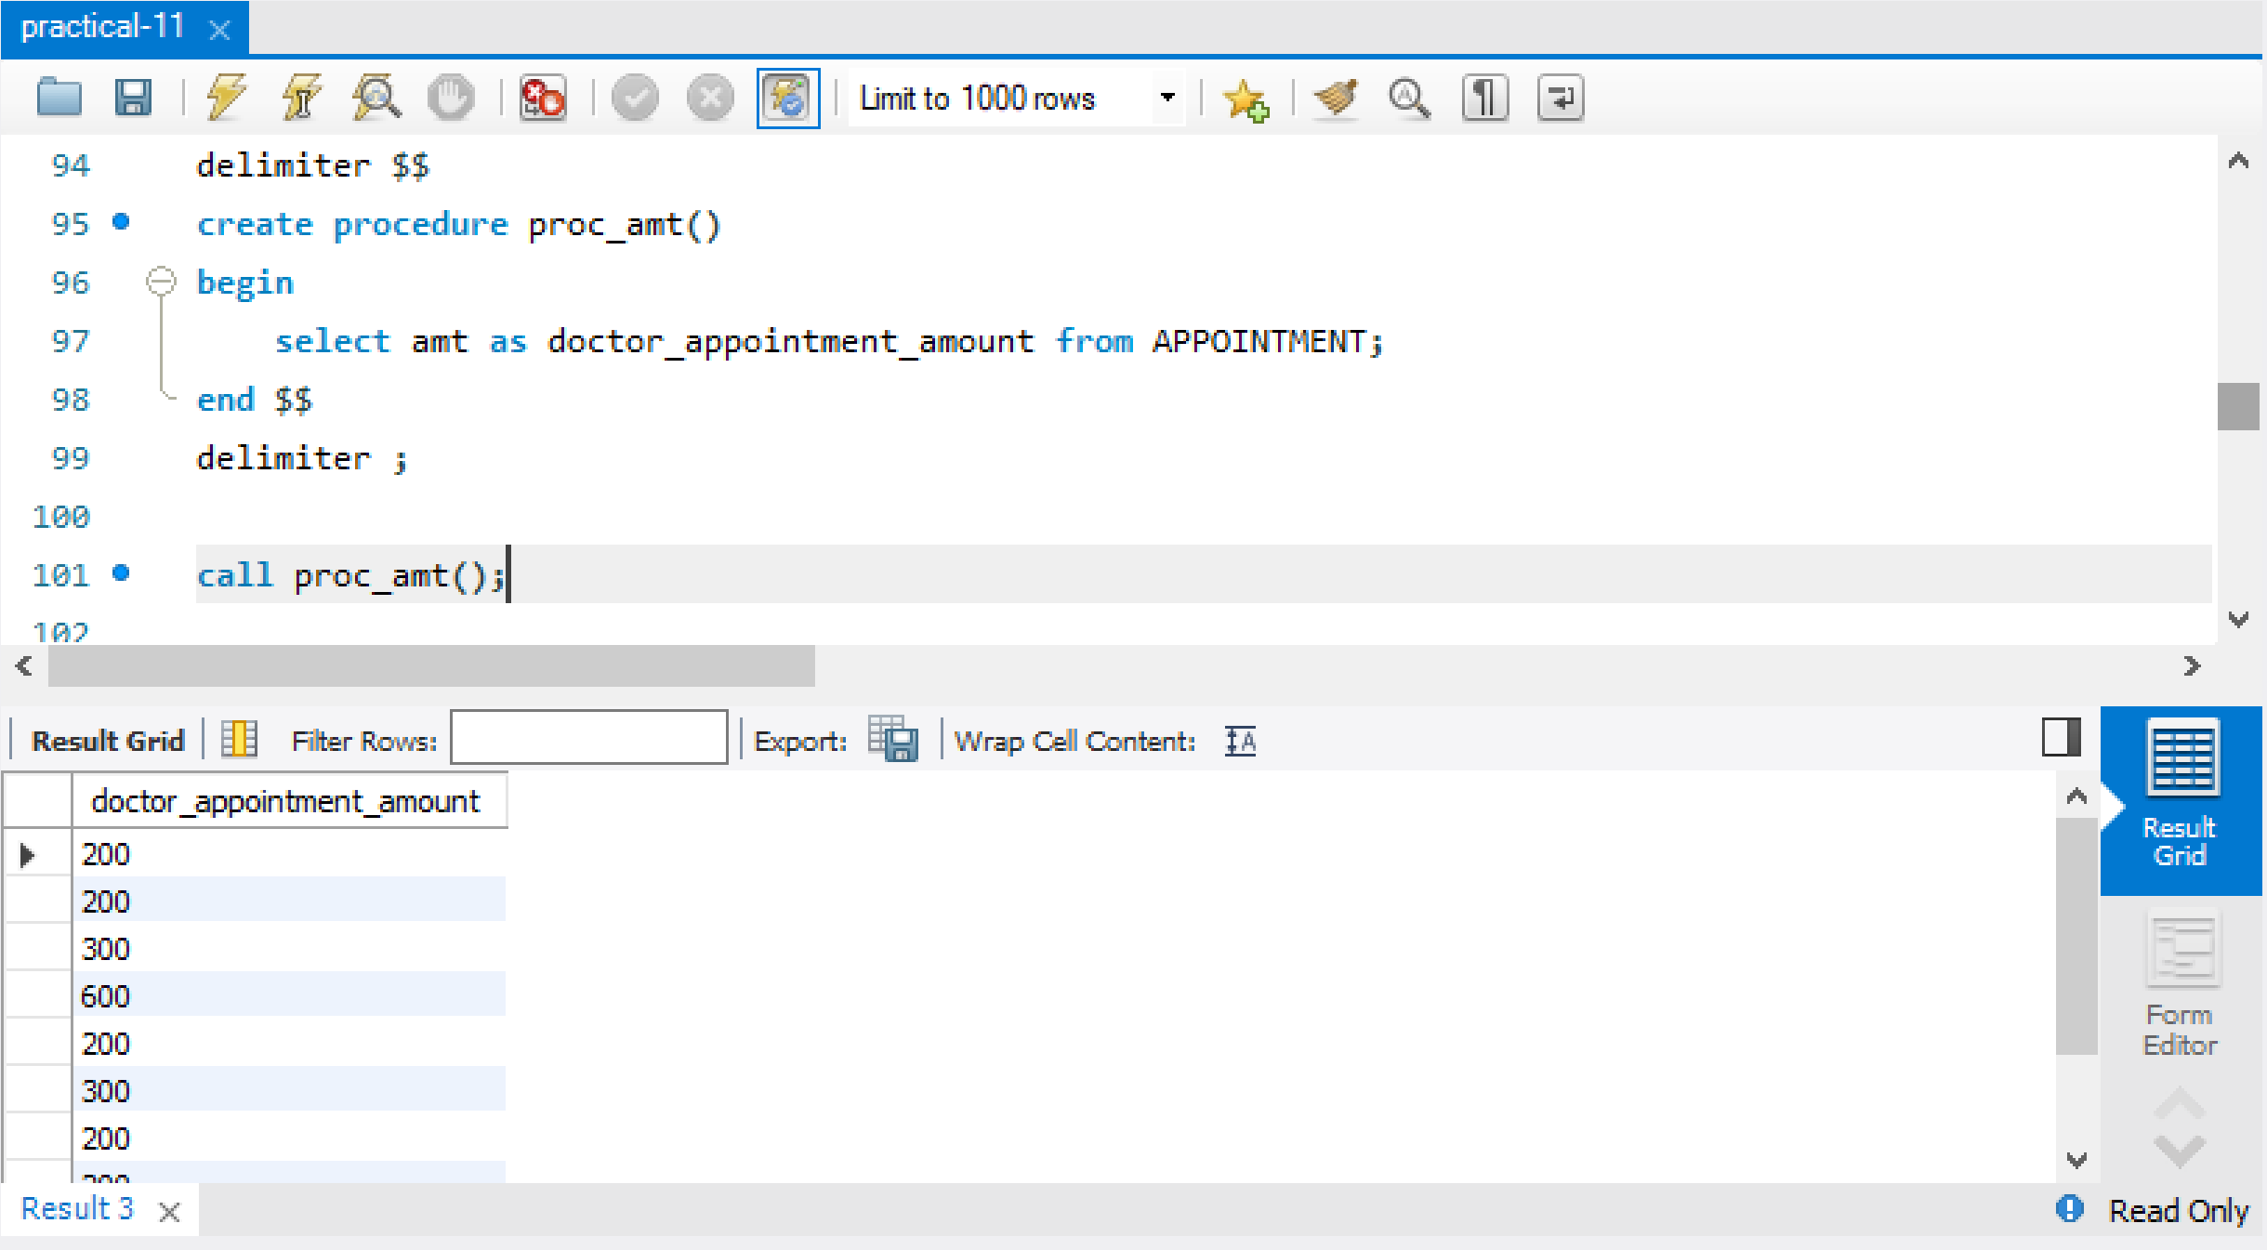

1. **Write PL/SQL program to delete appointment amount value 200**

delimiter $$

create procedure proc_delete()

begin

delete from APPOINTMENT where amt = 200;

end $$

delimiter ;

call proc_delete();

select *from APPOINTMENT;

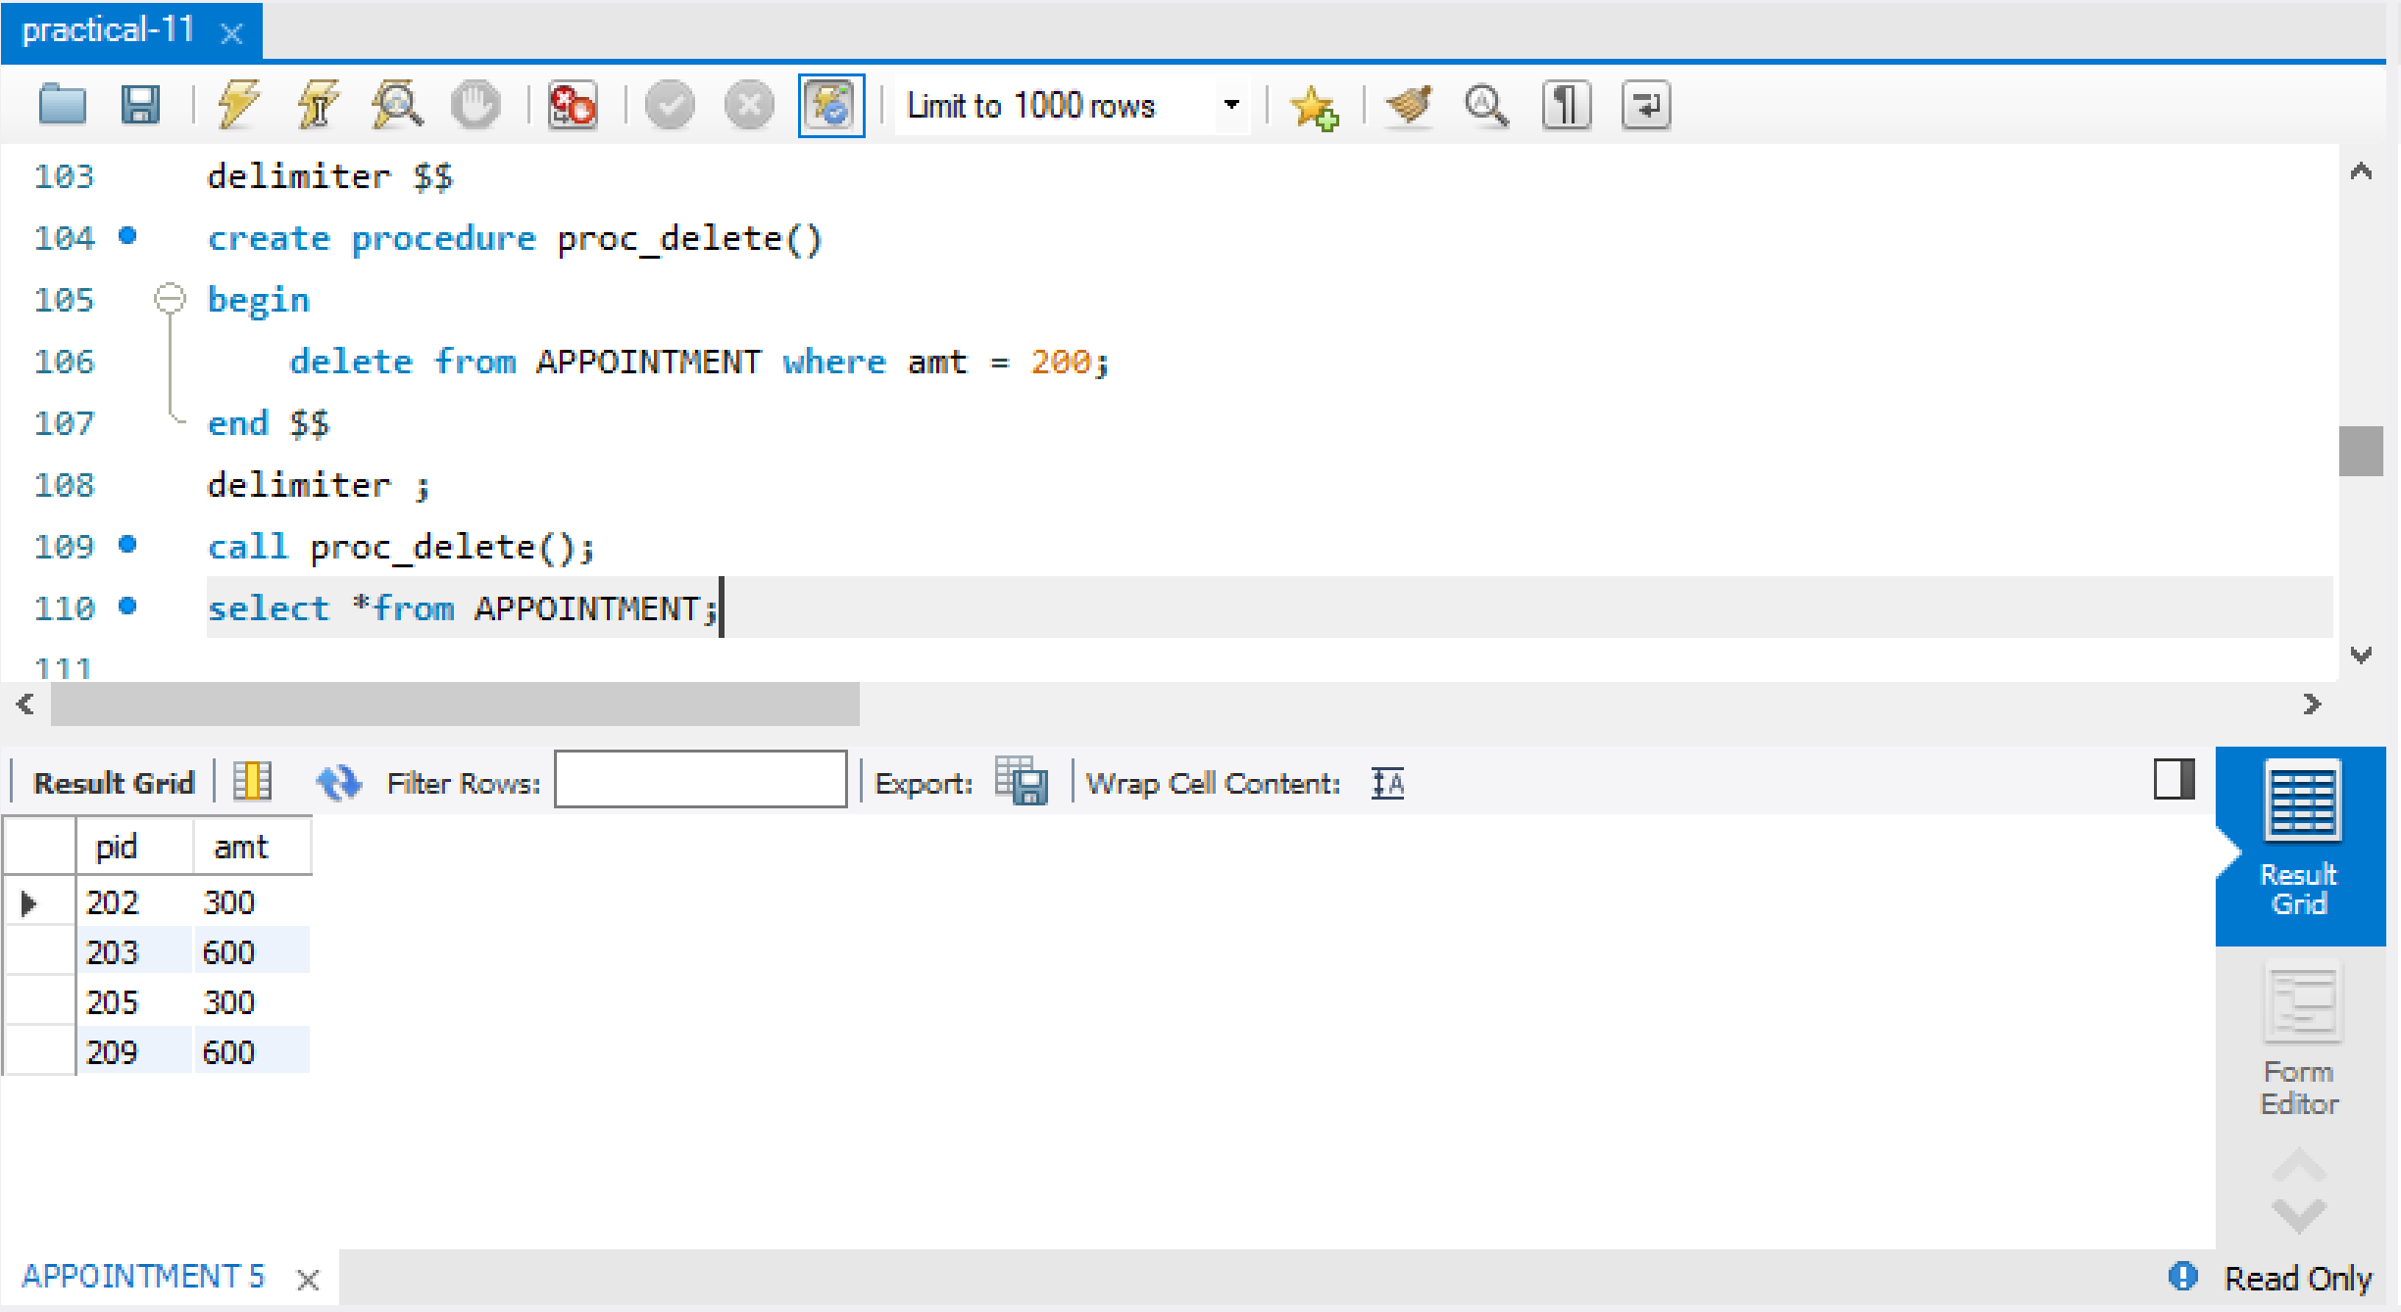

1. **Write a PL/SQL program using functions to display the address details from where the number of patients are more than 3.**

delimiter $@

create function Q12() returns varchar(100)

deterministic

begin

declare city varchar(45);

select address into city from Patient group by address order by count(*) desc limit 1;

return city;

end $@

delimiter ;

select Q12();

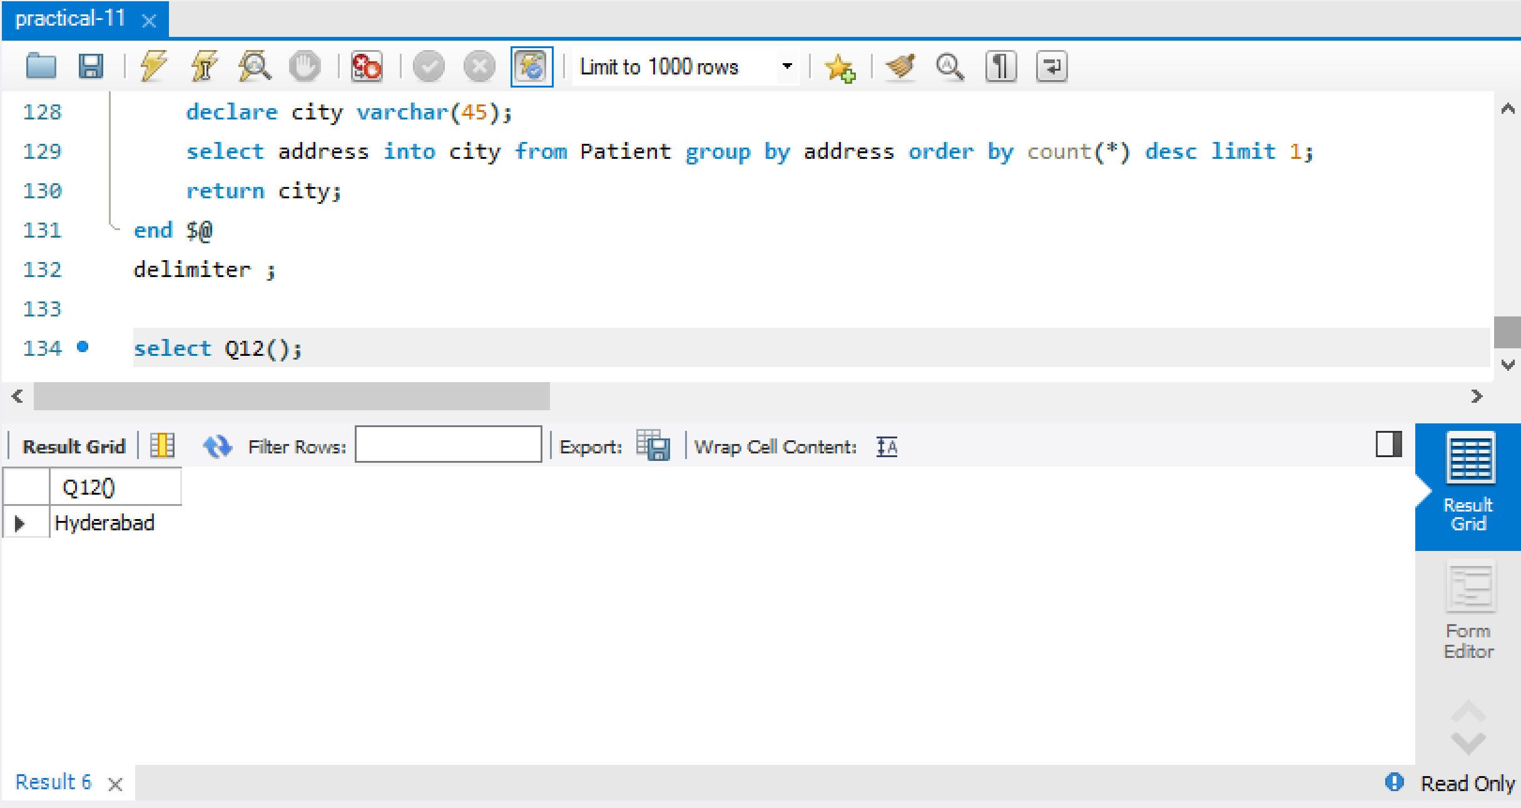

1. **Write an PL/SQL program using triggers to raise an exception on invalid patient ID**

delimiter $$

create trigger trig_patient before insert on Patient

for each row

begin

if new.pid not in (select pid from Patient) then

SIGNAL SQLSTATE '45000' SET MESSAGE_TEXT = 'Invalid Patient ID';

end if;

end $$

delimiter ;

insert into Patient values(210,'Naveen','Kumar','jghfr@gmail.com',2099135327,'Hyderabad' ,STR_TO_DATE('22-04-2020','%d-%m-%Y'));

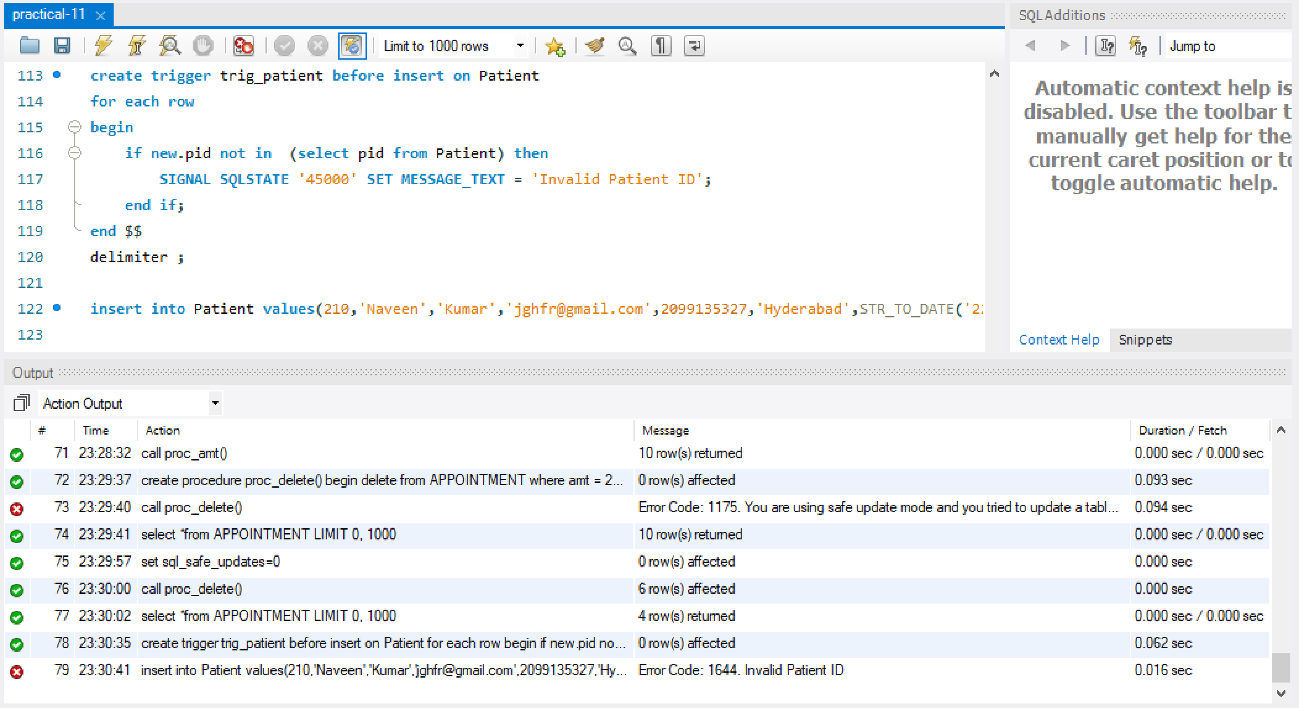



**PL/SQL programs on TOUR OPERATING SYSTEM**

1. **Create a procedure to display the tourist details who are visiting the same place**

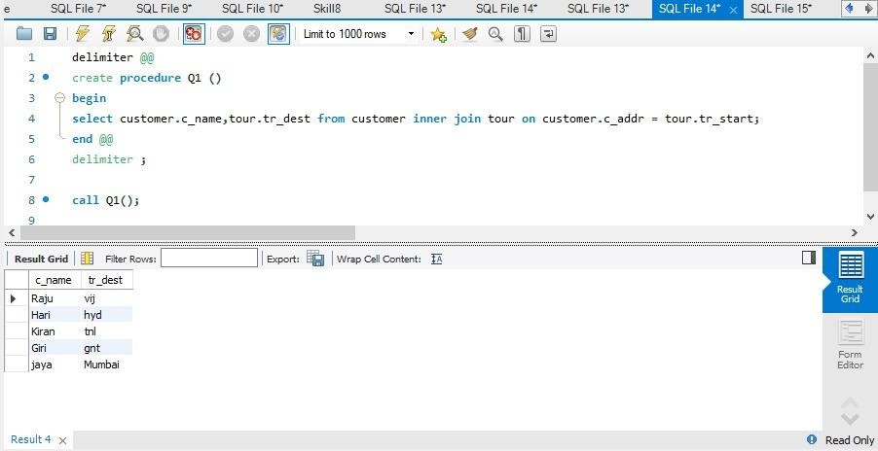

1. **Create a cursor to display the details of the customers/tourists**

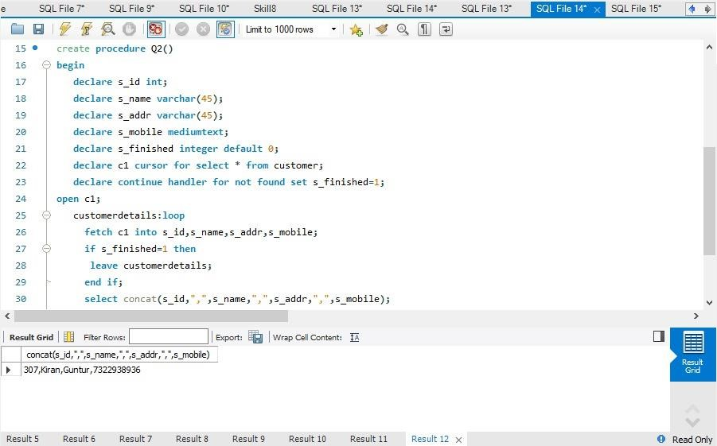

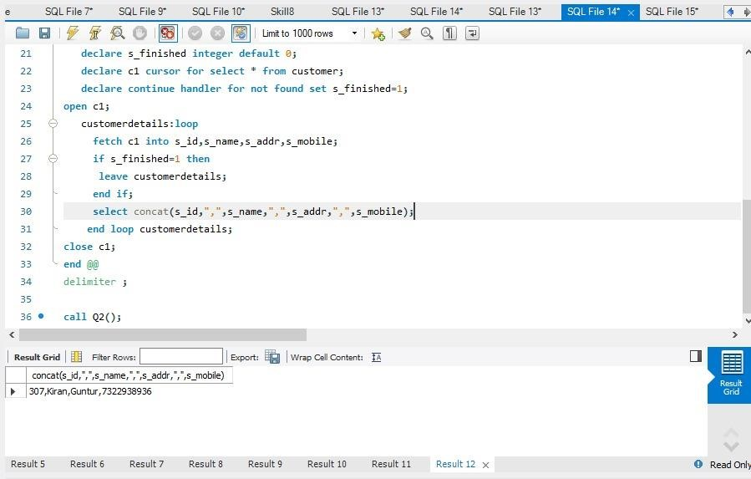

1. **Create a cursor to display the details of the travel agents where the tourists booked their tours**

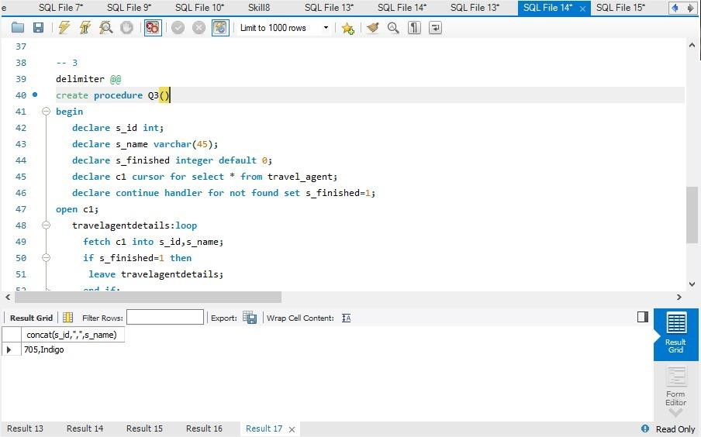

**POSTLAB**

1. **Write a PL/SQL PROGRAM to select the five highest paid employees from the emp table using CURSORS.**

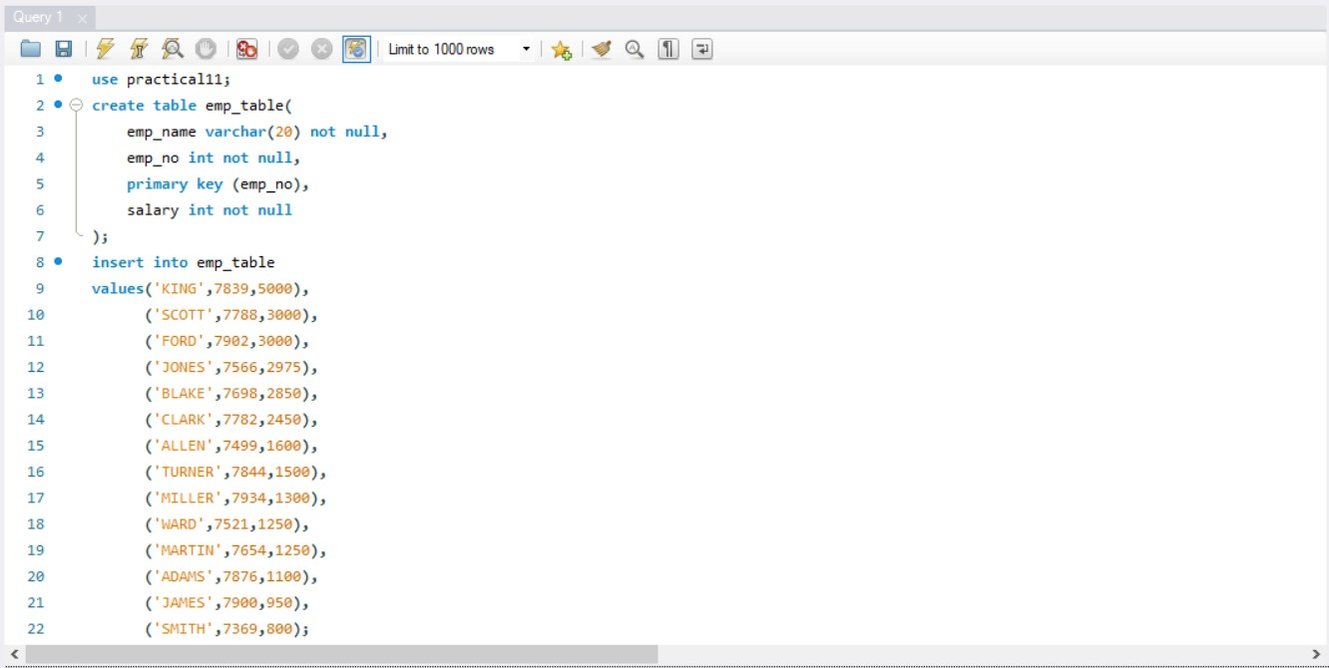

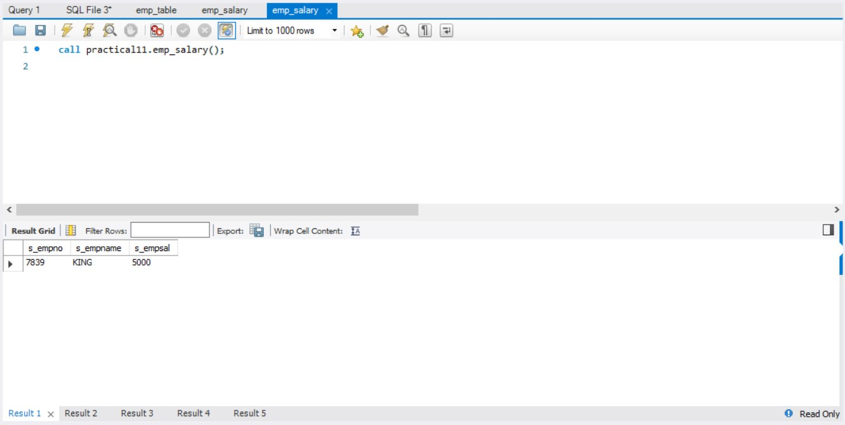

1. **Write a PL/SQL Program to check for an Armstrong Number**

declare

n number:=1634;

s number:=0;

r number;

len number;

m number;

begin

m := n;

len := length(to_char(n));

while n>0

loop

r := mod(n , 10);

s := s + power(r , len);

n := trunc(n / 10);

end loop;

if m = s

then

dbms_output.put_line('yes');

else

dbms_output.put_line('no');

end if;

end;

1. **Write a PL/SQL program to check whether a given character is letter or digit.**

DECLARE

get_ctr CHAR(1) := '&input_a_character';

BEGIN

IF ( get_ctr >= 'A'

AND get_ctr <= 'Z' )

OR ( get_ctr >= 'a'

AND get_ctr <= 'z' ) THEN

dbms_output.Put_line ('The given character is a letter'); ELSE

dbms_output.Put_line ('The given character is not a letter');

IF get_ctr BETWEEN '0' AND '9' THEN

dbms_output.Put_line ('The given character is a number'); ELSE

dbms_output.Put_line ('The given character is not a number');

END IF;

END IF; END;

Output: A

The given Character is a letter.