**IN LAB**

**CASE STUDY-1:**

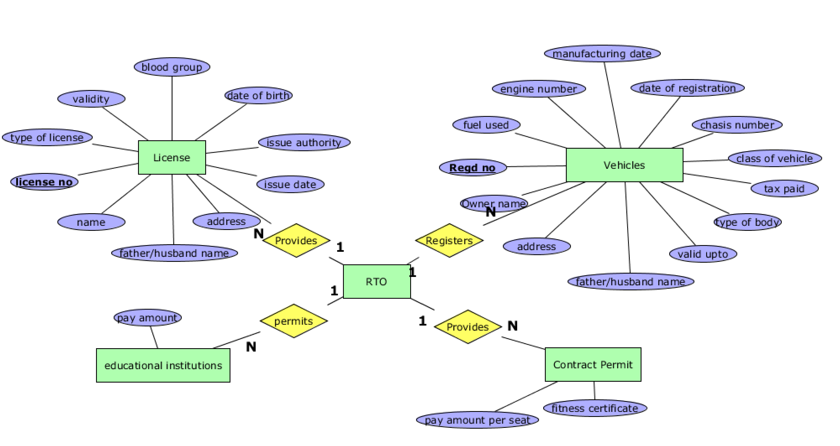

**CASE STUDY-2:**

