**PRACTICAL-3**

**PRELAB**

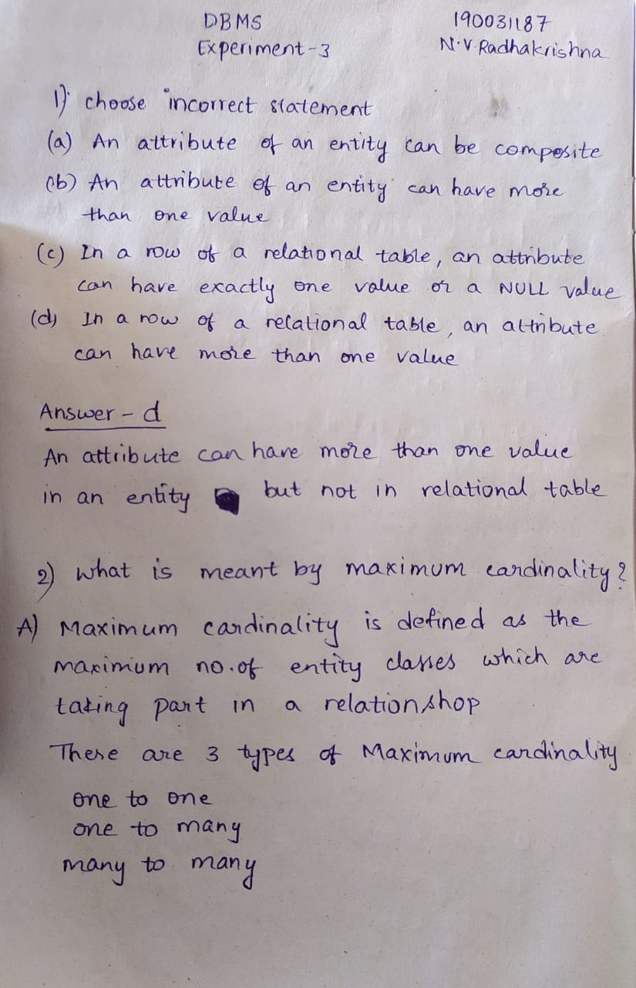

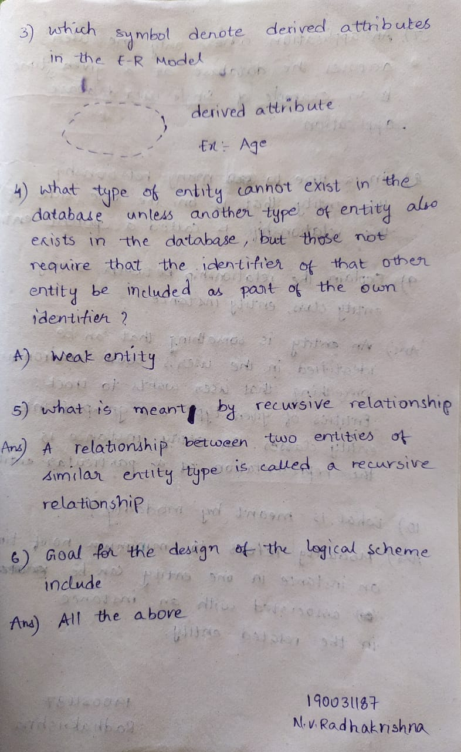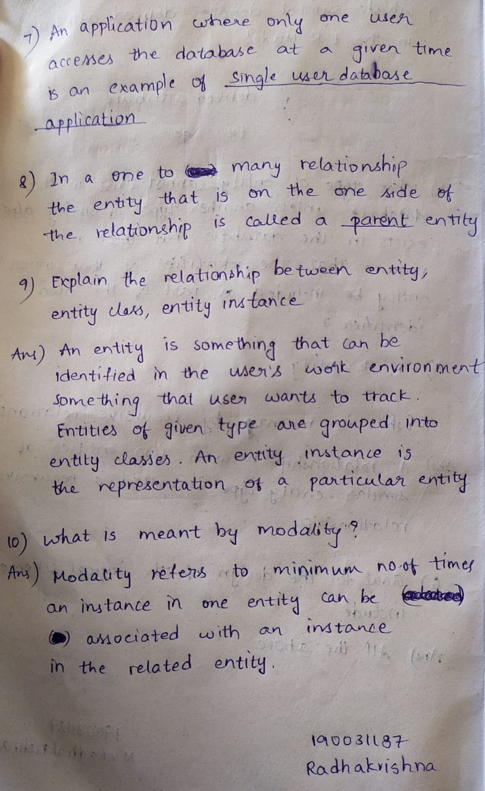

**INLAB**

**EMERGENCY ROOM INFORMATION SYSTEM**

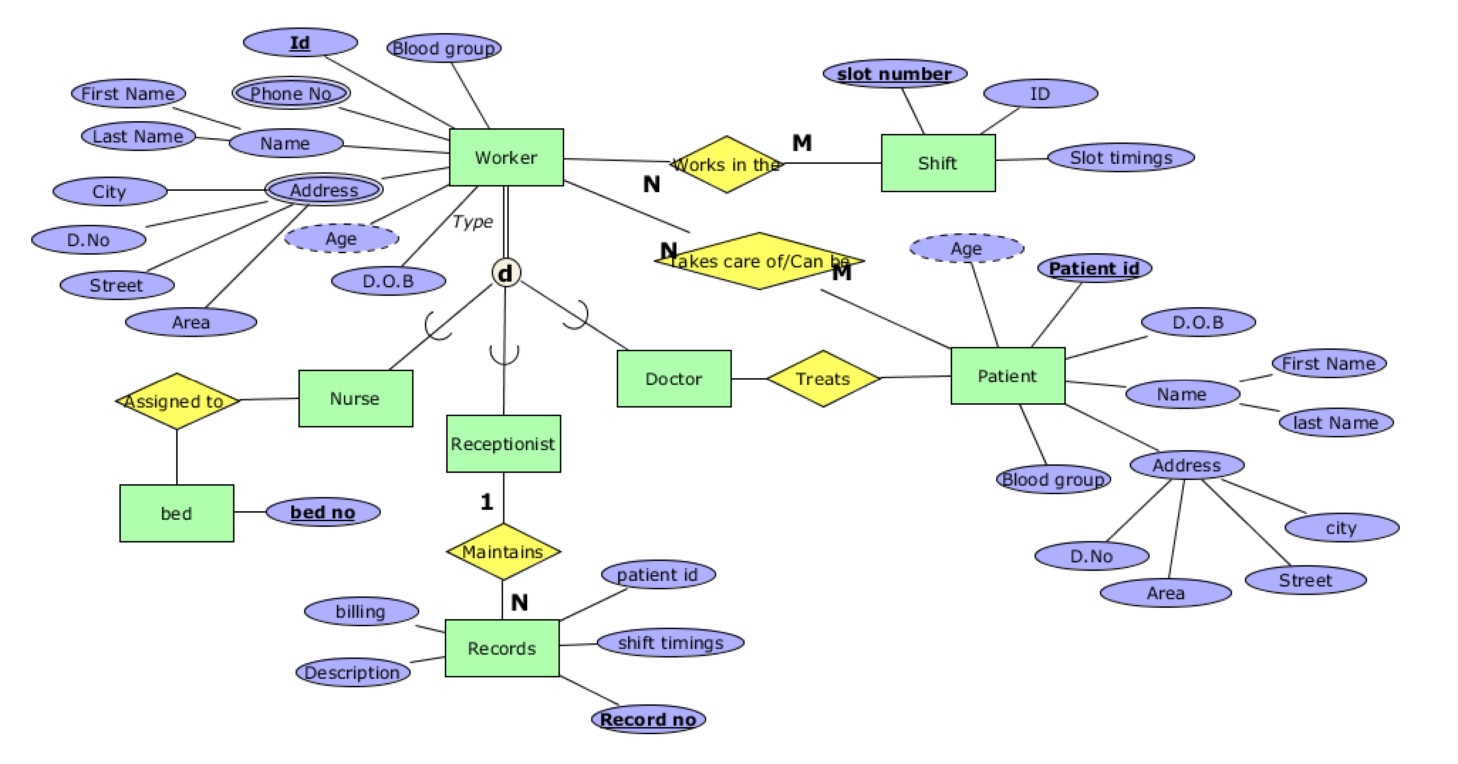

**TOUR OPERATING SYSTEM 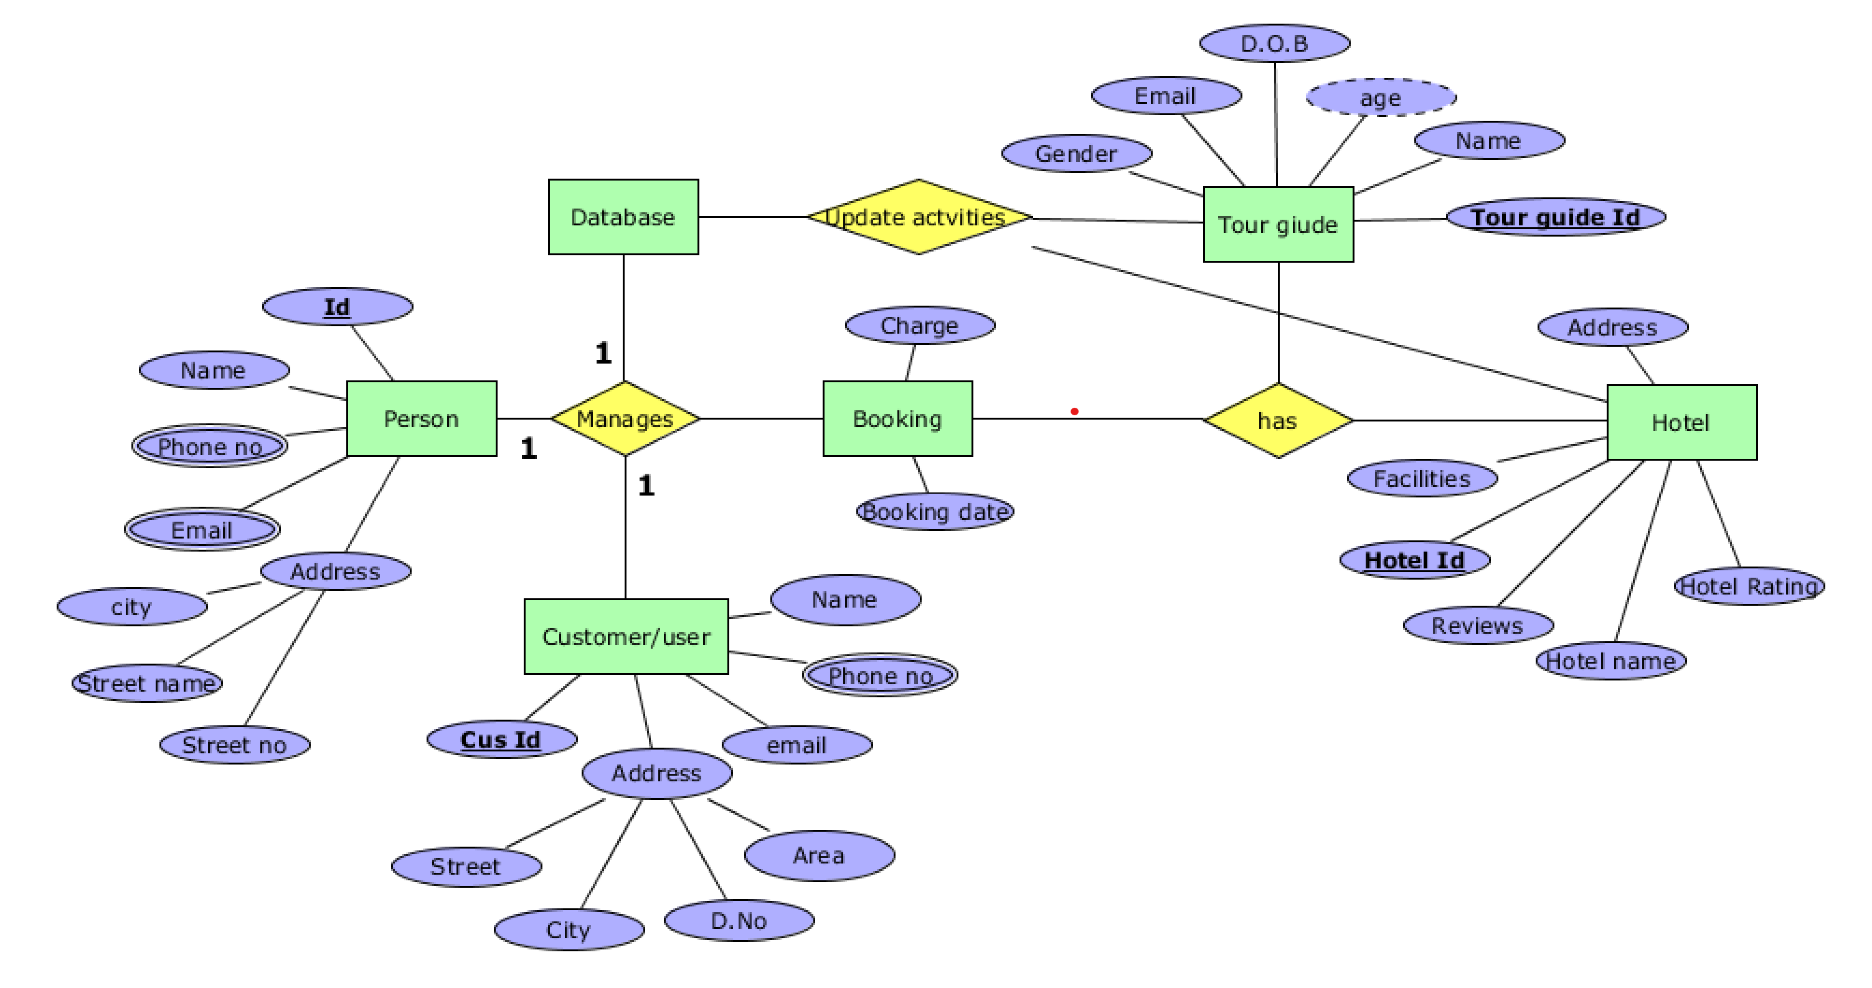POSTLAB**

1. Draw ER diagram showing two entities out of which, one is weak entity in a relationship say, a government employee health card and his/her spouse depending on that particular employee. Mention the attributes for the respective entities in the ER diagram.

