**DBMS PRACTICAL 5**

**INLAB**

**KL UNIVERSITY ERP**

1. Create the database in mysql and create the necessary tables for the given case study using appropriate keys and relationships between the tables
2. Insert atleast 10 records into every table that is implemented in the case study

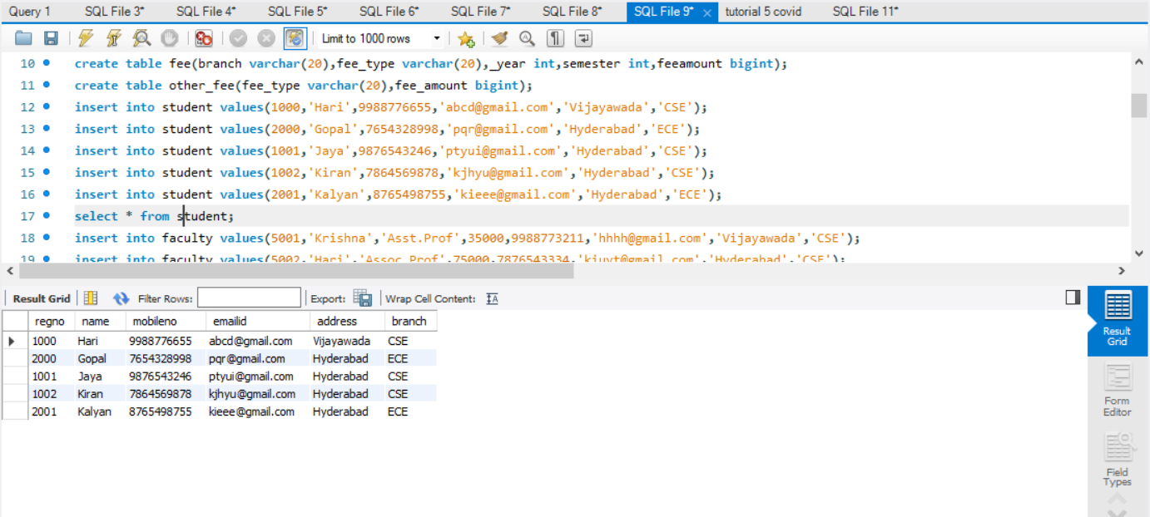

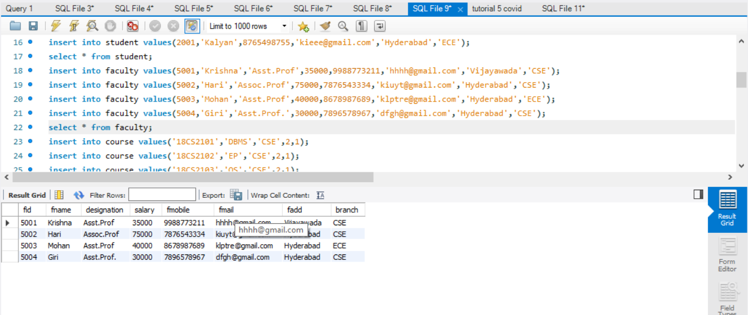

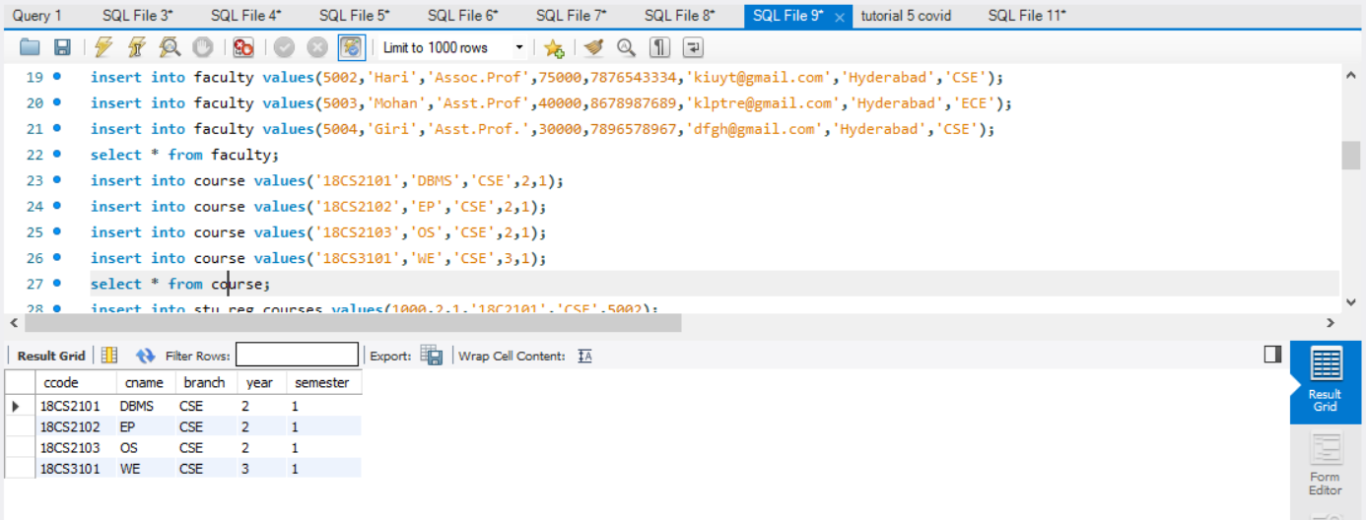

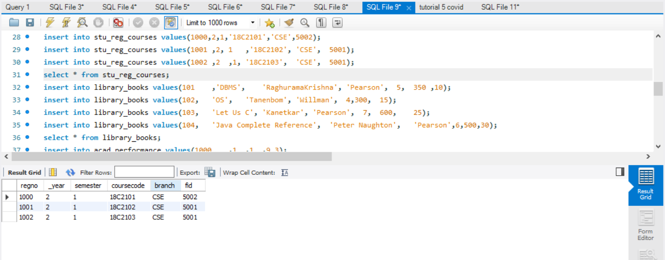

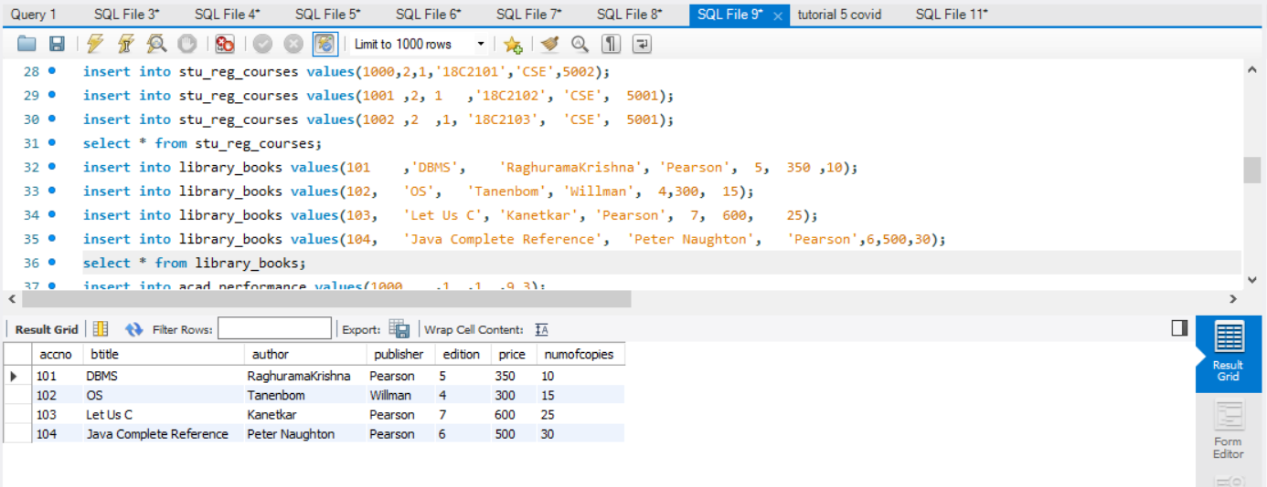

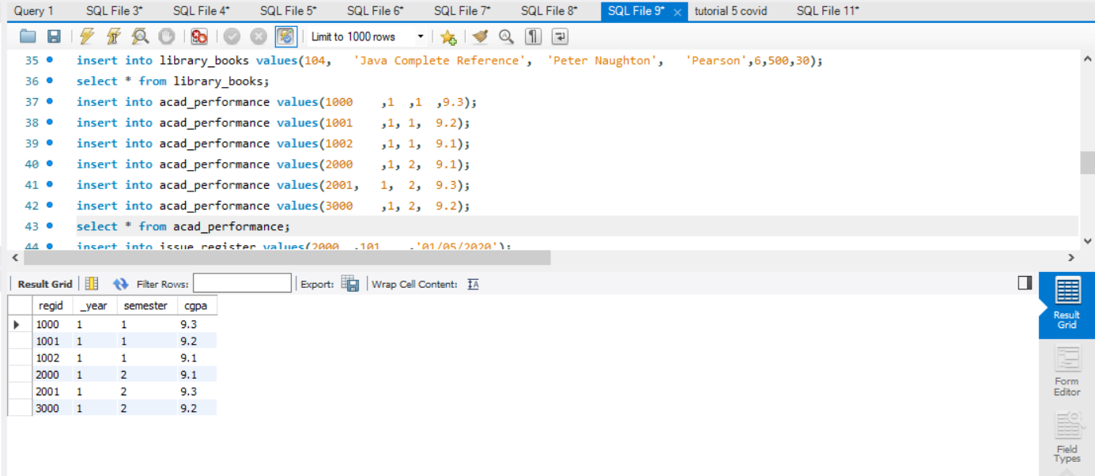

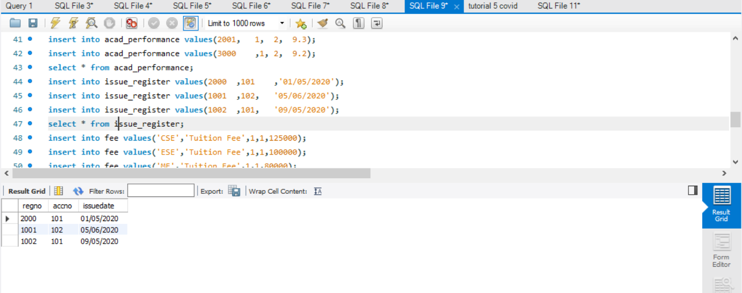

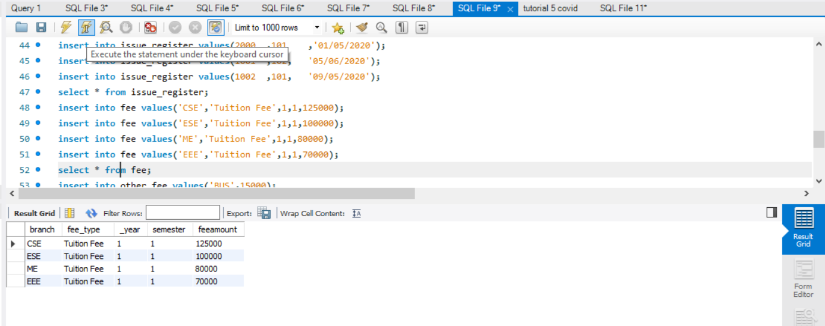

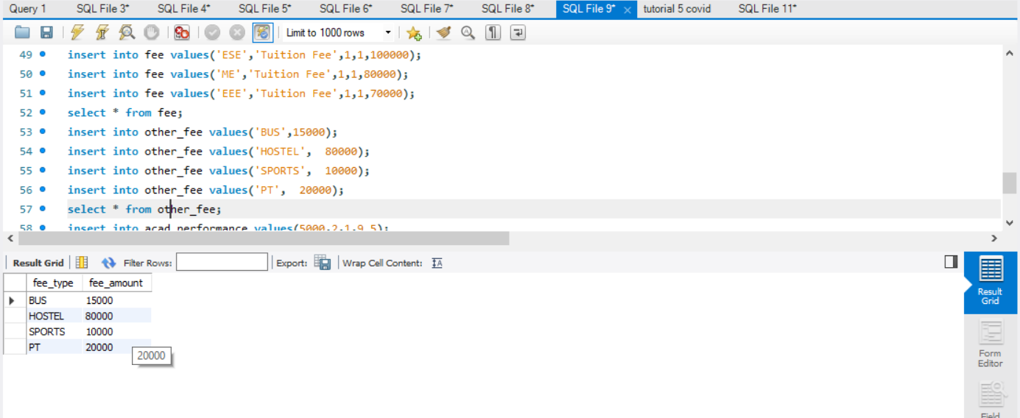

3.Write a query to find the number of students who got the CGPA 9 & above in year wise?

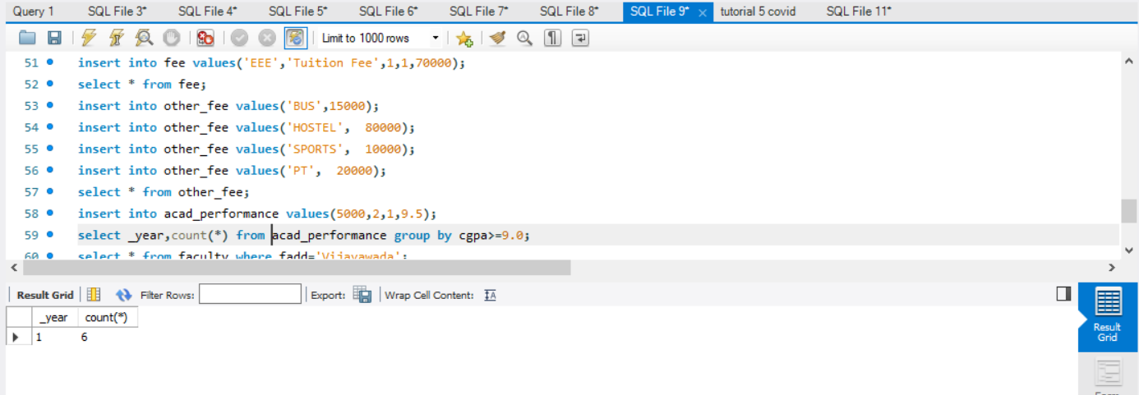

4.Display all faculties who stay in Vijayawada

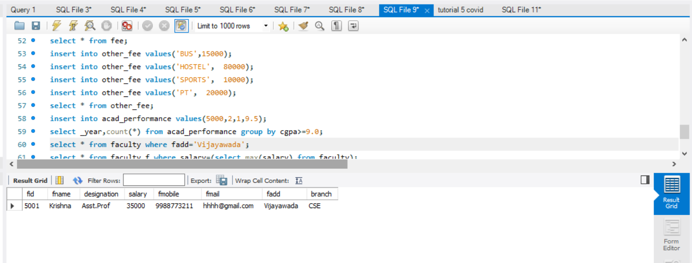

5.Write a query to display faculty id , fname, salary who is/are drawing highest salary in faculty id order.

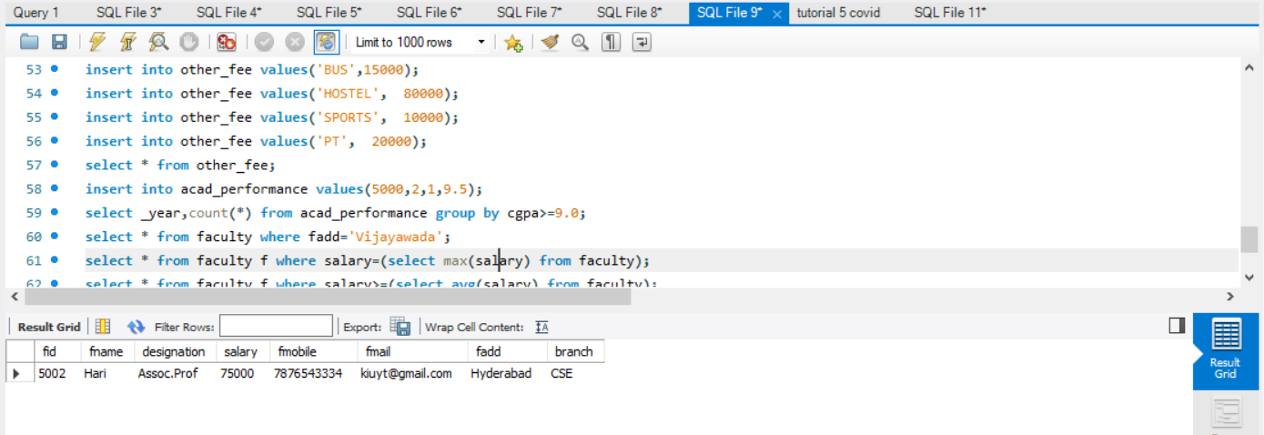

6.Write sql query to display all the faculty whose salary is greater than the average salary of all the faculty.

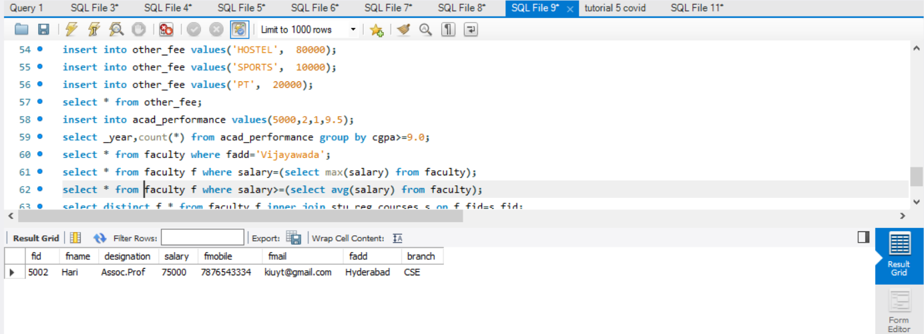

7.Write a query to display the faculty details for all courses registered by a student;

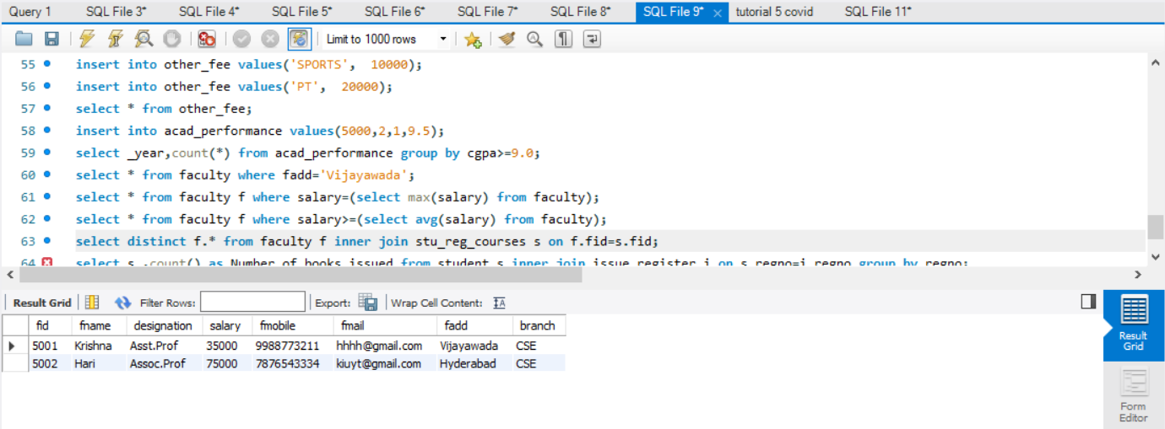

8.Display the number of books issued to each student with his details

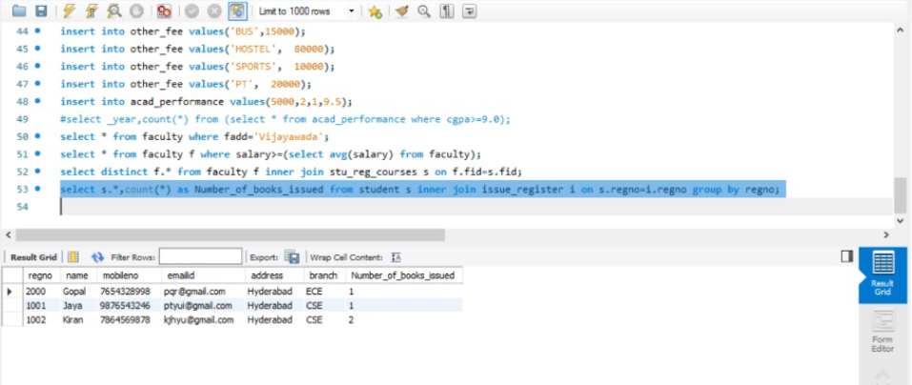

9.Display the number of students registered under each faculty

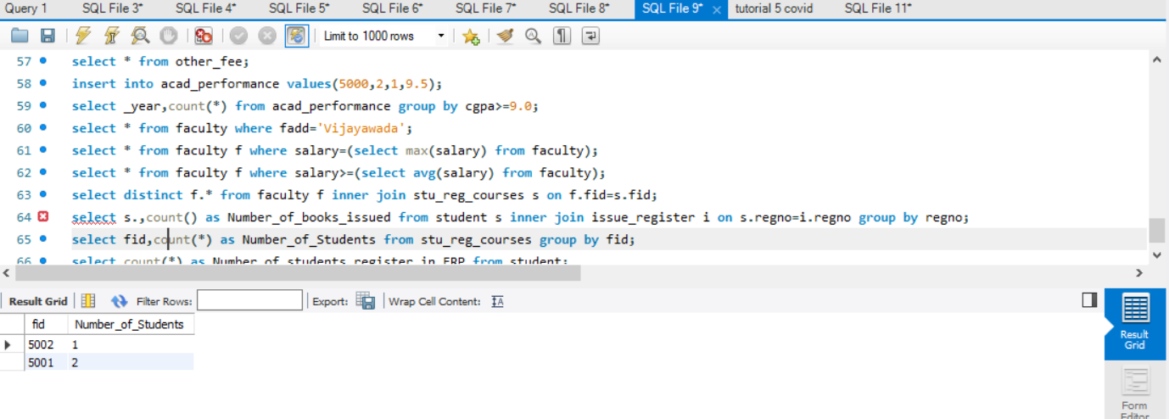

10.Display the number of students who registered in ERP

