**EXPERIMENT- 6**

**Implement Aggregate Functions, Group by & Having Clauses, Nested, Correlated Nested,**

**Views, Indices and DCL Commands on**

**PRE-LAB**

1. Discuss about GRANT, REVOKE and SYNONYM

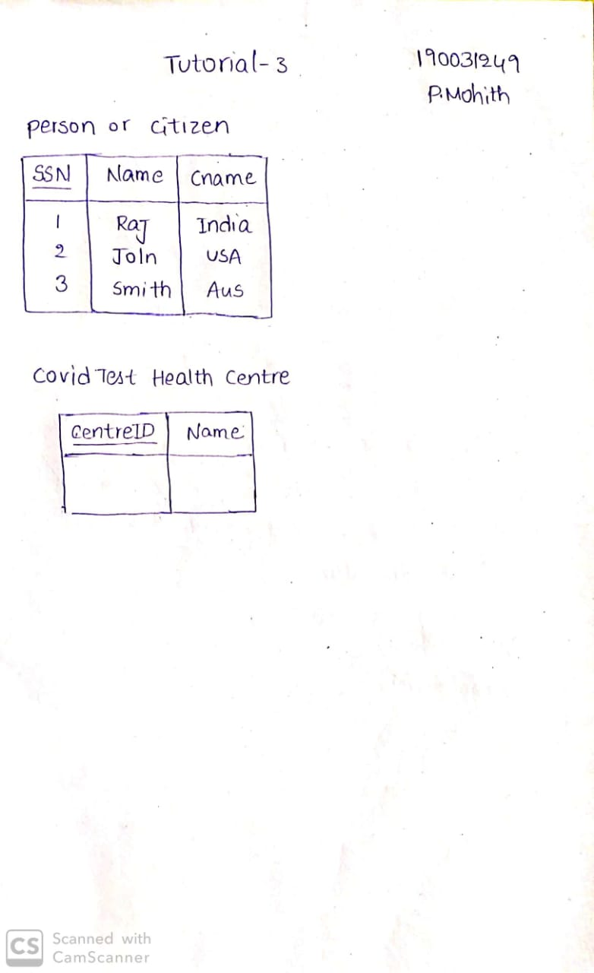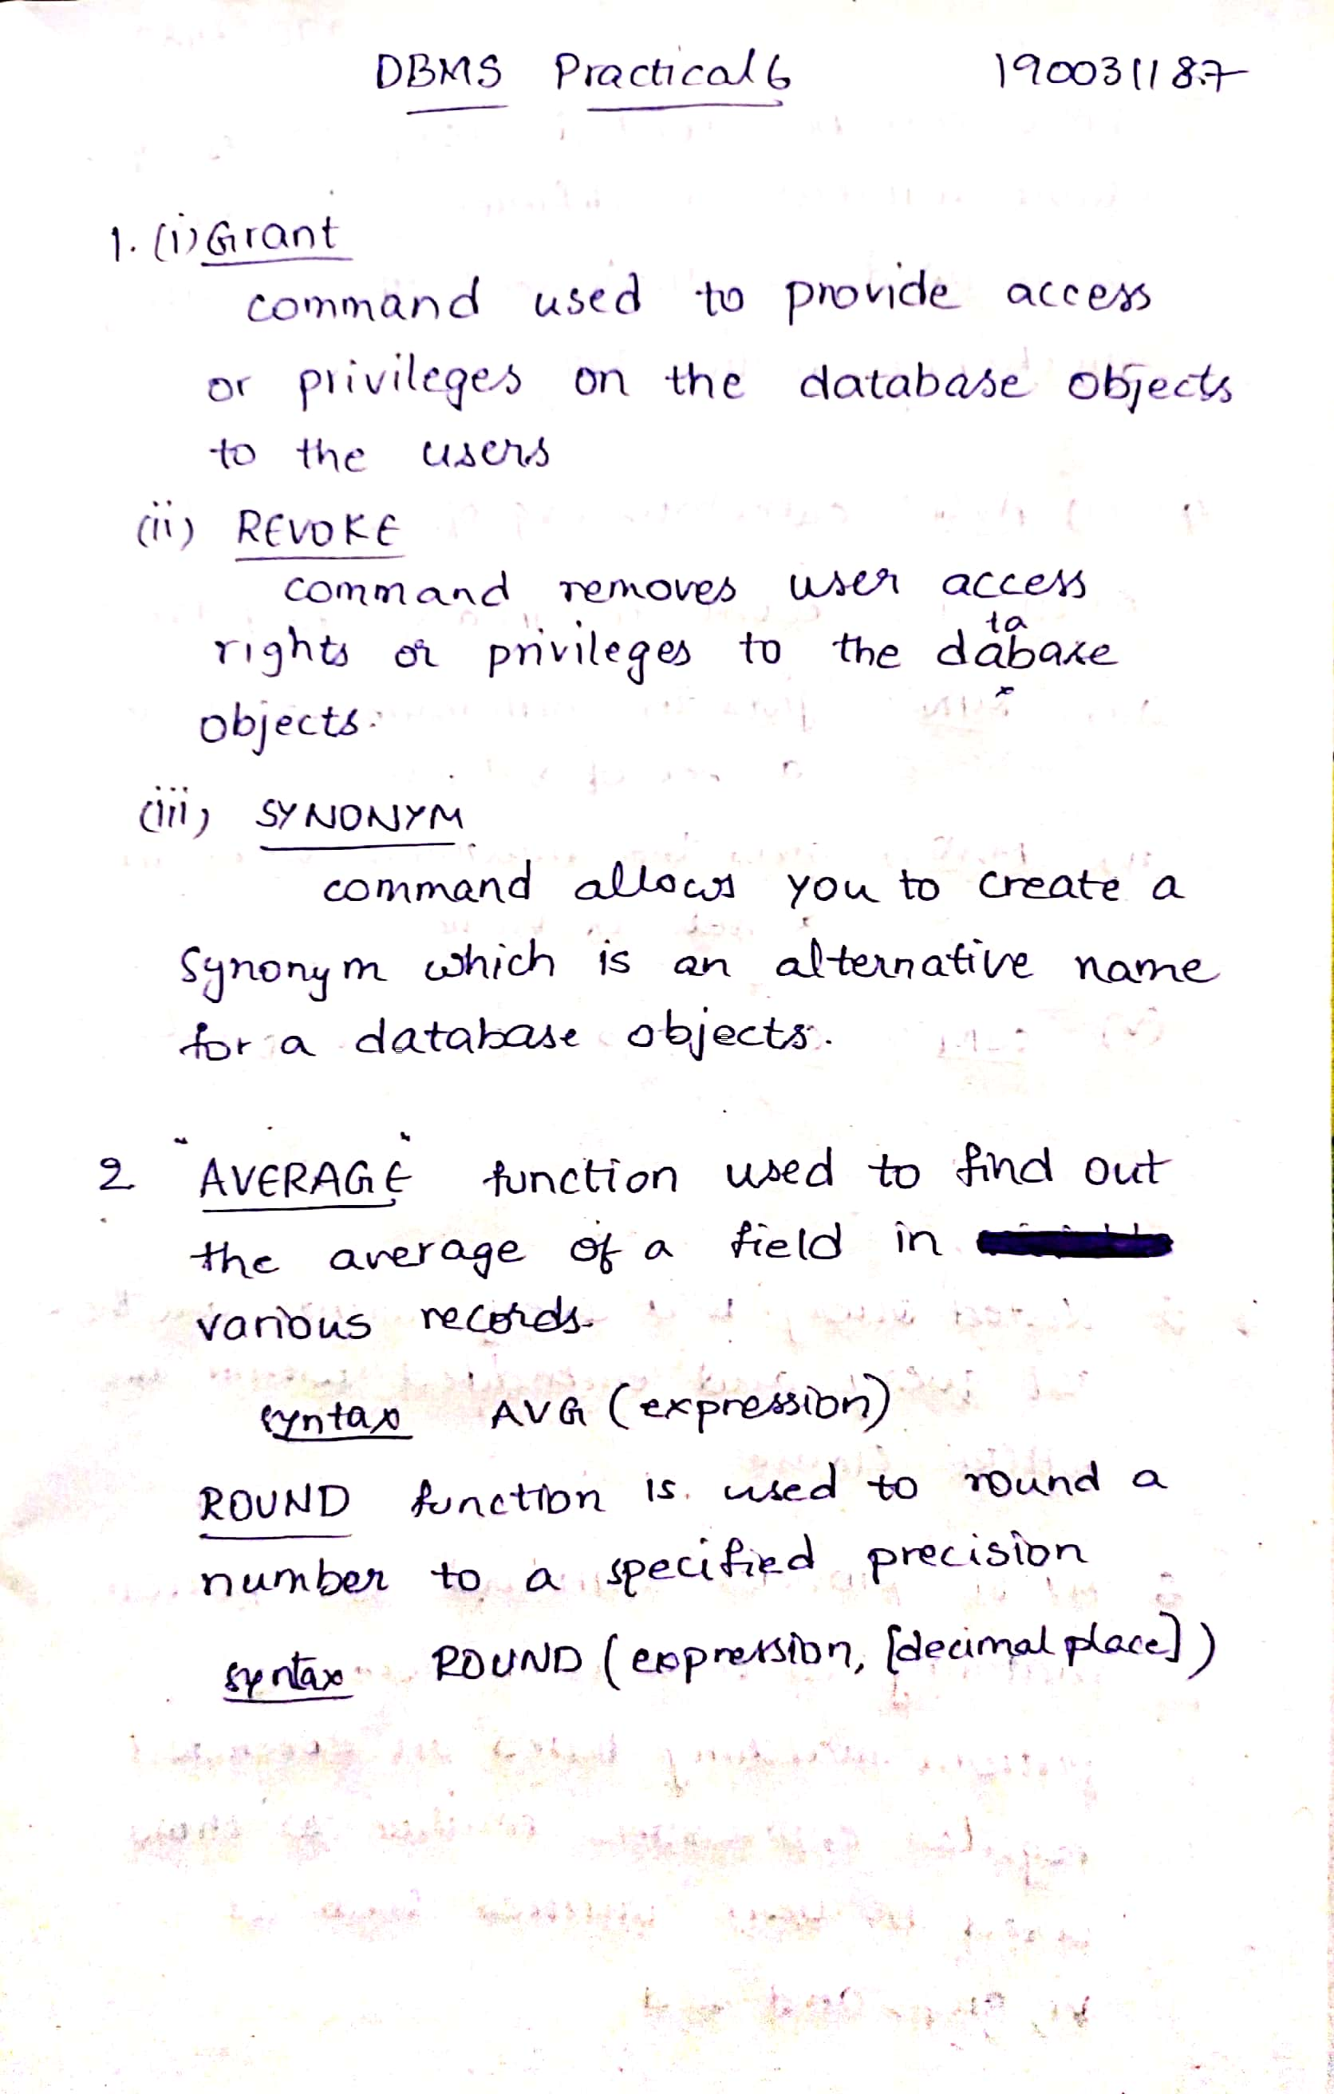  
2. Give the differences between AVERAGE and ROUND commands?



3. What is the use of VIEW statement in SQL?

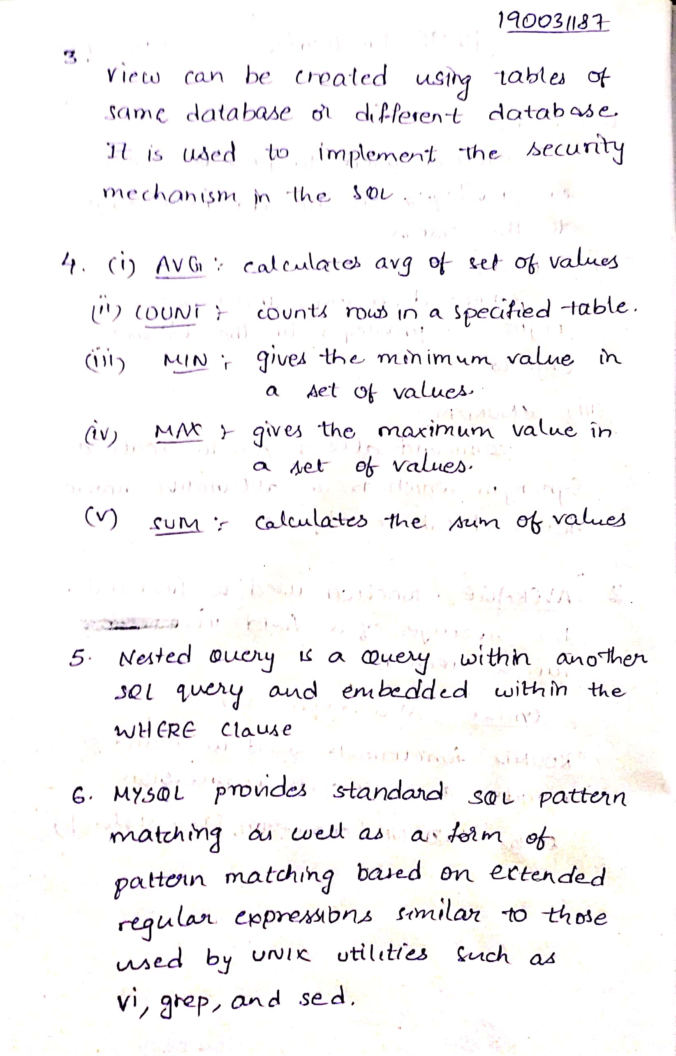  
4. Discuss about any 5 aggregate functions.



5.What do you mean by a nested query in SQL?



6. What are the pattern matching operators that can be used in mySQL?

  
7.Write a SQL Query to display the Current Date?

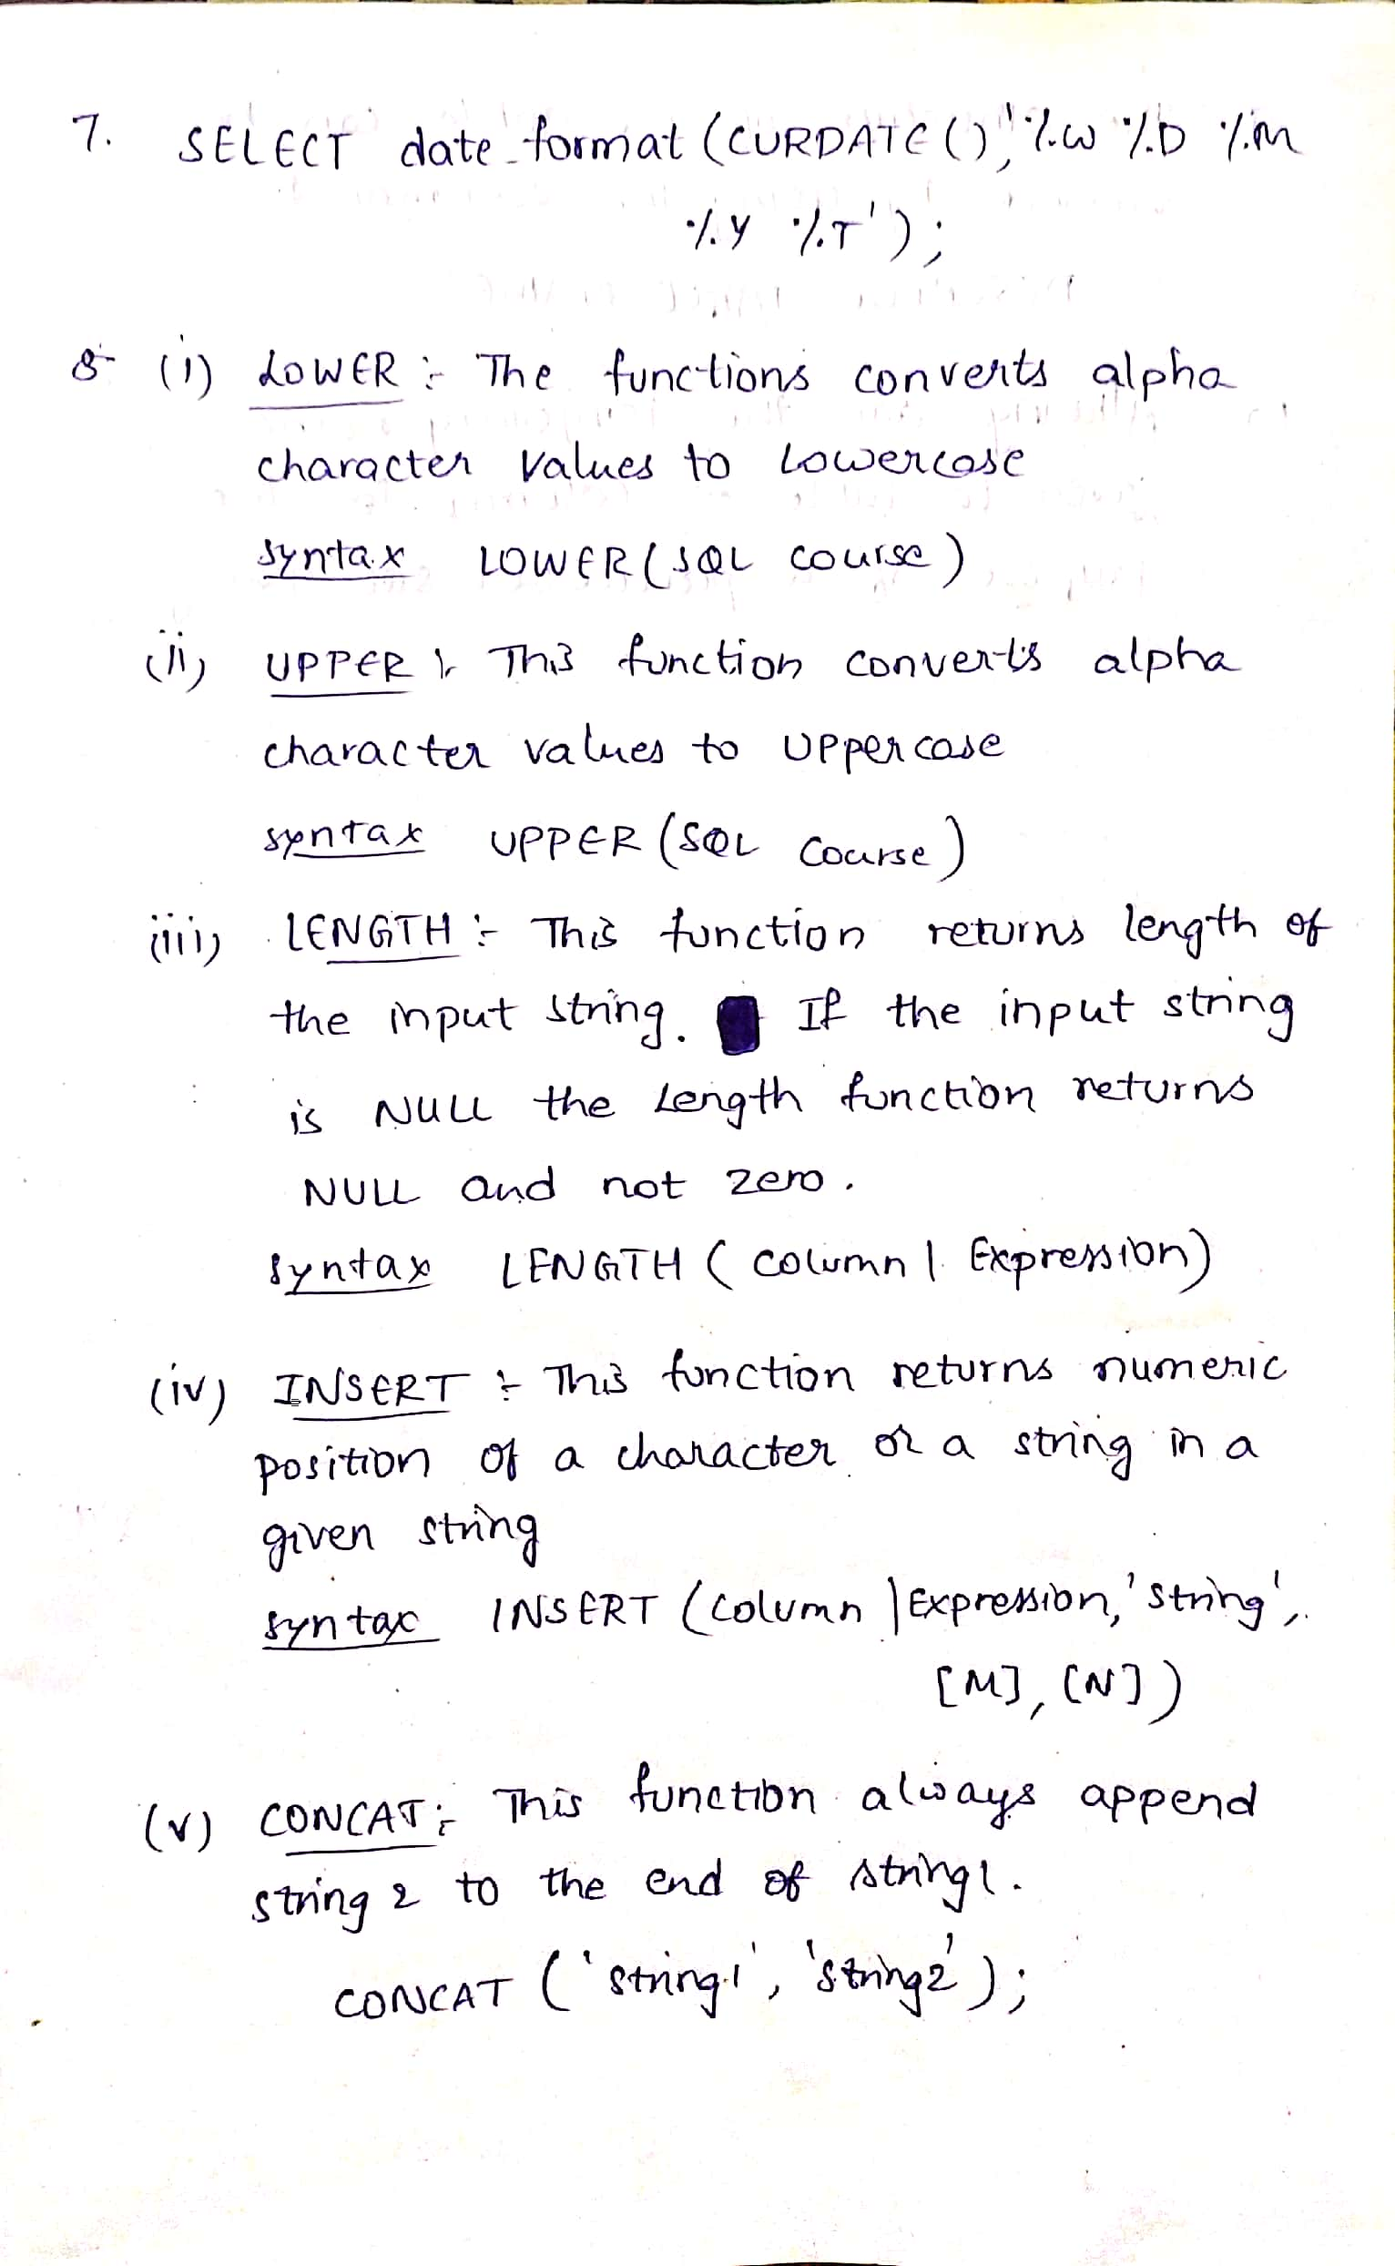

9. Display the structure of the table?

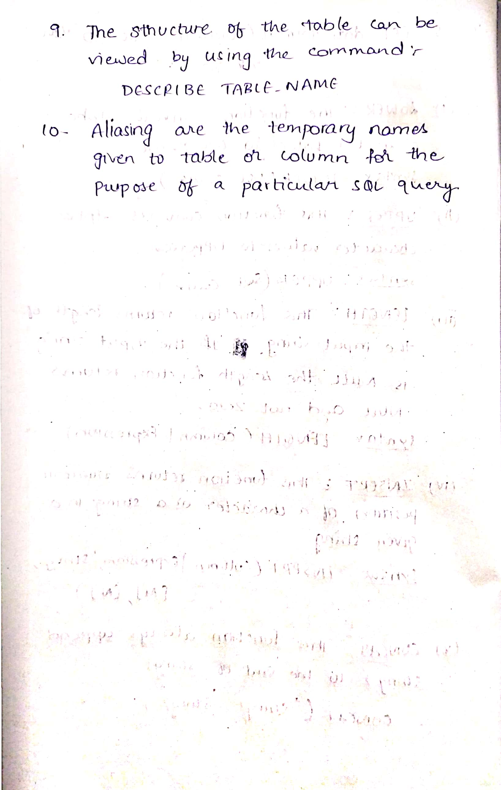

10.What is meant by aliasing in SQL?



8. Discuss about any 5 Character Manipulation functions?



**POST-LAB**

**Worker**

|  |  |  |  |  |  |
| --- | --- | --- | --- | --- | --- |
| WORKER_ID | FIRST_NAME | LAST_NAME | SALARY | JOINING_DATE | DEPARTMENT |
| 001 | Monika | Arora | 100000 | 2014-02-20 09:00:00 | HR |
| 002 | Niharika | Verma | 80000 | 2014-06-11 09:00:00 | Admin |
| 003 | Vishal | Singhal | 300000 | 2014-02-20 09:00:00 | HR |
| 004 | Amitabh | Singh | 500000 | 2014-02-20 09:00:00 | Admin |
| 005 | Vivek | Bhati | 500000 | 2014-06-11 09:00:00 | Admin |
| 006 | Vipul | Diwan | 200000 | 2014-06-11 09:00:00 | Account |
| 007 | Satish | Kumar | 75000 | 2014-01-20 09:00:00 | Account |
| 008 | Geetika | Chauhan | 90000 | 2014-04-11 09:00:00 | Admin |

**Bonus**

|  |  |  |
| --- | --- | --- |
| WORKER_REF_ID | BONUS_DATE | BONUS_AMOUNT |
| 1 | 2016-02-20 00:00:00 | 5000 |
| 2 | 2016-06-11 00:00:00 | 3000 |
| 3 | 2016-02-20 00:00:00 | 4000 |
| 1 | 2016-02-20 00:00:00 | 4500 |
| 2 | 2016-06-11 00:00:00 | 3500 |

**Title**

|  |  |  |
| --- | --- | --- |
| WORKER_REF_ID | WORKER_TITLE | AFFECTED_FROM |
| 1 | Manager | 2016-02-20 00:00:00 |
| 2 | Executive | 2016-06-11 00:00:00 |
| 8 | Executive | 2016-06-11 00:00:00 |
| 5 | Manager | 2016-06-11 00:00:00 |
| 4 | Asst. Manager | 2016-06-11 00:00:00 |
| 7 | Executive | 2016-06-11 00:00:00 |
| 6 | Lead | 2016-06-11 00:00:00 |
| 3 | Lead | 2016-06-11 00:00:00 |

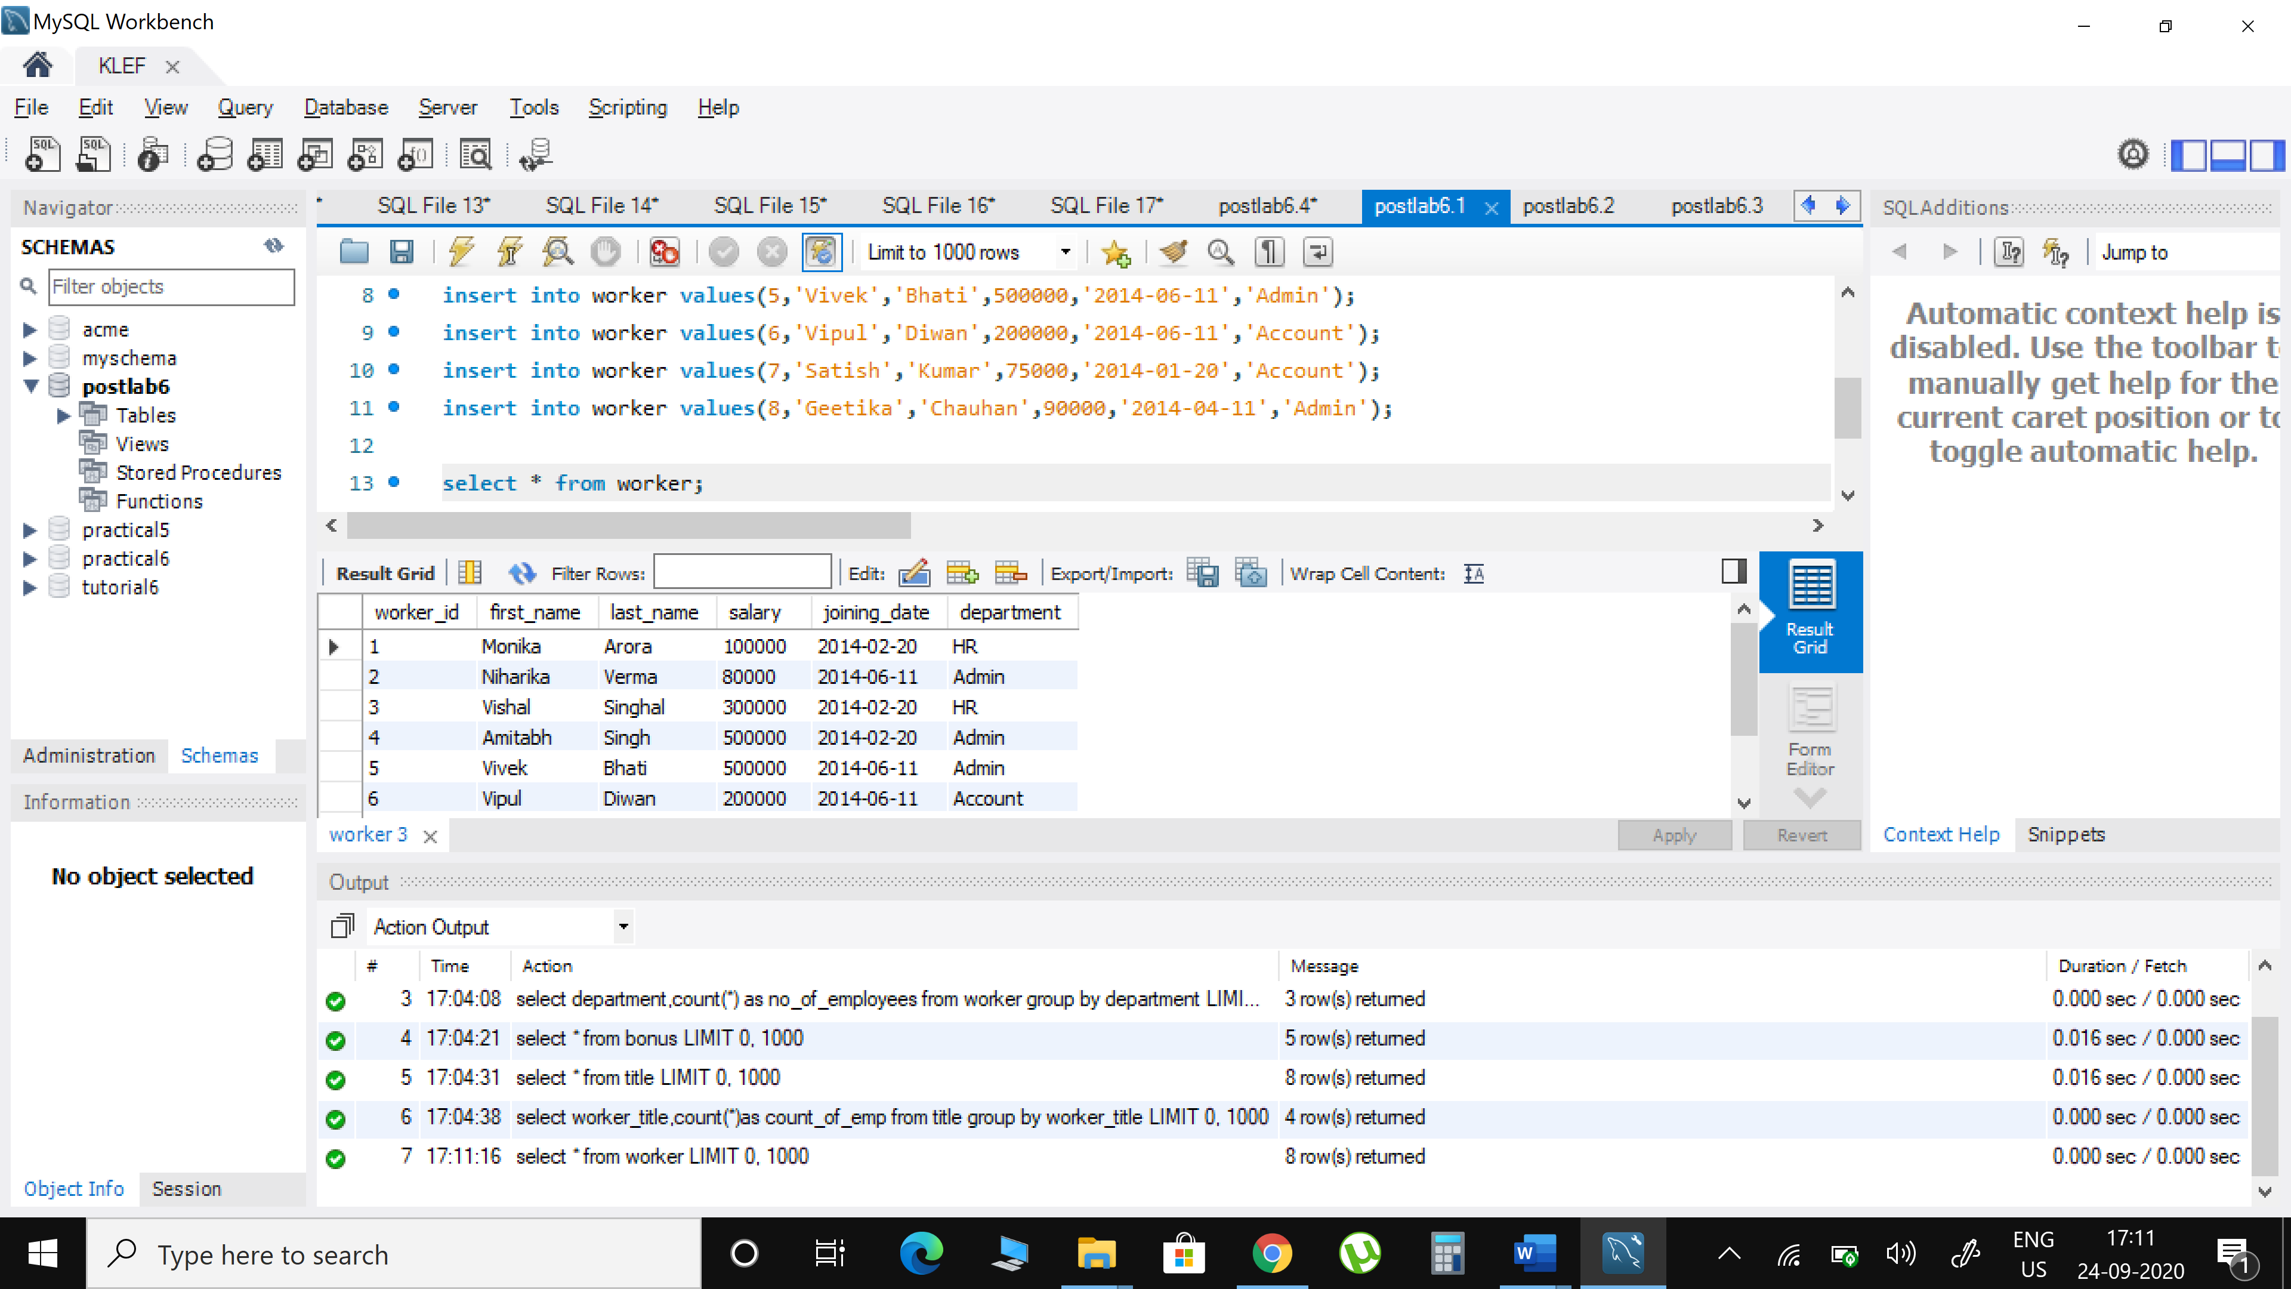

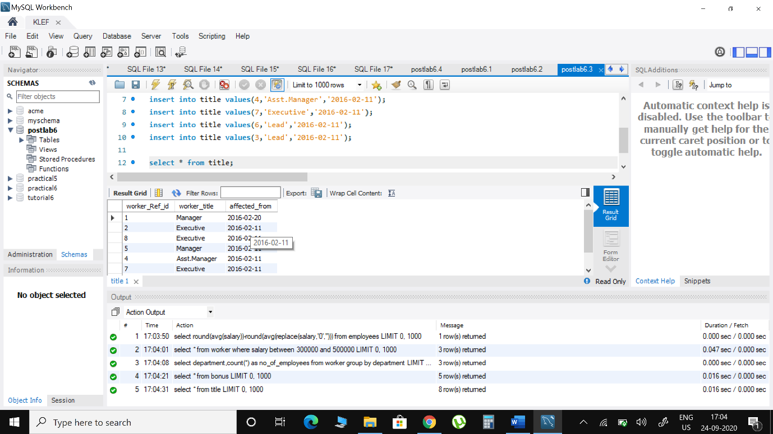

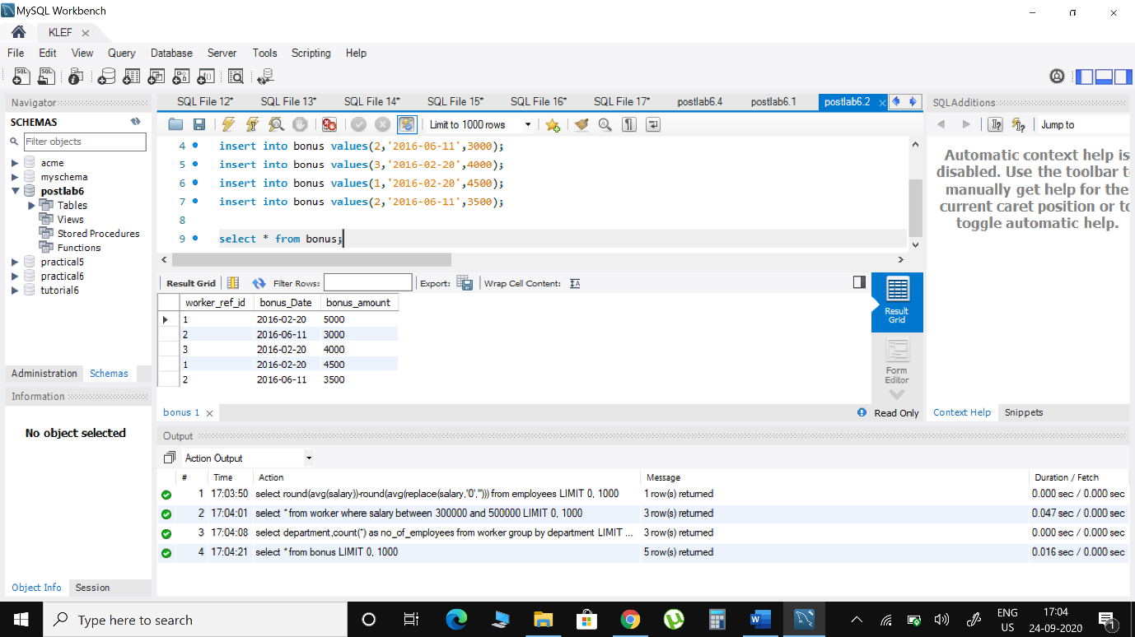

#### **Create a SQL query to display employeesdetailswhose salary is greater than 30000 and less than 50000**

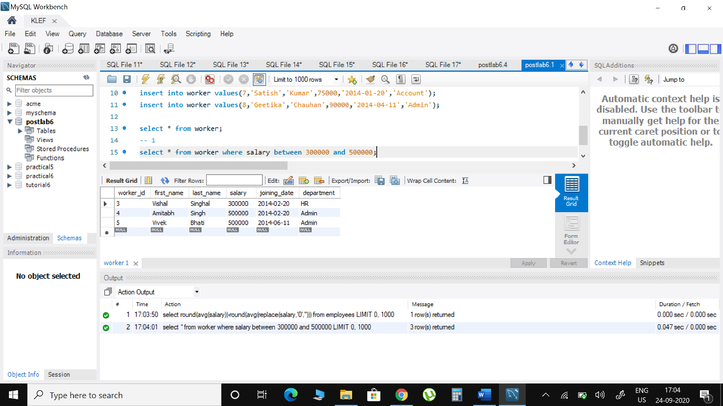

1. **Display the no. of employees in each department**

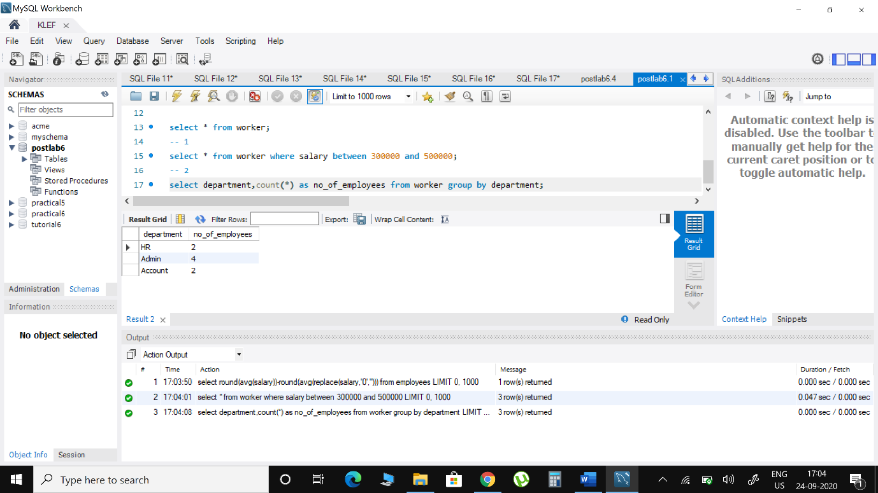

#### **Display the count of employees with same designation in an organization**

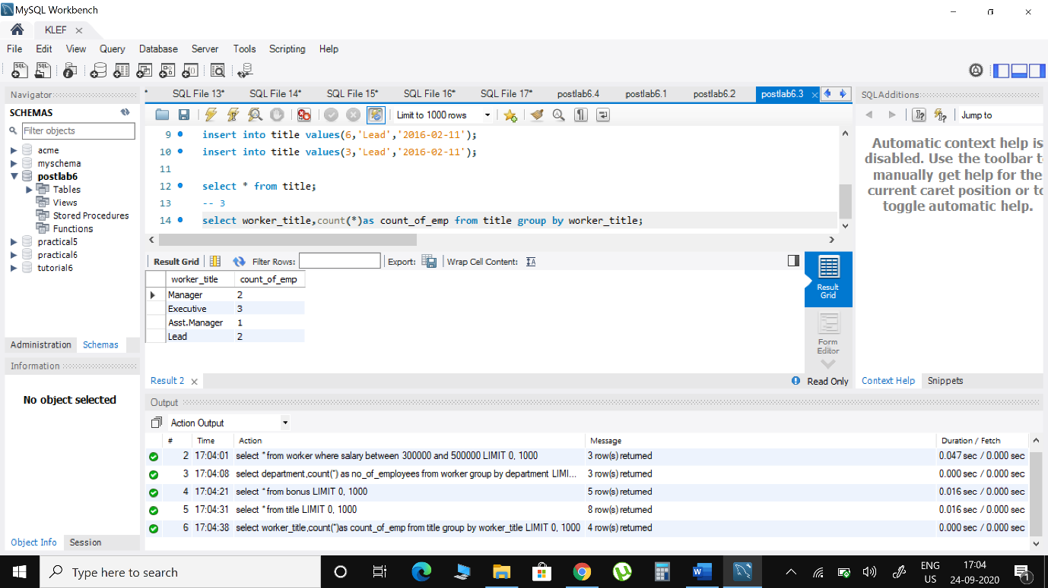

1. Problem:

Sharon was tasked with calculating the average monthly salaries for all employees in the **EMPLOYEES** table, but did not realize her keyboard's  key was broken until after completing the calculation. She wants your help finding the difference between her miscalculation (using salaries with any zeroes removed), and the actual average salary.Write a query calculating the amount of error (i.e.:  average monthly salaries), and round it up to the next integer.

**Input Format**

The **EMPLOYEES** table is described as follows:

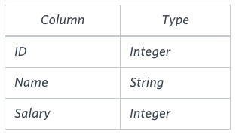

**Note:** Salary is measured in dollars per month and its value is .

**Sample Input**

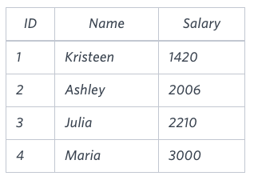

**Sample Output**

2061

**Explanation**

The table below shows the salaries without zeroes as they were entered by Samantha:

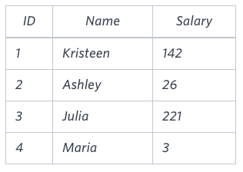

Sharon computes an average salary of 98.00. The actual average salary is 2195.00 . The resulting error between the two calculations is 2195.00-98.00=2061.00  which, when rounded to the next integer, is 2061 .

