**EXPERIMENT 9**

**PRE-LAB**

1)Which of the following statements are TRUE about an SQL query?  
P : An SQL query can contain a HAVING clause even if it does not have a GROUP BY clause  
Q : An SQL query can contain a HAVING clause only if it has a GROUP BY clause  
R : All attributes used in the GROUP BY clause must appear in the SELECT clause  
S : Not all attributes used in the GROUP BY clause need to appear in the SELECT clause

(A) P and R  
(B) P and S  
(C) Q and R  
(D) Q and S

**ANS) P and S**

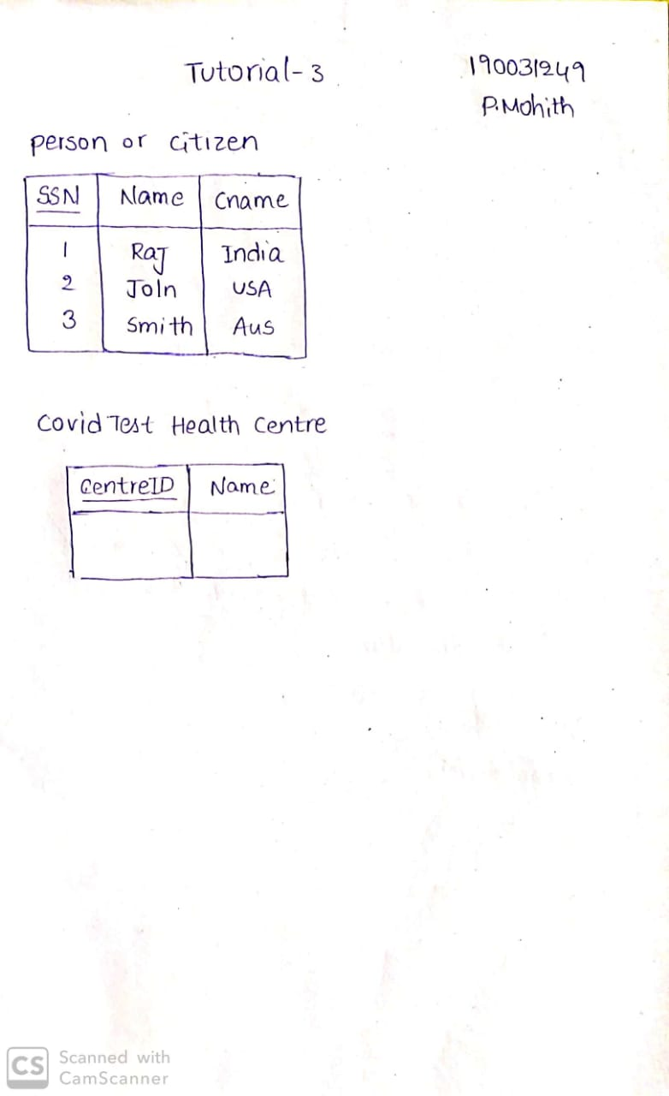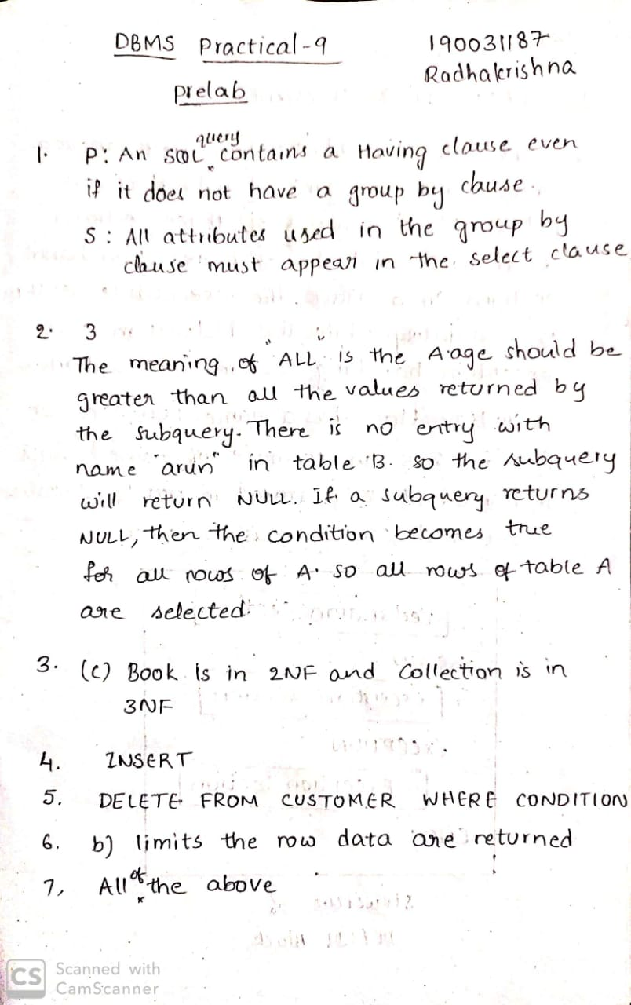

2)Table A

Id Name Age

--------------------

12 Arun 60

15 Shreya 24

99 Rohit 11

Table B

Id Name Age

--------------------

15 Shreya 24

25 Hari 40

98 Rohit 20

99 Rohit 11

Table C

Id Phone Area

--------------------

10 2200 02

99 2100 01

Consider the above tables A, B and C. How many tuples does the result of the following SQL query contains?

SELECT A.id FROM A WHERE A.age > ALL (SELECT B.age FROM B WHERE B. name = "arun")

**ANS) 3**



3) Consider the following relational schemes for a library database:

Book (Title, Author, Catalog_no, Publisher, Year, Price)  
Collection (Title, Author, Catalog_no)

within the following functional dependencies:

1. Title Author --> Catalog_no
2. Catalog_no --> Title Author Publisher Year
3. Publisher Title Year --> Price

Assume {Author, Title} is the key for both schemes. Which of the following statements is true?  
(A) Both Book and Collection are in BCNF  
(B) Both Book and Collection are in 3NF only  
(C) Book is in 2NF and Collection is in 3NF  
(D) Both Book and Collection are in 2NF only

**ANS) (C) Book is in 2NF and Collection is in 3NF**



4) You can add a row using SQL in a database by using which statement

**ANS) INSERT**



5) The command to remove rows from a table 'CUSTOMER' is ____

**ANS) DELETE FROM CUSTOMER WHERE {CONDITION}**

`

6) The SQL WHERE clause:

a) limits the column data that are returned

b) limits the row data are returned.

c) Both A and B are correct.

d) Neither A nor B are correct

**ANS) b) limits the row data are returned.**



7) An action assertion must include which of the following?

a) Anchor object b) Action c) Corresponding object d) All of the above.

**ANS) d) All of the above.**



**IN-LAB**

**Case Study 1: TRANSPORT DEPARTMENT**

1) Create a cursor to display all the customer details of a particular branch

delimiter @

create procedure cust_veh_details()

begin

declare ve_id int;

declare v_finished int default 0;

declare c1 cursor for select veh_id from contract_permission;

declare continue handler for not found set v_finished=1;

open c1;

v_details:loop

fetch c1 into ve_id;

if v_finished=1 then

leave v_details;

end if;

select * from customer c,vehicle v where v.veh_id=ve_id and c.v_id=ve_id;

end loop v_details;

close c1;

end @

delimiter ;

call cust_veh_details();

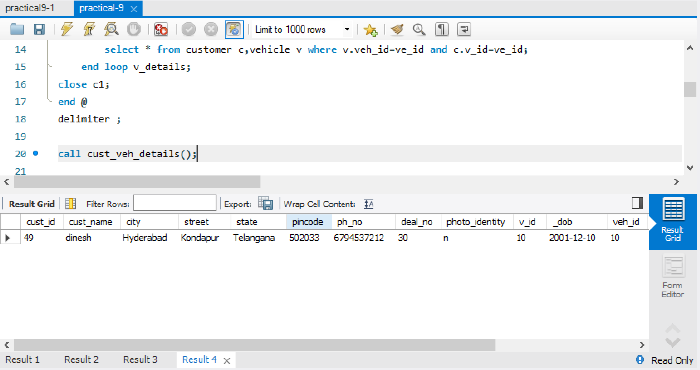

2) Create a cursor to display the customer details along with his vehicle details which are given contract permission.

delimiter $@

create procedure branch_cust_details()

begin

declare cus_id int;

declare b_finished int default 0;

declare c1 cursor for select c_id from branch;

declare continue handler for not found set b_finished=1;

open c1;

b_c_details:loop

fetch c1 into cus_id;

if b_finished=1 then

leave b_c_details;

end if;

select * from customer where cust_id=cus_id;

end loop b_c_details;

close c1;

end $@

delimiter ;

call branch_cust_details();

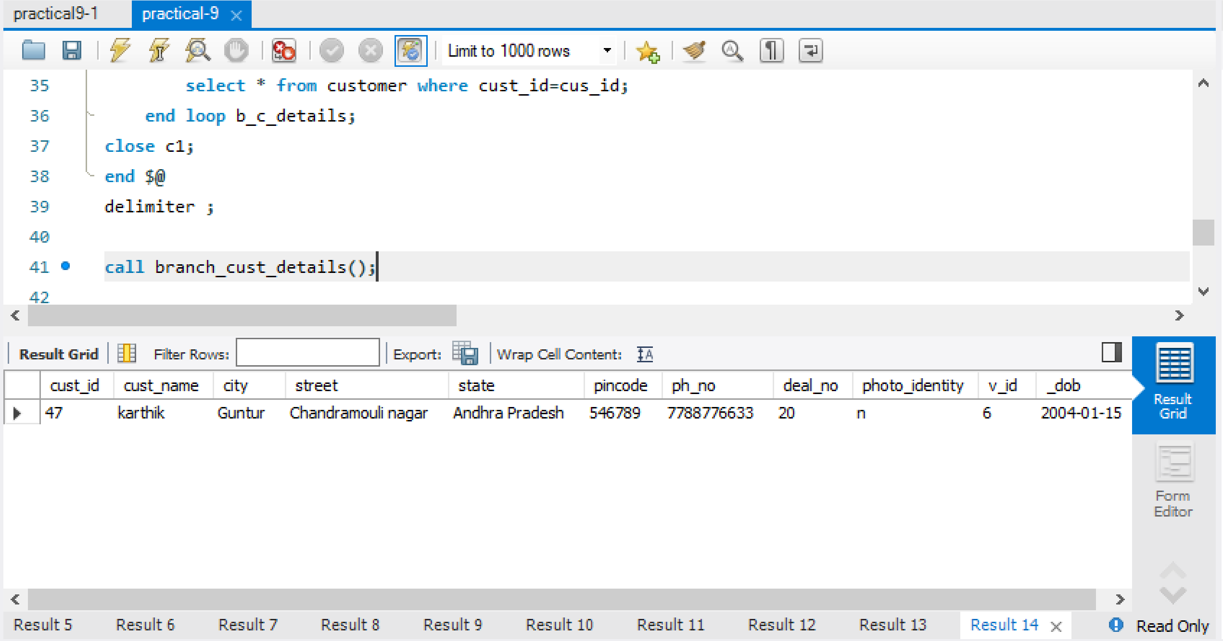

3) Create a cursor to display the customer details who are under a particular dealer.

delimiter $$

create procedure cust_details_under_dealer()

begin

declare cust_id int;

declare cust_name varchar(10);

declare cust_dob varchar(10);

declare cust_city varchar(25);

declare cust_street varchar(100);

declare cust_state varchar(25);

declare pincode numeric;

declare cust_phno bigint;

declare deal_no int;

declare photo_identity varchar(1);

declare v_id int;

declare deal_id int;

declare deal_name varchar(10);

declare c_finished integer default 0;

declare c1 cursor for select c.*,d.deal_id,d.deal_name from Customer c inner join registration r on r.cust_id = c.cust_id inner join Dealer d on r.deal_id = d.deal_id;

declare continue handler for NOT FOUND set c_finished = 1;

open c1;

get_customer: LOOP

fetch c1 into cust_id,cust_name,cust_city,cust_street,cust_state,pincode,cust_phno,deal_no,photo_identity,v_id,cust_dob,deal_id,deal_name;

if c_finished = 1 then

leave get_customer;

end if;

select concat(cust_id,',',cust_name,',',cust_dob,',',cust_street,',',cust_state,',',pincode,',',cust_phno,',',photo_identity,',',v_id,',',deal_id,',',deal_name);

end loop get_customer;

close c1;

end $$

delimiter ;

call cust_details_under_dealer();

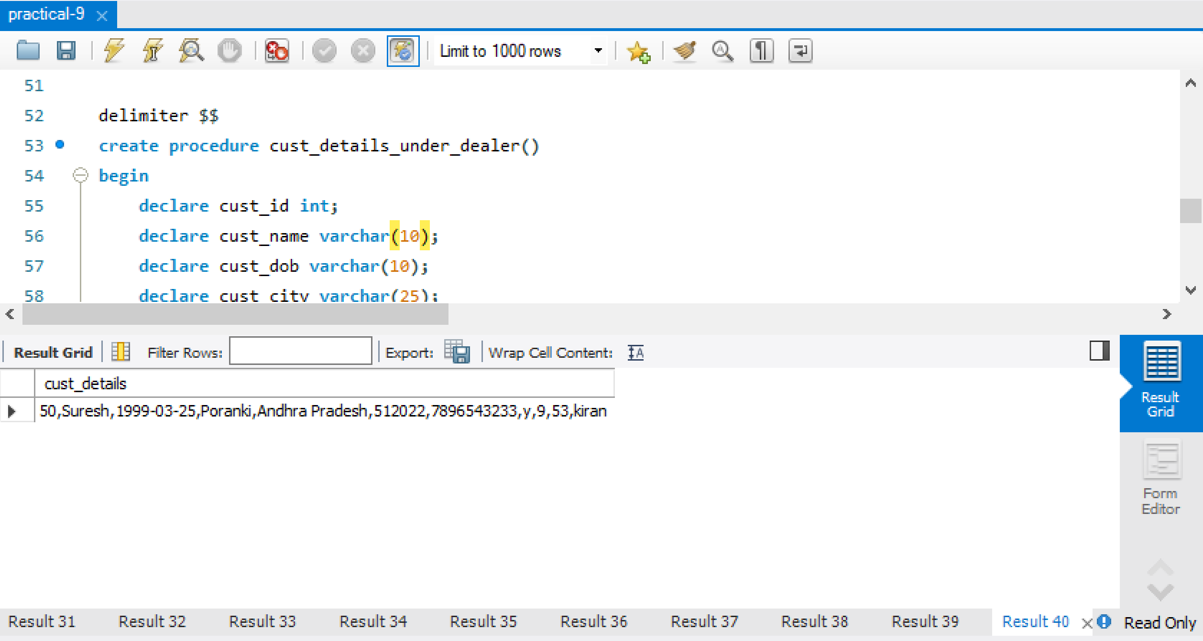

4) Create a procedure to display the educational vehicles applied for permit in a particular branch

ANS)delimiter $$

create procedure proc_edu()

begin

select e.*,b.branch_id,b.b_name from EDU_BUS e inner join Branch b on e.edu_id = b.e_id;

end $$

delimiter ;

call proc_edu();

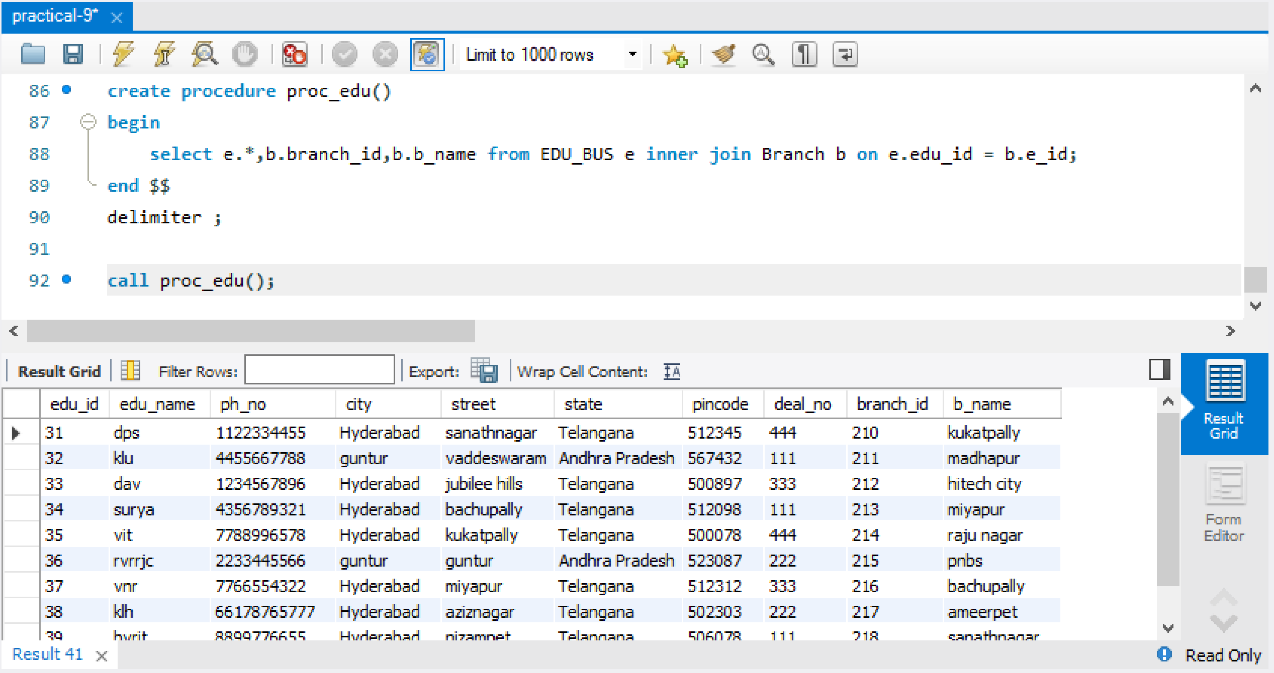

5) Create a procedure to display the details of the branches in a particular state when state is given as input when executing the procedure

delimiter $$

create procedure branch_details(in st varchar(20))

begin

select * from branch where state=st;

end $$

delimiter ;

call branch_details('Andhra pradesh');

**Case Study 4: KL UNIVERSITY ERP**

1. Create a cursor to display students details who register for a particular course

delimiter $$

drop procedure if exists proc_stu;

create procedure proc_stu()

begin

declare regno, year, semester, fid int;

declare name varchar(10);

declare Mobileno bigint;

declare email varchar(20);

declare address varchar(10);

declare branch varchar(10);

declare course_code varchar(10);

declare s_finished integer default 0;

declare c1 cursor for select s.REGNO,s.NAME,s.Mobileno,s.EMAIL,s.Address,s.Branch,st.YEAR,st.SEMESTER,st.COURSECODE,st.FID from Student s inner join Stu_Reg_Courses st on st.REGNO = s.REGNO;

declare continue handler for NOT FOUND set s_finished = 1;

open c1;

get_stu: LOOP

fetch c1 into regno,name,Mobileno,email,address,branch,year,semester,course_code,fid;

if s_finished = 1 then

leave get_stu;

end if;

select concat(regno,',',name,',',Mobileno,',',email,',',address,',',branch,',',year,',',semester,',',course_code,',',fid) as student_course_details;

end loop get_stu;

close c1;

end $$

delimiter ;

call proc_stu();

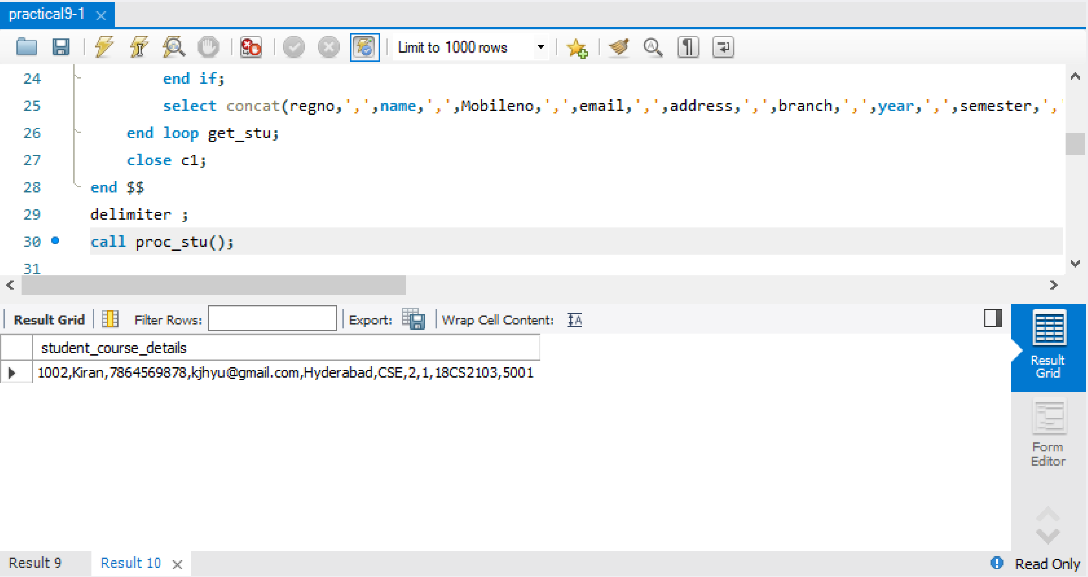

1. Create a procedure to display the fee details of the student

delimiter $$

create procedure fee_details()

begin

select s.*,f.Fee_Type,f.YEAR,f.SEMESTER,f.FEEAMOUNT from Student s inner join FEE f on s.Branch = f.BRANCH;

end $$

delimiter ;

call fee_details();

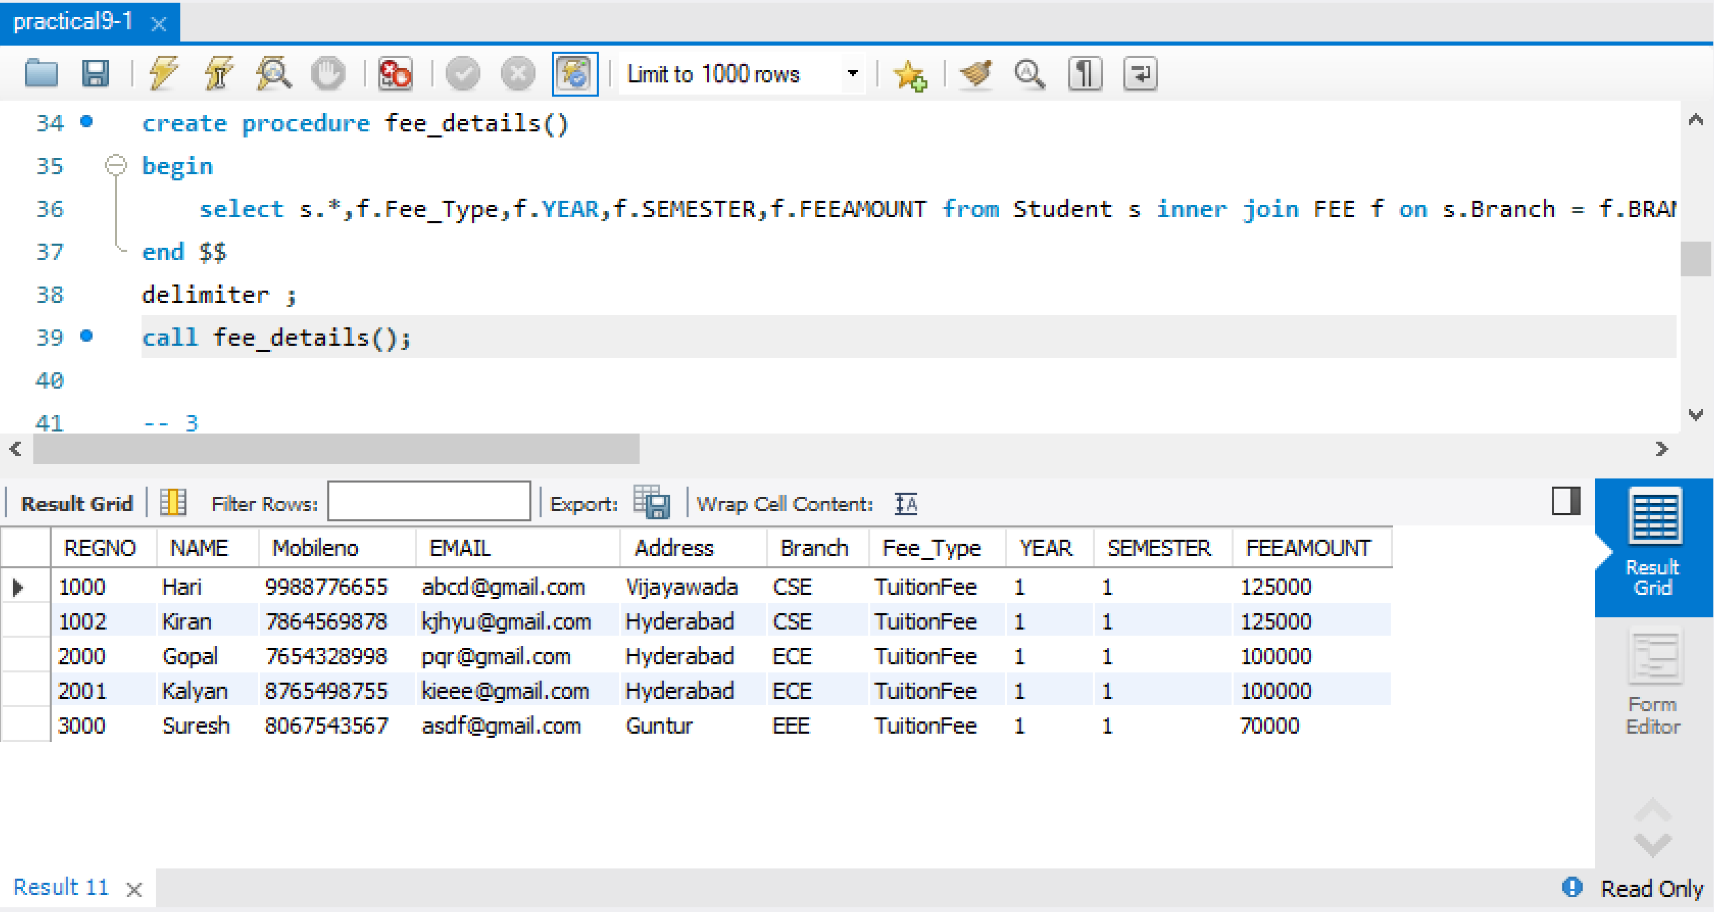

1. Create a trigger that will store the deleted student records in a log file

create table student_log(deleted_regno int,deleted_name varchar(10),deleted_mobile_no bigint,deleted_stu_email varchar(20),deleted_stu_address varchar(20),deleted_stu_branch varchar(10));

delimiter $$

create trigger trig_stu_delete after delete on Student

for each row

begin

insert into student_log values(old.REGNO,old.NAME,old.Mobileno,old.EMAIL,old.Address,old.Branch);

end $$

delimiter ;

delete from student where REGNO = 1001;

select *from student_log;

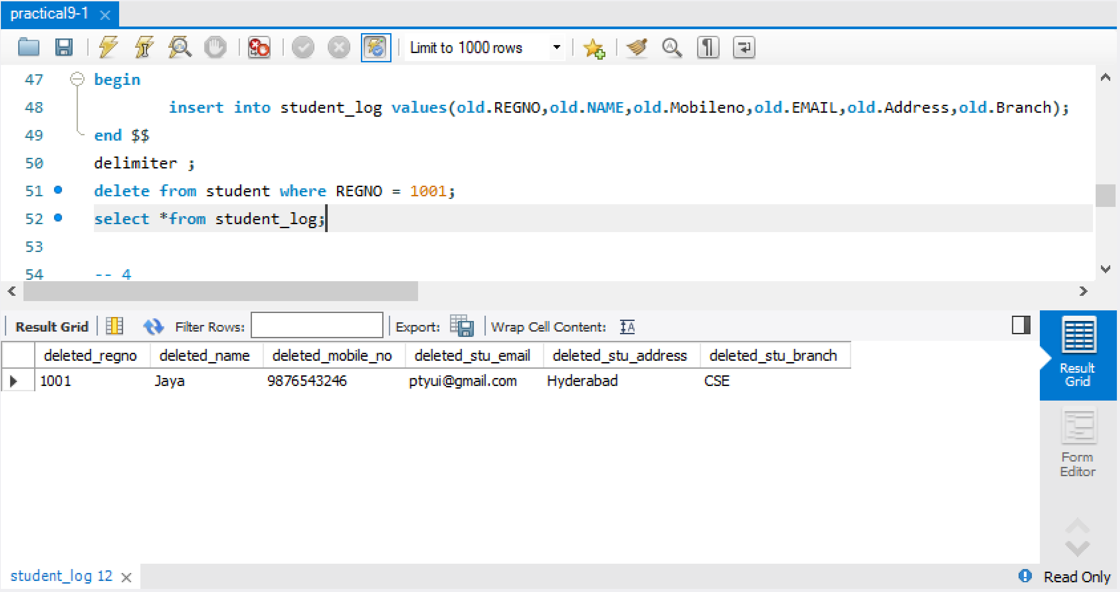

1. Create a cursor to update faculty salary with 1500 and display the updated details of faculty

delimiter $$

create procedure update_Faculty_salary()

begin

declare F_ID int;

declare f_finished integer default 0;

declare c1 cursor for select FID from Faculty;

declare continue handler for NOT FOUND set f_finished = 1;

open c1;

get_Faculty: LOOP

fetch c1 into F_ID;

if f_finished = 1 then

leave get_Faculty;

end if;

update Faculty set Salary = Salary + 1500 where FID = F_ID;

end loop get_Faculty;

close c1;

end $$

delimiter ;

-- before update

select * from Faculty;

call update_Faculty_salary();

-- after update

select * from Faculty;

BEFORE UPDATE

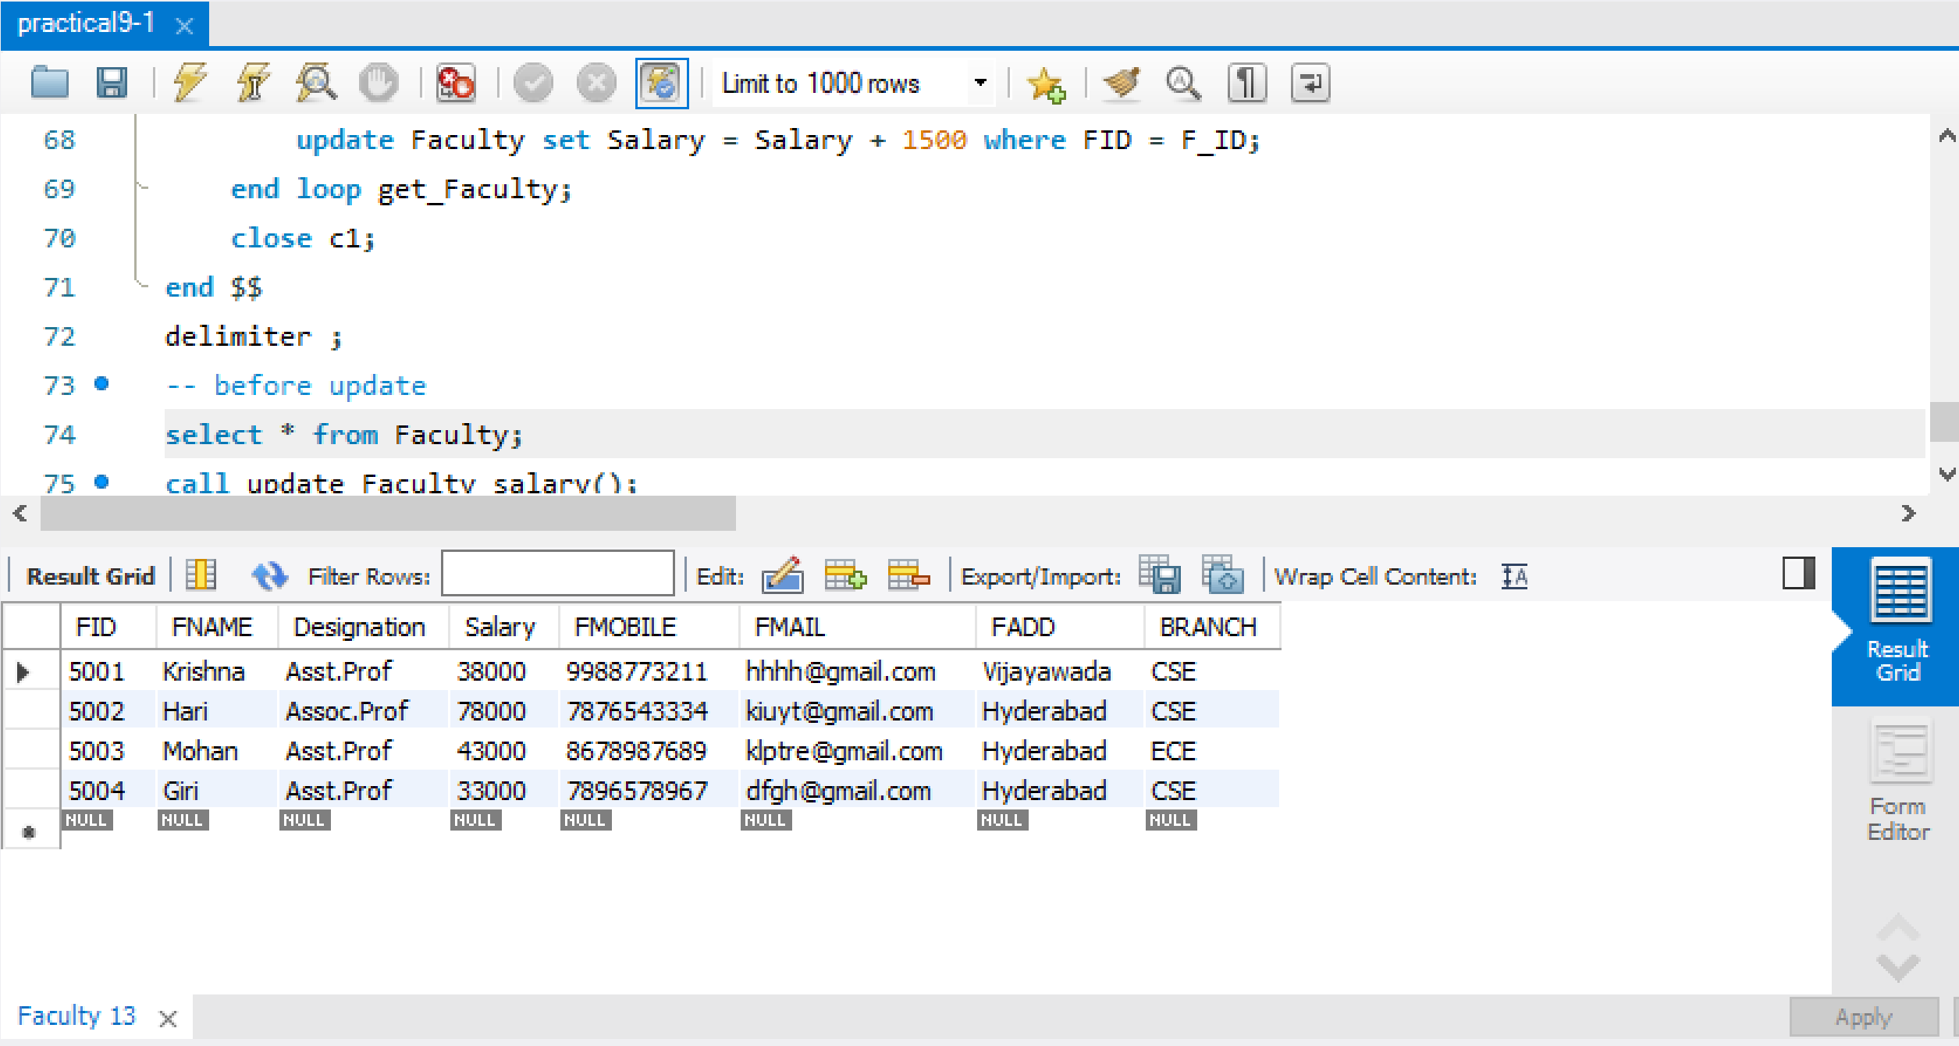

AFTER UPDATE

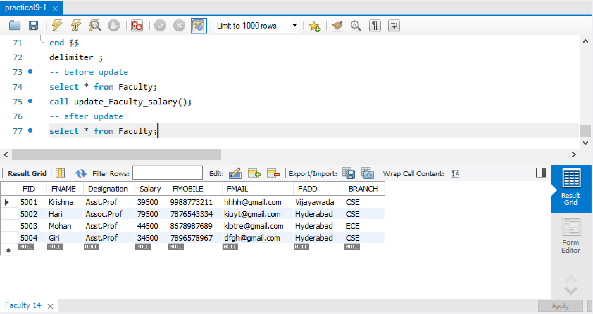

**POSTLAB**

1. Determine basic structure of a PL/SQL block. And define it briefly

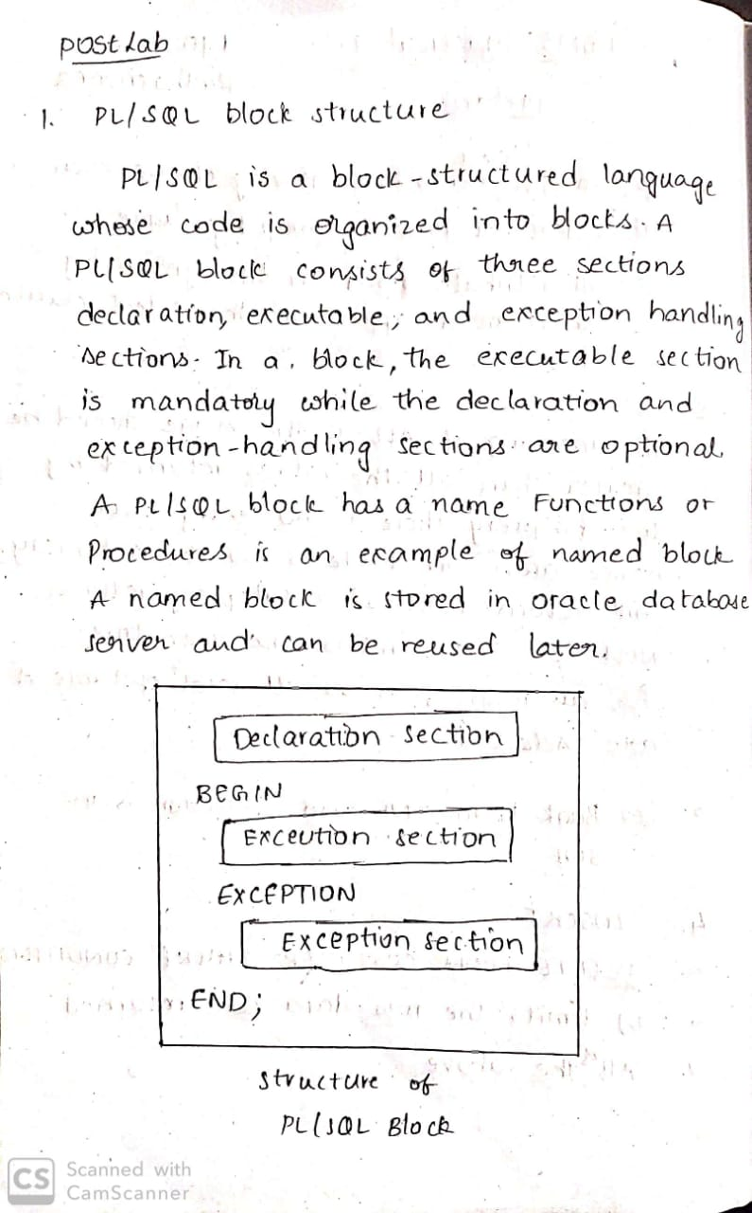

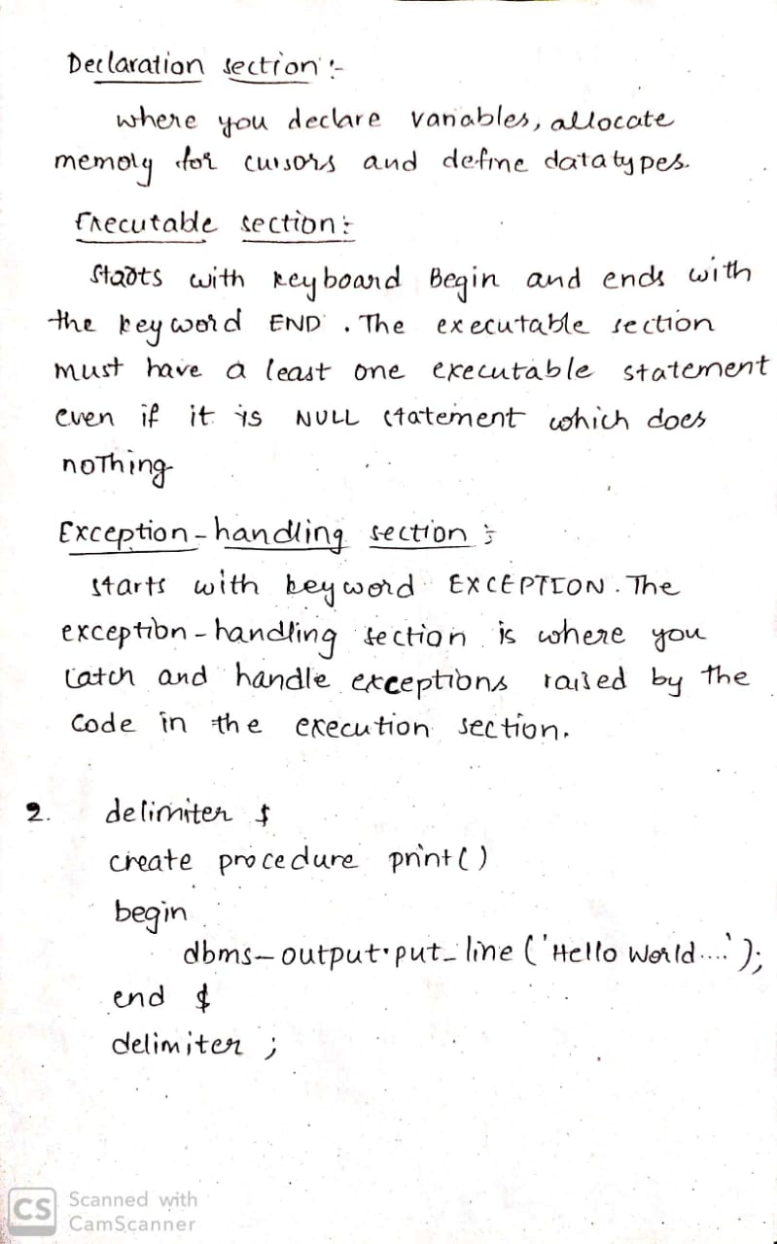

2. write a small query to print hello world by using PL/SQL Block.



3. prepare query to understand loops by using for loop to print

i is: 1 and j is: 1

i is: 1 and j is: 2

i is: 1 and j is: 3

i is: 2 and j is: 1

i is: 2 and j is: 2

i is: 2 and j is: 3

i is: 3 and j is: 1

i is: 3 and j is: 2

i is: 3 and j is: 3

**ANS)**

**delimiter $**

**create procedure loops()**

**begin**

**declare i,j int;**

**set i=1;**

**l1:loop**

**set j=1;**

**l2:loop**

**select concat('i is:',i,' j is:',j);**

**set j=j+1;**

**if j>3 then**

**leave l2;**

**end if;**

**end loop l2;**

**set i=i+1;**

**if i>3 then**

**leave l1;**

**end if;**

**end loop l1;**

**end $**

**delimiter ;**

**call loops();**

4. A Query on PL/SQL to find LEAST number. This function accepts some parameters like exp1, exp2, … exp_n. These each expression may be numbers or alphabets

**ANS)**

**delimiter @@**

**create function least_(i float,j float,k float) returns float**

**begin**

**return least(i,j,k);**

**end @@**

**delimiter ;**

**select least_(1,2,3);**

5.Query to find floor value. This function accepts a parameter number which is the input number on which FLOOR function

**ANS)**

**delimiter $@**

**create function floor_(f float) returns int**

**begin**

**declare r int;**

**set r=floor(f);**

**return r;**

**end $@**

**delimiter ;**

**select floor_(2.6);**