**EXPERIMENT-12**

**PRELAB**

1. **What is CRUD?**

CRUD - Create, Read, Update, Delete

When we are build an api's we want our models to provide four basic types of functionalities. Computer scientists often refer them as CRUD.

1. **What is a Namespace in MongoDB?**

MongoDB stores BSON objects in the collection. The concentration of the collection name and database name is called a namespace.

1. **What are the components of the Sharded cluster****?**

A sharded cluster consists of shards , mongos, routers and config severs. Shards (upper left ) store the application data only the mongo routers or system administrators should be connecting directly to shards .

1. **What is the syntax of the limit() method and sort() method?**

**Syntax of limit Method**

> db.collection_name.find().limit(number)

**Syntax of sort Method**

> db.collection_name.find().sort({KEY:1})

1. **What is the difference between MongoDB and MySQL?**

MySQL is a relational database management system (RDBMS) from the oracle corporation. Like other relational systems , MySQL stores data in tables and uses structured query language (SQL) for database access. MongoDB is a NoSQL database that stores data as JSON documents.

**INLAB**

**Construct Queries using MongoDB on Case Study 7**

1. **Write a query to create a collection called Property Owner with an attributes defined in skilling session 5.**

**Basic Syntax:**

>db.createCollection("collection name",{capped:true, size:number (bytes), max: number });

Here Collection Name is **Property Owner** So,

>db.createCollection("PropertyOwner",{capped:true, size:5000, max: 5 });

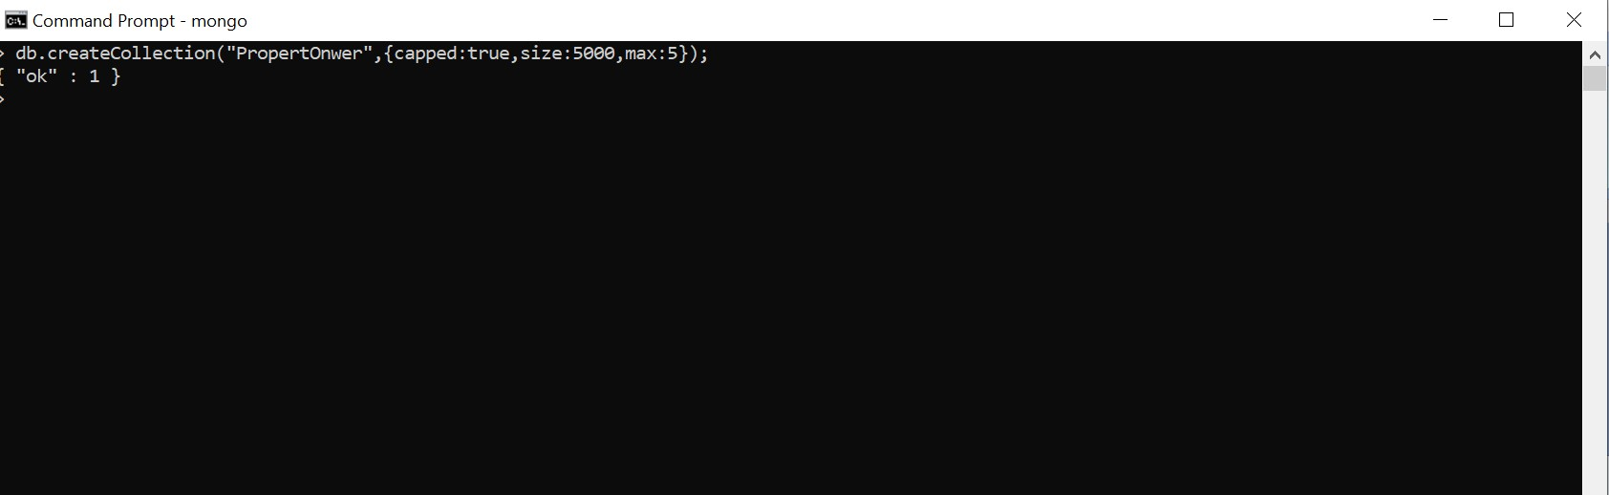

1. **Write a query to construct a collection called Business Owner with an attributes defined in skilling session 5**

**Basic Syntax:**

>db.createCollection("collection name",{capped:true, size:number (bytes), max: number });

Here Collection Name is **Business Owner** So,

>db.createCollection("BusinessOwner",{capped:true, size:6000, max: 7 });

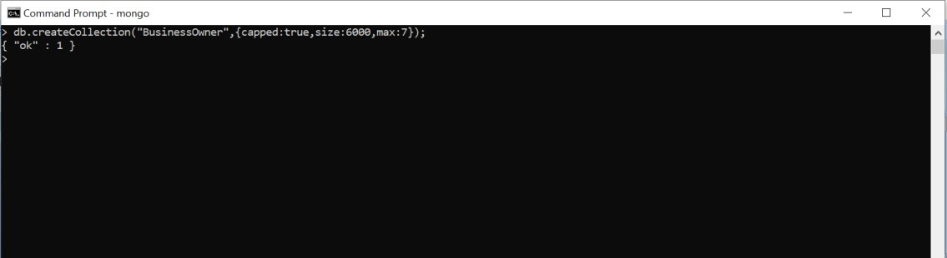

1. **Write a query to create a collection with the property details with an attributes defined in lab skilling session 5**

**Basic Syntax:**

>db.createCollection("collection name",{capped:true, size:number (bytes), max: number });

Here Collection Name is **Property Details** So,

>db.createCollection("PropertyDetails",{capped:true, size:4000, max: 6 });

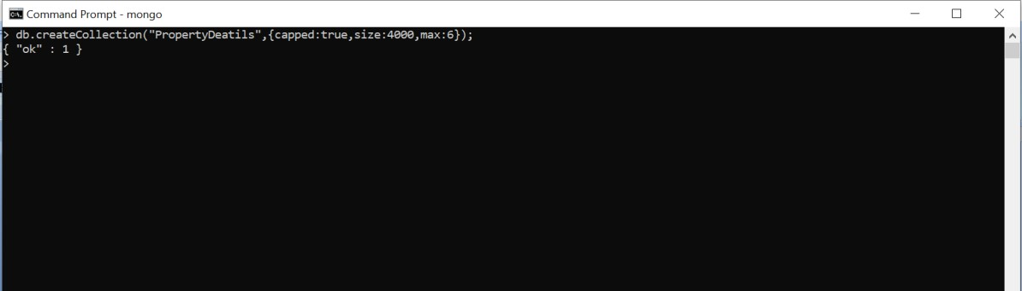

1. **Construct a query to insert data into above created collections.**

**Basic Syntax:**

>db.COLLECTION_NAME.insert(document)

Here for PropertyOwner

>db.PropertyOwner.insert({wonerno:8000,name:”Shiva”,occupation:”Employee”,Address:”Hyderabad”,Phno:89267427846})

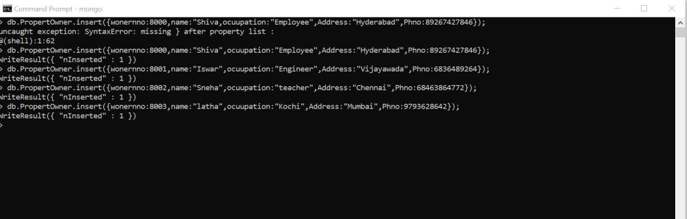



**Basic Syntax:**

>db.COLLECTION_NAME.insert(document)

Here for BusinessOwner

>db.BusinessOwner.insert({bno:9801,name:”raja”,occupation:”clerk”,Address:”Mumabi”,Phno:8869264862})

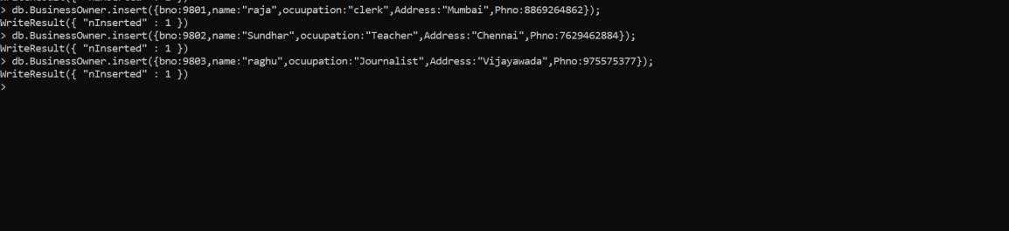

**Basic Syntax:**

>db.COLLECTION_NAME.insert(document)

Here for PropertyDetails

>db.PropertyDetails.insert({pno:63589Address:”hyderabad”,Owned_By:8892,Ownes_seen_by:50012})

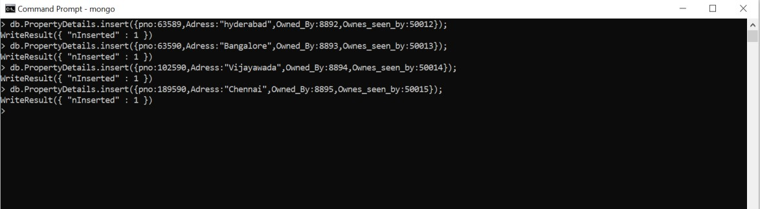

1. **Construct a query which retrieves details of Property that have hired or being hired by each renter.**

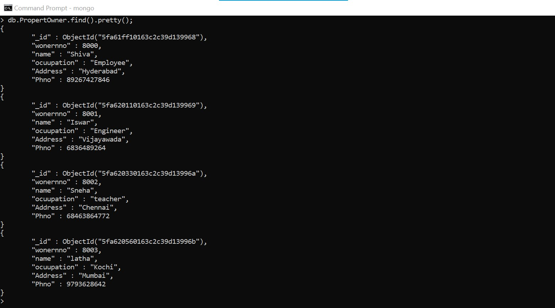

1. **Construct a query which retrieves details of property submitted for hire by each property owner.**

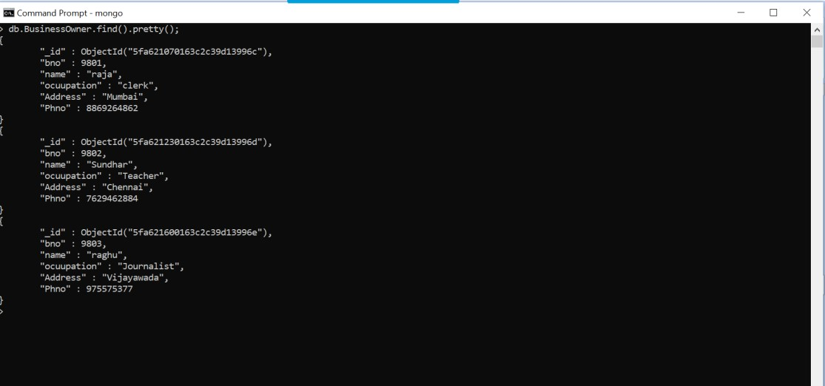

**POSTLAB**

* 1. **MongoDB process collection of documents using operations.**

**Ans)** Map-reduce

* 1. **Which pipeline is used for aggregation in MongoDB?**

**Ans)** MongoDB provides the db.collection.aggregate() method in the mongo shell and the aggregate ccommand to run the agggregation pipeline.

* 1. **In aggregation pipeline, the pipeline stage provides access to MongoDB queries.**

**Ans)** $match

* 1. **To suppress the _id field from the result set, specify in the projection document.**

**Ans)** _id:0

* 1. **command display the list of databases.**

**Ans)** show dbs;

* 1. **Command to check existence of collection is**

**Ans)** show collections