# DBMS SKILL-3

**PRE-LAB:**

1. What is the use of the IS A relationship?

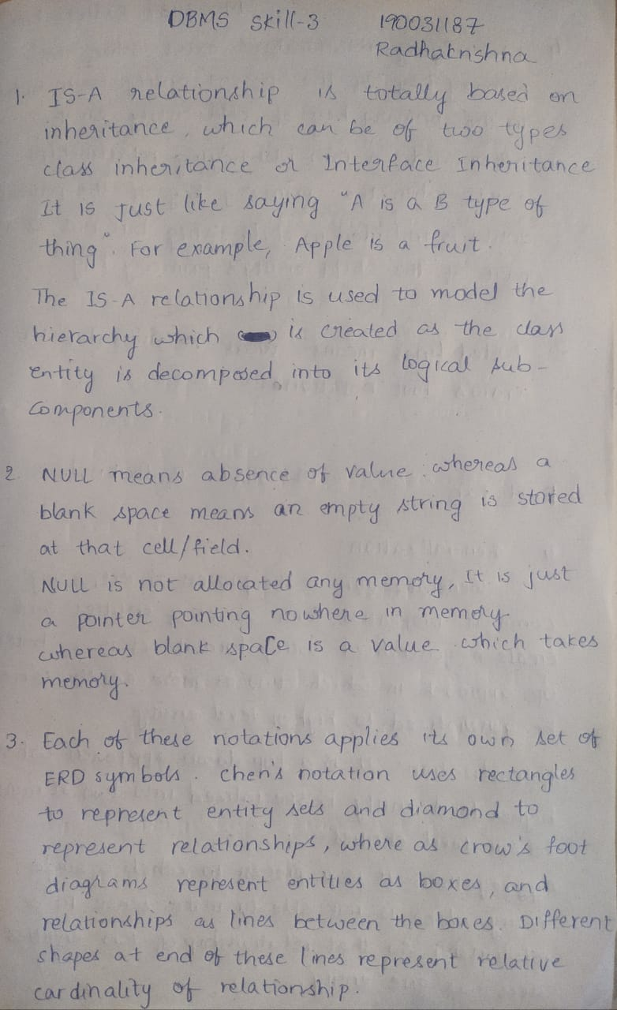

1. What is the difference between NULL and Blank space in a specific field of the table?



1. How is Chen’s notation different from crow’s foot notation?



1. State the differences between identifying and non-identifying relationships.

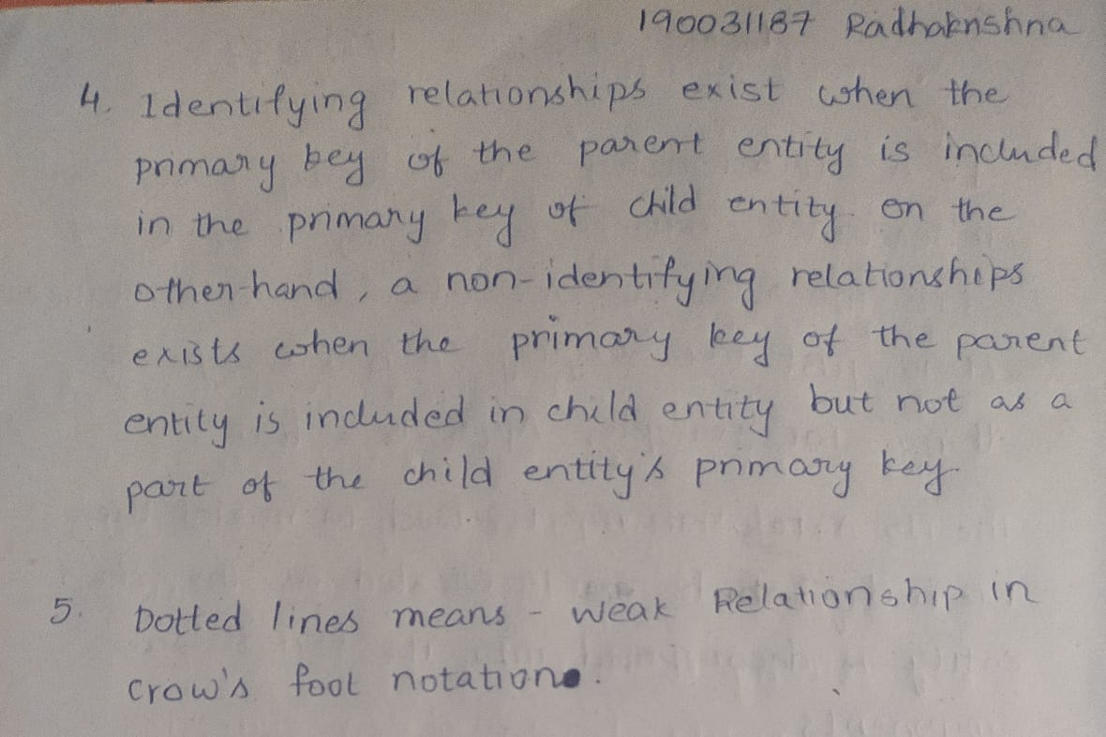

1. How to represent the weak relationship in crow’s foot model?



**INLAB**

**CASE STUDY 8 : SAINT GOBAIN**

There is glass industry SAINT GOBAIN in Nellore in which there is a large problem to store all the information as there is a large fact to shop. So, the management commenced to store it in database. There are a lot of glasses available there within the industry in order that they want to list out the forms of glasses and then unique thicknesses in it and then special colors in that thicknesses. As the distinct glasses have specific thicknesses and unique shades in it, they need to consider all the things and then determine a way to store it in a database.

Different types: Various types of glasses available in that industry.

Clear glass Tinted glass Cooling glass Reflective glass Lacquer glass

Mirror

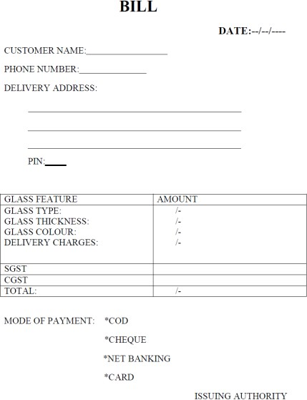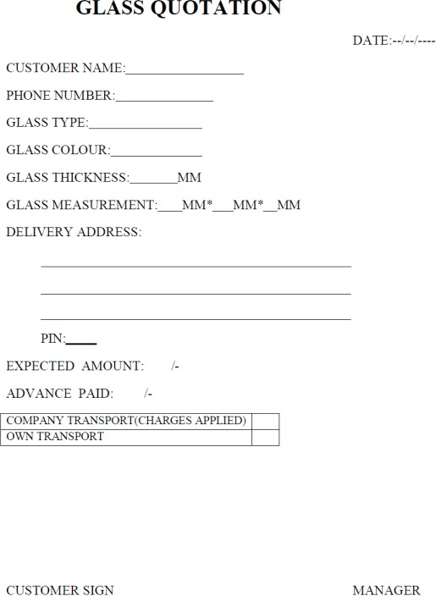The manager approached database team to help him to maintain all this data. Now if customer wants to buy a glass first customer has to fill in an online portal, so that the management can do preparation for the processing. In that portal customer will be asked to fill what type of glass he wants and then followed by thickness he wants and shade in the selected thickness. Now according to the online portal’s primary requirements, the glass is manufactured and after that customer is asked for further details like the type of design and the shape. And then the bill is generated according to the selection of the customer.

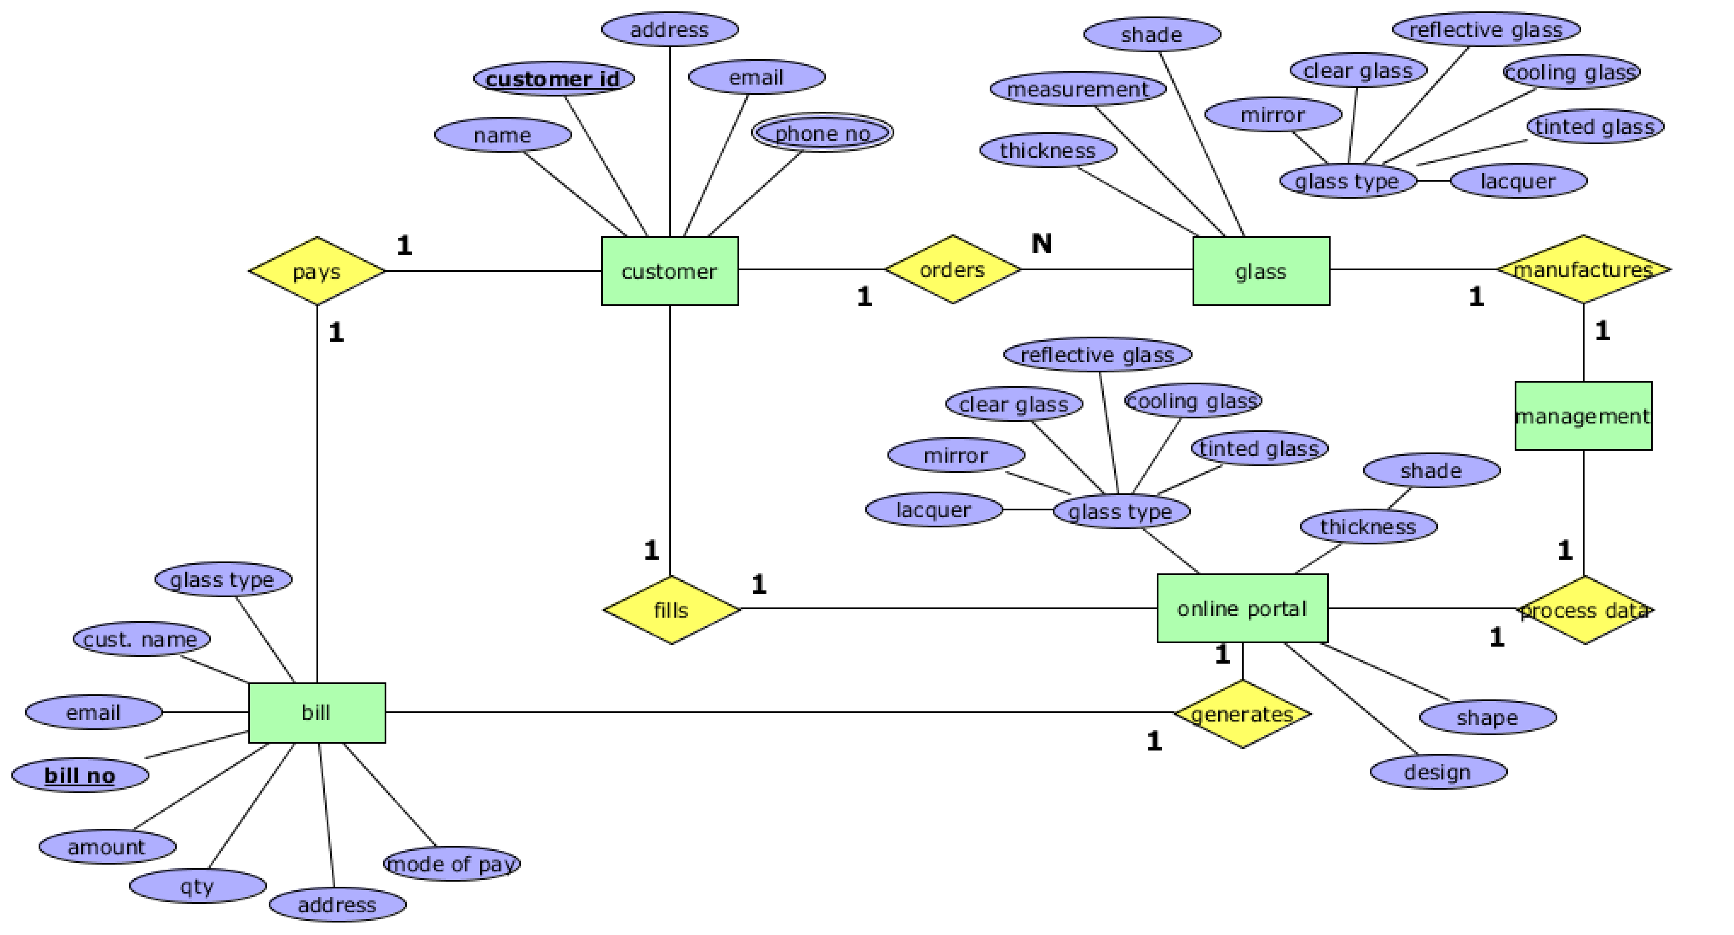

**POSTLAB**

1. In a city every person has his own car. The car has participated in accidents at some times and it has an estimation of the damage amount. Make an ER diagram using this information - a person has driver-id, address, name as attributes, the car has a license, model, year as attributes and accident has its date, report number, and location.

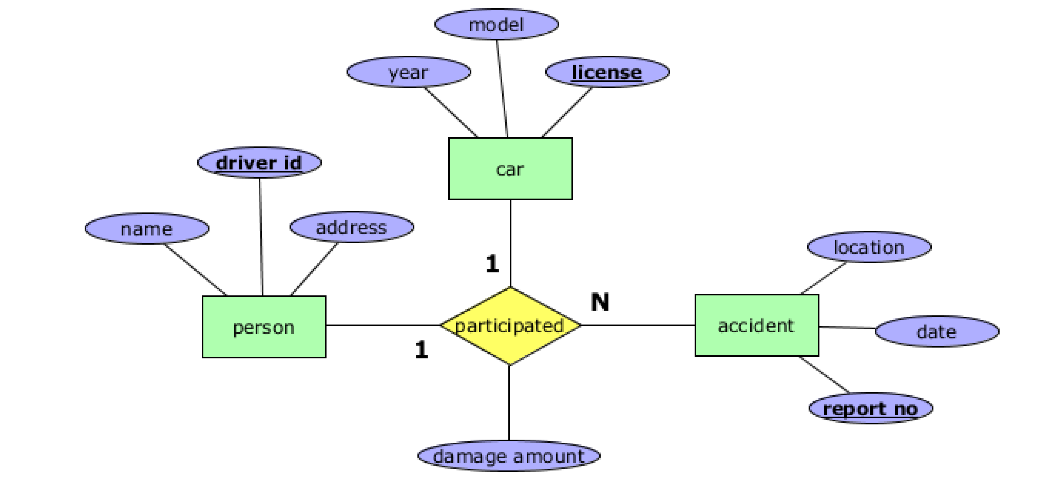

1. In hospital, patients have consulted the doctor for some tests performed by doctor. Make ER diagram using these information - patients has name, insurance, date-admitted, date-checked- out, the doctor has attributes name and specialization and the test has attributes id, name, date, time, result.

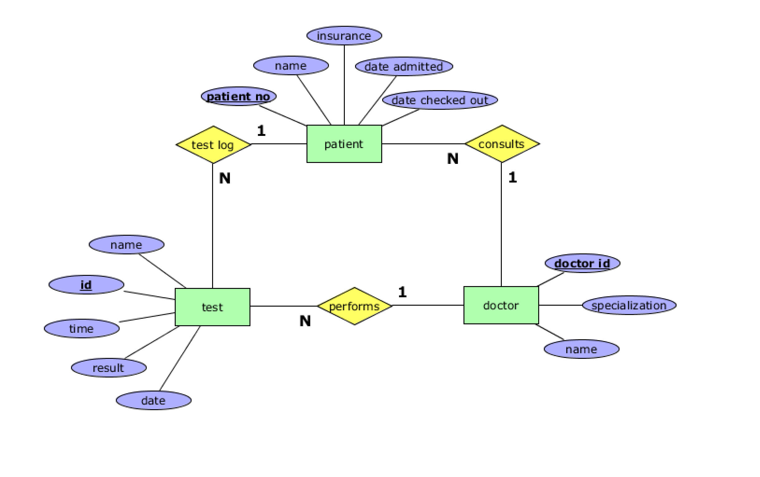

1. The motor vehicle branch administrators driving tests and issue driver’s licenses. Any person who wants a driver’s license must first take a learner’s exam at any motor vehicle branch in the province. If he/she fails the exam, he can take the exam again any time after a week of the failed exam date, at any branch. If he passes the exam, he will be issued a license (learner’s type) with a unique license number. A learner’s license may contain a single restriction on it. The person may take his driver’s exam at any branch any time before the learner’s license expiry date (which is usually set at six months after the license issue date). If he passes the exam, the branch issues him a driver’s license. A driver’s license must also record if the driver has completed driver’s education, for insurance purposes. Each driver should own a vehicle. If he has no money, he can lend it through the loan. Find out the relationships among the entities?

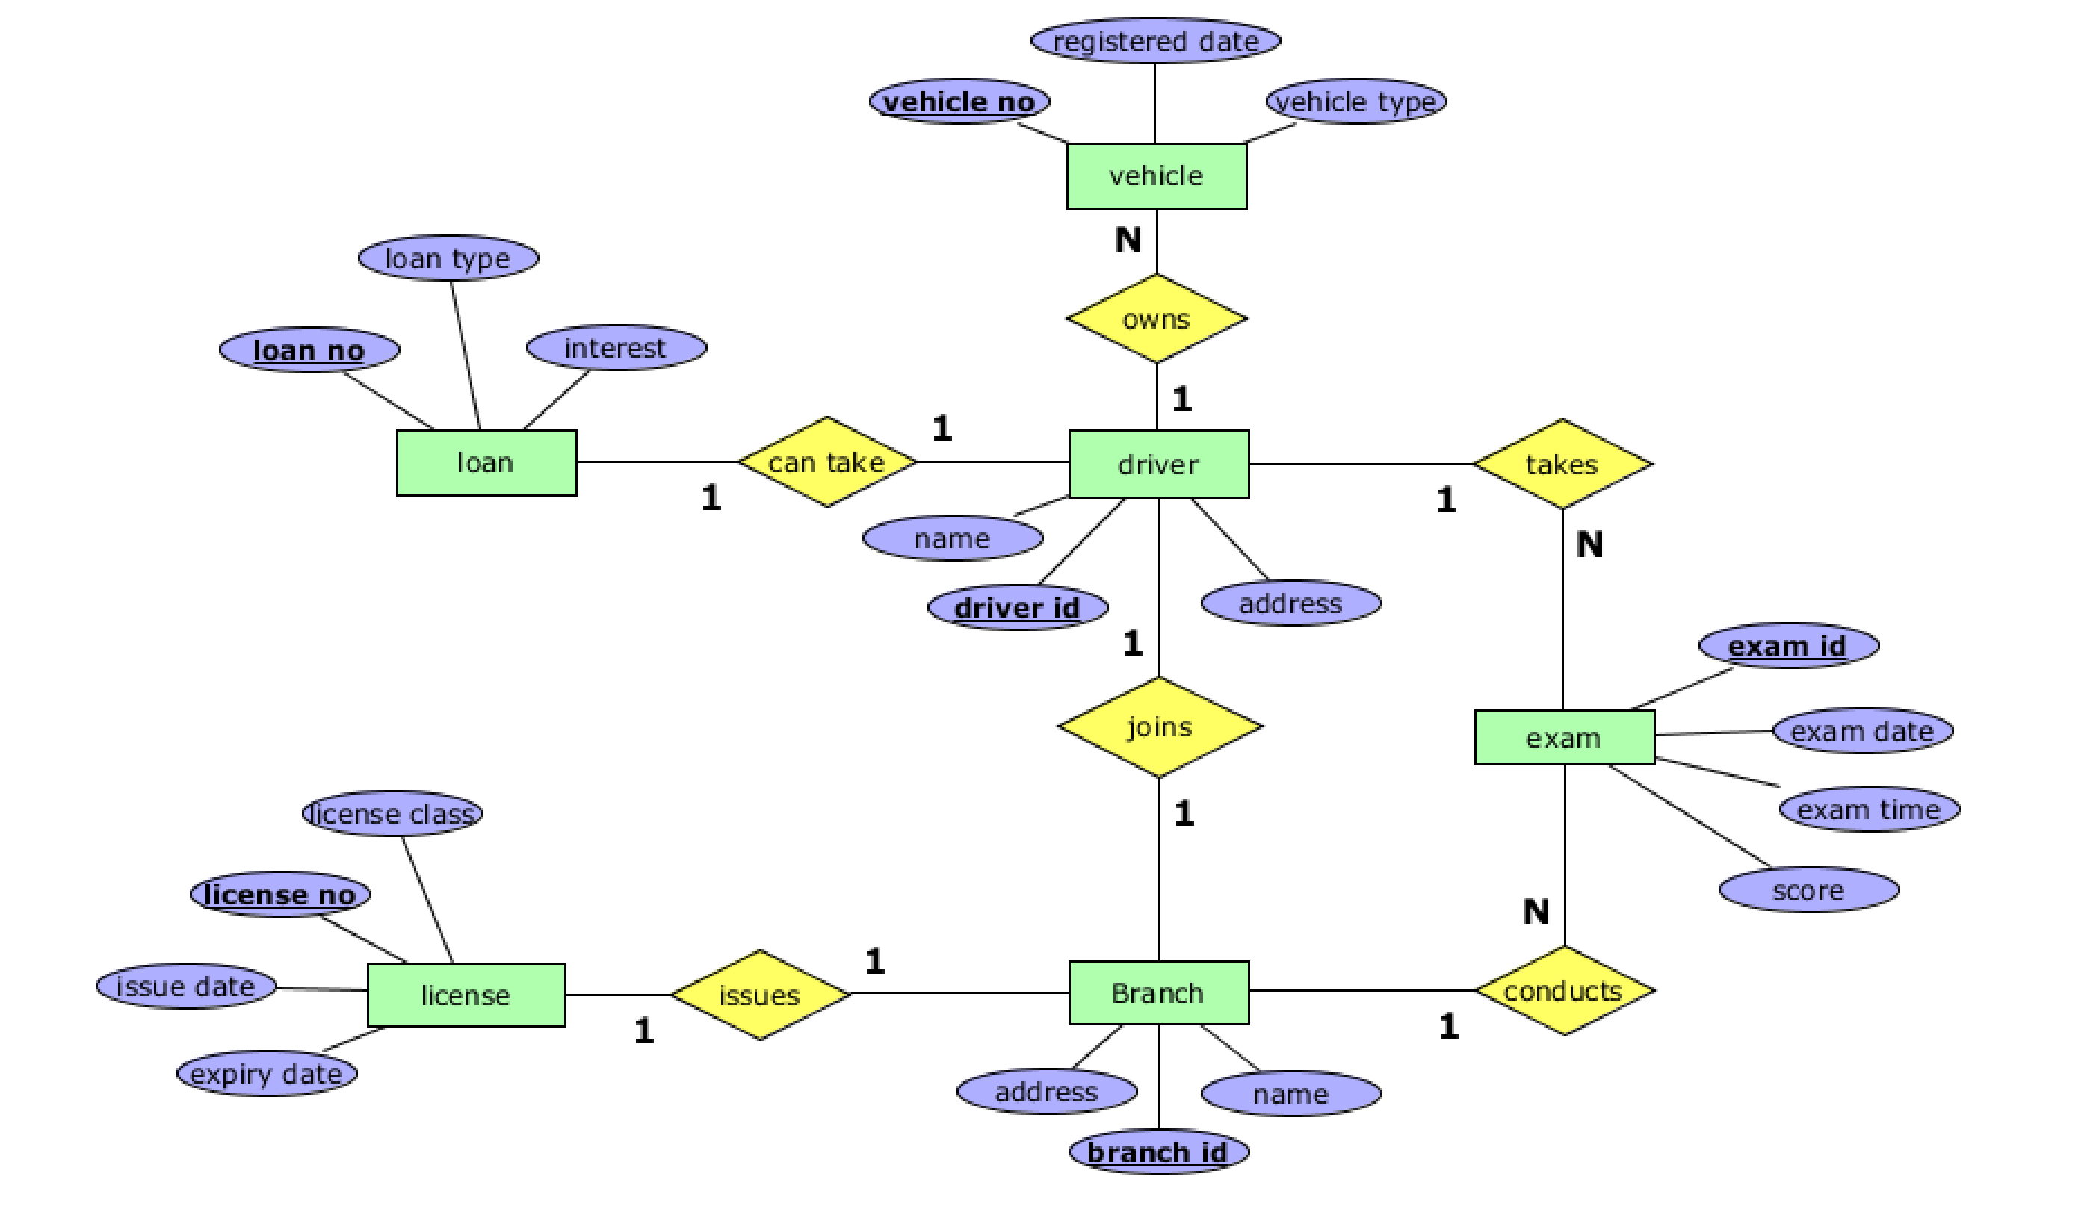

1. Explain Generalization, Specialization and Aggregation with examples with respect to ER Model.

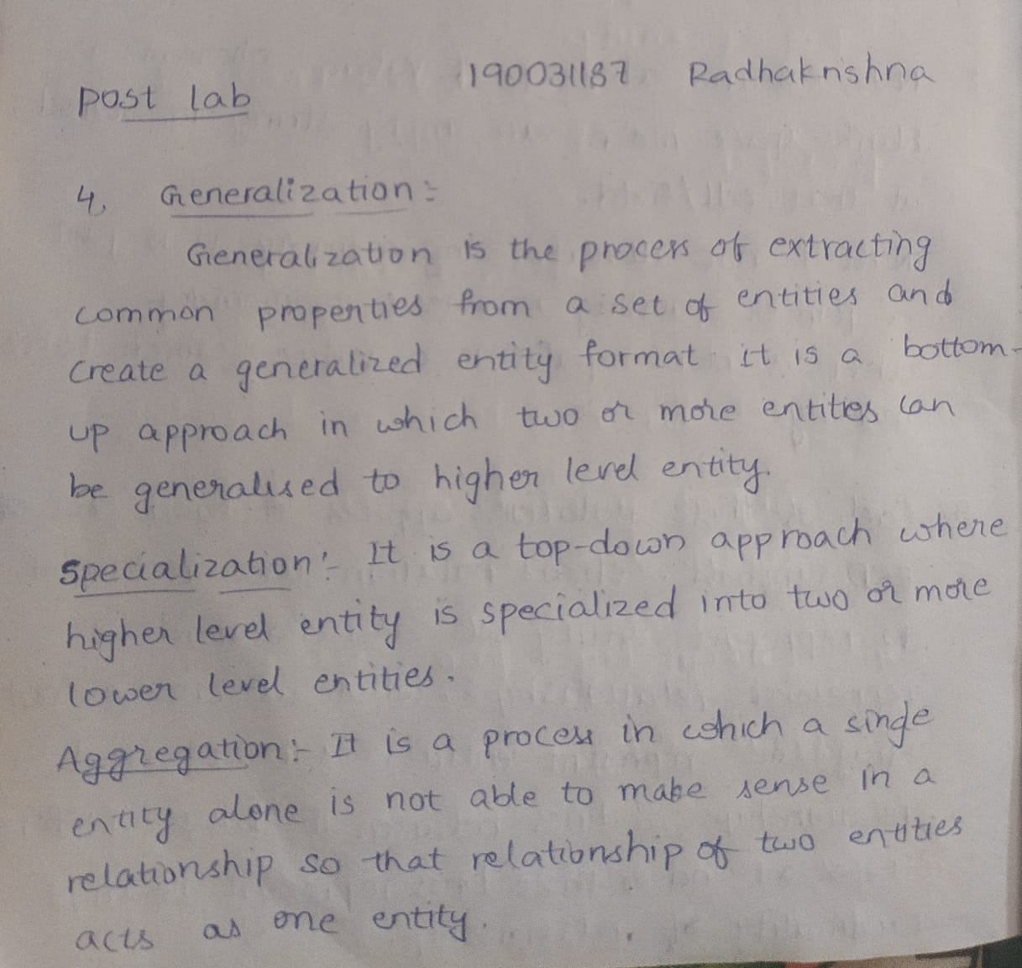

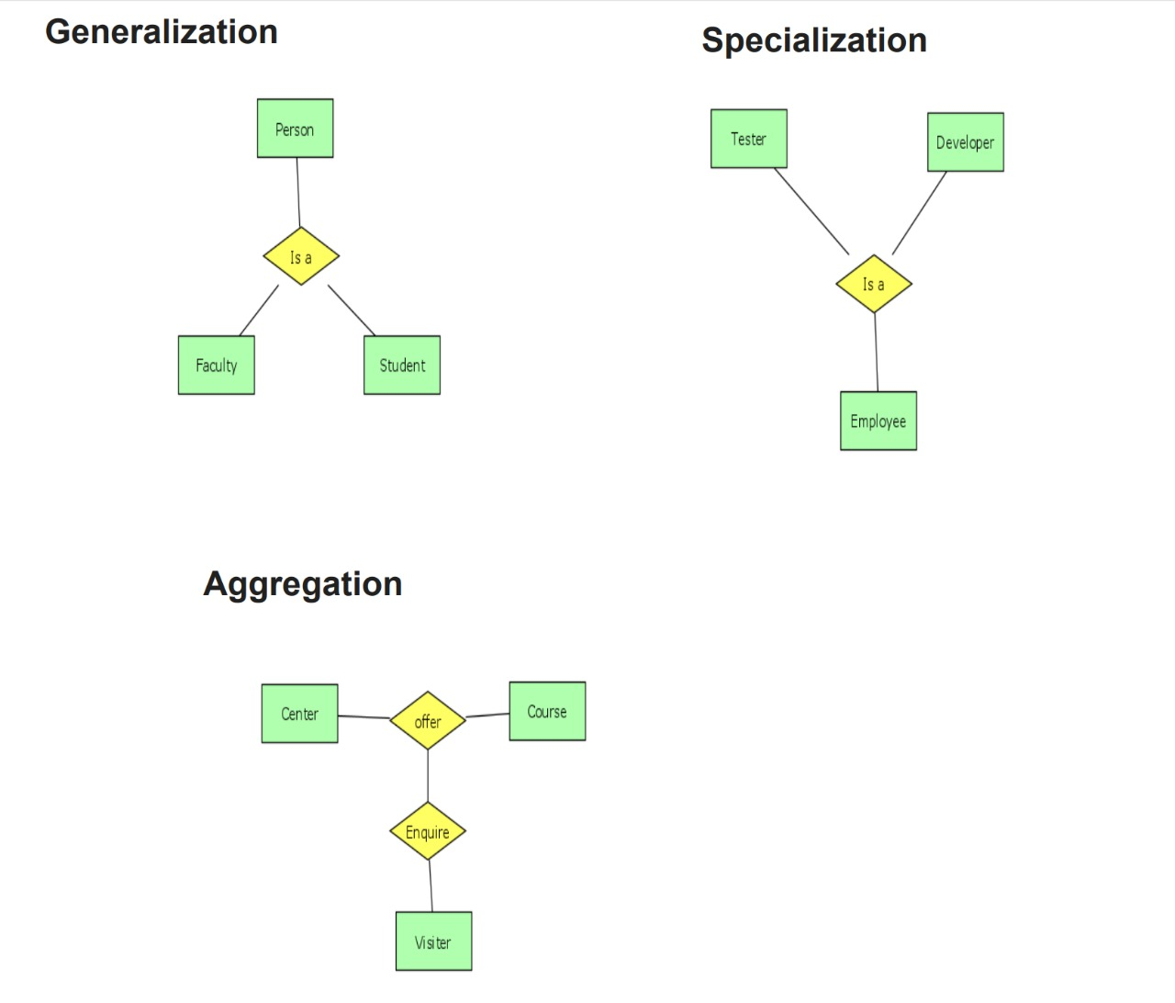

1. 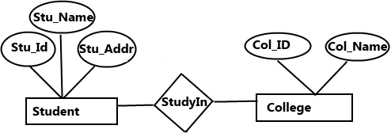What did you understand from this below ER diagram and describe it

