**DBMS SKILL-5**

**PRE-LAB**

1. The properties of a primary key are already known. A combination of which individual constraints resembles “Primary Key” constraint?

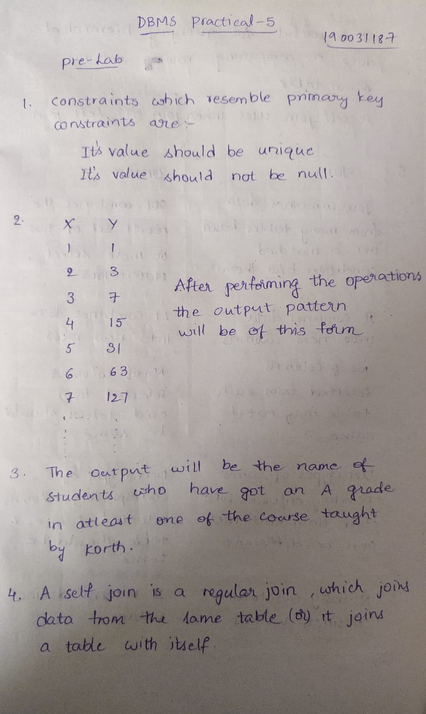

1. Consider a database table T containing two columns X and Y each of type integer. After the creation of the table, one record (X=1, Y=1) is inserted in the table. Let MX and MY denote the respective maximum values of X and Y among all records in the table at any point in time. Using MX and MY, new records are inserted in the table 128 times with X and Y values being MX+1, 2*MY+1 respectively. It may be noted that each time after the insertion, values of MX and MY change. What will be the output of the following SQL query after the steps mentioned above are carried out? Explain.



1. Consider the set of relations shown below and the SQL query that follows. Students: (Roll_number, Name, Date_of_birth)

Courses: (Course number, Course_name, Instructor) Grades: (Roll_number, Course_number, Grade) What is the output of the given SQL query?

**select** distinct Name **from** Students, Courses, Grades **where** Students. Roll_number = Grades.Roll_number **and** Courses.Instructor = ‘Korth’ **and** Courses.Course_number = Grades.Course_number **and** Grades.grade = ‘A’



1. What self join and why it is required?



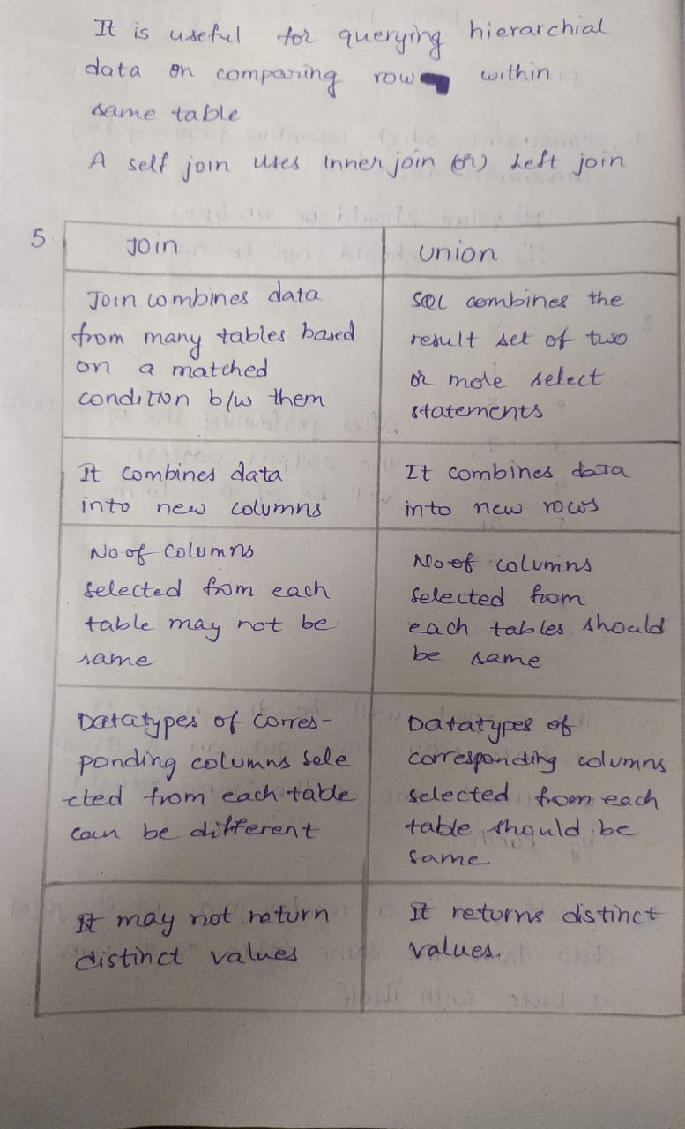

1. State the difference between UNION clause and JOIN ?



1. Classify Outer join operations and explain briefly.

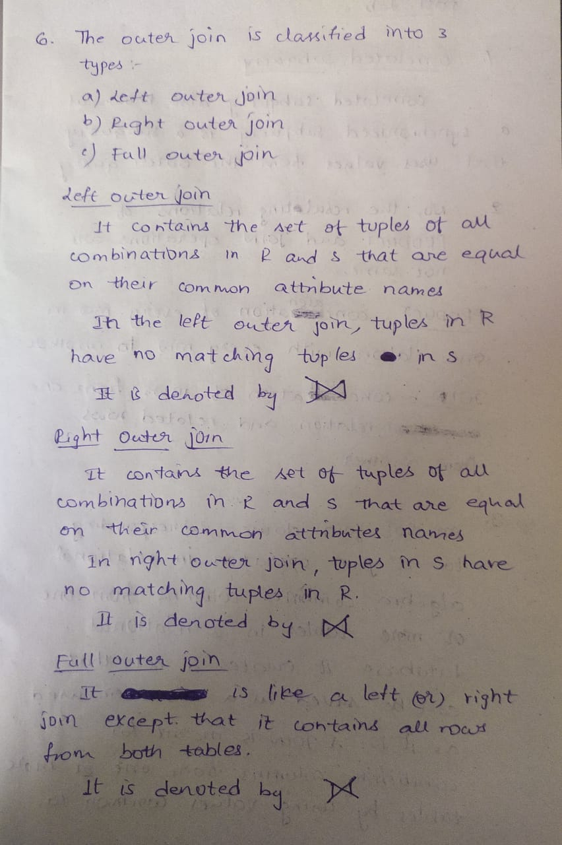

**POST LAB**

* 1. What do you mean by Correlated subquery?

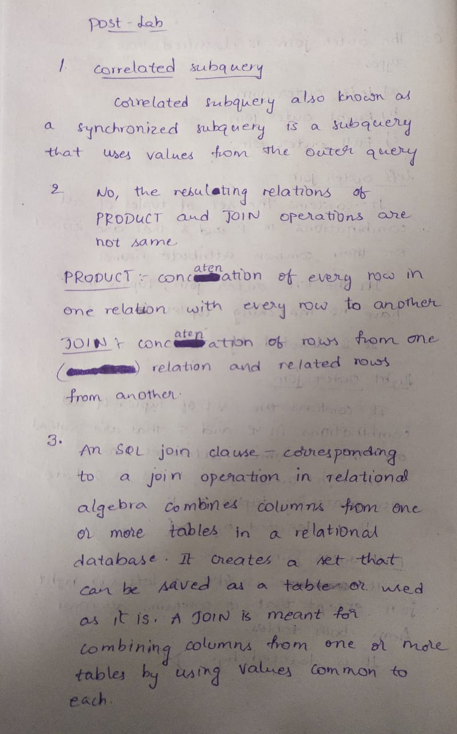

* 1. Are the resulting relations of PRODUCT and JOIN operation the same? Explain.



* 1. Explain a join between tables



* 1. Describe the difference between embedded and dynamic SQL.

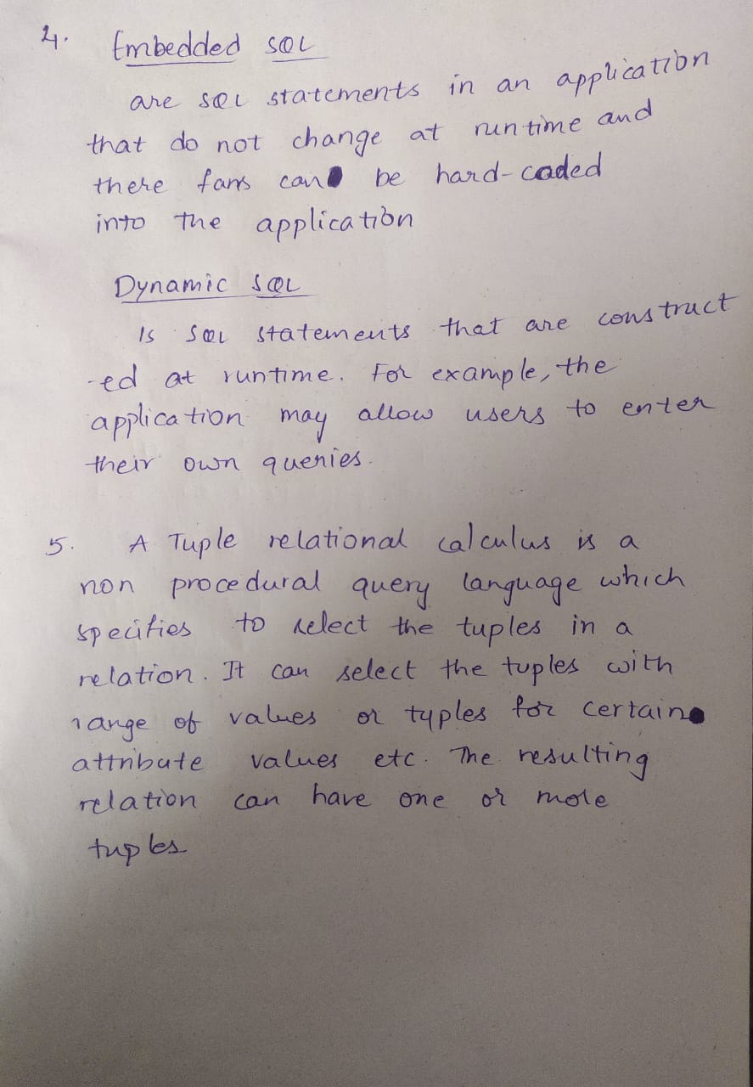

* 1. How does Tuple-oriented relational calculus differ from domain-oriented relational calculus?

