**DBMS SKILL-5**

**PRE-LAB**

1. The properties of a primary key are already known. A combination of which individual constraints resembles “Primary Key” constraint?

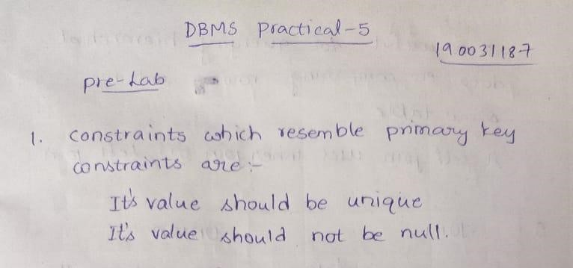

1. Consider a database table T containing two columns X and Y each of type integer. After the creation of the table, one record (X=1, Y=1) is inserted in the table. Let MX and MY denote the respective maximum values of X and Y among all records in the table at any point in time. Using MX and MY, new records are inserted in the table 128 times with X and Y values being MX+1, 2*MY+1 respectively. It may be noted that each time after the insertion, values of MX and MY change. What will be the output of the following SQL query after the steps mentioned above are carried out? Explain.

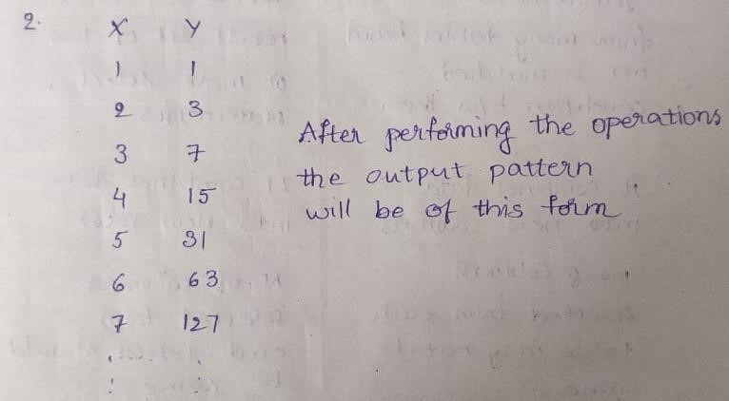

1. Consider the set of relations shown below and the SQL query that follows. Students: (Roll_number, Name, Date_of_birth)

Courses: (Course number, Course_name, Instructor) Grades: (Roll_number, Course_number, Grade) What is the output of the given SQL query?

**select** distinct Name **from** Students, Courses, Grades **where** Students. Roll_number = Grades.Roll_number **and** Courses.Instructor = ‘Korth’ **and**

Courses.Course_number = Grades.Course_number **and** Grades.grade = ‘A’

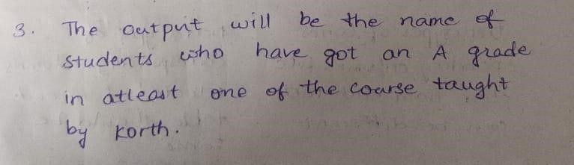

1. What self join and why it is required?

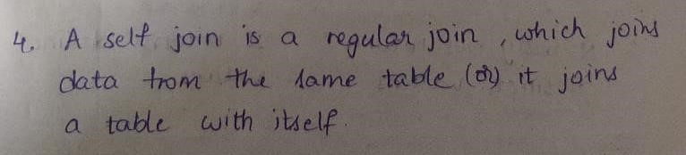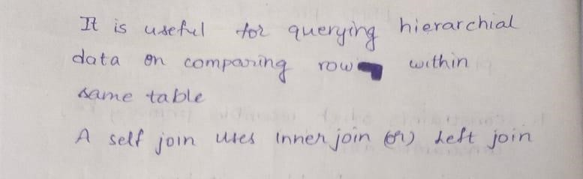

1. State the difference between UNION clause and JOIN ?

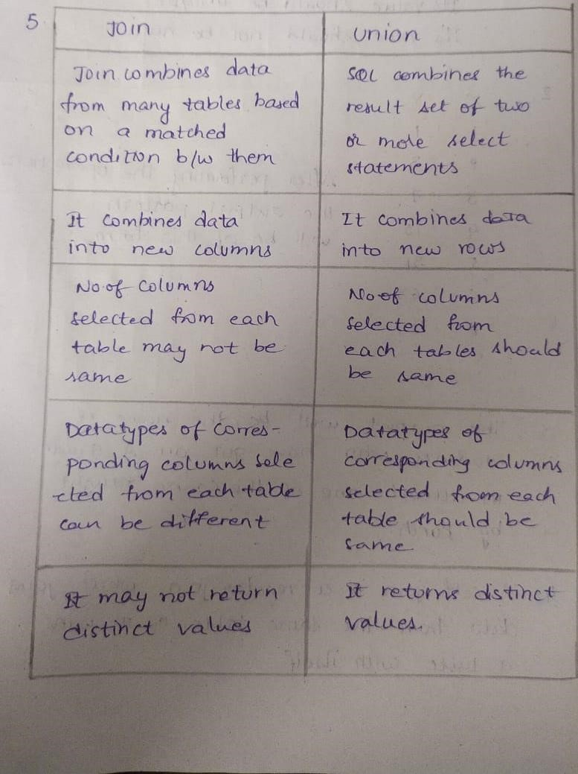

1. Classify Outer join operations and explain briefly.

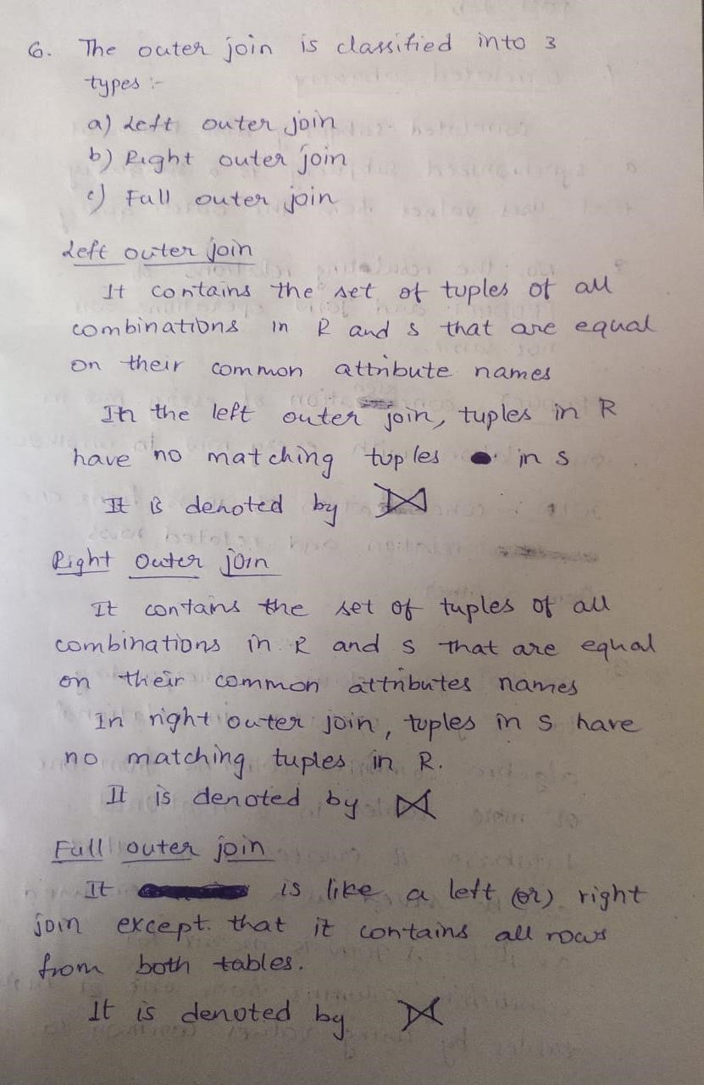

**POST LAB** 1. What do you mean by Correlated subquery?

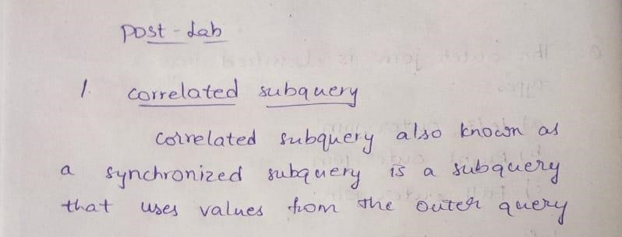

1. Are the resulting relations of PRODUCT and JOIN operation the same? Explain.

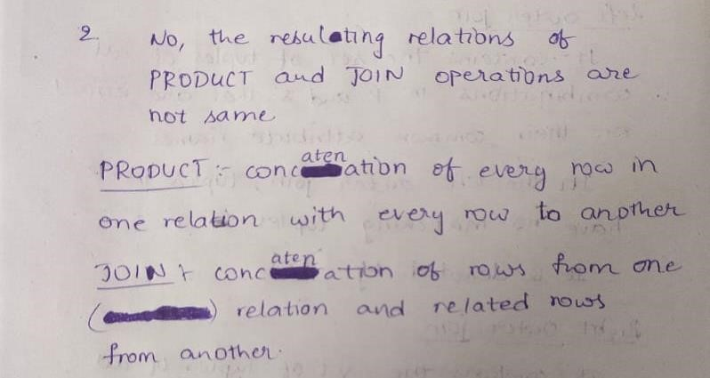

1. Explain a join between tables

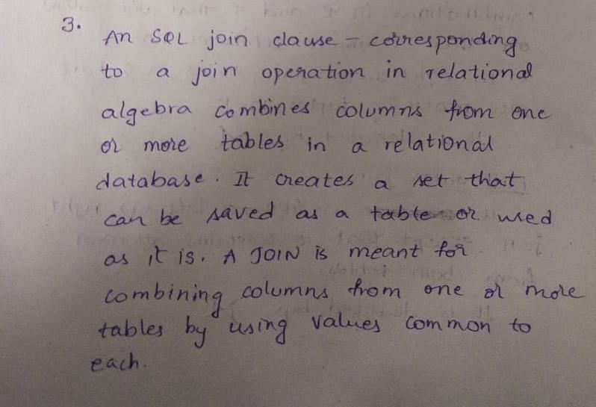

1. Describe the difference between embedded and dynamic SQL.

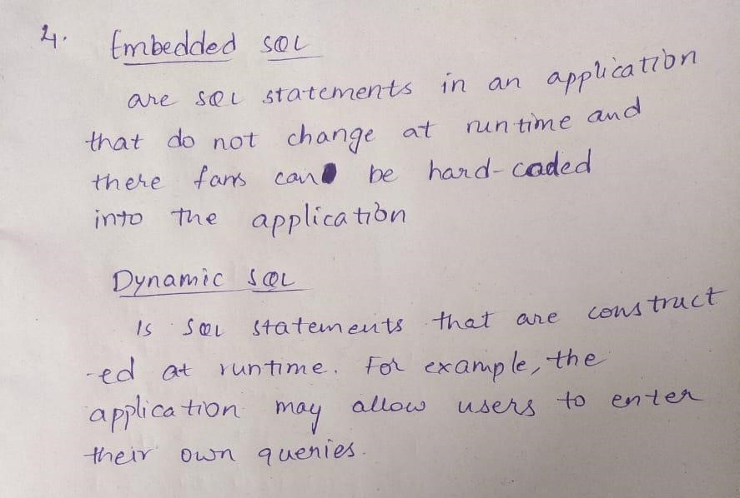

1. How does Tuple-oriented relational calculus differ from domain-oriented relational calculus?

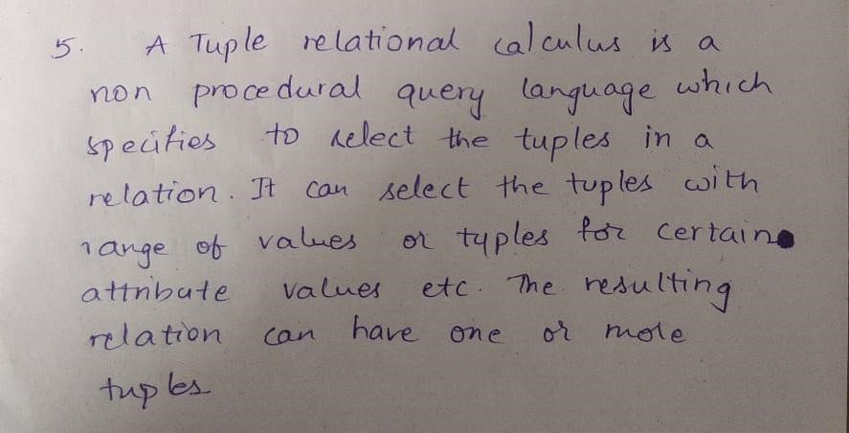

**DBMS SKILL-5**

**INLAB**

1. Create tables with the required constraints for the given case study
2. Insert 10 records into the created tables

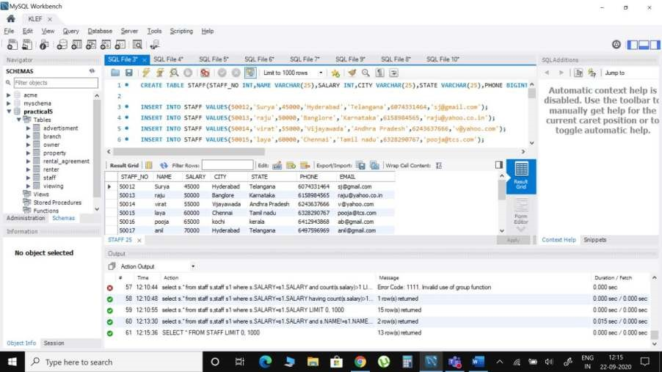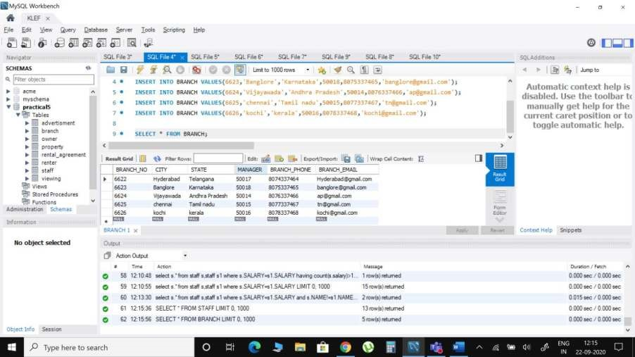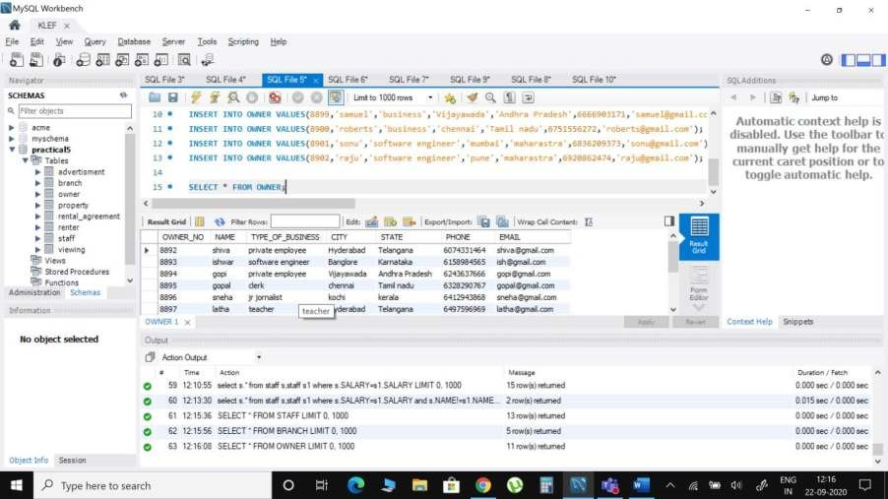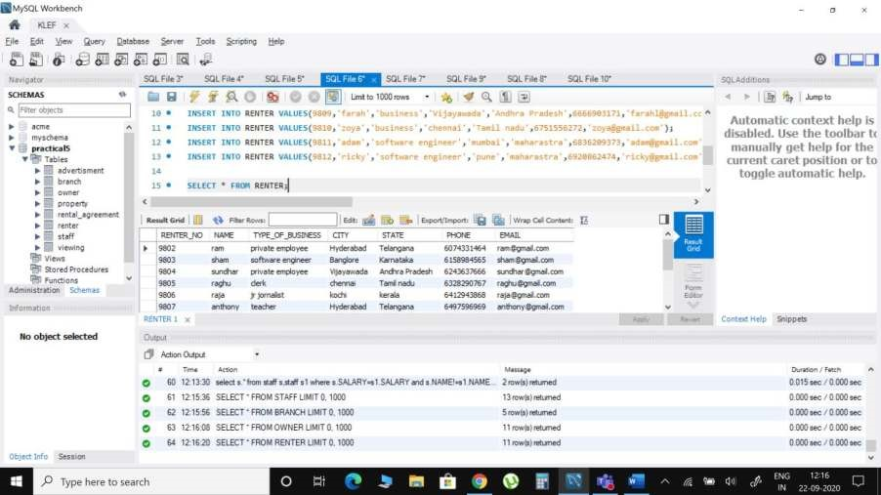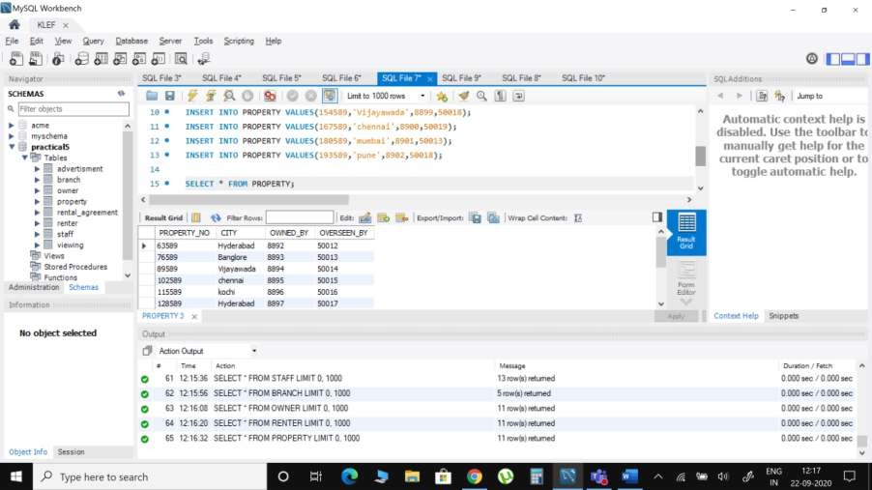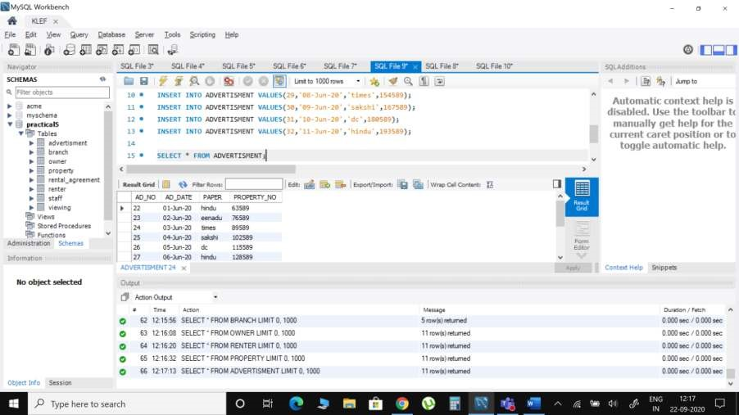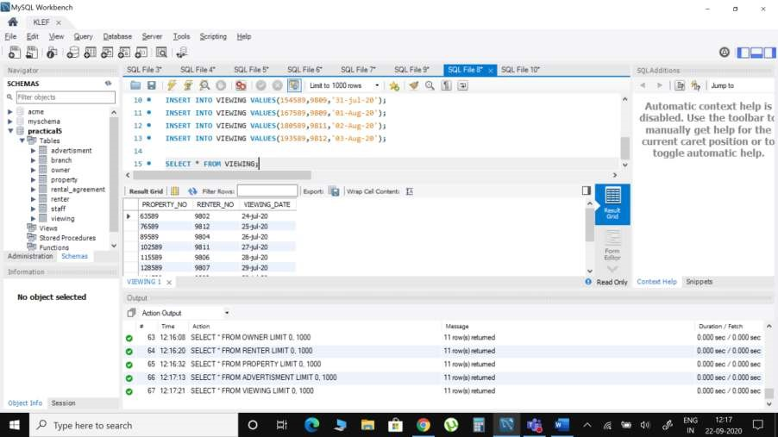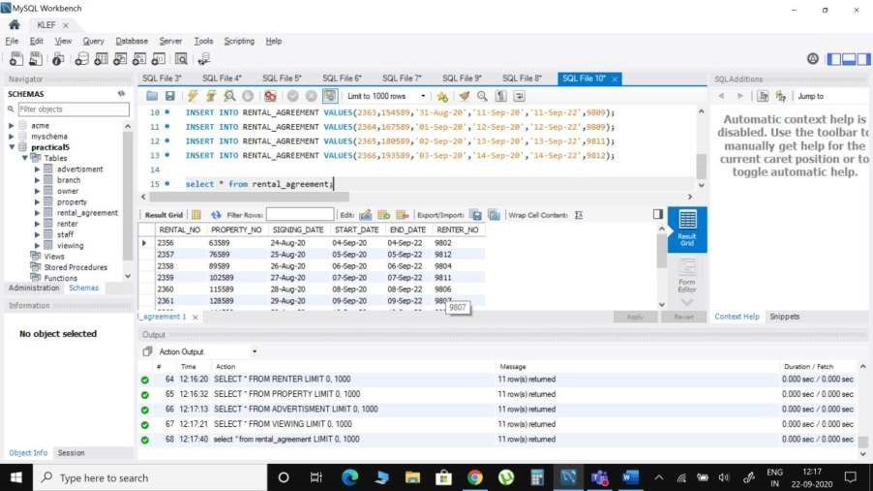

1. Display renter details which are unique.

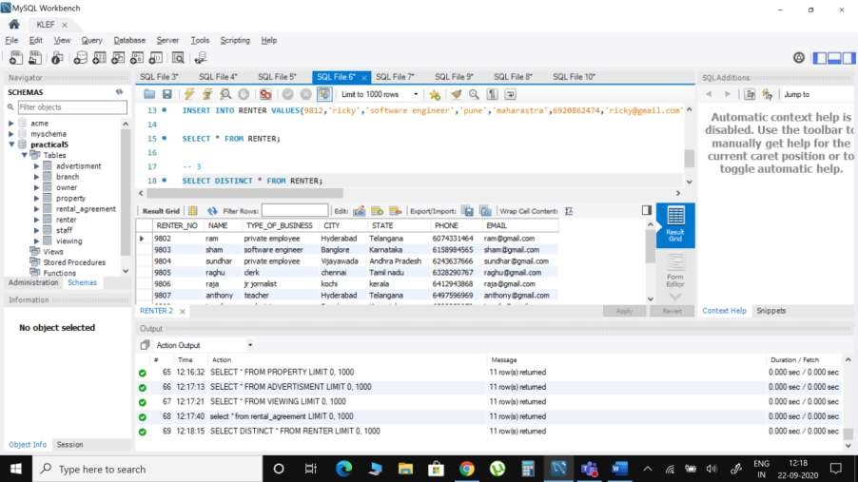

1. Give the email addresses and the renter number for all the private renters.

Please, sort them by the renter number.

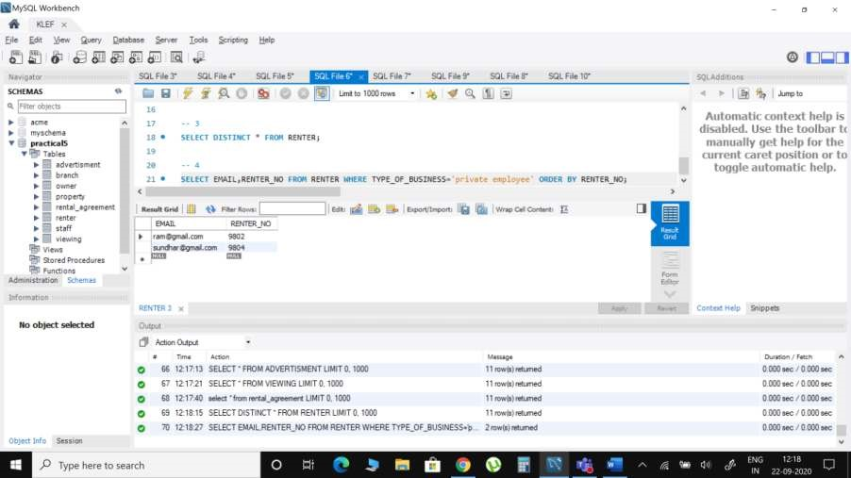

1. Find unique property name and number of branches for each property.

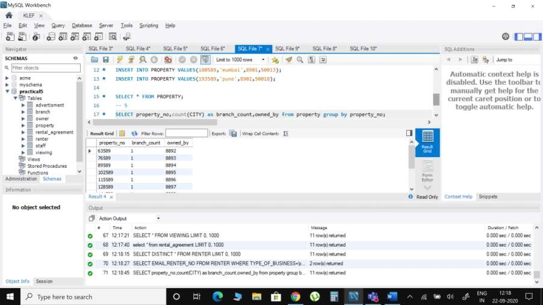

1. Create table for staff member and insert all the details of the staff members.



1. Give the dates of all the advertisements posted in THE GLOBE AND MAIL in 2005.

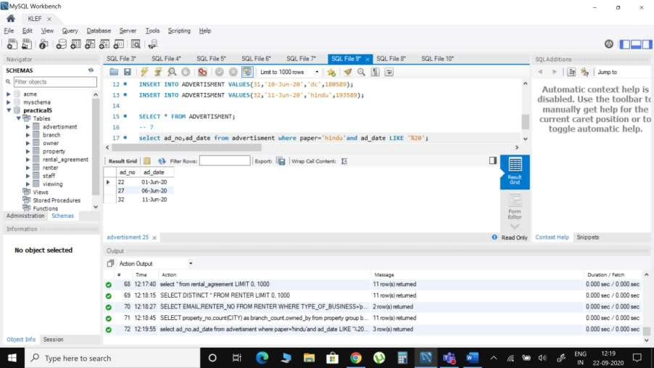

1. Display the count of staff in each branch and display them in descending order on count.

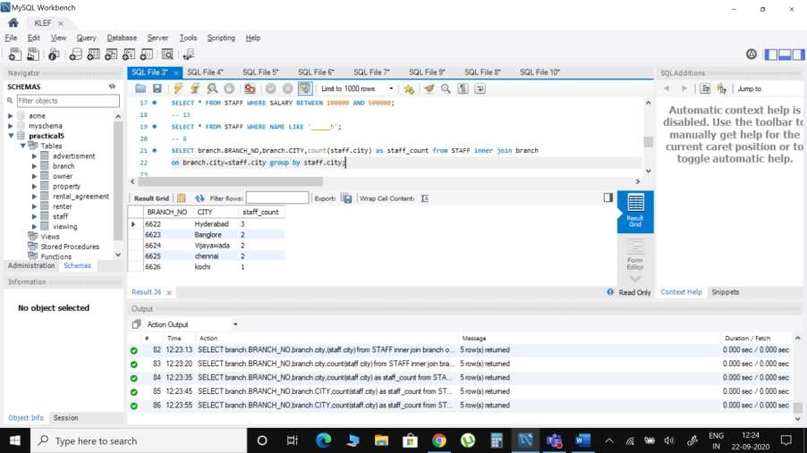

1. Find the properties that are already advertised but not yet rented.

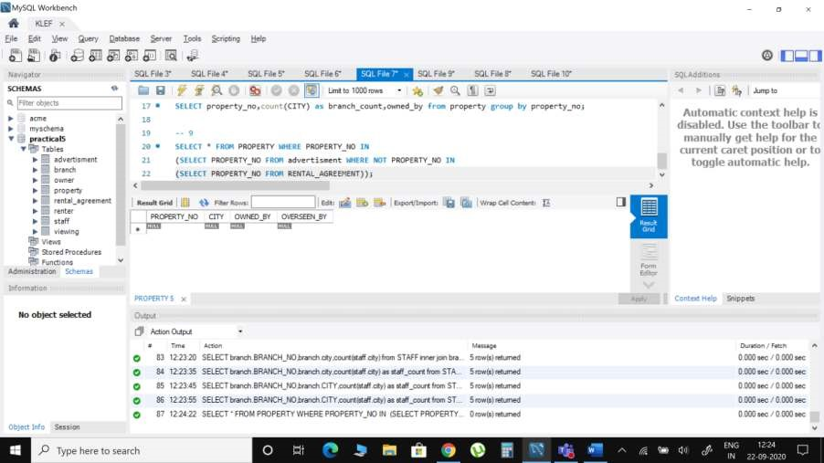

1. Assuming that each advertisement costs 100 dollars, give the branch number and the amount spent on the advertisements for each branch. Name the branch number as Branch no, and the amount as ad cost.

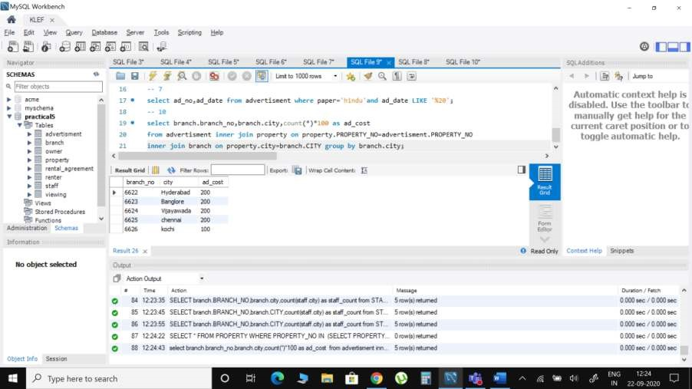

1. Display the details of staff who are working in a particular branch.

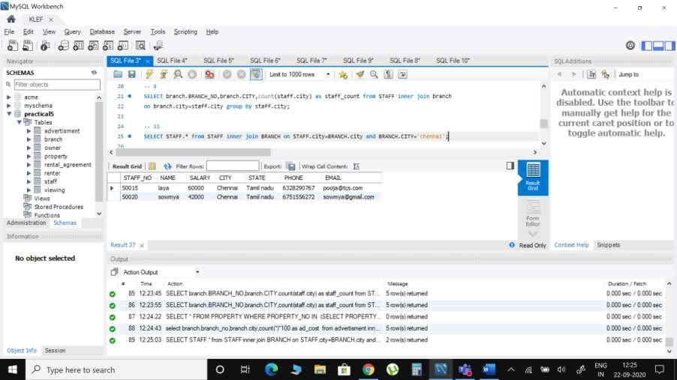

1. Write down a query to find out the Name, Address and Position of the branch staff whose salary is the second highest without using TOP or limit method.

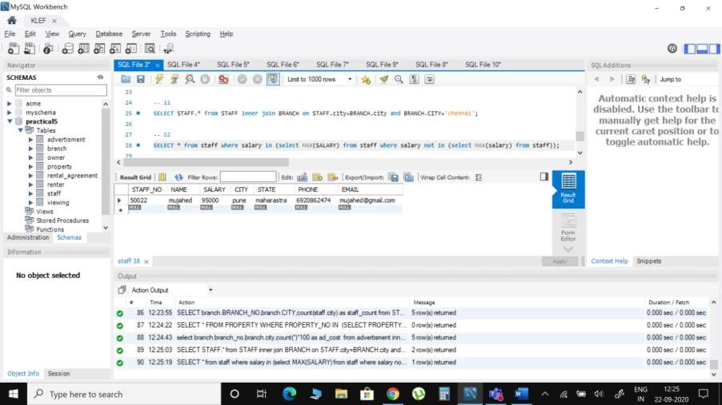

1. Write a query to print details of the staff whose Name ends with ‘h’ and contains six alphabets.

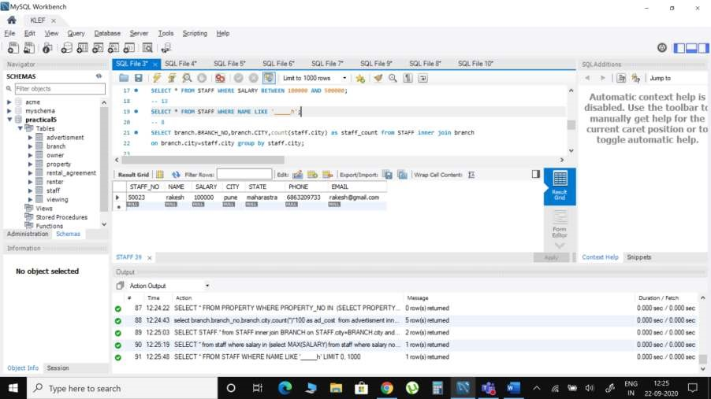

1. Write a query to print details of the staff whose SALARY lies between 100000 and 500000.

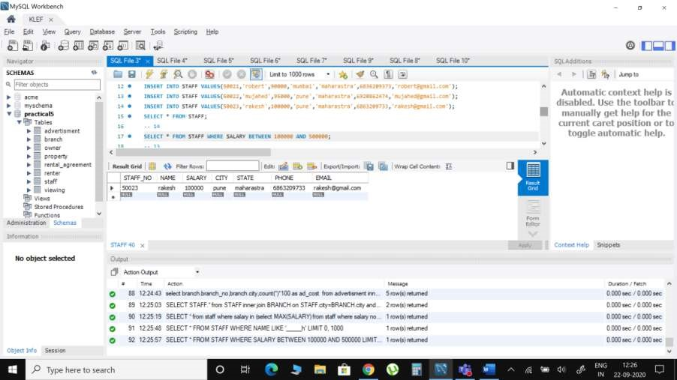

1. Write a query to display the list of employees who draw same salary

