**Tutorial – 10**

Implement the following PL/SQL programs on Case Study 2

1. Create a procedure to display the information of rooms allocated for a particular course that user inputs

**delimiter @**

**create procedure classdetails(class_id int)**

**begin**

**select * from examclass where CLID=class_id;**

**end @**

**delimiter ;**

**call classdetails(102);**

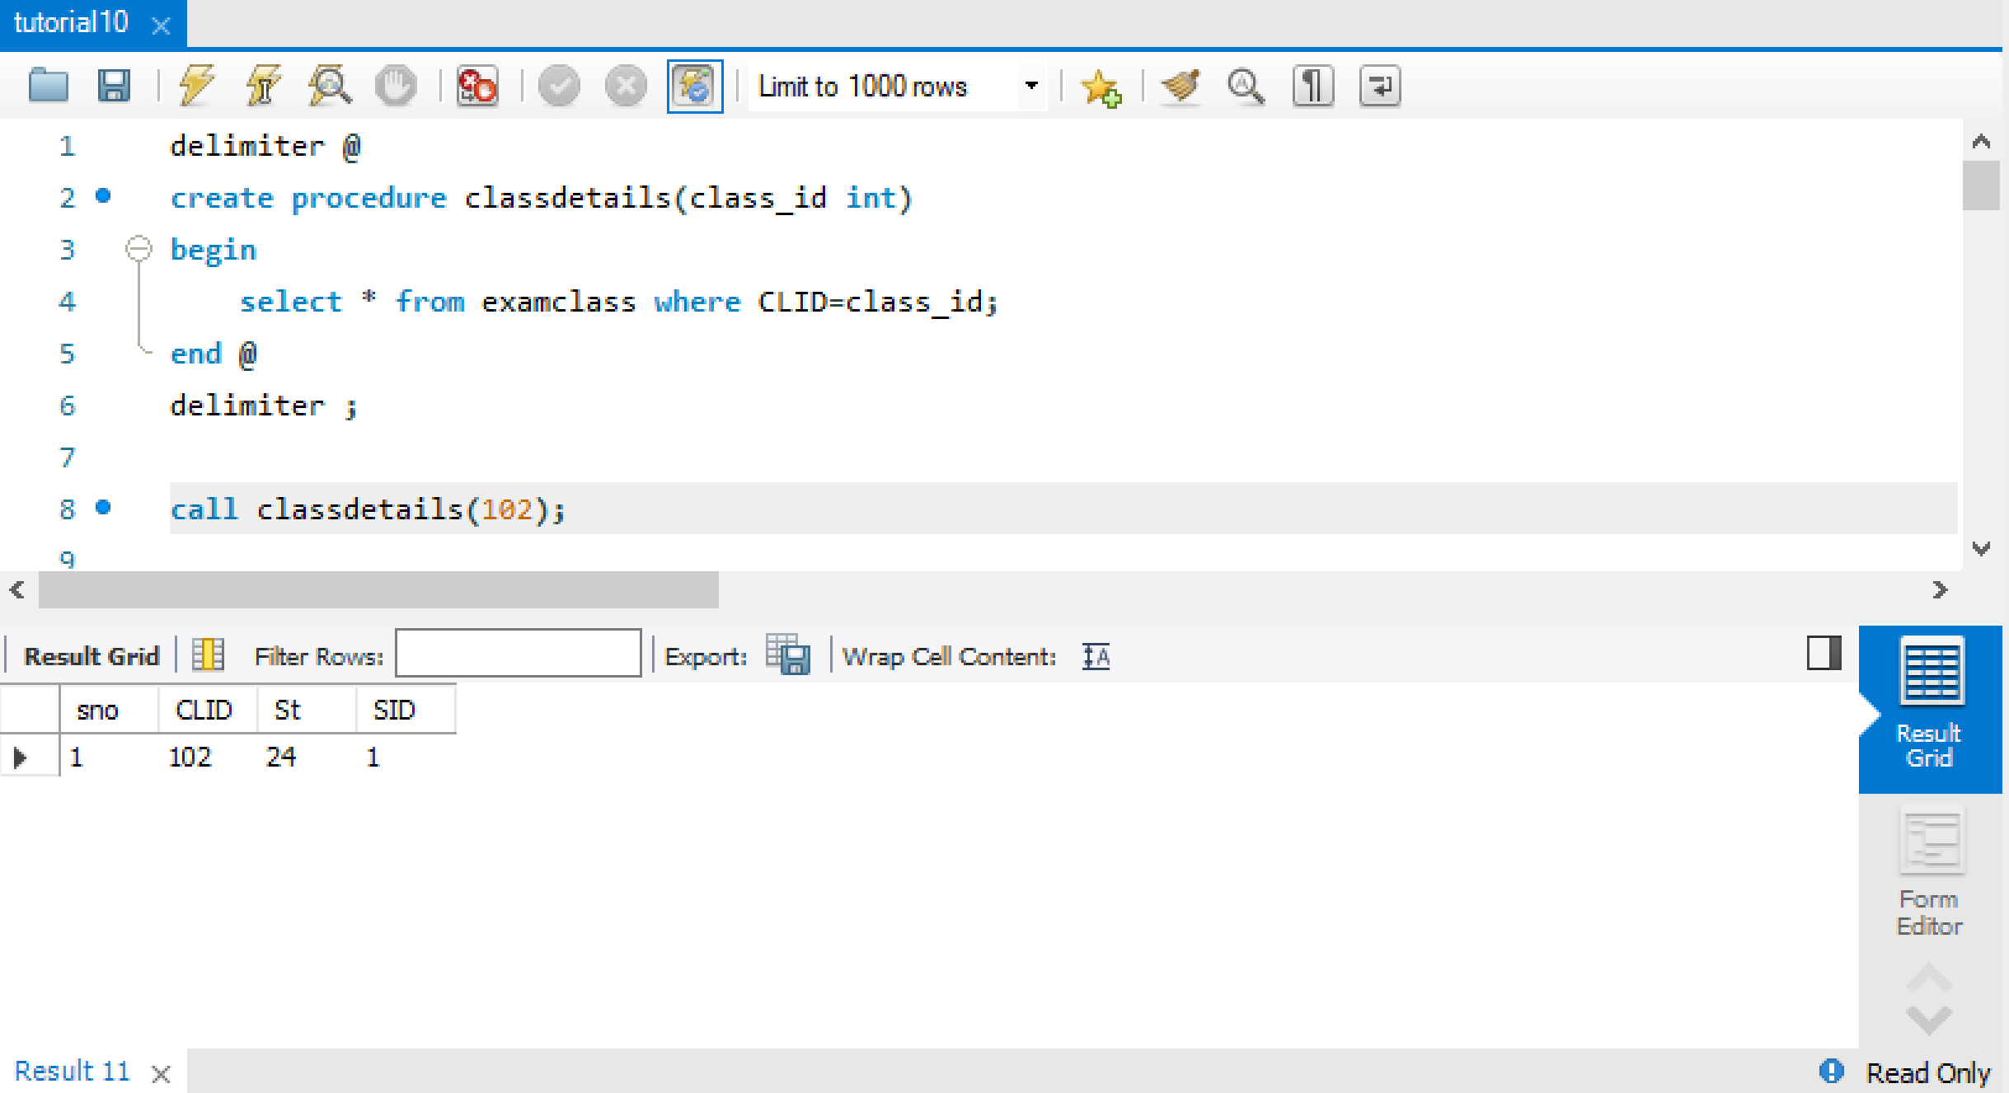

1. Create a Cursor to display the details of faculty working as squad and the no. of duties done by each.

**delimiter $**

**create procedure facdetails()**

**begin**

**declare fac_id int;**

**declare fac_name varchar(25);**

**declare fac_address varchar(25);**

**declare fac_phone int;**

**declare fac_emgPN int;**

**declare fac_duties int;**

**declare fac_finished int default 0;**

**declare c1 cursor for select * from fac;**

**declare continue handler for not found set fac_finished=1;**

**open c1;**

**fac_det:loop**

**fetch c1 into fac_id,fac_name,fac_address,fac_phone,fac_emgPN;**

**if fac_finished=1 then**

**leave fac_det;**

**end if;**

**select count(FID) into fac_duties from examt where FID=fac_id;**

**select fac_id,fac_name,fac_address,fac_phone,fac_emgPN,fac_duties;**

**end loop;**

**close c1;**

**end $**

**delimiter ;**

**call facdetails();**

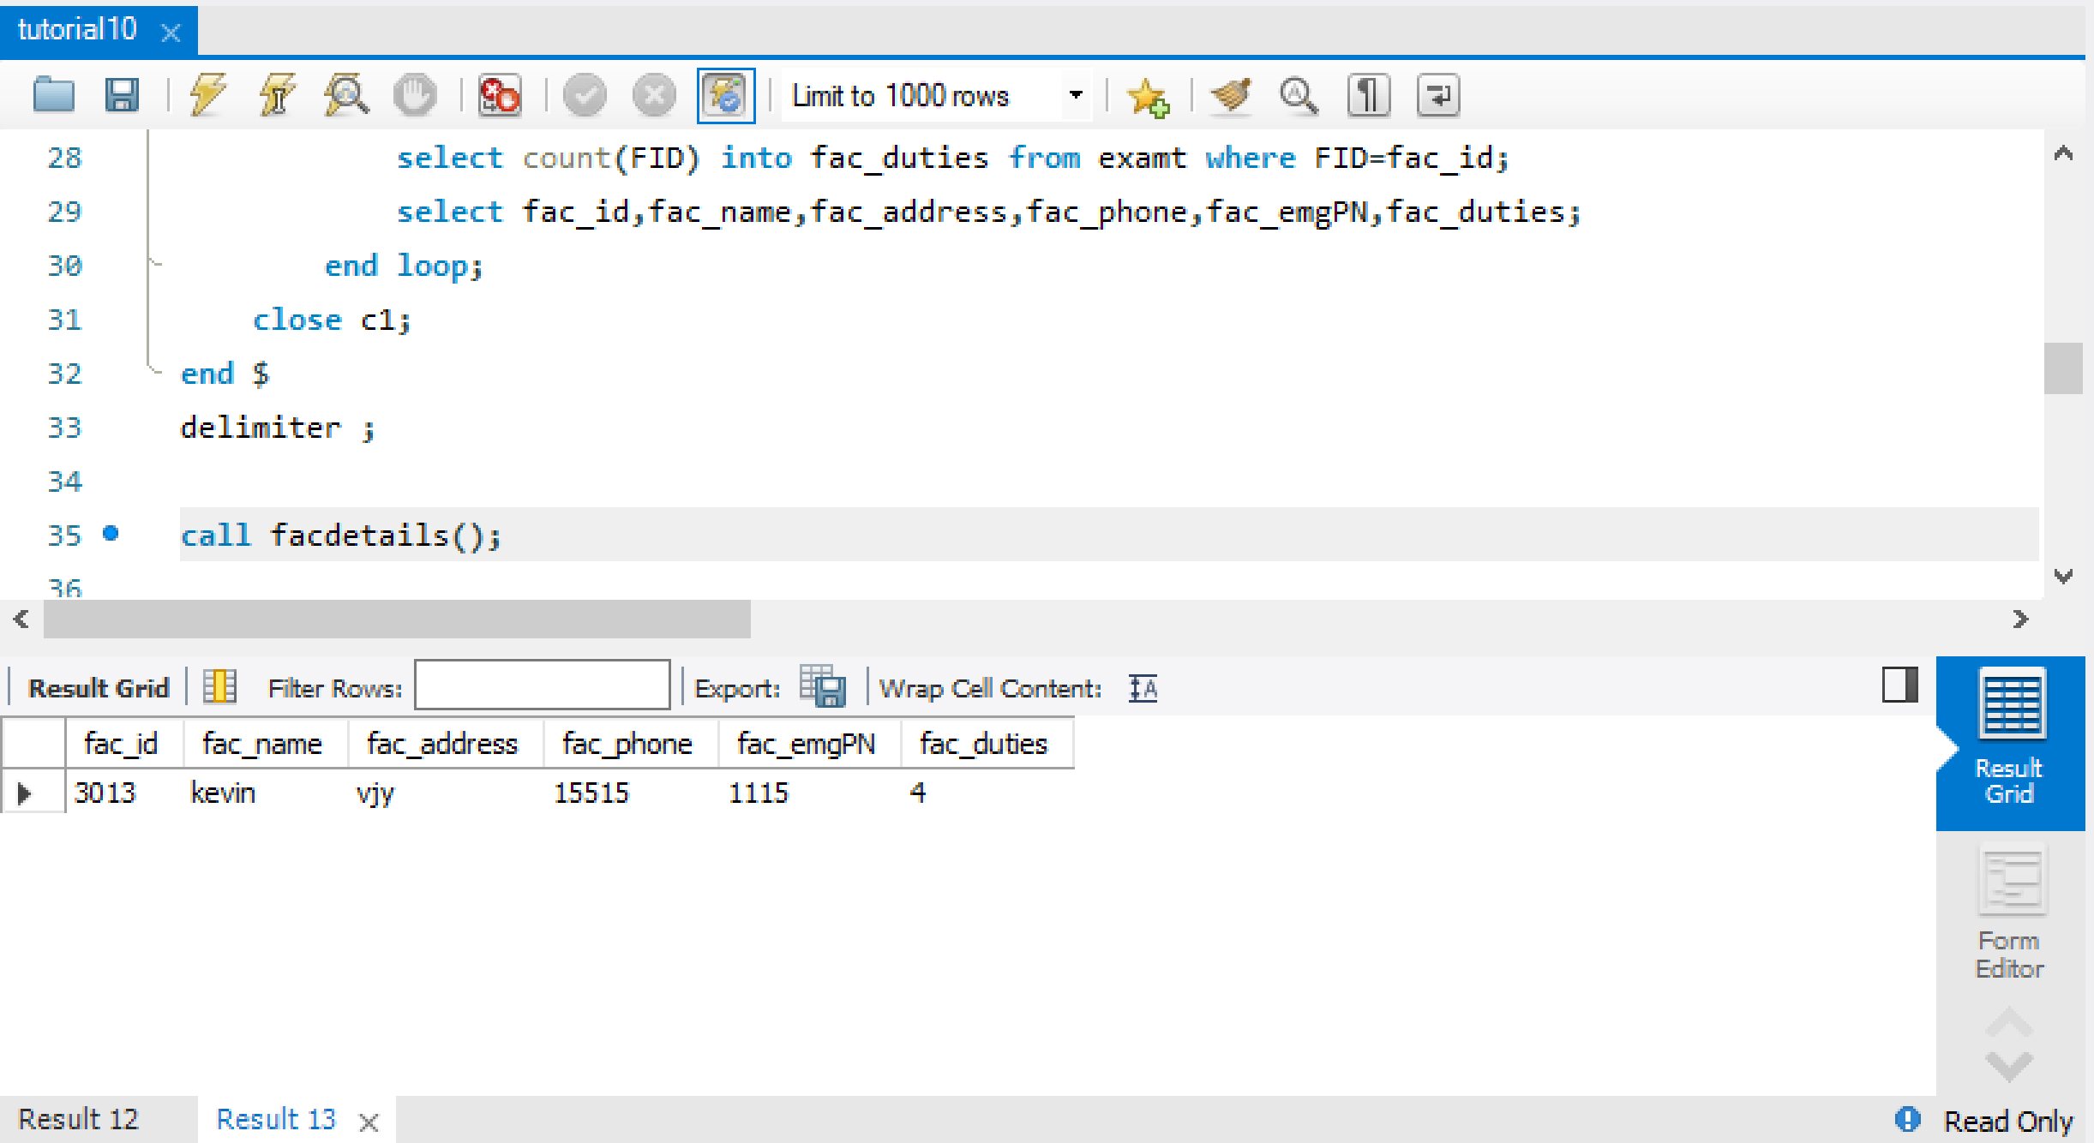

1. Create a cursor to display the examination details of a faculty doing proctoring duty.

**delimiter $@**

**create procedure fac_exam_details(fac_id int)**

**begin**

**declare fac_name varchar(25);**

**declare fac_examtype varchar(25);**

**declare fac_examdate date;**

**declare fac_examcoursecode int;**

**declare fac_finished int default 0;**

**declare c1 cursor for select CID,examtype,dte from examt where FID=fac_id;**

**declare continue handler for not found set fac_finished=1;**

**open c1;**

**fac_ext:loop**

**fetch c1 into fac_examcoursecode,fac_examtype,fac_examdate;**

**if(fac_finished=1) then**

**leave fac_ext;**

**end if;**

**select name into fac_name from fac where FID=fac_id;**

**select fac_id,fac_name,fac_examtype,fac_examdate,fac_examcoursecode;**

**end loop;**

**close c1;**

**end $@**

**delimiter ;**

**call fac_exam_details(3012);**

