**Tutorial – 12: Normalization**

Consider a relation *vehicle-rent* with attributes *vehicle-rent* (c_id, name, city, pin-code, vehicle-requested, request-date, return-date), which stores the details of the vehicles booked by a customer. Each customer is identified by a unique id (c_id). Customers can request multiple vehicles simultaneously, but they can place only single request in a day. A sample instance of the relation is as shown below (**use only the given instance to derive the FDs**):

|  |  |  |  |  |  |  |
| --- | --- | --- | --- | --- | --- | --- |
| c_id | name | city | pin-code | vehicle-requested | request-date | return-date |
| 1 | Ram | Delhi | 333001 | Sedan, Ertiga | 01/06/19 | 03/06/19 |
| 1 | Shyam | Delhi | 333001 | Jaguar | 02/06/19 | 04/06/19 |
| 2 | Arjun | Mumbai | 333031 | Sedan | 05/06/19 | 06/06/19 |
| 2 | Akash | Mumbai | 333031 | Ertiga, Mercedes | 02/06/19 | 06/06/19 |
| 3 | Vicky | Hyderabad | 333026 | Rolls Royce | 03/06/19 | 05/06/19 |

1. Identify the candidate key(s) for the relation after deriving the FDs from the above instance.

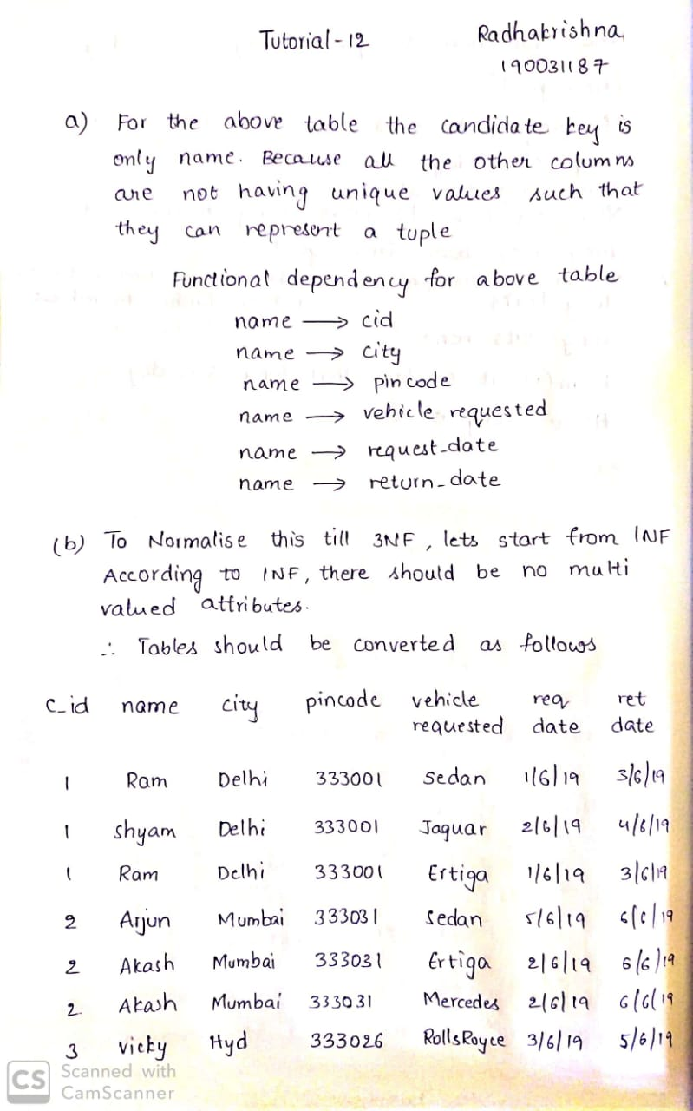

1. Normalize the relation till 3NF. Show the steps.

