**TUTORIAL -5**

**(CONTINUATION)**

1. Display the top 5 countries affected with corona virus.

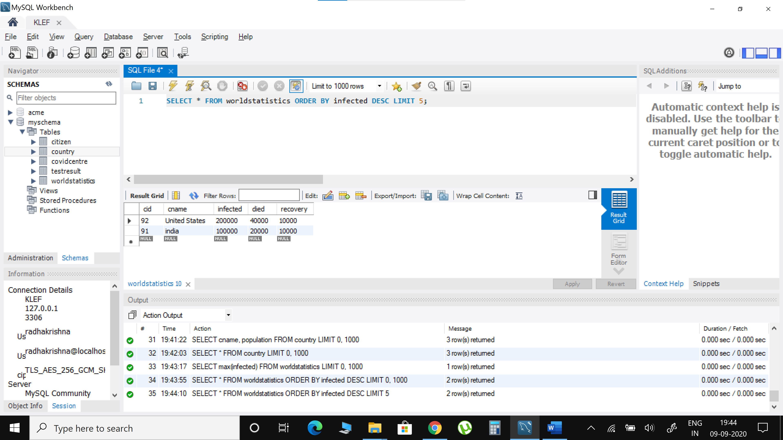

1. Display the countries with death toll above 1000

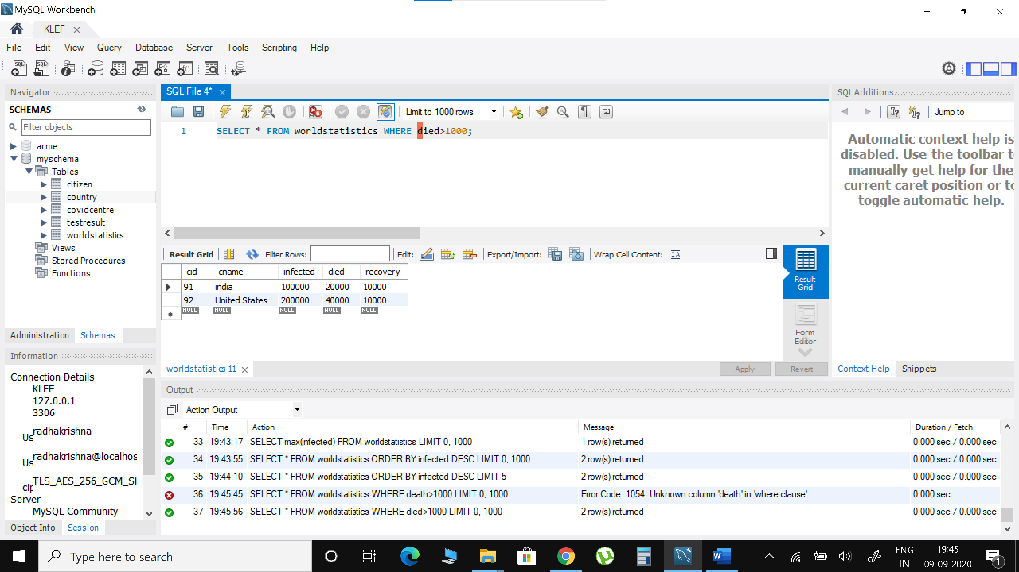

1. Display the record of all corona virus affected countries which starts with ‘United’

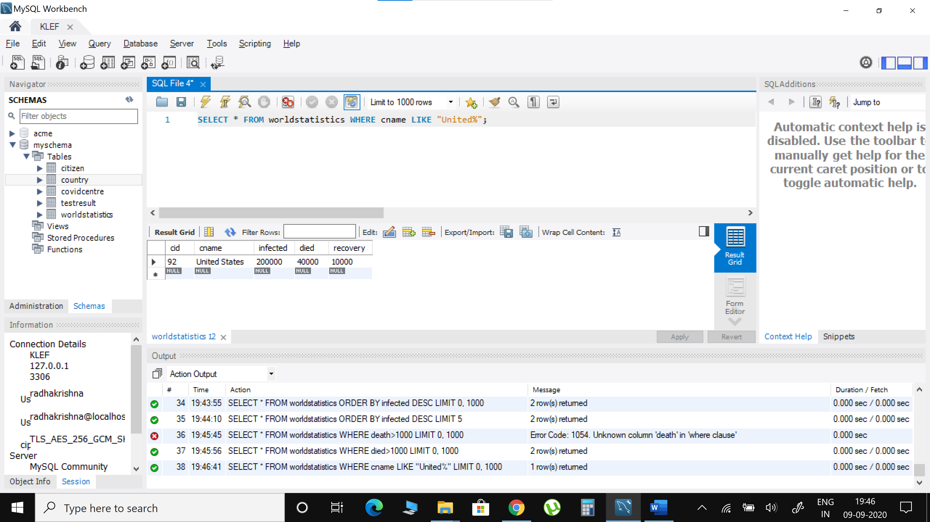

1. Display the country with highest recovery rate.

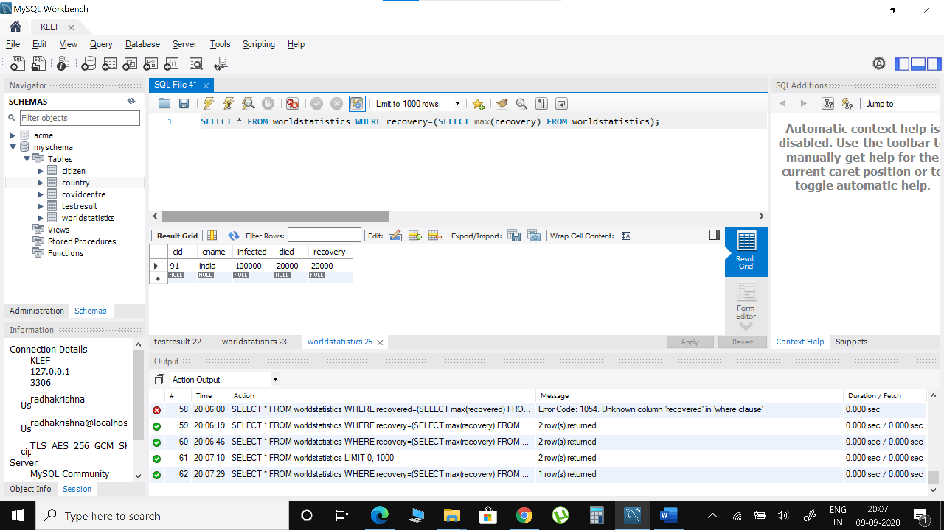

1. Discover the new cases in last 2 days

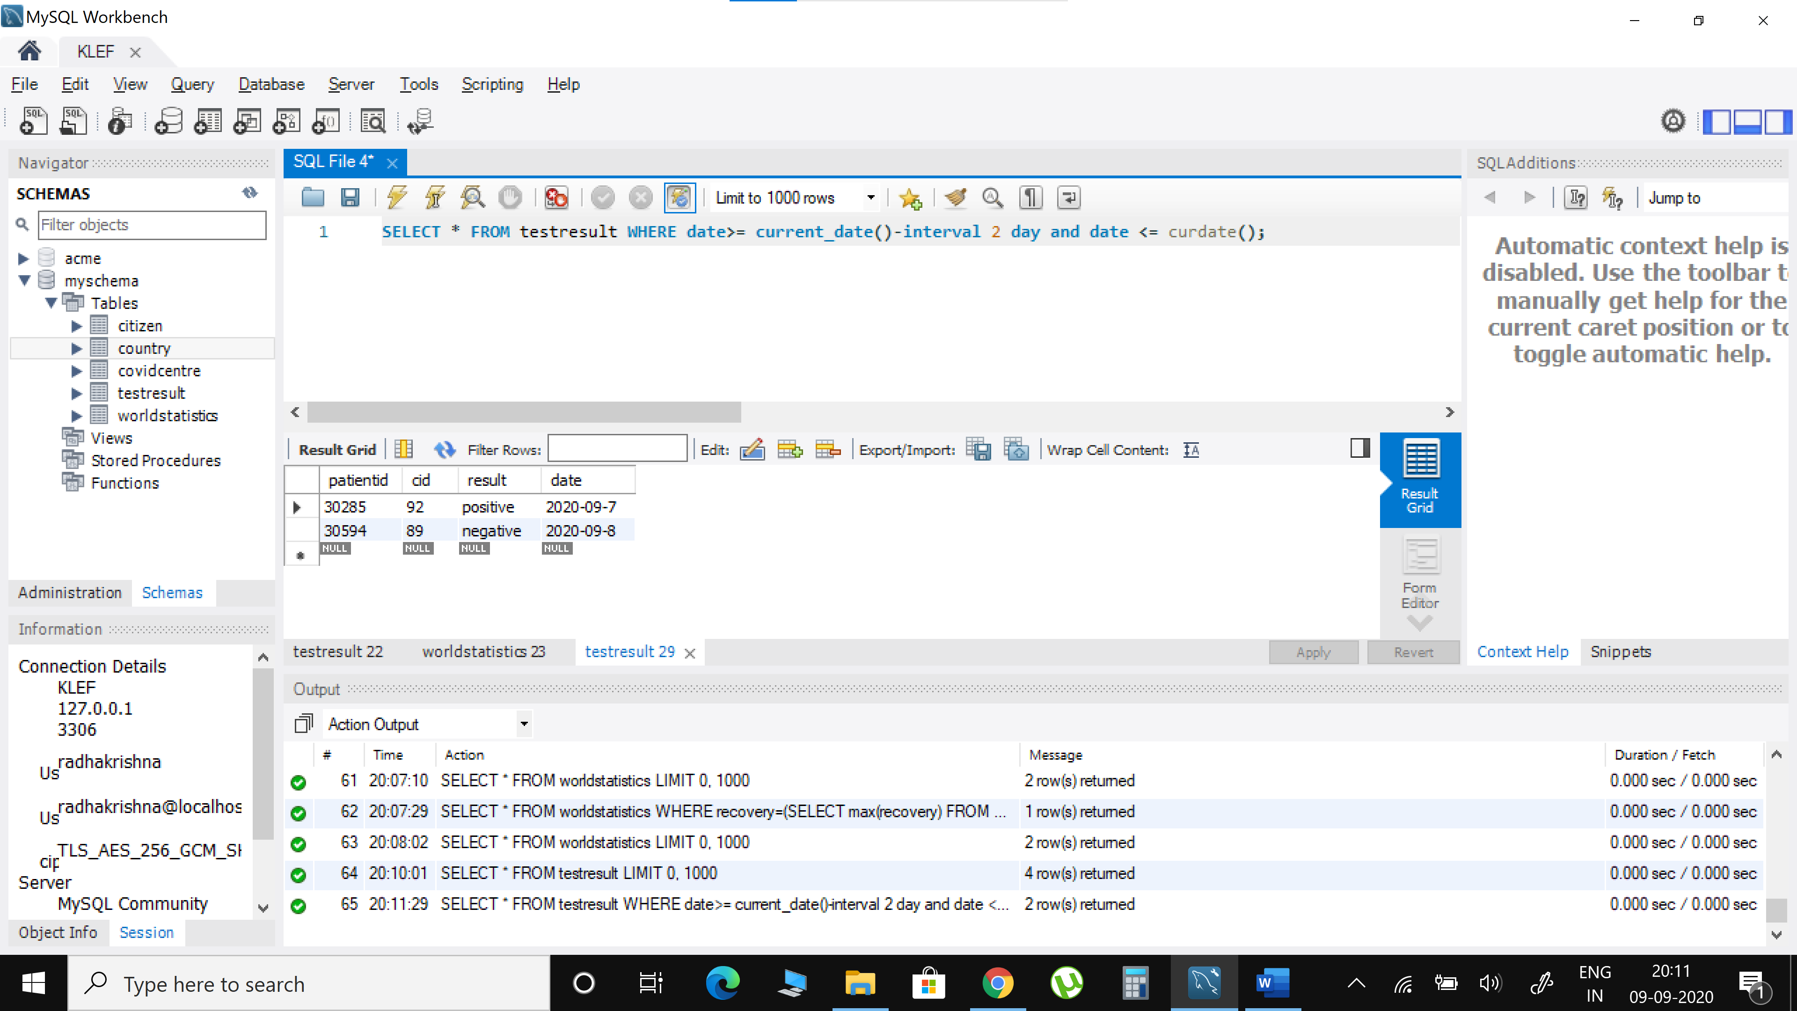

1. Display the no. of dependents based on the present corona cases in each country in ascending order

