**DBMS**

**TUTORIAL 7**

Implement Relational Algebra Expressions for all the queries on case study 1

Implement Relational Algebra Expressions for all the queries on Covid Pandemic

Country-wise Database System

1. Display the population of each country

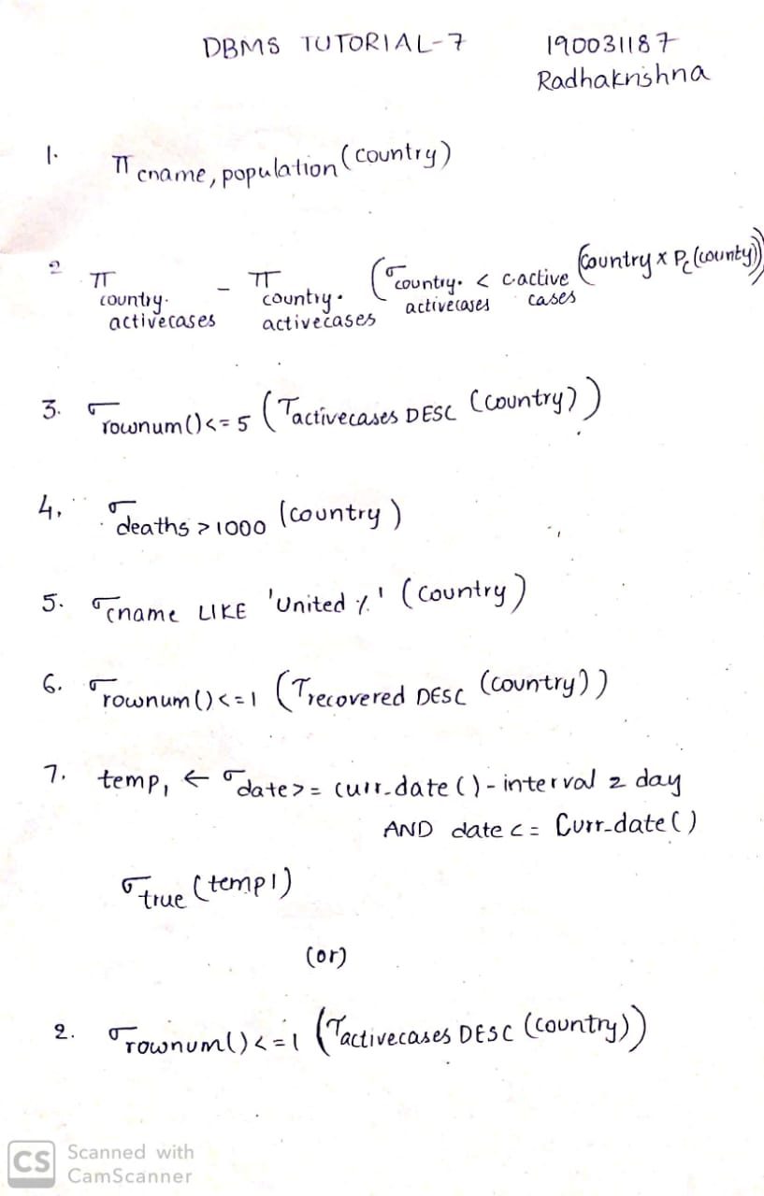

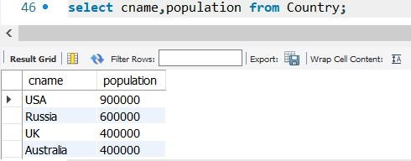

1. Show the highest number of confirmed corona virus cases in the world.





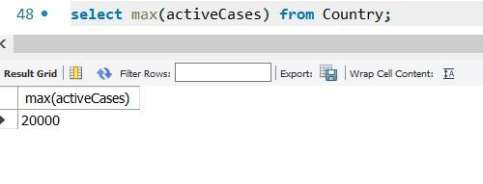

1. Display the top 5 countries affected with corona virus.

`

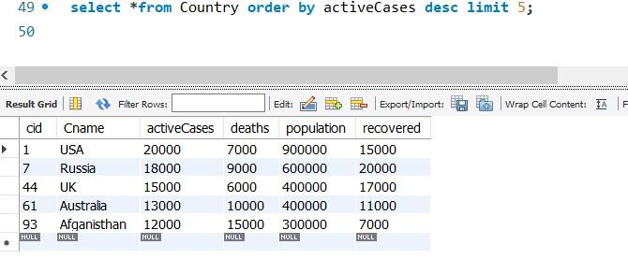

1. Display the countries with death toll above 1000



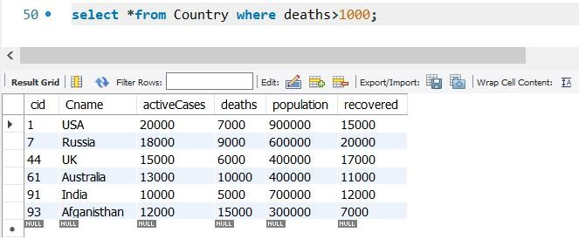

1. Display the record of all corona virus affected countries which starts with ‘United’



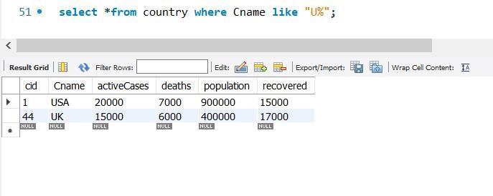

1. Display the country with highest recovery rate.



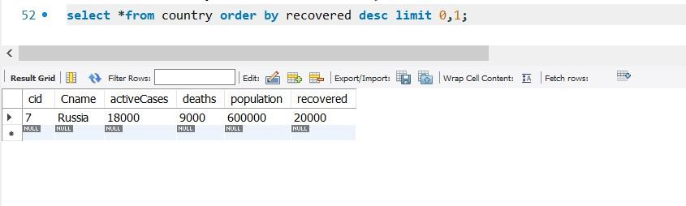

1. Discover the new cases in last 2 days



