**Tutorial – 8**

Implement Relational Algebra Expressions for all the queries on University Online Examination Scheduling system

1. **Display the number of students enrolled for exam ‘DBMS’**

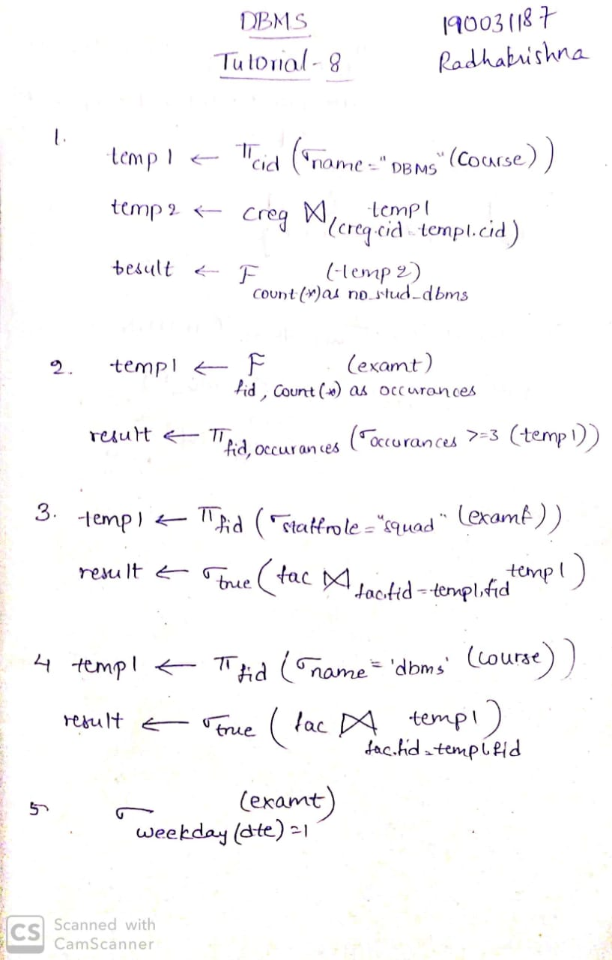

select count(*) as no_stud_dbms from creg where cid in (select cid from course where name='dbms');

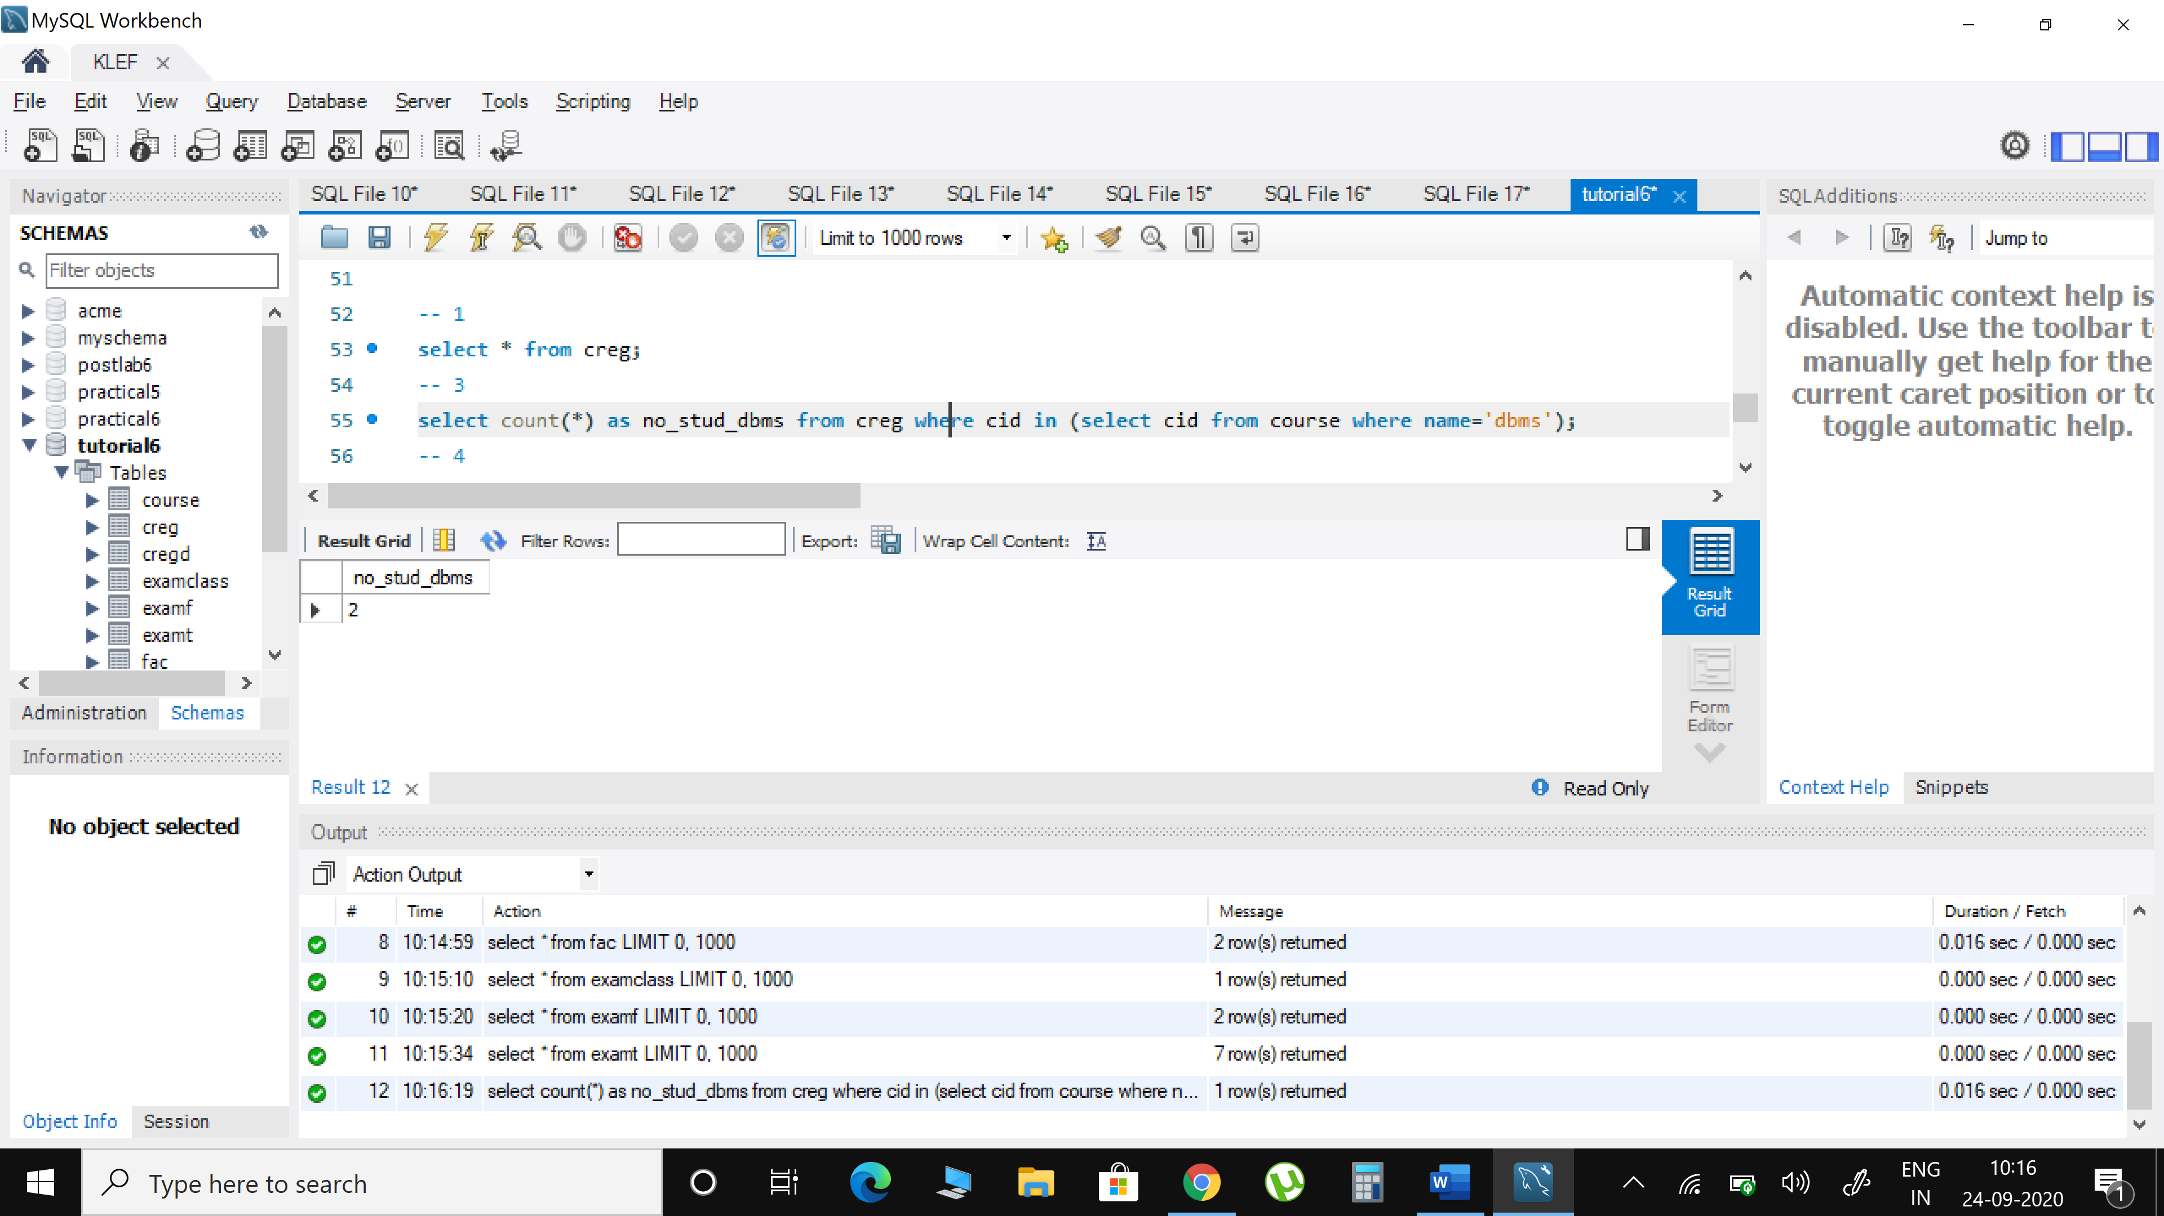

1. **Show the details of proctors having duty more than 3 times**



select * from fac where fid in (select fid from examt group by fid having count(*)>=3);

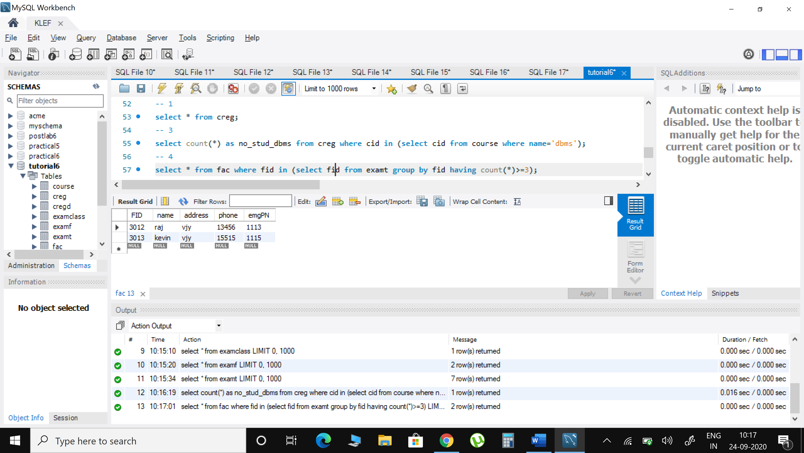

1. **Get the details of faculty working as squad**



select * from fac where fid in (select fid from examf where staffrole='squad');

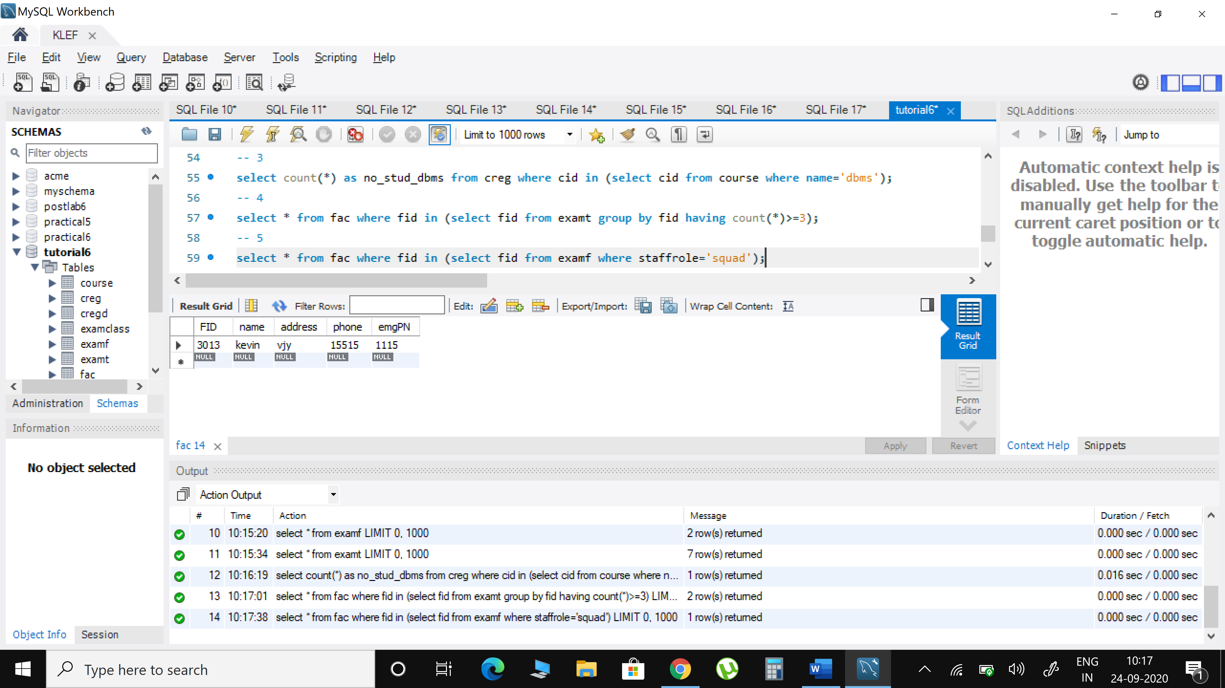

1. **Display the details of proctors and squad for exam ‘DBMS’**



select * from fac where fid in (select fid from examt where CID in (select cid from course where name='DBMS'));

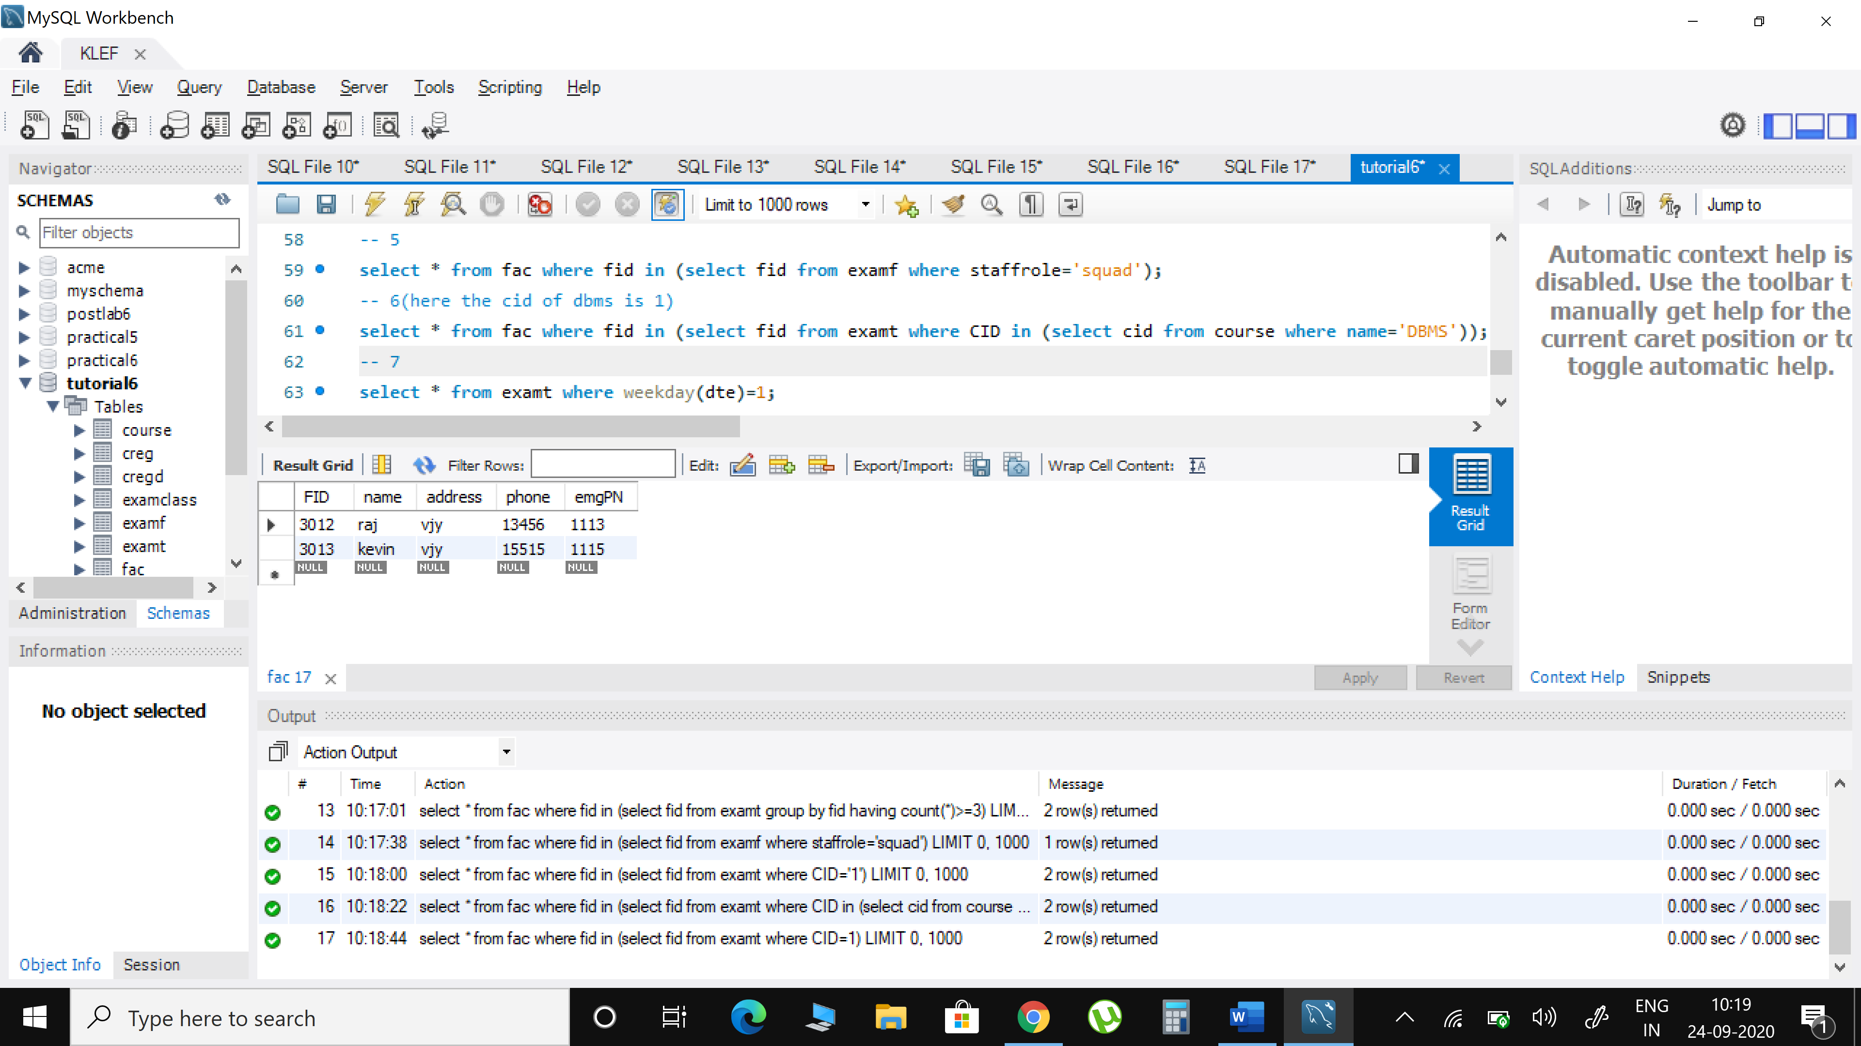

1. **Show the number of rooms allotted for each course on ‘Tuesday’**



select * from examt where weekday(dte)=1;

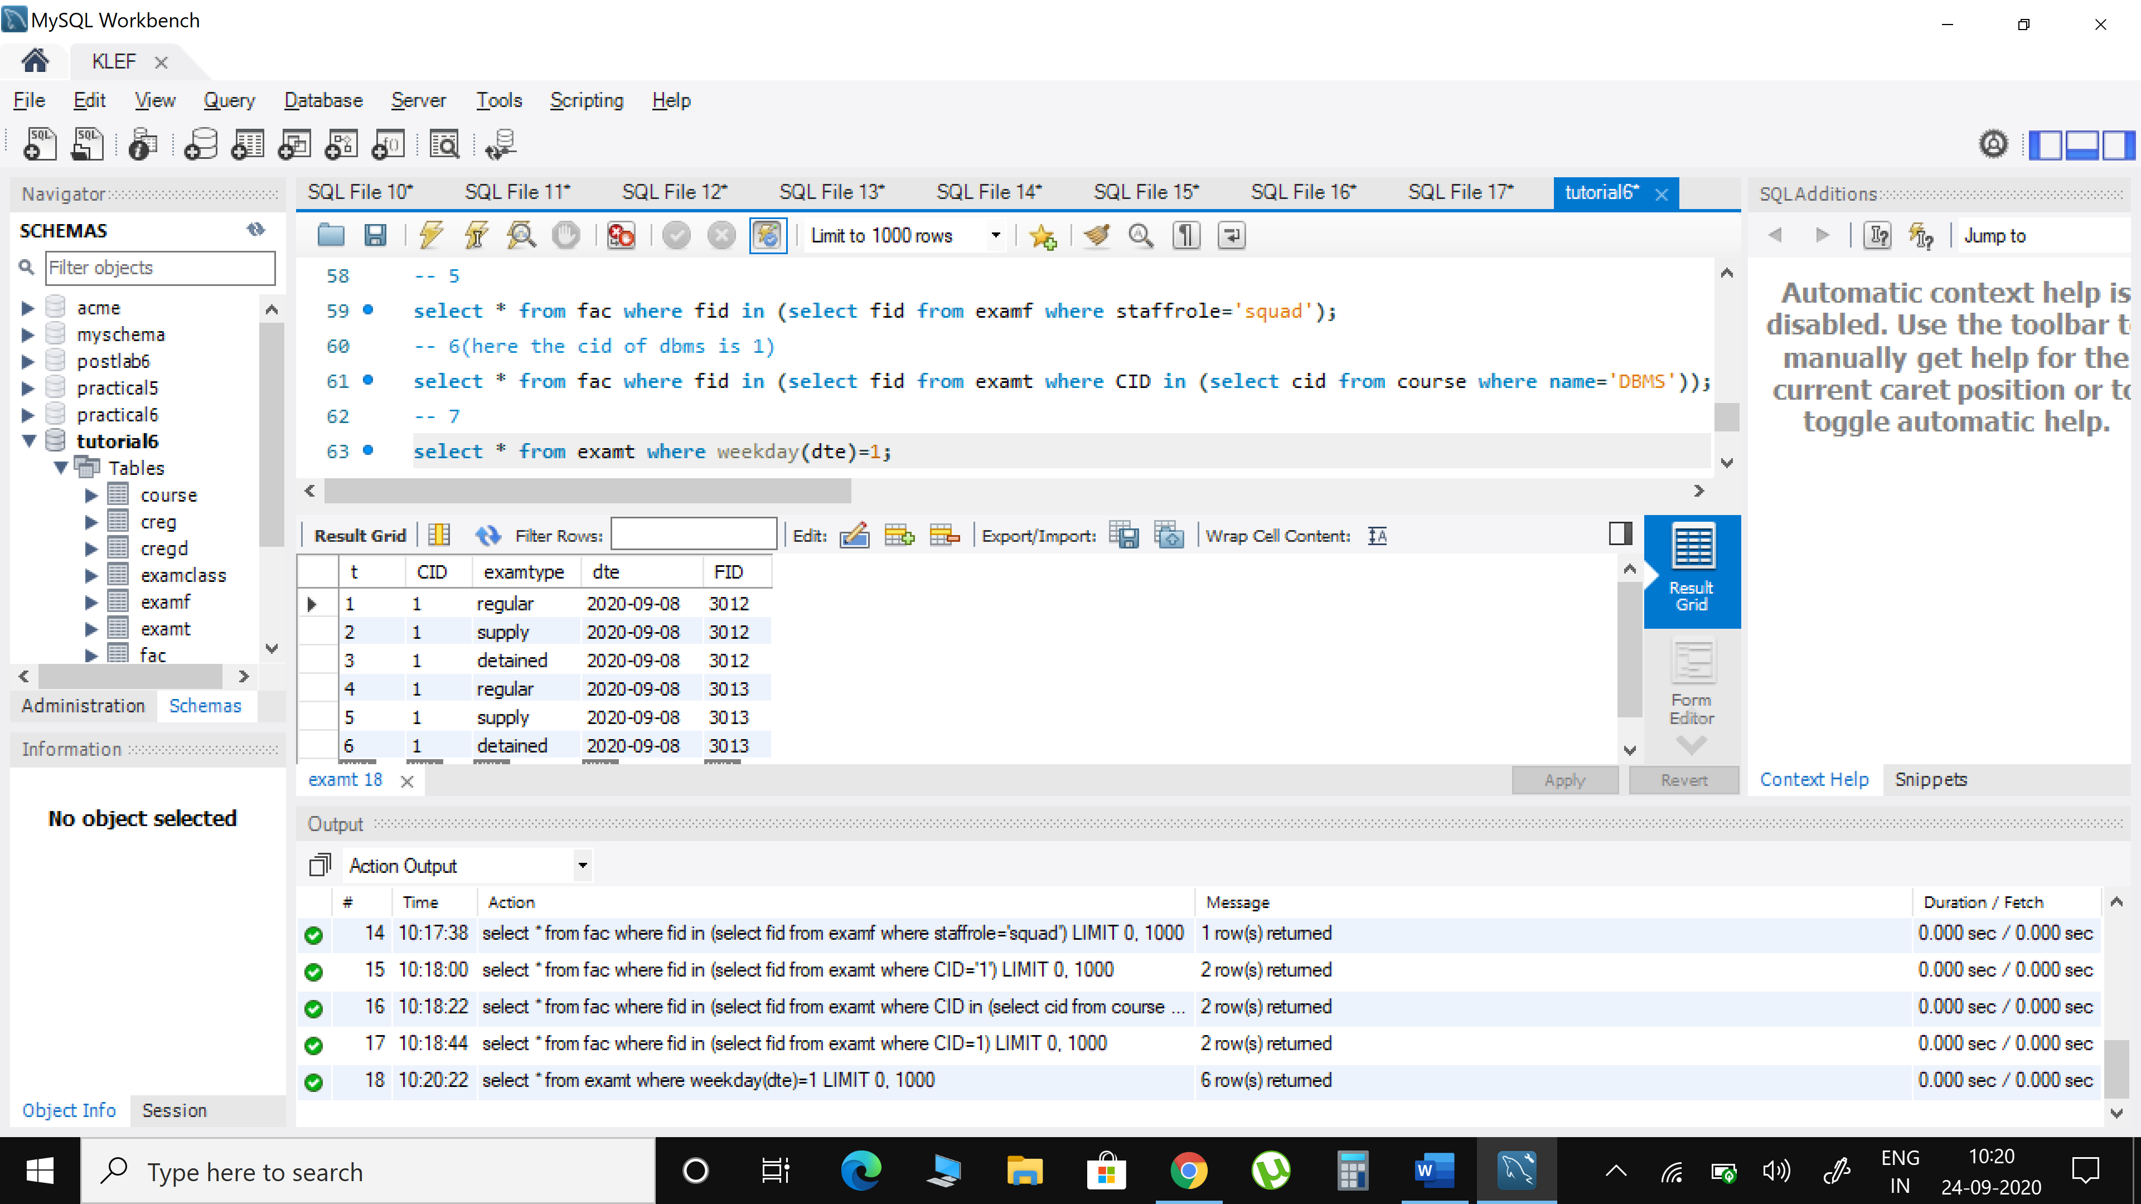

1. **Update the exam date of ‘OS’ which is postponed to 2 days after the scheduled date**

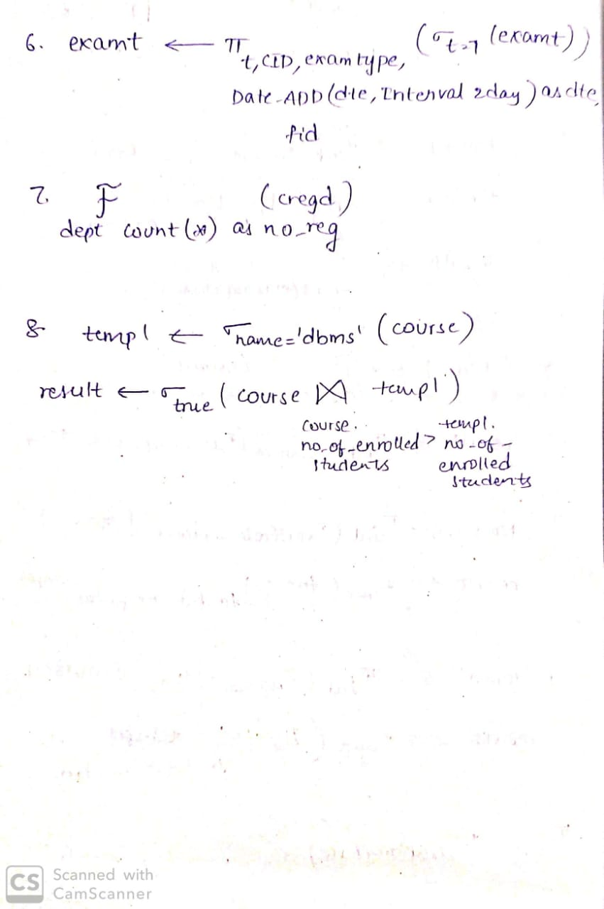

update examt set dte='2020-09-11' where cid=2 and t=7;

select * from examt where t=7;

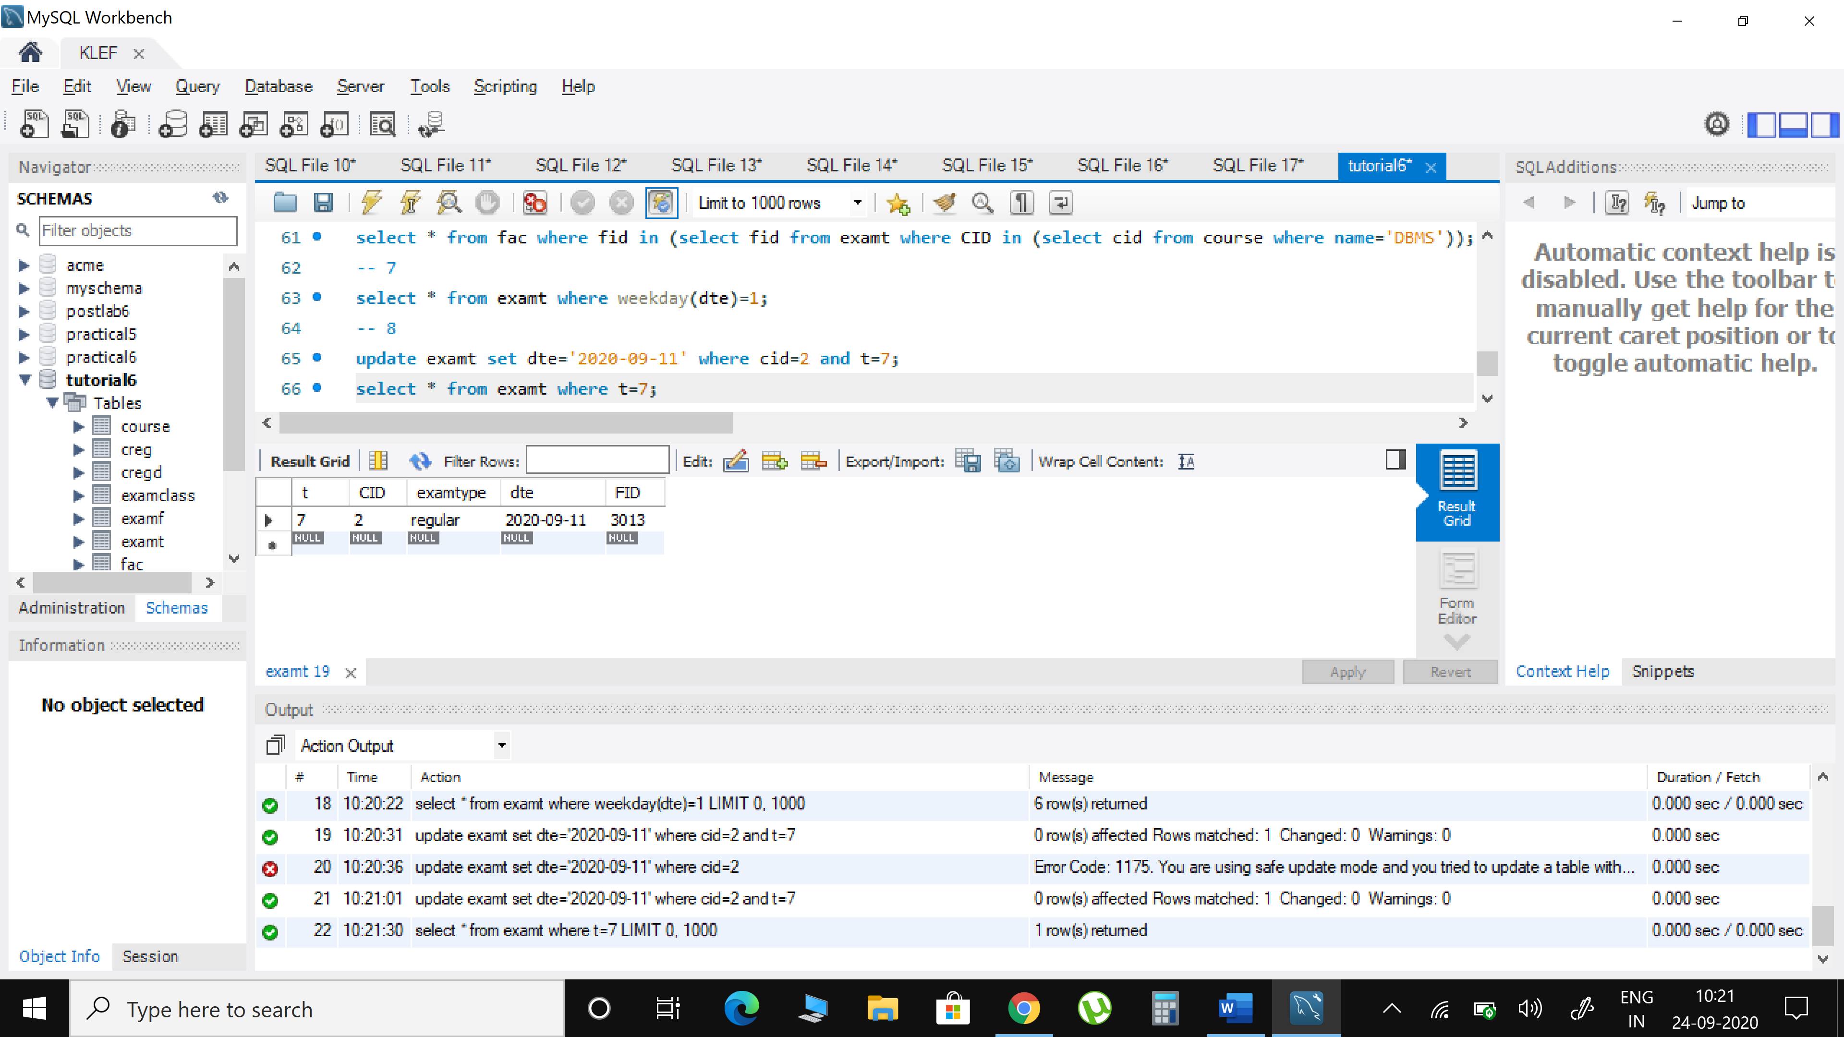

1. **Give the no. of students enrolled in each course department-wise**



select d.dept,course.name,count(*)as students_count from creg c inner join cregd d on c.SID=d.sid inner join course on c.cid=course.cid group by d.dept,c.cid;

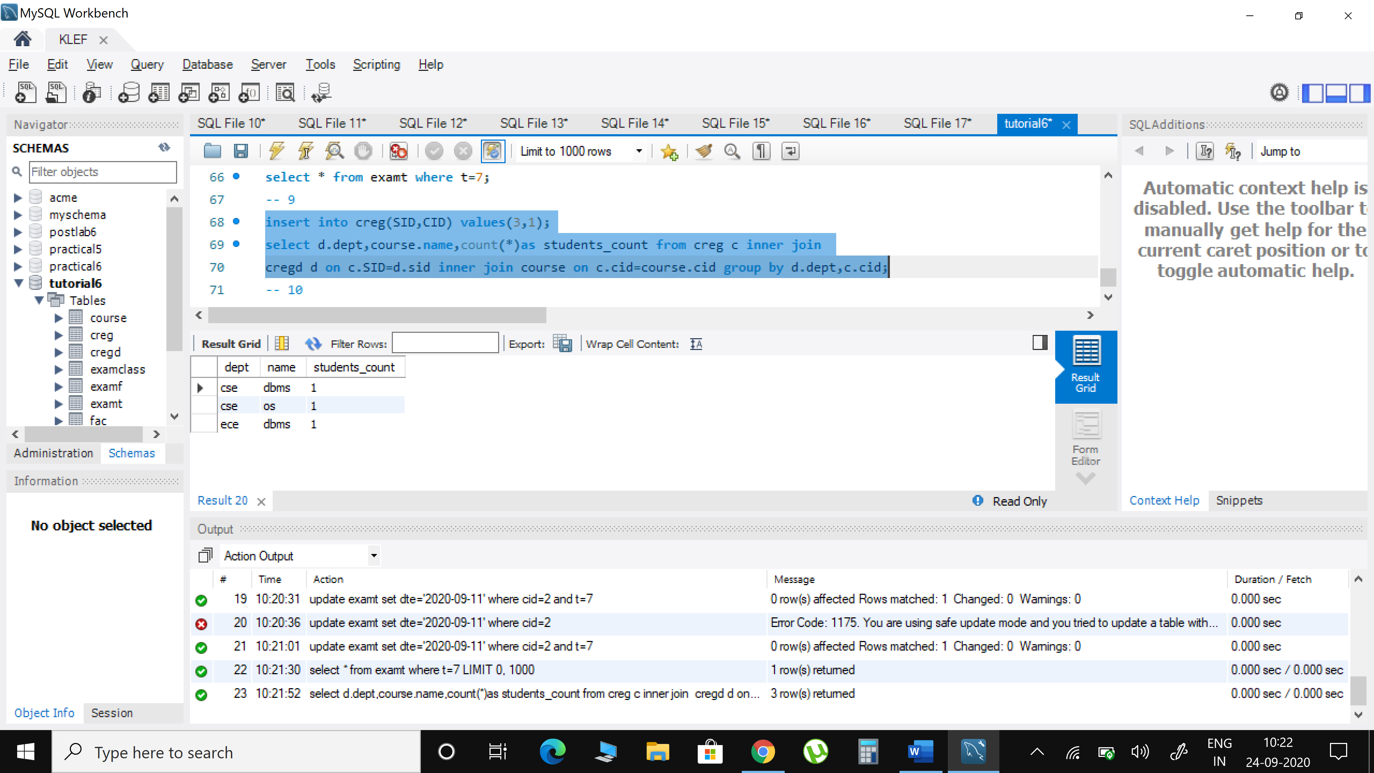

1. **Display the course details where the enrolled students are greater than the enrolled students in DBMS**



select * from creg group by cid having count(*) > (select count(*) from creg where cid in (select cid from course where name='DBMS'));

