**DBMS Tutorial – 9**

Implement the following PL/SQL programs on Covid Pandemic Country-wise Database System

1. **Create a PL/SQL program to display the details of countries**

delimiter @

create procedure countryDetails()

begin

select c.cid,c.cname,c.population,w.infected,w.died,w.recoverd from country c,worldstatistics w where w.cid=c.cid;

end @

delimiter ;

call countryDetails();

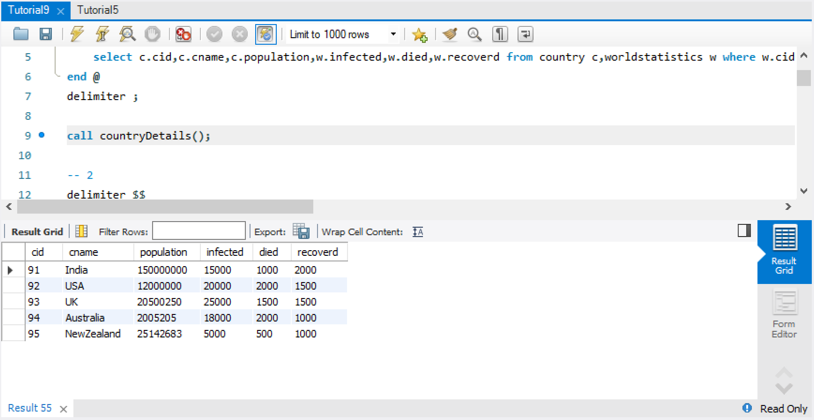

1. **Create a Cursor to display corona virus affected countries with no. of cases and death toll**

delimiter $$

create procedure CasesDetails()

begin

declare ctyname varchar(20);

declare cases int;

declare death int;

declare c_finished int default 0;

declare c1 cursor for select cname,infected,died from worldstatistics;

declare continue handler for not found set c_finished=1;

open c1;

c_details:loop

fetch c1 into ctyname,cases,death;

if c_finished=1 then

leave c_details;

end if;

select concat(ctyname,',',cases,',',death) as country_Details;

end loop c_details;

close c1;

end $$

delimiter ;

call CasesDetails();

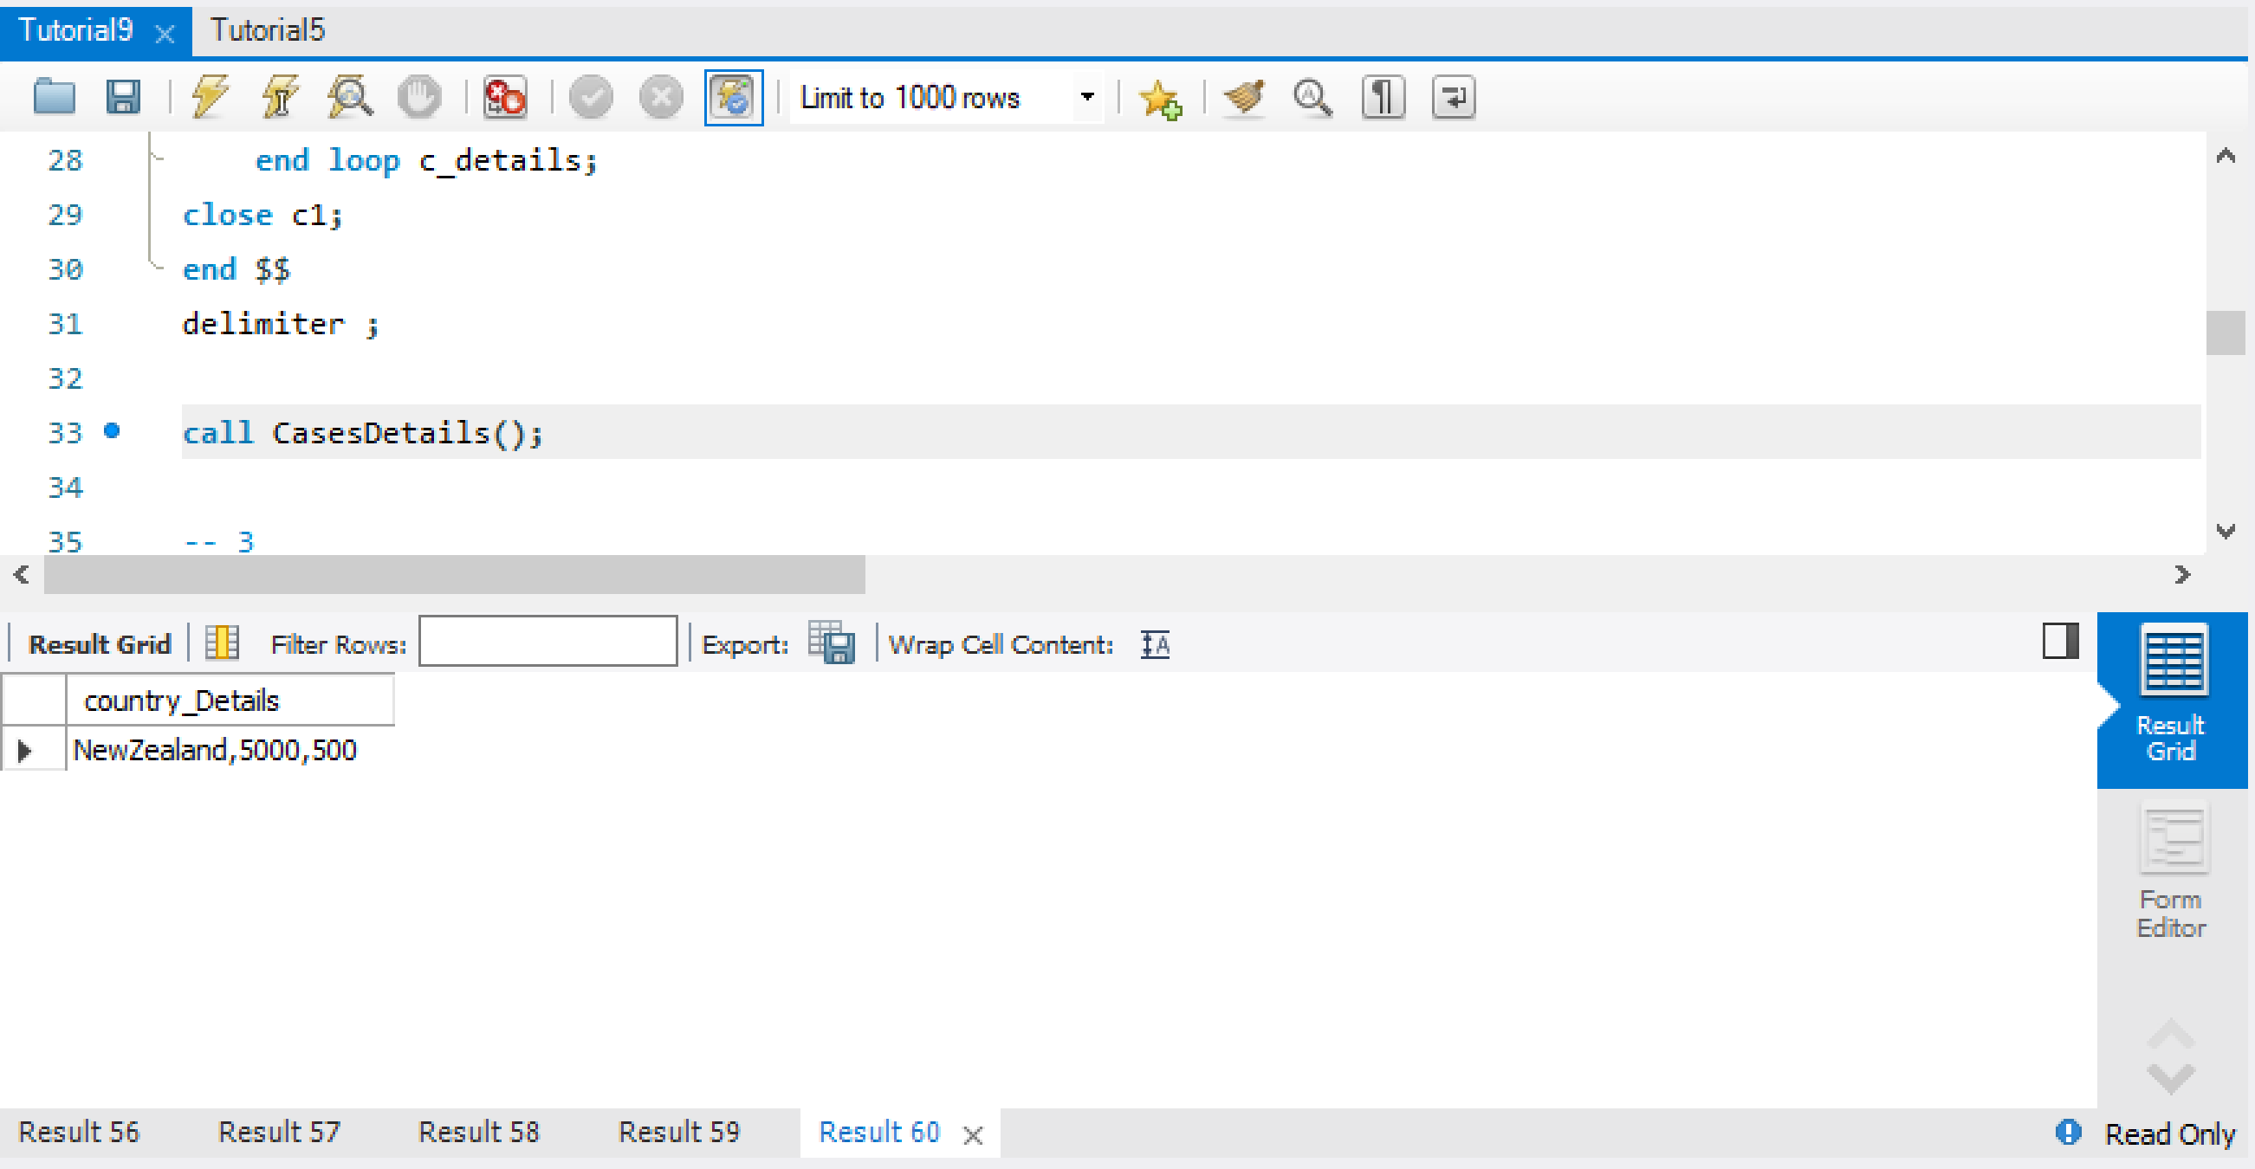

1. **Create a trigger to insert patient details into CASES table whenever the person status in PERSON table changes from Negative to Positive.**

create table cases(ssn int,cid int,name varchar(20),result varchar(20),date varchar(20),status varchar(20),changed_At TIMESTAMP NOT NULL DEFAULT CURRENT_TIMESTAMP);

delimiter @@

create trigger addPatientLog after update on person

for each row

begin

if OLD.result='Negative' and NEW.result='Positive' then

insert into cases values(OLD.ssn,OLD.cid,OLD.name,NEW.result,OLD.date,OLD.status,current_timestamp);

end if;

end @@

delimiter ;

update person set result="positive" where ssn=2;

select * from cases;

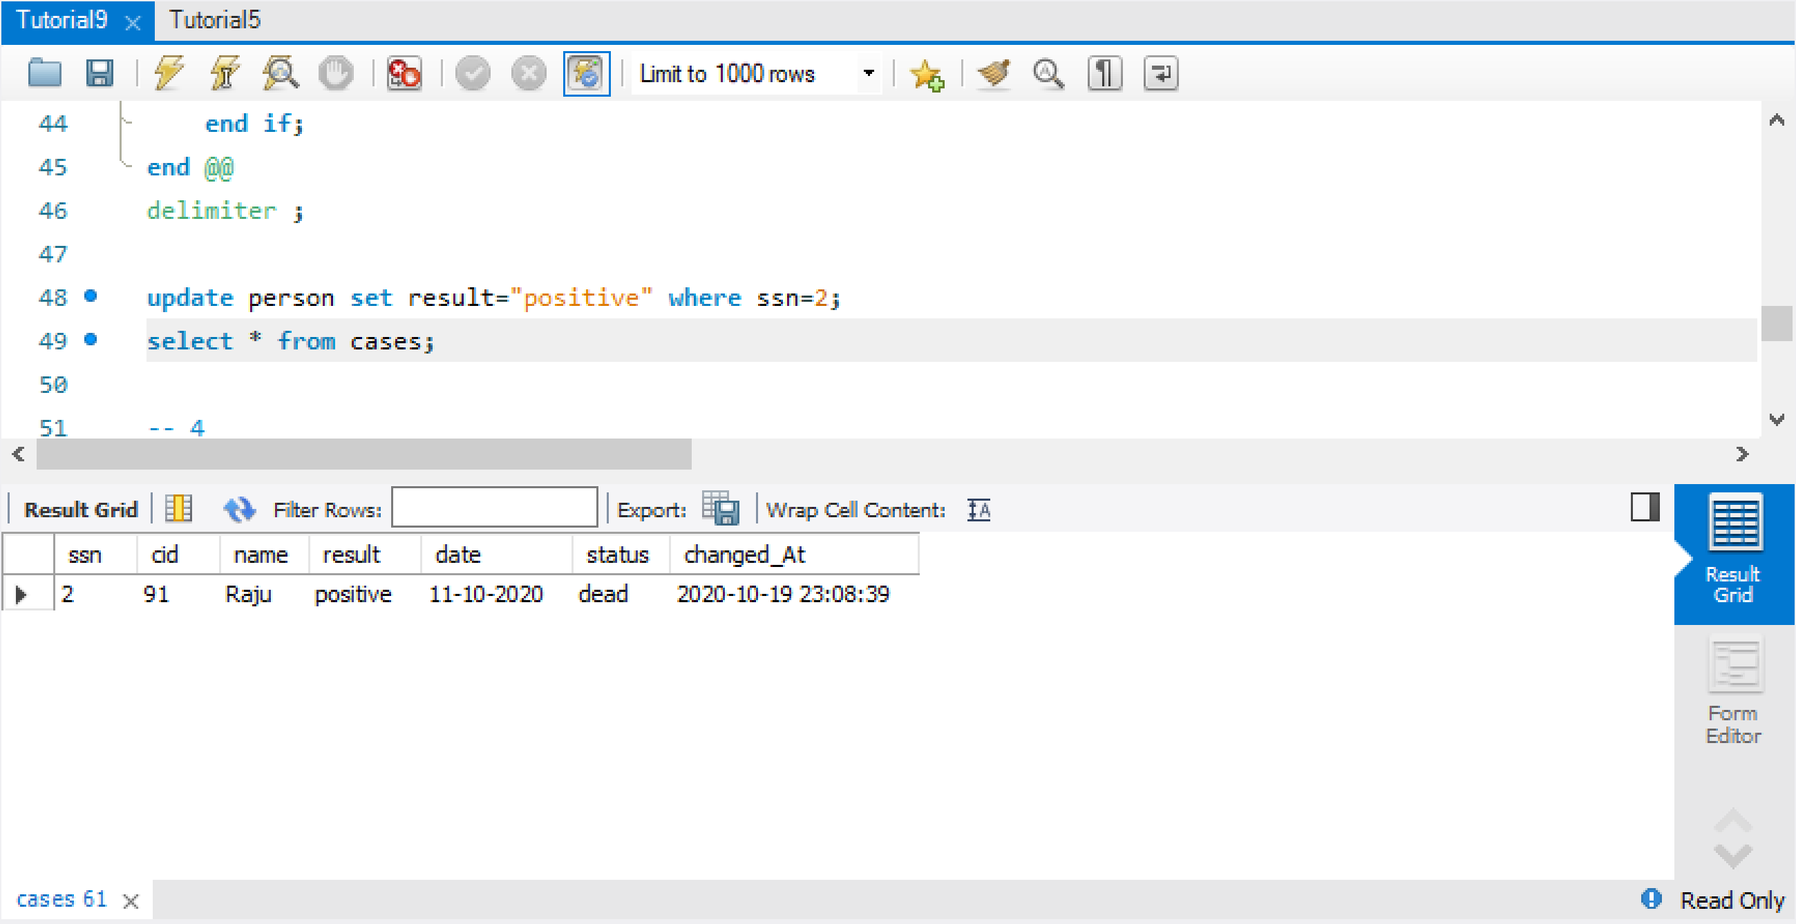

1. **Create a trigger to store the person details whose status is dead.**

create table personlog(ssn int,cid int,name varchar(20),result varchar(20),date varchar(20),status varchar(20),changedAt TIMESTAMP NOT NULL DEFAULT CURRENT_TIMESTAMP);

delimiter $

create trigger addPersonLog after insert on person

for each row

begin

if NEW.status = 'dead' then

insert into personlog values(NEW.ssn,NEW.cid,NEW.name,NEW.result,NEW.date,NEW.status,current_timestamp());

end if;

end $

delimiter ;

insert into person values(13,95,'akhil','positive','12-10-2020','dead');

select * from personlog;

