**Question-7**

**Class Diagram**

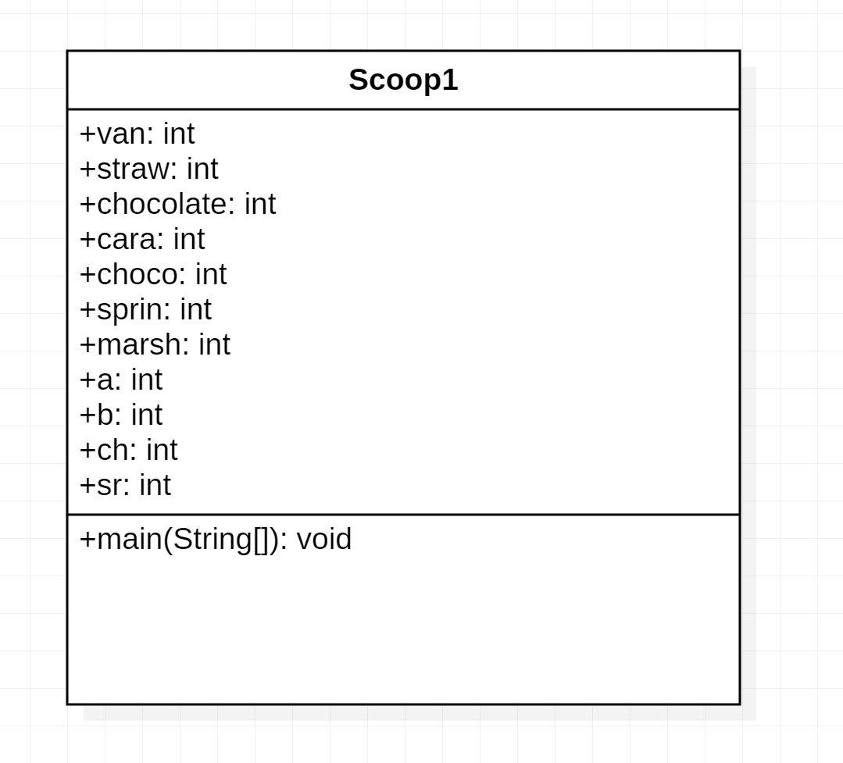

**Code**

**Package** exam2;

**import** java.util.*;

**public** **class** scoop1

{

**public** **static** **void** main(String[] args)

{

Scanner sc=**new** Scanner(System.***in***);

**int** van=50;

**int** straw=60;

**int** chocolate=70;

**int** cara=20;

**int** choco=30;

**int** sprin=40;

**int** marsh=50;

**int** a=0,b=0;

System.***out***.println("Select the option for required ice-cream");

System.***out***.println("1-Vanilla");

System.***out***.println("2-Strawberry");

System.***out***.println("3-Chocolate");

**int** opt=sc.nextInt();

**if**(opt==1)

{

a=50;

**int** x=0;

**while**(**true**)

{

System.***out***.println("Select the required topping");

System.***out***.println("1-Caramel");

System.***out***.println("2-Choco-Chips");

System.***out***.println("3-Sprinkles");

System.***out***.println("4-Marsh Mellow");

System.***out***.println("5-Thats all for me");

**int** ch=sc.nextInt();

**if**(ch==5)

**break**;

System.***out***.println("Enter number of Servings");

**int** sr=sc.nextInt();

**if**(ch==1)

b=b+sr*cara;

**else** **if**(ch==2)

b=b+sr*choco;

**else** **if**(ch==3)

b=b+sr*sprin;

**else** **if**(ch==4)

b=b+sr*marsh;

}

b=a+b;

}

**else** **if**(opt==2)

{

a=60;

**while**(**true**)

{

System.***out***.println("Select the required topping");

System.***out***.println("1-Caramel");

System.***out***.println("2-Choco-Chips");

System.***out***.println("3-Sprinkles");

System.***out***.println("4-Marsh Mellow");

System.***out***.println("5-Thats all for me");

**int** ch=sc.nextInt();

**if**(ch==5)

**break**;

System.***out***.println("Enter number of Servings");

**int** sr=sc.nextInt();

**if**(ch==1)

b=b+sr*cara;

**else** **if**(ch==2)

b=b+sr*choco;

**else** **if**(ch==3)

b=b+sr*sprin;

**else** **if**(ch==4)

b=b+sr*marsh;

}

b=a+b;

**if**(opt==3)

{

a=70;

**while**(**true**)

{

System.***out***.println("Select the required topping");

System.***out***.println("1-Caramel");

System.***out***.println("2-Choco-Chips");

System.***out***.println("3-Sprinkles");

System.***out***.println("4-Marsh Mellow");

System.***out***.println("5-Thats all for me");

**int** ch=sc.nextInt();

**if**(ch==5)

**break**;

System.***out***.println("Enter number of Servings");

**int** sr=sc.nextInt();

**if**(ch==1)

b=b+sr*cara;

**else** **if**(ch==2)

b=b+sr*choco;

**else** **if**(ch==3)

b=b+sr*sprin;

**else** **if**(ch==4)

b=b+sr*marsh;

}

b=a+b;

}

}

System.***out***.println("Total cost for the Ice-Cream is"+b);

}

}