**Question-5**

**Class Diagram**

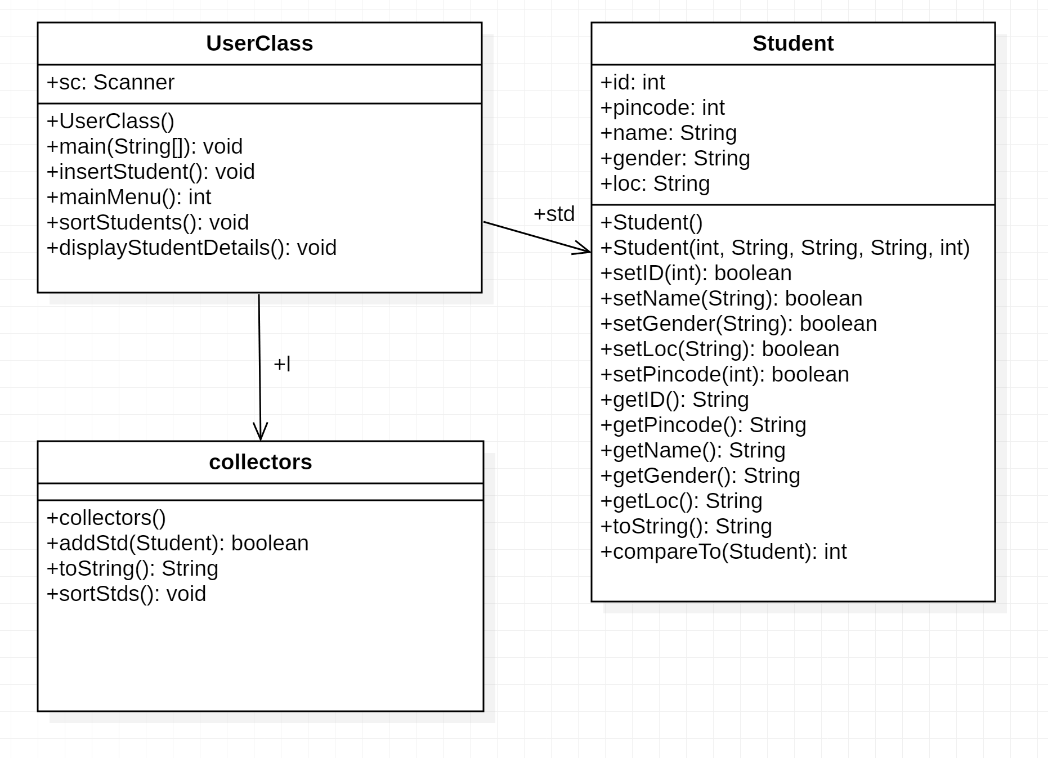

**Code**

**package** entity;

**public** **class** Student **implements** Comparable<Student>{

**private** **int** id,pincode;

**private** String name,gender,location;

**private** Student() {

**this**.id=0;

**this**.name="xxx";

**this**.gender="male";

**this**.location="xxx";

**this**.pincode=0;

}

**public** Student(**int** id,String name,String gender,String location,**int** pincode) {

**this**();

**this**.setId(id);

**this**.setName(name);

**this**.setGender(gender);

**this**.setLocation(location);

**this**.setPincode(pincode);

}

**public** **boolean** setId(**int** id) {

**if**(id>0) {

**this**.id=id;

**return** **true**;

}

**return** **false**;

}

**public** **boolean** setName(String name) {

**if**(!name.isEmpty() && name!=**null**) {

**this**.name=name;

**return** **true**;

}

**return** **false**;

}

**public** **boolean** setGender(String gender) {

**if**(!gender.isEmpty() && gender!=**null**) {

**this**.gender=gender;

**return** **true**;

}

**return** **false**;

}

**public** **boolean** setLocation(String location) {

**if**(!location.isEmpty() && location!=**null**) {

**this**.location=location;

**return** **true**;

}

**return** **false**;

}

**public** **boolean** setPincode(**int** pincode) {

**if**(pincode>0) {

**this**.pincode=pincode;

**return** **true**;

}

**return** **false**;

}

**public** String getId() {

**return** Integer.*toString*(**this**.id);

}

**public** String getPincode() {

**return** Integer.*toString*(**this**.pincode);

}

**public** String getName() {

**return** **this**.name.toUpperCase();

}

**public** String getGender() {

**return** **this**.gender.toUpperCase();

}

**public** String getLocation() {

**return** **this**.location.toUpperCase();

}

**public** String toString() {

String out ="";

out+=String.*format*("Id = %s %n", **this**.getId());

out+=String.*format*("Name = %s %n", **this**.getName());

out+=String.*format*("Gender: %s %n", **this**.getGender());

out+=String.*format*("Location: %s %n", **this**.getLocation());

out+=String.*format*("Pincode: %s %n", **this**.getPincode());

**return** out;

}

**public** **int** compareTo(Student s) {

**int** c=s.getPincode().compareTo(**this**.getPincode());

**if**(c==0) {

c=**this**.getName().compareTo(s.getName());

**if**(c==0) {

c=s.getId().compareTo(**this**.getId());

}

}

**return** c;

}

}

**package** collector;

**import** entity.Student;

**import** java.util.*;

**public** **class** collectors {

**private** ArrayList<Student> std;

**public** collectors() {

std=**new** ArrayList<Student>();

}

**public** **boolean** addStudent(Student s) {

**if**(s!=**null**) {

std.add(s);

**return** **true**;

}

**return** **false**;

}

**public** String toString() {

String out="";

**for**(Student s:std) {

out+=s.toString();

}

**return** out;

}

**public** **void** sortStudents() {

Collections.*sort*(std);

}

}

**package** enduser;

**import** entity.Student;

**import** java.util.Scanner;

**import** collector.collectors;

**public** **class** UserClass {

**private** **static** Scanner *sc* = **new** Scanner(System.***in***);

collectors l1 =**new** collectors();

**public** **static** **void** main(String[] args) {

UserClass u=**new** UserClass();

**boolean** repeat = **true**;

**while**(repeat) {

**switch**(u.mainMenu()) {

**case** 1: u.insertStudent();

**break**;

**case** 2: u.displayStudentDetails();

**break**;

**case** 3: u.sortStudents();

**break**;

**default**: repeat = **false**;

}

}

}

**public** **void** insertStudent() {

System.***out***.println("Enter Student Id");

**int** id=*sc*.nextInt();

System.***out***.println("Enter Student Name");

String name=*sc*.next();

System.***out***.println("Enter Student Gender");

String gender=*sc*.next();

System.***out***.println("Enter Student Location");

String location=*sc*.next();

System.***out***.println("Enter Student Pincode");

**int** pincode=*sc*.nextInt();

Student s = **new** Student(id,name,gender,location,pincode);

l1.addStudent(s);

}

**public** **int** mainMenu() {

System.***out***.println("1.Add Student");

System.***out***.println("2.Display Students");

System.***out***.println("3.Sort Students");

System.***out***.println("Enter any other number to exit");

**return** *sc*.nextInt();

}

**public** **void** sortStudents() {

l1.sortStudents();

System.***out***.println("*****Sorted by Name and Location*****");

}

**public** **void** displayStudentDetails() {

System.***out***.println(l1);

}

}