***Covid-19 Tracing System***

We all know that the world has been shaken by the Pandemic COVID-19 which has infected millions of people and affected all the humanity stature. And the governments are trying their level best in controlling the situations. But in India with a population of over 1.3 billon it’s difficult to keep track of details.

So Design a Project to track the details of State situation with regarding to Covid-19. Create a State Class and store details of Group of States where each State contains the following details ->

1. Name of the State.

2. Zone (RED, GREEN, YELLOW) depicting the severity.

3. Number of Positive Cases Registered.

4. Number of Deaths Registered**.**

Design two different console based programs for Citizen of State and Government Officials.

Design the Citizen’s Console as Citizen can check what the status of the states is and act accordingly. Collect details of Citizen and should have the features to check his State’s Status and details of it.

And for the Government Officials to access the State information can enter new State details, update the details. In order to access the Government Official Console provides a prefixed password so that only they can access these features.

**+** Use modularization techniques and also unit-test case development while building the project.

1. Draw the Use Case Diagrams

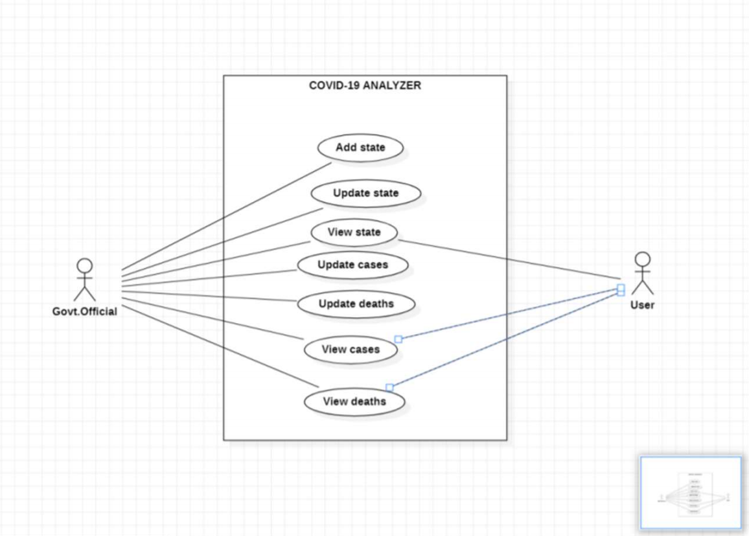

2. Draw the Class Diagrams.

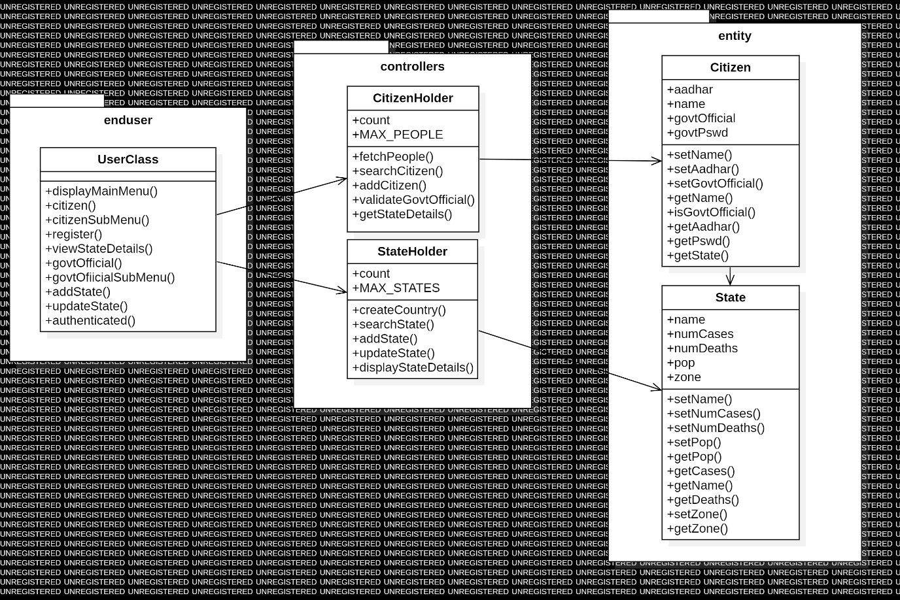

3. Code of the project.

CITIZENHOLDER CLASS

**package** controllers;

**import** entity.Citizen;

**public** **class** CitizenHolder {

**private** Citizen[] people;

**private** **int** count;

**private** **static** **final** **int** ***MAX_PEOPLE***=10000;

**private** **static** **final** CitizenHolder ***ch***=**new** CitizenHolder();

**public** CitizenHolder()

{

**this**.people=**new** Citizen[***MAX_PEOPLE***];

**this**.count=0;

}

**public** **static** CitizenHolder fetchPeople()

{

**return** ***ch***;

}

**private** Citizen searchCitizen(**long** a)

{

**for**(**int** i=0;i<count;i++)

{

**if**(people[i].getAadhar()==a)

**return** people[i];

}

**return** **null**;

}

**public** **boolean** addCitizen(String n,**long** a)

{

Citizen c=**this**.searchCitizen(a);

**if**(c==**null** && count<***MAX_PEOPLE***)

{

**this**.people[count++]=**new** Citizen(n,a);

**return** **true**;

}

**return** **false**;

}

**public** **boolean** validateGovtOfficial(**long** a,String Pswd)

{

**return** (**this**.searchCitizen(a)!=**null** && Pswd.equals(Citizen.*getPswd*()));

}

**public** **boolean** getStateDetails(**long** a)

{

Citizen c=**this**.searchCitizen(a);

**if**(c!=**null**)

{

System.***out***.println(c.getState());

}

**return** **false**;

}

}

CITIZEN CLASS

**package** entity;

**public** **class** Citizen {

//members

**long** aadhar;

String name;

**private** State s;

**boolean** govtOfficial;

**private** **static** **final** String ***govtPswd***="Govt@123";

//methods

//constructor

**private** Citizen() {

**this**.aadhar=-1;

**this**.name="no name";

**this**.govtOfficial=**false**;

}

**public** Citizen(String name, **long** aadhar) {

**this**();

**if**(name!=**null** && !(name.isEmpty())) **this**.name=name;

**if**(aadhar>0) **this**.aadhar =aadhar;

}

//mutator

**public** **boolean** setName(String n) {

**if**(n!=**null** && !(n.isEmpty())) {

**this**.name=n;

**return** **true**;

}

**return** **false**;

}

**public** **void** setAadhar(**long** n) {

// if(n>100000000000 && n<1000000000000) {

**this**.aadhar=n;

// return true;

// }

// return false;

}

**public** **void** setGovtOfficial(**boolean** b) {

**this**.govtOfficial=b;

}

//accessor

**public** String getName() {

**return** **this**.name.toUpperCase();

}

**public** **boolean** isGovtOfficial() {

**return** **this**.govtOfficial;

}

**public** **long** getAadhar() {

**return** **this**.aadhar;

}

**public** **static** String getPswd() {

**return** ***govtPswd***;

}

**public** State getState() {

**return** **this**.s;

}

}

**STATEHOLDER CLASS**

**package** controllers;

**import** entity.State;

**public** **class** StateHolder {

//members

**private** State[] country;

**private** **int** count;

//if a member is final - indicates that it can only be initialized once

//static - it belongs to class and there is only one copy of the variable

//instance - it belongs to the object of the class and there is a copy of the variable for every object

**private** **static** **final** **int** ***MAX_STATES*** =29;

**private** **static** StateHolder *sh* = **null**;

//private no-parameter constructor is to initialize the members especially when the members are reference type

**public** StateHolder() {

country= **new** State[***MAX_STATES***];

**this**.count=0;

}

//do other classes create objects of this class?

//assumptions in the project - one country

//my code should let me create objects but should not allow me to create more than one object

//alternate ways to create objects other than using public constructors

//creational design pattern - singleton pattern (lazy instantiation and early instantiation)

**public** **static** StateHolder createCountry() {

**if**(*sh*==**null**) *sh*=**new** StateHolder();

**return** *sh*;

}

//functional methods

//search data

//add data

//update data

**private** State searchState(String n) {

State s = **null**;

//logic

**for**(**int** i=0;i<count;i++) {

**if**(country[i].getName().equalsIgnoreCase(n)) s=country[i];

}

**return** s;

}

**public** **boolean** addState(String n,**long** p) {

//logic

//conditions - n should not already exists, data structure is not full, n is not null, n is not empty,

**if**(n!=**null** && !(n.isEmpty()) && searchState(n)==**null** && count<***MAX_STATES***) {

//logic to add state

country[count++]= **new** State(n,p);

**return** **true**;

}

**return** **false**;

}

**public** **boolean** updateState(String n,**int** nc,**int** nd) {

//logic

State s=**this**.searchState(n);

**if**(s!=**null**) {

//logic to update

s.setNumCases(nc);

s.setNumDeaths(nd);

s.setZone();

**return** **true**;

}

**return** **false**;

}

**public** String displayStateDetails(String n) {

State s=**this**.searchState(n);

**if**(s!=**null**) **return** s.toString();

**else** **return** "State with name "+n+" doesn't exist";

}

}

**STATE CLASS**

**package** entity;

**public** **class** State {

//members;

String name;

**long** numCases;

**long** numDeaths;

**long** pop;

String zone;

//methods

//constructors

//accessors and mutators

//functional methods

//display methods

**private** State() {

**this**.name="no name";

**this**.numCases=0;

**this**.numDeaths=0;

**this**.pop=0;

**this**.zone="no zone set";

}

**public** State(String name, **long** pop) {

**this**(); //chaining this constructor with no parameter constructor

**this**.setName(name);

**this**.setPop(pop);

}

//mutator method

**public** **boolean** setName(String name) {

**if**(name!=**null**) {

**this**.name=name;

**return** **true**;

}

**return** **false**;

}

**public** **boolean** setNumCases(**long** n) {

**if**(n>=0) {

**this**.numCases=n;

**return** **true**;

}

**return** **false**;

}

**public** **boolean** setNumDeaths(**long** n) {

**if**(n>=0) {

**this**.numDeaths=n;

**return** **true**;

}

**return** **false**;

}

**public** **boolean** setPop(**long** p) {

**if**(p>10000) {

**this**.pop=p;

**return** **true**;

}

**return** **false**;

}

//no mutator for zone - zone is calculated or determined, it is not set

//accessor methods

**public** String getName() {

**return** **this**.name.toUpperCase();

}

**public** **long** getCases() {

**return** **this**.numCases;

}

**public** **long** getDeaths() {

**return** **this**.numDeaths;

}

**public** **long** getPop() {

**return** **this**.pop;

}

**public** String getZone() {

**this**.setZone();

**return** **this**.zone.toUpperCase();

}

//functional methods

**public** **void** setZone() {

**if** (**this**.getCases()*100/**this**.getPop()>30) **this**.zone="RED";

**else** **if** (**this**.getCases()*100/**this**.getPop()>20) **this**.zone="YELLOW";

**else** **this**.zone="GREEN";

}

//display method

**public** String toString() {

String output = "";

output= String.*format*("State Name: %S%nNumber of +ve Cases: %d%nNumber of Deaths=%d%nYour State is in %s zone%n", **this**.getName() , **this**.getCases(), **this**.getDeaths() , **this**.getZone());

**return** output;

}

}

**USERCLASS**

**package** enduser;

**import** java.util.*;

**import** controllers.CitizenHolder;

**import** controllers.StateHolder;

**public** **class** UserClass {

//Take input

//use classes and their functionality

//give output

**static** CitizenHolder *ch*=**new** CitizenHolder();

**static** StateHolder *sh*=**new** StateHolder();

**private** **static** **final** Scanner ***s***=**new** Scanner(System.***in***);

**public** **static** **void** main(String[] args) {

**boolean** repeat =**true**;

**while**(repeat) {

**switch**(*displayMainMenu*()) {

**case** 1:

*citizen*();

**break**;

**case** 2:

*govtOfficial*();

**break**;

**default**:

repeat = **false**;

}

}

}

**private** **static** **int** displayMainMenu() {

System.***out***.println("Who are you?");

System.***out***.println("1. Citizen");

System.***out***.println("2. Government Ofiicial");

System.***out***.println("Enter any other number to exit");

**return** ***s***.nextInt();

}

**private** **static** **void** citizen() {

//write sub-menu for citizen

**boolean** repeat=**true**;

**while**(repeat) {

**switch**(*citizenSubMenu*()) {

**case** 1: *register*();

**break**;

**case** 2: *viewStateDetails*();

**break**;

**default**: repeat=**false**;

}

}

}

**private** **static** **int** citizenSubMenu() {

System.***out***.println("1. Registration");

System.***out***.println("2. Viewing State Details");

System.***out***.println("Enter any other number for exiting the sub-menu");

**return** ***s***.nextInt();

}

**private** **static** **void** register() {

System.***out***.println("Enter Name");

String name=***s***.next();

System.***out***.println("Enter Aadhar Number");

**long** a = ***s***.nextLong();

**if**(*ch*.addCitizen(name,a)) System.***out***.println("Citizen Registered Successfully");

**else** System.***out***.println("Citizen cannot be registered");

}

**private** **static** **void** viewStateDetails() {

//logic citizen enters state name, search for state and view details of state

System.***out***.println("Enter state name");

String name=***s***.next();

System.***out***.println(*sh*.displayStateDetails(name));

}

**private** **static** **void** govtOfficial() {

//all operations as govt Official coded here

//logic - display sub-menu for govt official

//functionalities - add state, update state

//functionality - authenticate a govt official

//functionality - display all citizens details

**boolean** repeat=**true**;

**while**(repeat) {

**switch**(*govtOfficialSubMenu*()) {

**case** 1: *addState*();

**break**;

**case** 2: *updateState*();

**break**;

**default**: repeat=**false**;

}

}

}

**private** **static** **int** govtOfficialSubMenu() {

System.***out***.println("1. Add new State");

System.***out***.println("2. update an existing state");

System.***out***.println("Enter any other number to exit");

**return** ***s***.nextInt();

}

**private** **static** **void** addState() {

//logic - if authenticated then add state by taking name and pop from the console

**if**(*authenticated*()) {

System.***out***.println("Enter State Name");

String sname=***s***.next();

System.***out***.println("Enter State Population");

**long** p=***s***.nextLong();

**if**(*sh*.addState(sname,p)) System.***out***.println("State added successfully");

**else** System.***out***.println("State cannot be added");

}

**else** System.***out***.println("User not authenticated");

}

**private** **static** **void** updateState() {

//logic - authenticate, ask for state name and if state exists then update state

**if**(*authenticated*()) {

System.***out***.println("Enter state name");

String sname=***s***.next();

System.***out***.println("Enter No of Cases");

**int** nc=***s***.nextInt();

System.***out***.println("Enter No of Deaths");

**int** nd=***s***.nextInt();

**if**(*sh*.updateState(sname,nc,nd)) System.***out***.println("State Updated Successfully");

**else** System.***out***.println("State "+sname+" doesn't exist");

}

**else** System.***out***.println("User not authenticated");

}

**private** **static** **boolean** authenticated() {

//logic need aadhar and password

//if citizen exists with aadhar and if password is matching then return true

System.***out***.println("Enter Aadhar Number");

**long** a=***s***.nextLong();

System.***out***.println("Enter password");

String pswd=***s***.next();

**return** *ch*.validateGovtOfficial(a,pswd);

}

}

**OUTPUT**

