**CGPA Calculator**

**WEEK-2**

Create a class CGPA which takes name of the subject, credits, and marks gained. The class calculates the CGPA of the semester. Store the details in arrays.

Make it menu driven method involve the following methods:

1. Changing of details

2. Adding a course

3. Deleting a course

4. Percentage calculation

Print the table format of the details after each change.

Add various test cases to the grading method using j-unit. (+Use class level modularization)

**Input format:**

First line contains number of test cases‘t’ and‘t’ lines contains following details of a subject

**-subject name → String type**

**-credits → Double type**

**-marks → Integer type**

**Output format:**

-First column contains course name → String type

- Second column contains credits → Double type

-Third column contains marks →Integer type

-Fourth column contains points → Integer type

-Fifth column contains grade →Character type

-Last line contains end result (CGPA) →Double type

**Input Constrains**:

0< Names <=20 without white spaces

0< credits <=7

0<=marks <=100

**Output Constrains:**

Grades= {O,A,B,C,D,F}

90<=Marks <=100 →grades – ‘O’

80<=Marks <90 → grades – ‘A’

70<=Marks <80 → grades – ‘B’

60<=Marks <70 → grades – ‘C’

50<=Marks <60 → grades – ‘D’

Less than 50 → grades – ‘F’

**Sample Input:**

2

Java

5

91

Oops

4

89

**Sample Output:**

Course credits marks points grade

Course credits marks points grade

Java 5 91 10 O

Oops 4 89 9 A

CGPA: 9.56

**Note :The given below are make pdf as a single file upload it in a java pbl week-2 in LMS.**

1. Draw the Use Case Diagrams

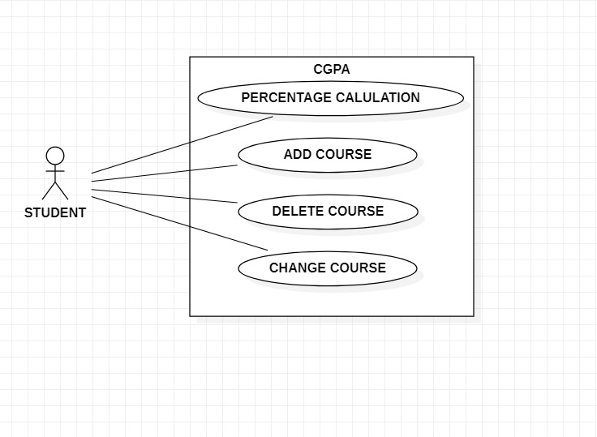

2. Draw the Class Diagrams.

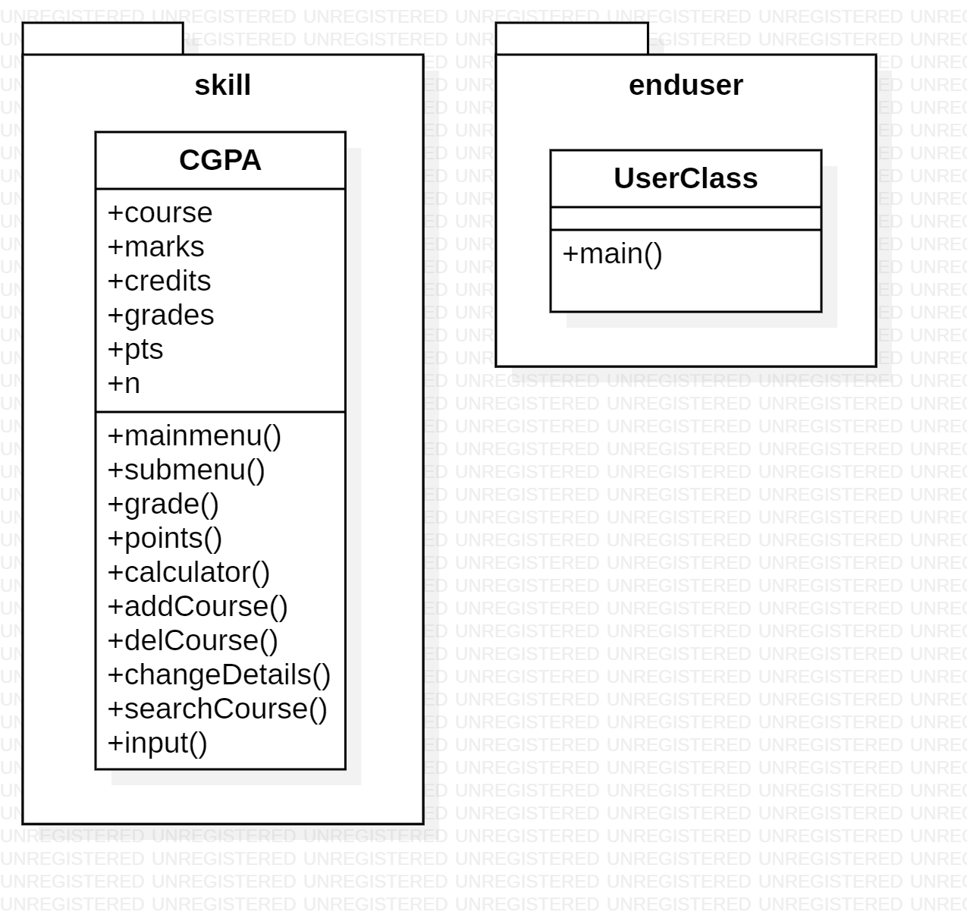

3. Code of the project.

**CGPA CLASS**

// 190031187 RADHAKRISHNA

**package** skill;

**import** java.util.*;

**public** **class** CGPA {

Scanner s=**new** Scanner(System.***in***);

**private** ArrayList<String> course;

**private** ArrayList<Integer> marks;

**private** ArrayList<Double> credits;

**private** ArrayList<Character> grades;

**private** ArrayList<Integer> pts;

**private** **int** n;

**public** CGPA() {

**this**.course = **new** ArrayList<String>();

**this**.marks = **new** ArrayList<Integer>();

**this**.credits = **new** ArrayList<Double>();

**this**.grades = **new** ArrayList<Character>();

**this**.pts = **new** ArrayList<Integer>();

**this**.n=0;

}

// public void input() {

// System.out.println("Enter number of subjects:");

// n= s.nextInt();

// for(int i=0;i<n;i++) {

// System.out.println("Enter course name");

// course.add(s.next());

// System.out.println("Enter course credits");

// credits.add(s.nextDouble());

// System.out.println("Enter marks obtained in that course");

// marks.add(s.nextInt());

// grades.add(grade(marks.get(i)));

// pts.add(points(grades.get(i)));

// }

// mainmenu(n);

// }

**public** **void** mainmenu() {

**boolean** repeat=**true**;

**while**(repeat) {

**switch**(submenu()) {

**case** 1:

addCourse(s.next(),s.nextDouble(),s.nextInt());

**break**;

**case** 2:

delCourse(s.next());

**break**;

**case** 3:

changeDetails(s.next(),s.next(),s.nextDouble(),s.nextInt());

**break**;

**case** 4:

calculator();

**break**;

**default**:

repeat=**false**;

}

}

}

**private** **int** submenu() {

System.***out***.println("Available operations:");

System.***out***.println("1.Add a course");

System.***out***.println("2.Delete a course");

System.***out***.println("3.Change course Details");

System.***out***.println("4.Percentage calculation");

System.***out***.println("Enter any other number to exit");

System.***out***.println("Choose your option:");

**return** s.nextInt();

}

**private** **char** grade(**int** m) {

**char** x=' ';

**if**(m>=90 && m<=100) { x='O';}

**else** **if**(m>=80 && m<90) { x='A';}

**else** **if**(m>=70 && m<80) { x='B';}

**else** **if**(m>=70 && m<60) { x='C';}

**else** **if**(m>=60 && m<50) { x='D';}

**else** **if**(m<=50) { x='F';}

**else** {

// System.out.println("Invalid Marks Try again From First!!");

}

**return** x;

}

**private** **int** points(**char** c) {

**int** z=0;

**if**(c=='O') {z= 10;}

**else** **if**(c=='A') {z=9;}

**else** **if**(c=='B') {z=8;}

**else** **if**(c=='C') {z=7;}

**else** **if**(c=='D') {z=6;}

**else** **if**(c=='F') {z=5;}

**return** z;

}

**private** **void** calculator() {

**float** cgpa;

**float** sum=0,total=0;

**for**(**int** i=0;i<n;i++) {

sum+=credits.get(i)*pts.get(i);

total+=credits.get(i);

}

cgpa=sum/total;

System.***out***.println("Course\t\tCredits\tMarks\tPoint\tGrades");

**for**(**int** i=0;i<n;i++) {

System.***out***.println(course.get(i)+"\t\t"+credits.get(i)+"\t"+marks.get(i)+"\t"+pts.get(i)+"\t"+grades.get(i));

}

System.***out***.printf("CGPA: %.2f\n",cgpa);

}

**public** **void** addCourse(String name,Double cdts,**int** mark) {

n=n+1;

// System.out.println("You are ready to add your course");

// System.out.println("Enter course name");

course.add(name);

// System.out.println("Enter course credits");

credits.add(cdts);

// System.out.println("Enter marks obtained in that course");

marks.add(mark);

grades.add(grade(marks.get(n-1)));

pts.add(points(grades.get(n-1)));

// calculator();

}

**private** **int** searchCourse(String name) {

**for**(**int** i=0;i<n;i++) {

**if**(course.get(i).equalsIgnoreCase(name)) {

**return** i;

}

}

**return** -1;

}

**public** **boolean** delCourse(String name) {

// System.out.println("Enter course name you want to delete:");

**int** j=searchCourse(name);

**if**(j!=-1) {

course.remove(j);

credits.remove(j);

marks.remove(j);

grades.remove(j);

pts.remove(j);

n=n-1;

// System.out.println("Deleted the course Successfully");

// calculator();

**return** **true**;

}

// System.out.println("No such course exists");

// calculator();

**return** **false**;

}

**public** **boolean** changeDetails(String name,String newname,Double newcdts,**int** newmark) {

// System.out.println("Enter course name you want to change details:");

**int** j=searchCourse(name);

**if**(j!=-1) {

course.remove(j);

credits.remove(j);

marks.remove(j);

grades.remove(j);

pts.remove(j);

// System.out.println("You are ready to change your course");

// System.out.println("Enter course name");

course.add(newname);

// System.out.println("Enter course credits");

credits.add(newcdts);

// System.out.println("Enter marks obtained in that course");

marks.add(newmark);

grades.add(grade(marks.get(n-1)));

pts.add(points(grades.get(n-1)));

// System.out.println("Changes are done Successfully");

// calculator();

**return** **true**;

}

// System.out.println("No such course exits");

// calculator();

**return** **false**;

}

**public** **double** TestCGPACalulator() {

**double** cgpa;

**double** sum=0,total=0;

**for**(**int** i=0;i<n;i++) {

sum+=credits.get(i)*pts.get(i);

total+=credits.get(i);

}

cgpa=sum/total;

**return** cgpa;

}

}

**ENDUSER CLASS**

**package** enduser;

**import** skill.CGPA;

**public** **class** UserClass{

**public** **static** **void** main(String[] args) {

CGPA c= **new** CGPA();

// c.input();

c.mainmenu();

}

}

**OUTPUT**

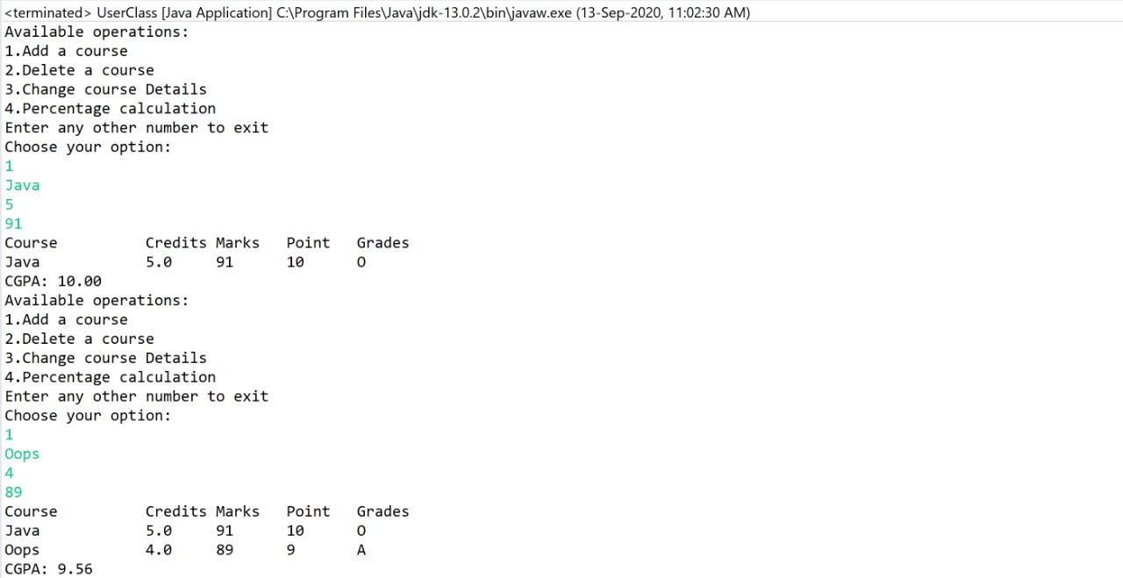

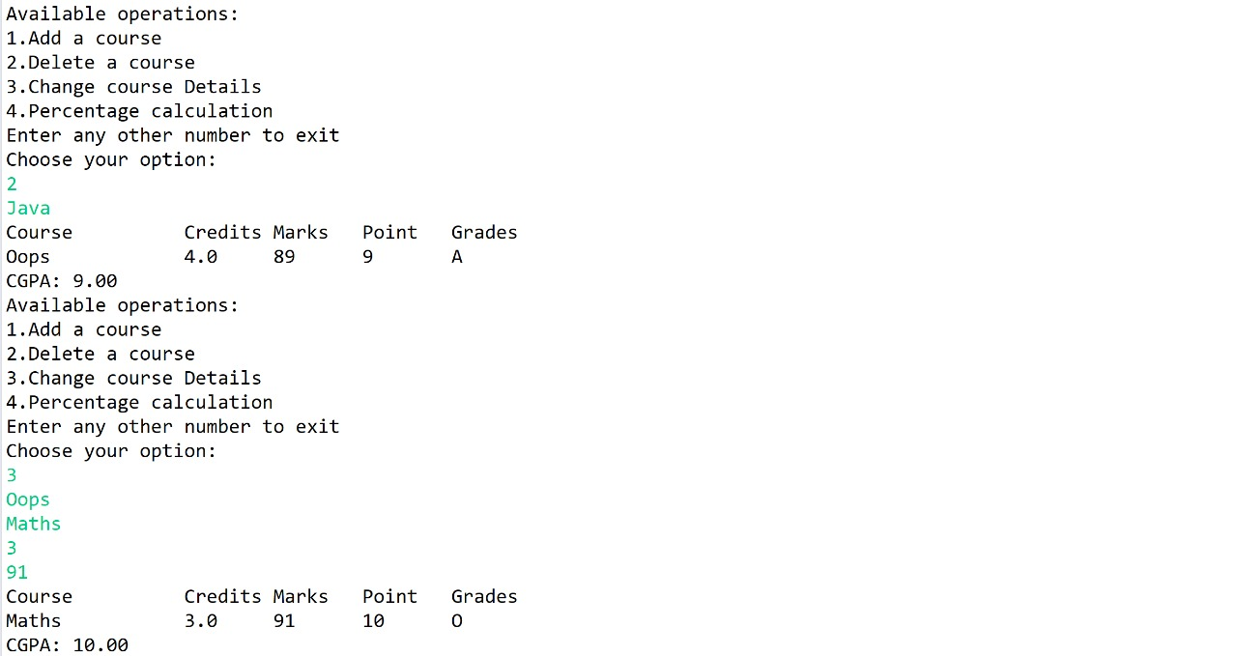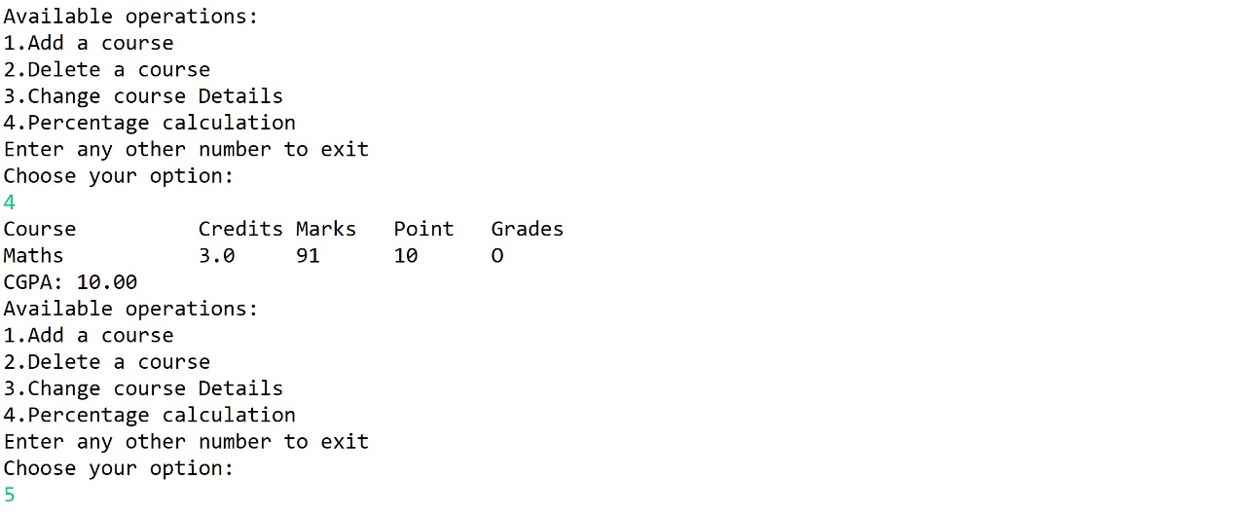

**JUNIT TEST**

**package** test;

**import** org.junit.*;

**import** skill.CGPA;

**public** **class** TestCalculator {

CGPA c=**new** CGPA();

@Before

**public** **void** addCourseTest() {

c.addCourse(“Java”,5.0,91);

}

// @SuppressWarnings(“deprecation”)

@Test

**public** **void** TestCal() {

**double** expresult=10.0;

**double** actresult=c.TestCGPACalulator();

Assert.*assertEquals*(expresult, actresult, 0.0);

}

}

**JUNIT OUTPUT**

