**CO1 HOME ASSIGNMENT**

1. Maximize *z* = *x*1 + 2*x*2, subject to: *x*1 − 2*x*2≤ 3, *x*1 + *x*2≤3, *x*1, *x*2≥ 0.

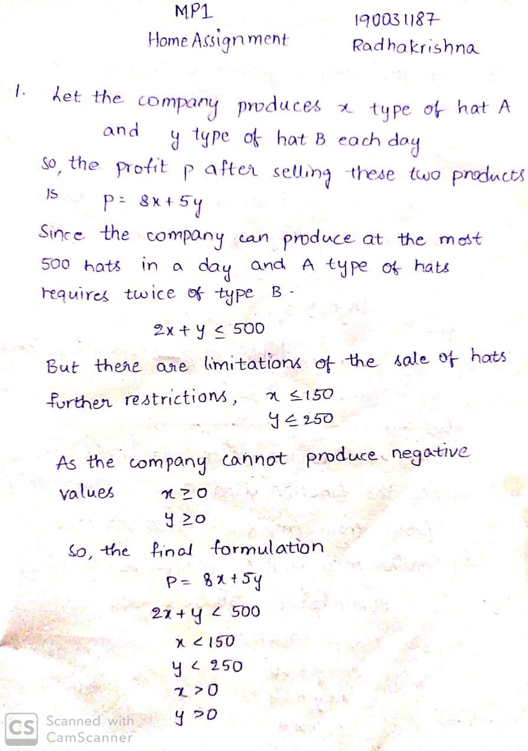

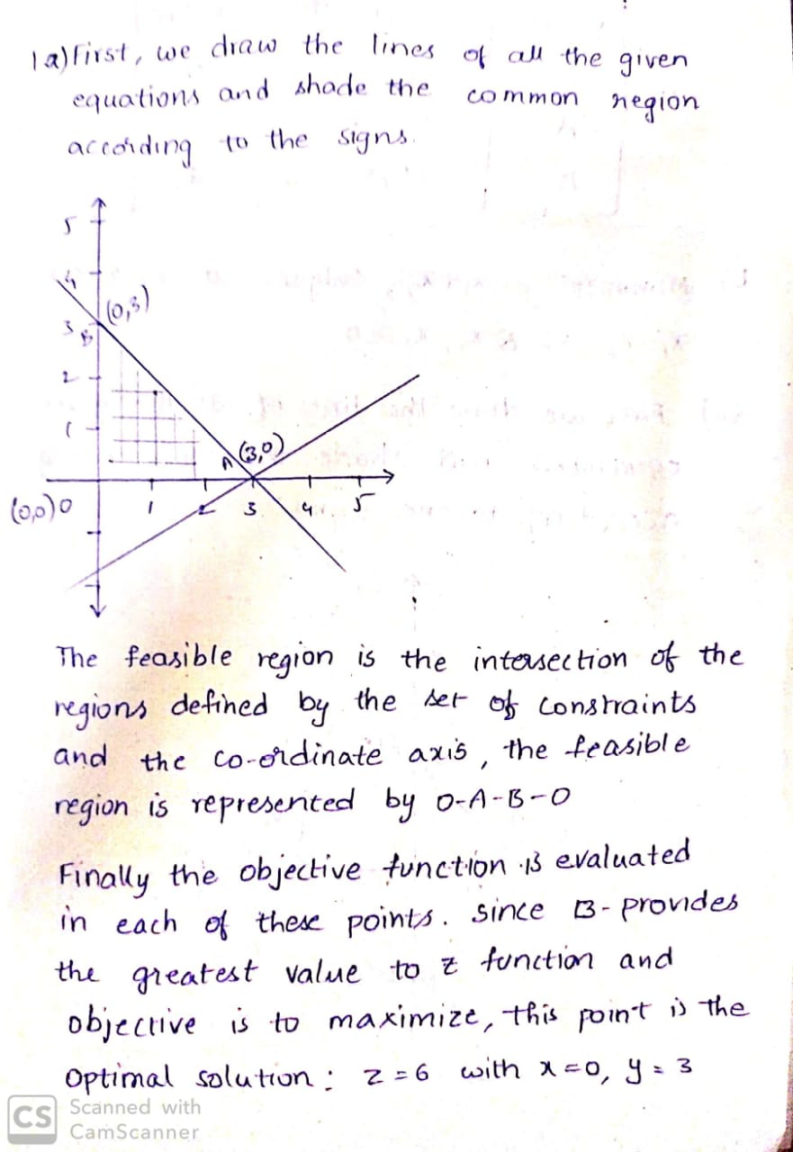

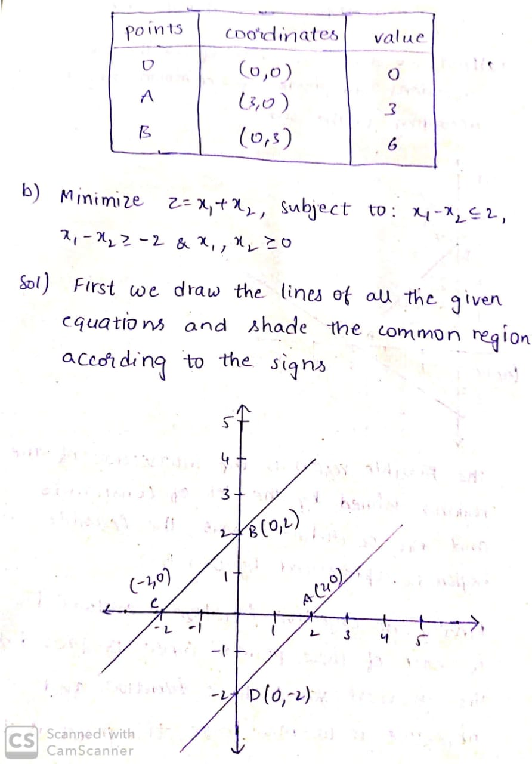

1. Minimize *z* = *x*1 + *x*2, subject to: *x*1 -*x*2≤ 2, *x*1 -*x*2≥ −2, *x*1, *x*2 ≥ 0.



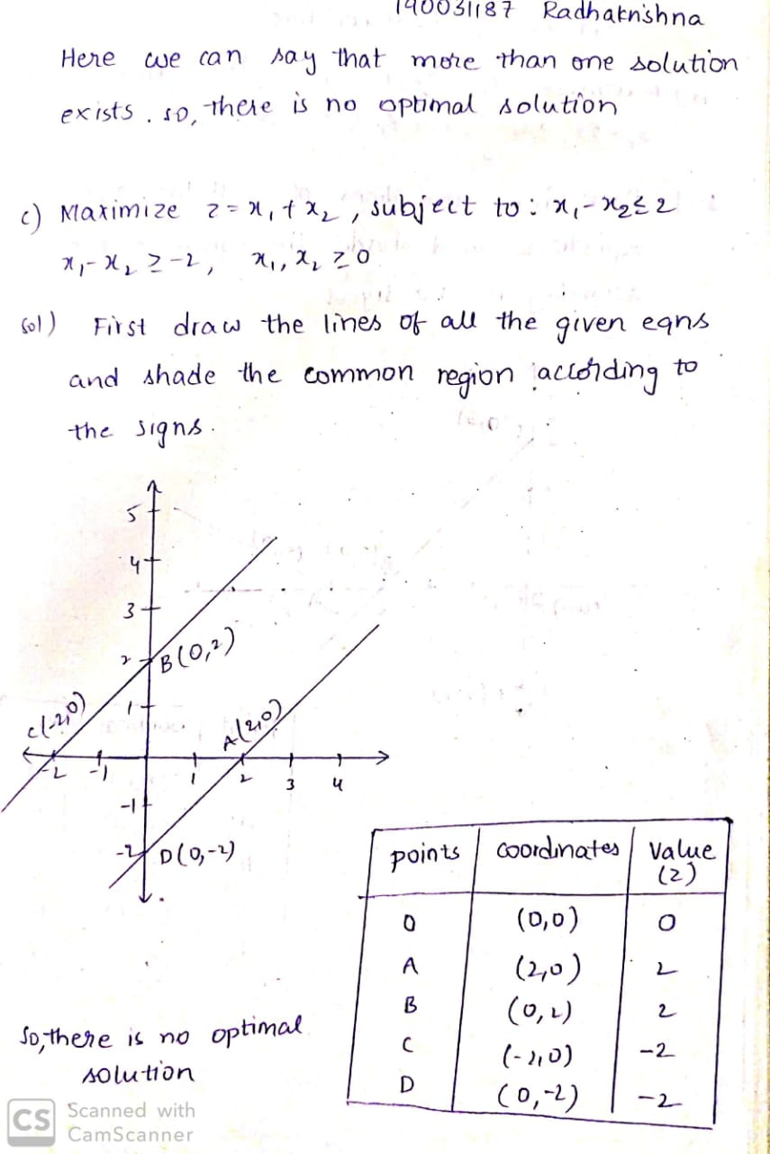

1. Consider the following linear program: Maximize *z* = 2*x*1 + *x*2 subject to: 12*x*1 + 3*x*2≤ 6, −3*x*1 + *x*2≤ 7, *x*2≤ 10, *x*1,*x*2≥ 0. Draw a graph of the constraints and shade in the feasible region. Label the vertices of this region with their coordinates.

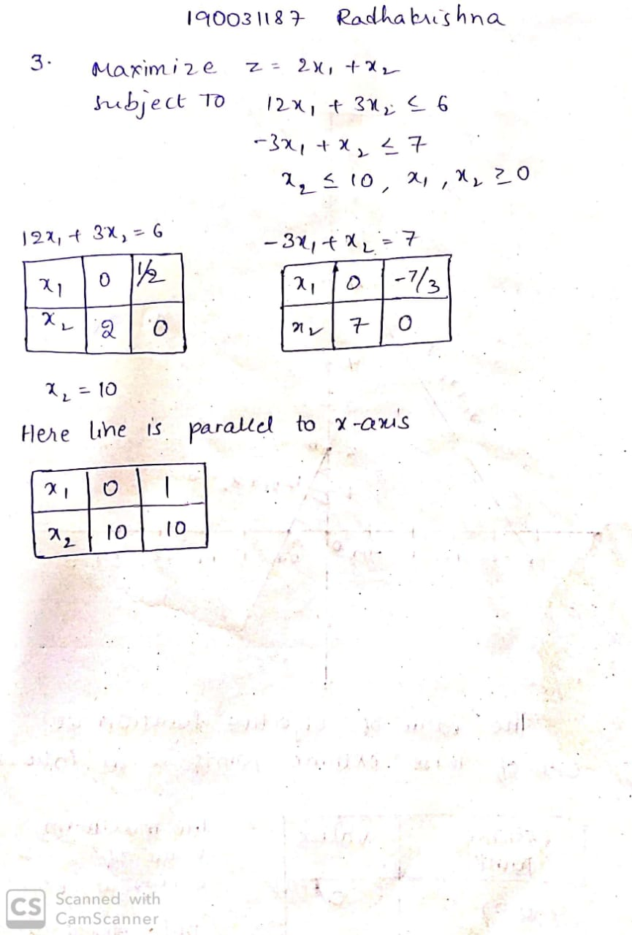

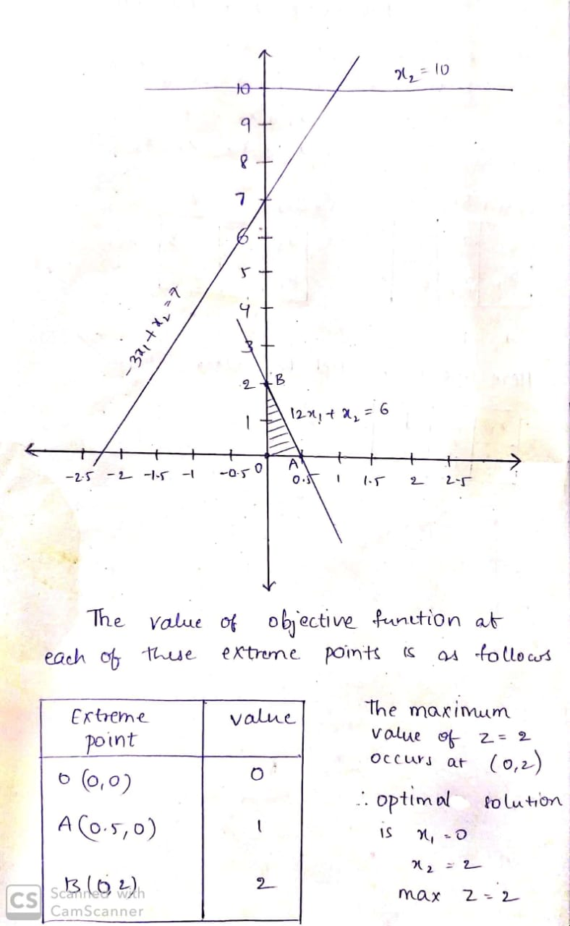

1. A company produces 2 types of cowboy hats. Each hat of the first type requires twice as much labour time as the second type. The company can produce a total of 500 hats a day. The market limits the daily sales of first and second types to 150 and 250 hats. Assuming that the profits per hat are $8 per type A and $5 per type B, formulate the problem as Linear Programming model in order to determine the number of hats to be produced of each type so as to maximize the profit.



1. A cooperative society of farmers has 50 hectares of land to grow two crops X and Y. The profit from crops X and Y per hectare are estimated as Rs 10,500 and Rs 9,000 respectively. To control weeds, a liquid herbicide must be used for crops X and Y at rates of 20 litres and 10 litres per hectare. Further, no more than 800 litres of herbicide should be used to protect fish and wildlife using a pond which collects drainage from this land. How much land should be allocated to each crop to maximise the total profit of the society? (formulating Mathematical modelling of LPP)

