**MP-1 HOME ASSIGNMENT-2**

1.Find the solution of dual problem of LPP

Max Z=5x1+3x2

Subject to the constraints x1+ x2 <= 2, 5x1+2x2<=10, 3x1+8x2 <= 12x1,x2 >=0

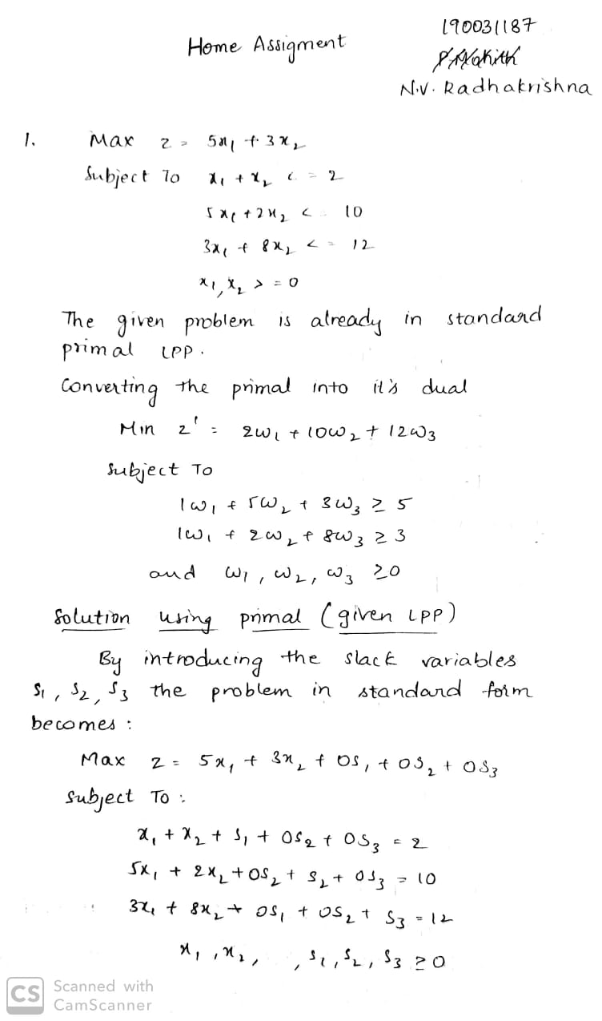

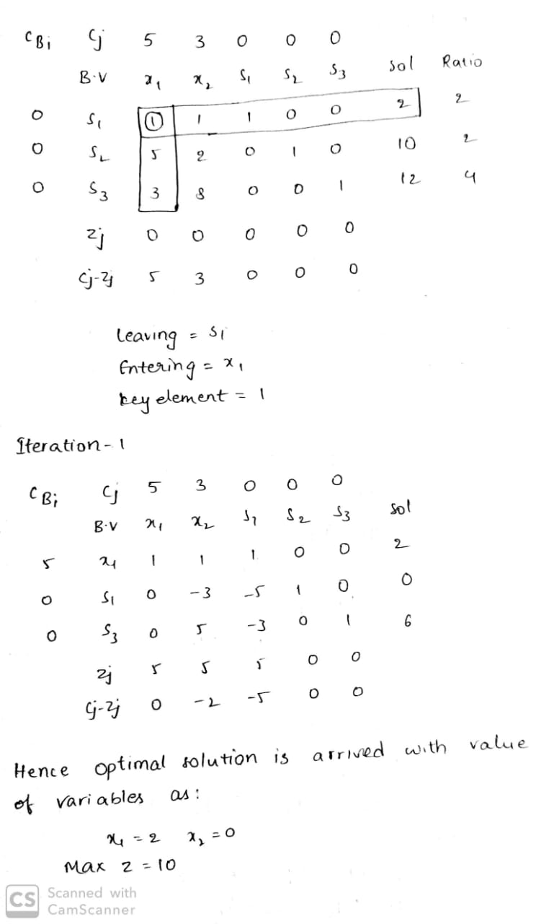

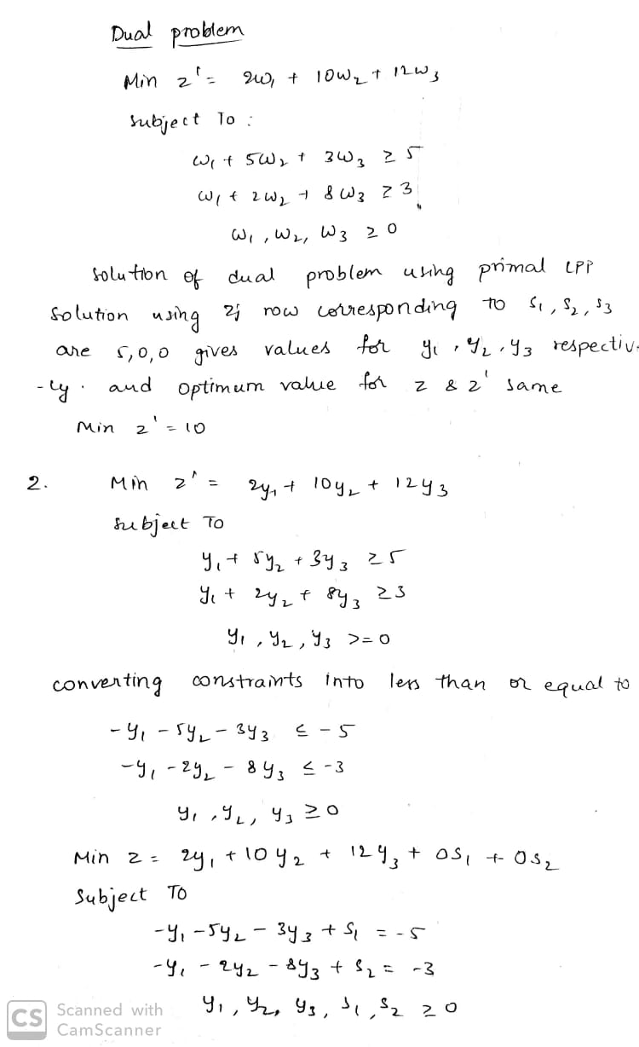

2. Find the solution for Dual problem:

Min Z’=2 y1+10 y2+12 y3

s.to the constraints y1+5y2+3y3 >= 5 ,

y1+2 y2+8y3 >= 3, y1,y2,y3 >=0



