**MP-1 HOME ASSIGNMENT-3**

1. Three jobs are to be assigned to three contractors. The estimated time to complete the job by any of the contractor is given in the following table. What must be allocation so that the time taken to complete all jobs is always minimum.

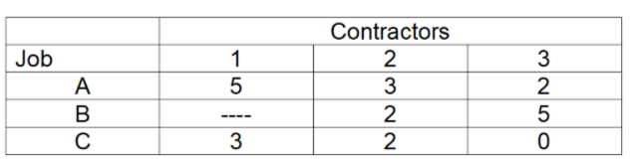

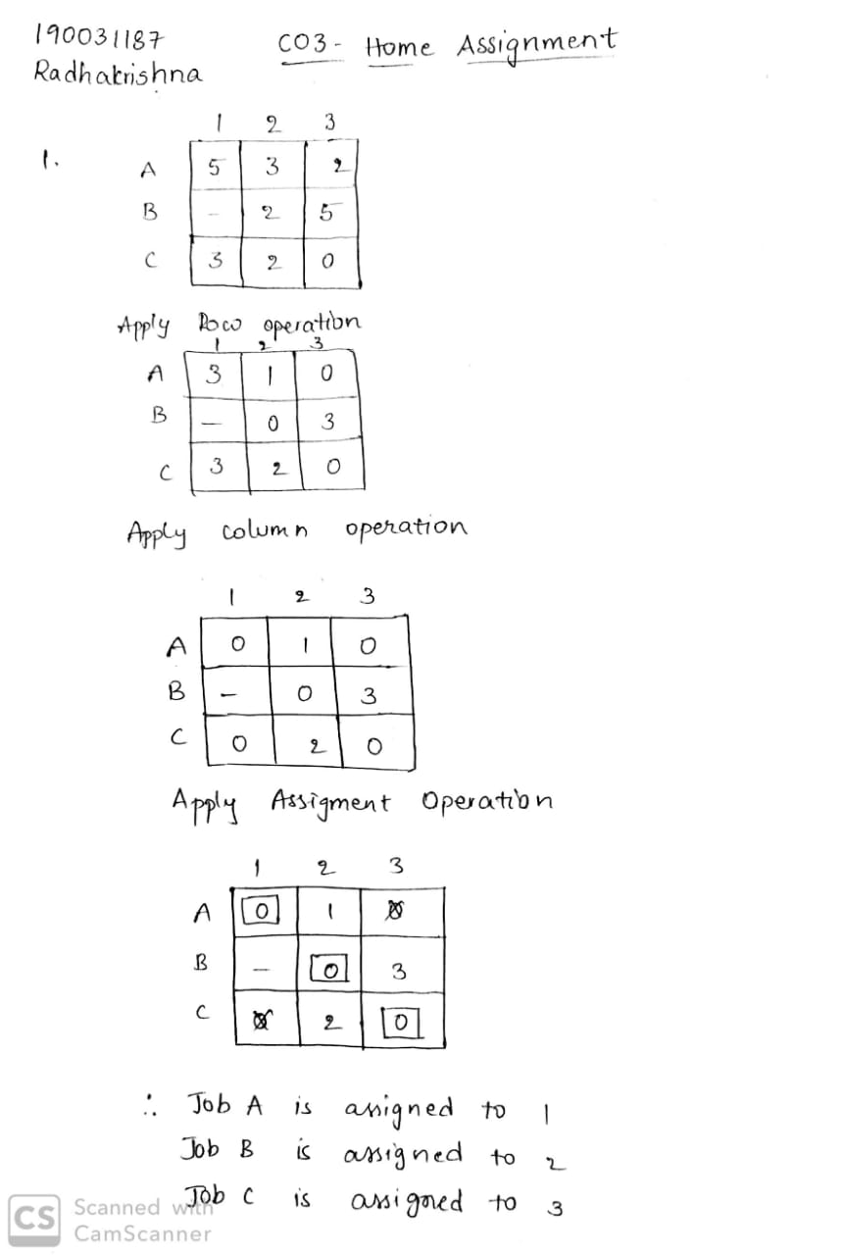

1. Find the best way of transporting the material from the godowns to the factories so that the cost of transportation is always minimum. The entry in each of the cell indicates the unit shipment cost from godown to the factory.Obtain the initial solution by using NW corner rule.

