**MP-1 PRACTICAL-1**

1. **Develop a python program to demonstrate the Graphical method in Linear Programming.**

**QUESTION:**

Maximize

Z=4x+3yZ=4x+3y

Subject TO:

x≥0

y≥2

2y≤25–x

4y≥2x–8

y≤2x−5

Solve LP graphically using python

**Code:**

import numpy as np

import matplotlib.pyplot as plt

%matplotlib inline

# Construct lines

# x > 0

x = np.linspace(0, 20, 2000)

# y >= 2

y1 = (x*0) + 2

# 2y <= 25 - x

y2 = (25-x)/2.0

# 4y >= 2x - 8

y3 = (2*x-8)/4.0

# y <= 2x - 5

y4 = 2 * x -5

# Make plot

plt.plot(x, y1, label=r'$y\geq2$')

plt.plot(x, y2, label=r'$2y\leq25-x$')

plt.plot(x, y3, label=r'$4y\geq 2x - 8$')

plt.plot(x, y4, label=r'$y\leq 2x-5$')

plt.xlim((0, 16))

plt.ylim((0, 11))

plt.xlabel(r'$x$')

plt.ylabel(r'$y$')

# Fill feasible region

y5 = np.minimum(y2, y4)

y6 = np.maximum(y1, y3)

plt.fill_between(x, y5, y6, where=y5>y6, color='grey', alpha=0.5)

plt.legend(bbox_to_anchor=(1.05, 1), loc=2, borderaxespad=0.)

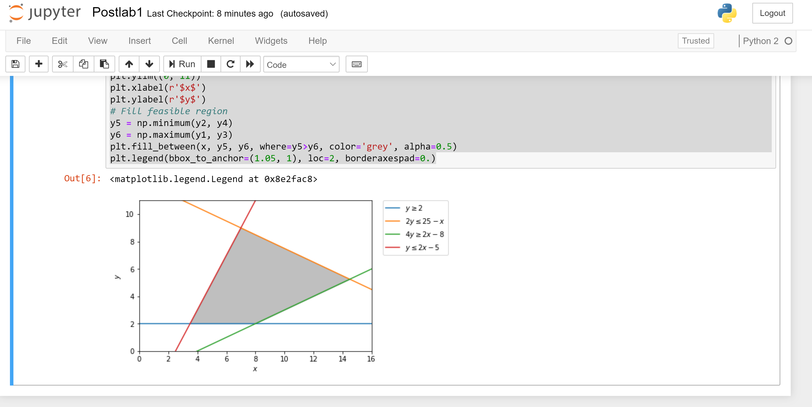

1. **Develop a python program to demonstrate the Simplex method**

**QUESTION**:  
Maximize Z=3 x1 + 5 x2

Subject To:

3 x1 + 2 x2 =18

X1 <= 4

2 x2 <= 12

X1 >=0

X2 >= 0

Solve LP using simplex method using Python

**Code:**

**import numpy as np**

**import scipy as sp**

**c = [-3, -5]**

**A = [[1, 0], [0, 2], [3, 2]]**

**b = [4, 12, 18]**

**x0_bounds = (0, None)**

**x1_bounds = (0, None)**

**from scipy.optimize import linprog**

**# Solve the problem by Simplex method in Optimization**

**res = linprog(c, A_ub=A, b_ub=b, bounds=(x0_bounds, x1_bounds), method='simplex', options={"disp": True})**

**print res**

