**MP-1 TUTORIAL-1**

1. **Demonstrate the Graphical method**

**QUESTION:**

Minimize 4p + 5q + 6r

Subject to:

p + q >= 11

p - q <= 5

r - p - q = 0

7p >= 35 – 12q

p >= 0 q >= 0 r >= 0

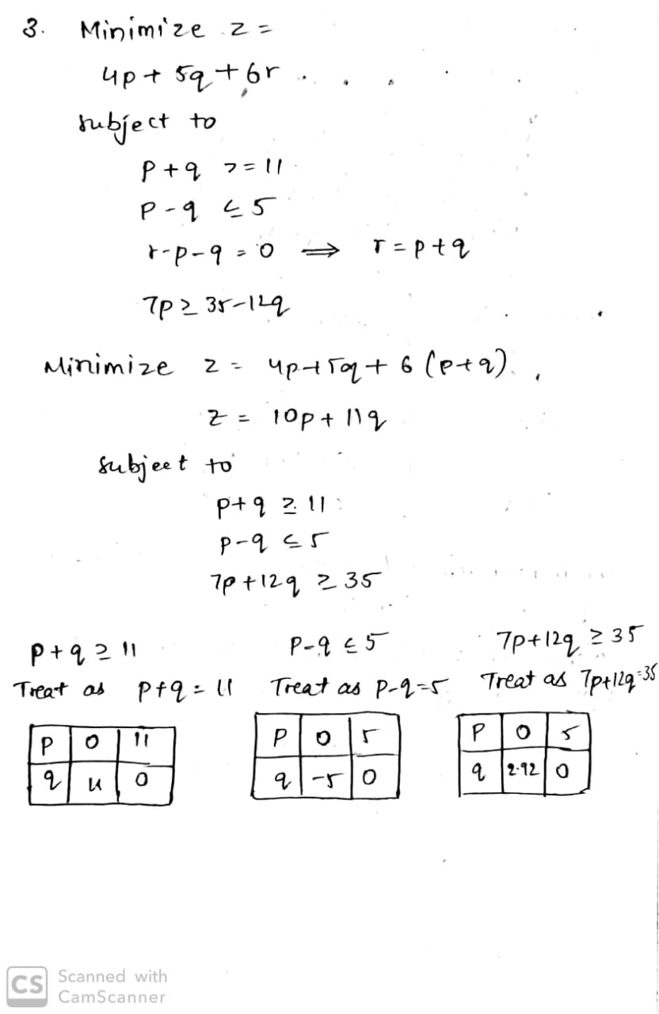

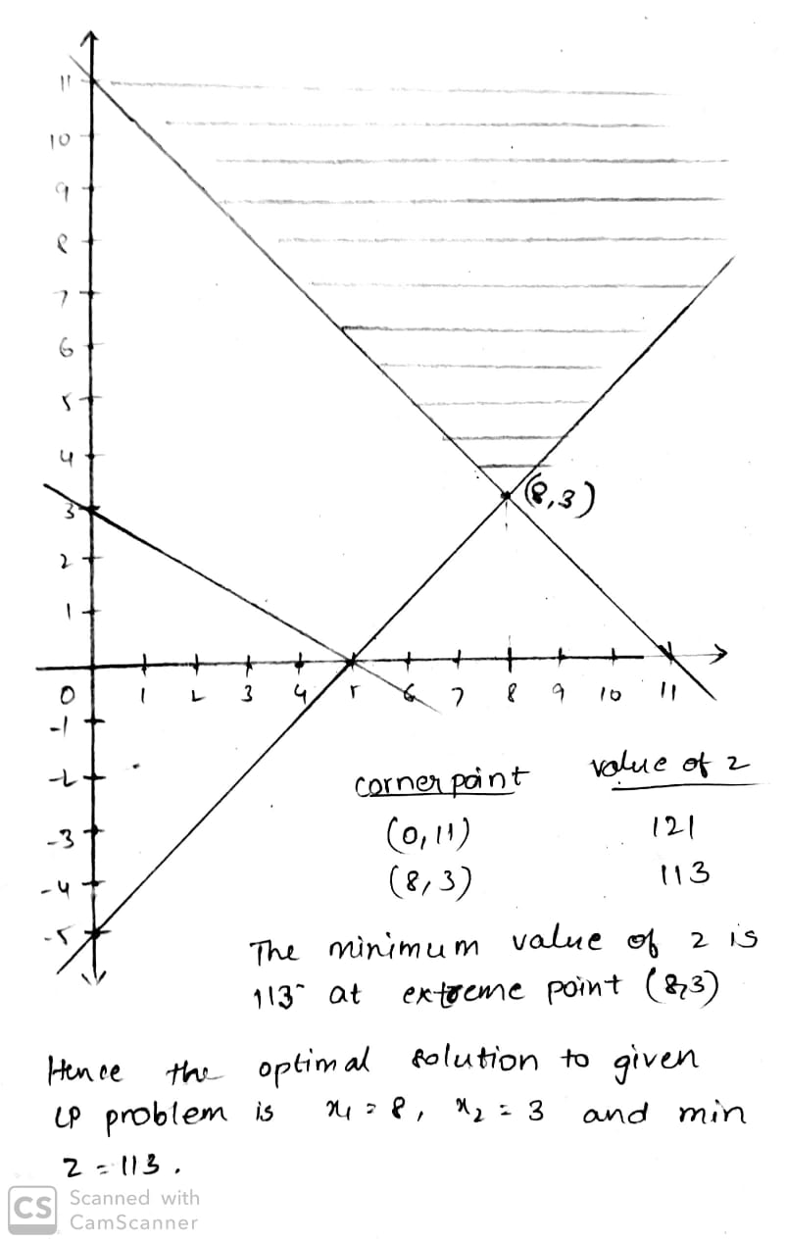

1. **Demonstrate the Simplex method in Linear Programming.**

**QUESTION:**

Maximize: P=40x1+35x2

Subject To:

x1 +x2 <=24

3x1 +2x2<=60

X1,x2 >=0

