**MP-1 TUTORIAL-11**

1. Demonstrate the Assignment problem using Hungarian method.

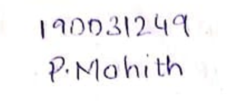**QUESTION:**

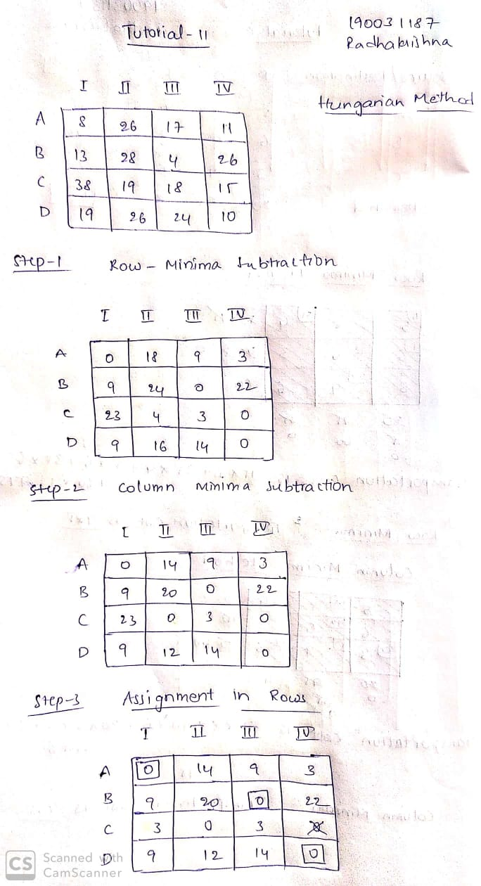

**ANSWER:**



