**MP-1 TUTORIAL-8**

1. Demonstrate the Initial Basic Solution in Transportation problem using Row Minimum method, Demonstrate the Initial Basic Solution in Transportation problem using Column Minimum method in Linear Programming.

**QUESTION:**

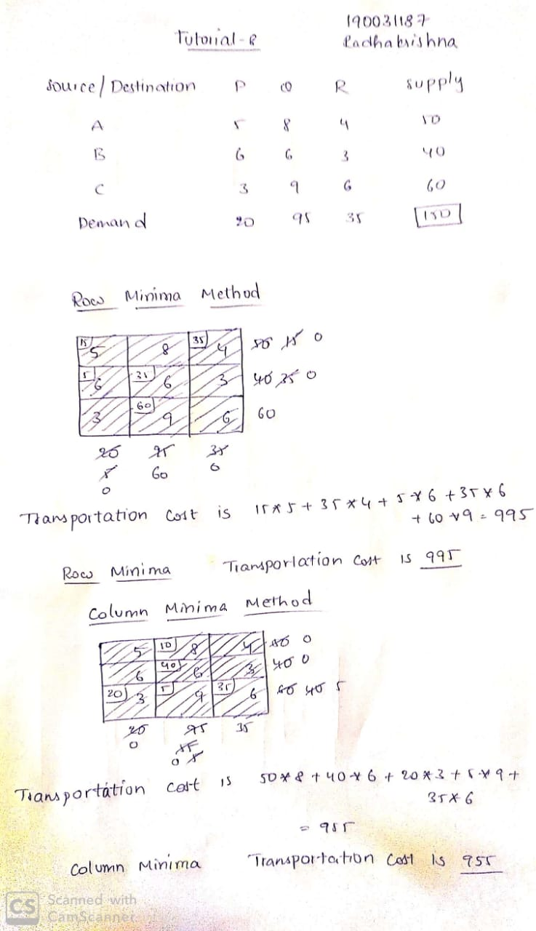

**ANSWER:**



1. Demonstrate the Initial Basic Solution in Transportation problem using Column Minimum method in Linear Programming.

**QUESTION**



**ANSWER**

