**MP-1 TUTORIAL-1**

**PRE-LAB**

1. Write the algorithm for Linear Programming Graphical Method. Define the following:

a. Objective Function.

b. Decision Variables.

c. Constraints.

d. Non negativity Restrictions.

e. Feasible Solution.

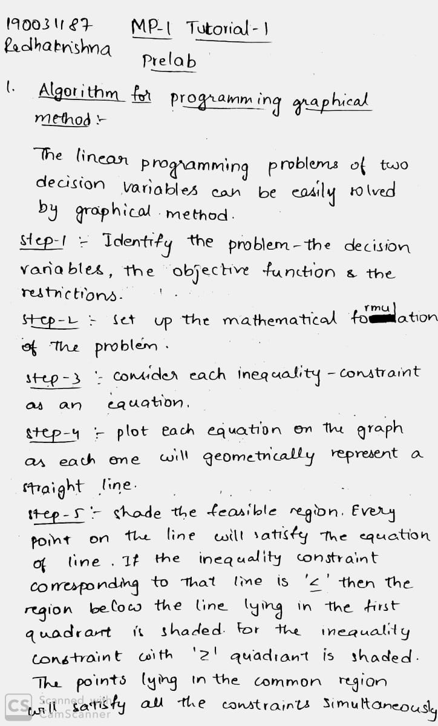

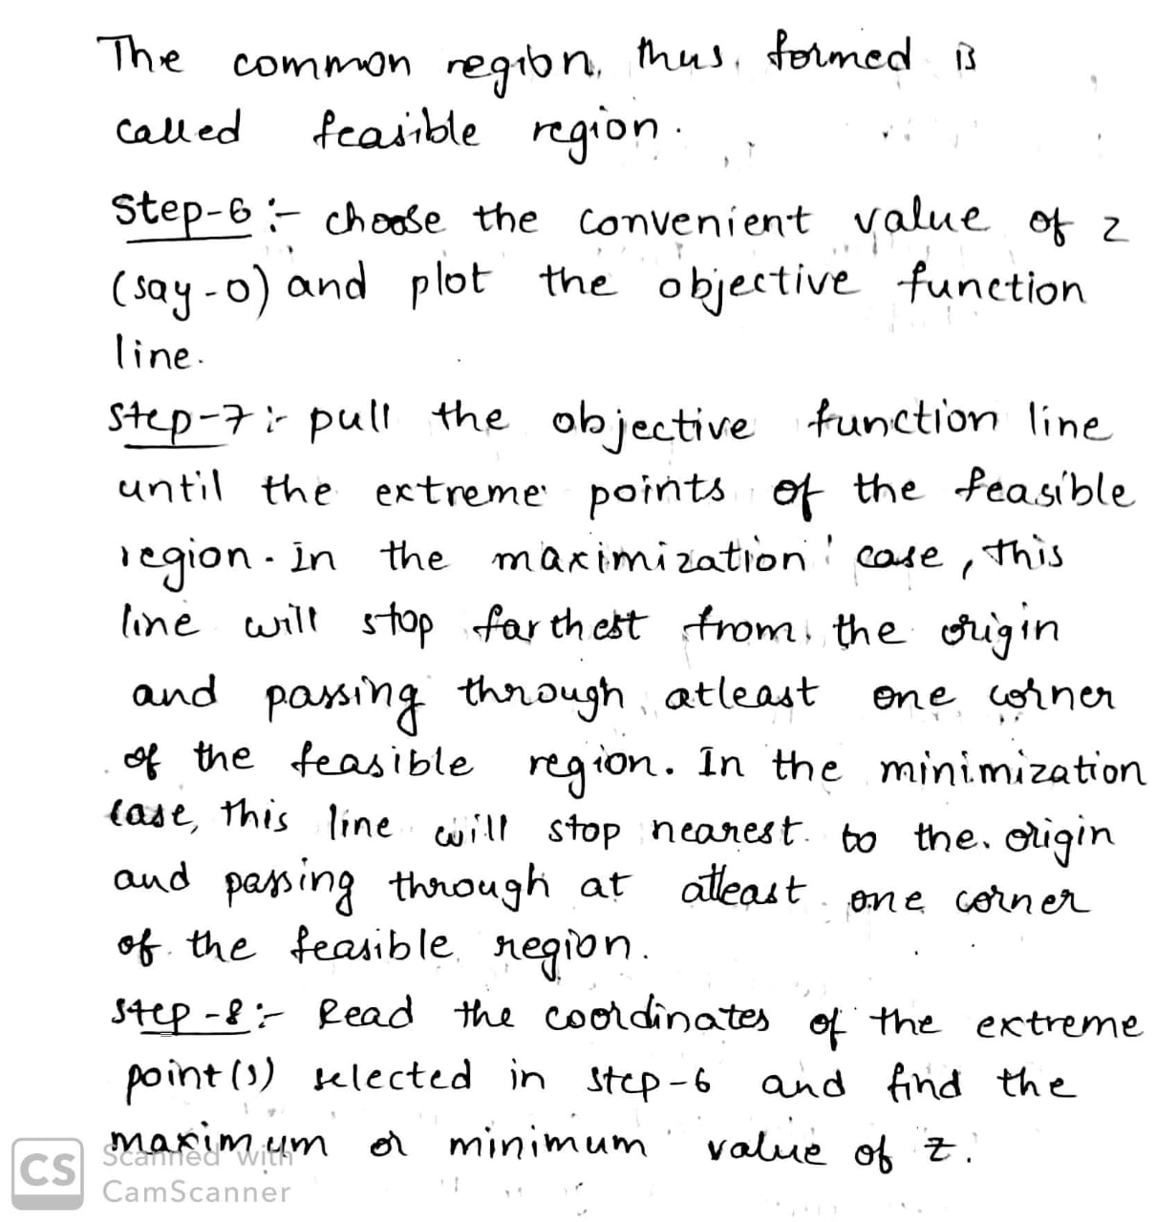

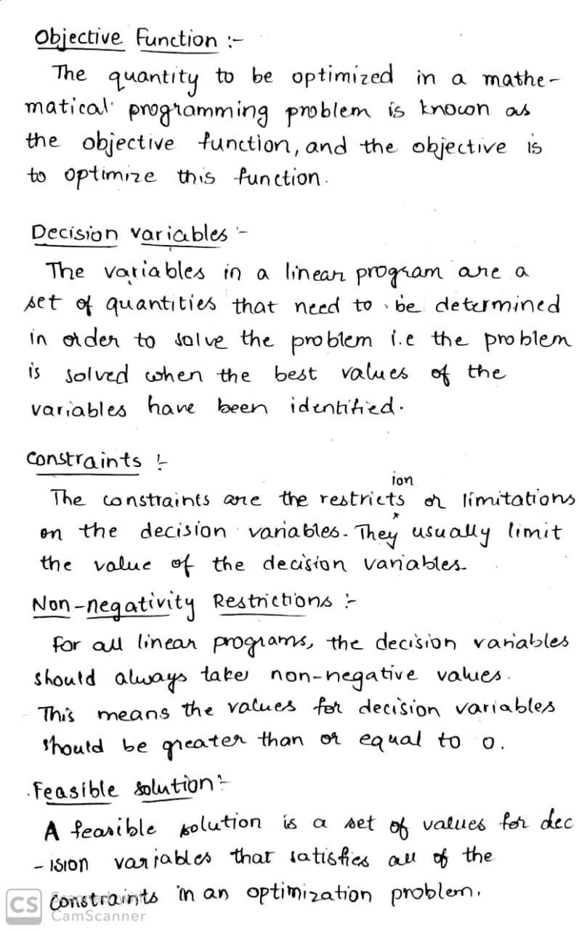

2. Solve the following problem graphically:

Maximize C=3a+2b Subject to the constraints a+2b≤10 3a+b≤15 a,b≥0

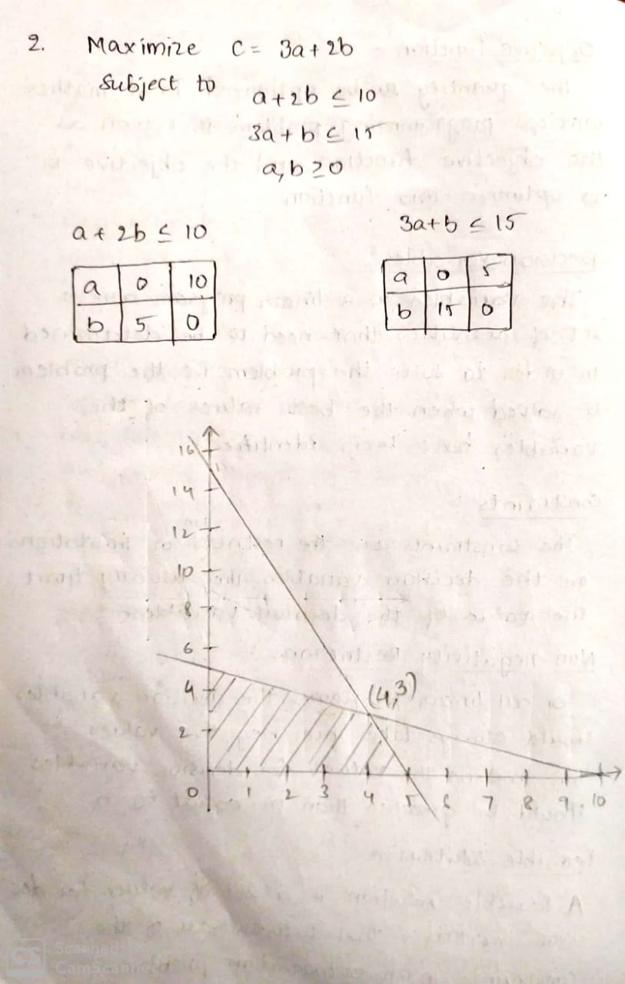

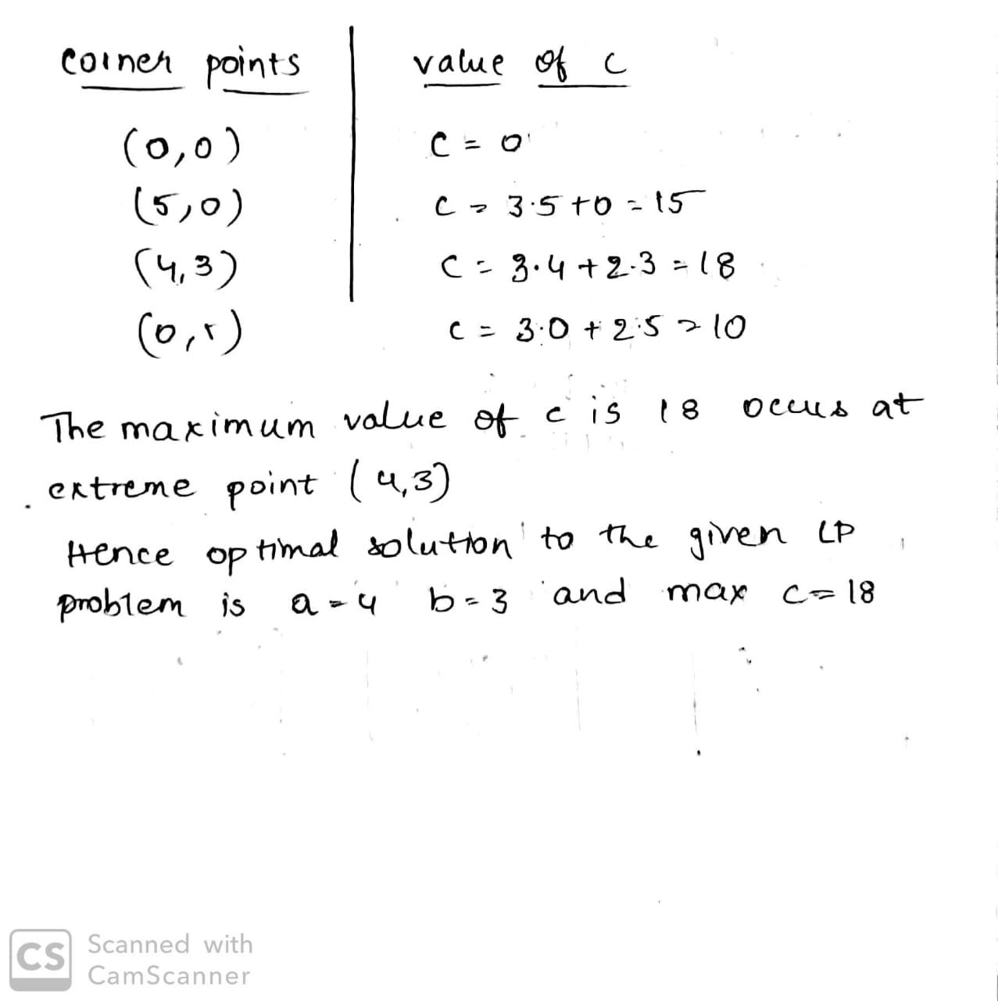

3. Solve LPP using Graphical Method

Minimize

4p + 5q + 6r

Subject to:

p + q >= 11

p - q <= 5

r - p - q = 0

7p >= 35 – 12q

p >= 0 q >= 0 r >= 0

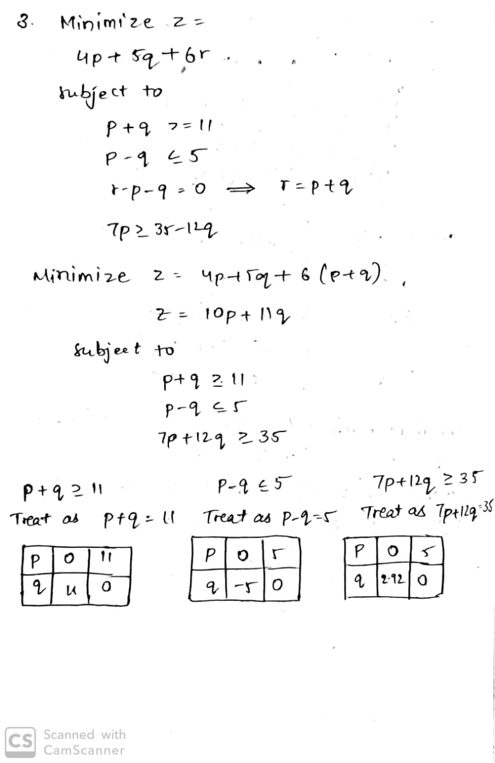

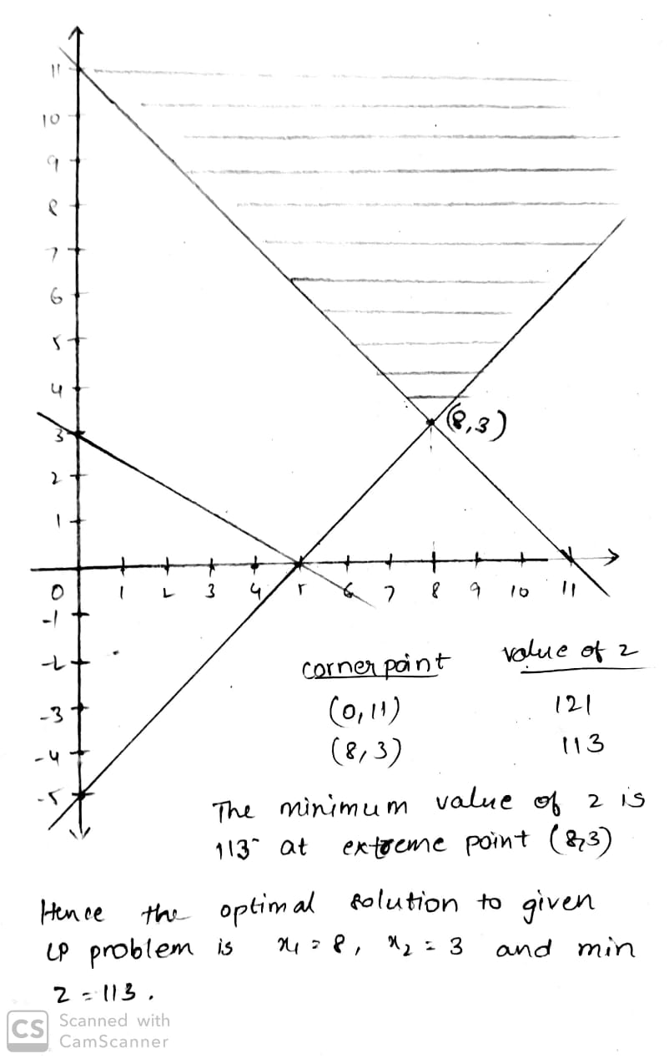

**INLAB**

1. An Industry started in producing A and B, two products. These two products need two resources, machine power and man power. For product A, require 13 machine power and 20 man power. For the product B, require 19 machine power and 29 man power. Industry has 40 hrs of machine power which is available in the coming working week but only 35hrs of man power. The cost of machine power is $10 per hour worked and man power is $2 per hour worked. Both machine and manpower idle times incur no costs. The revenue received for each product produced (all production is sold) is $20 for A and $30 for B. For a customer, Industry has a specific contract to produce 10 products of A per week.

· Formulate the problem of deciding how much to produce per week as a linear program and represent the linear program graphically.

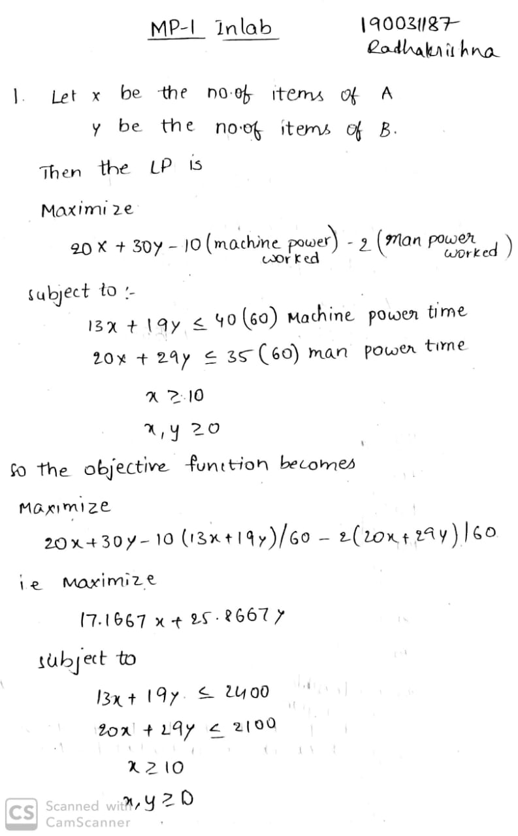

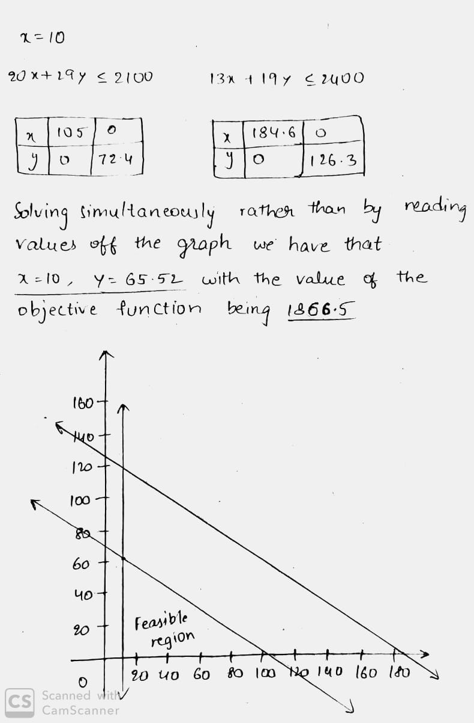

· Solve the problem using python

**Code:**

**# import the library pulp as p**

**import pulp as p**

**# Create a LP Minimization problem**

**Lp_prob = p.LpProblem('Problem', p.LpMaximize)**

**# Create problem Variables**

**x = p.LpVariable("x", lowBound = 0) # Create a variable x >= 0**

**y = p.LpVariable("y", lowBound = 0) # Create a variable y >= 0**

**# Objective Function**

**Lp_prob += 17.1667 * x + 25.8667 * y**

**# Constraints:**

**Lp_prob += 13 * x + 19 * y <= 2400**

**Lp_prob += 20 * x + 29 * y <= 2100**

**Lp_prob += x >= 10**

**Lp_prob += x >= 0**

**Lp_prob += y >= 0**

**# Display the problem**

**print(Lp_prob)**

**status = Lp_prob.solve() # Solver**

**print p.LpStatus[status]**

**# Printing the final solution**

**print p.value(x), p.value(y), p.value(Lp_prob.objective)**

**OUTPUT**

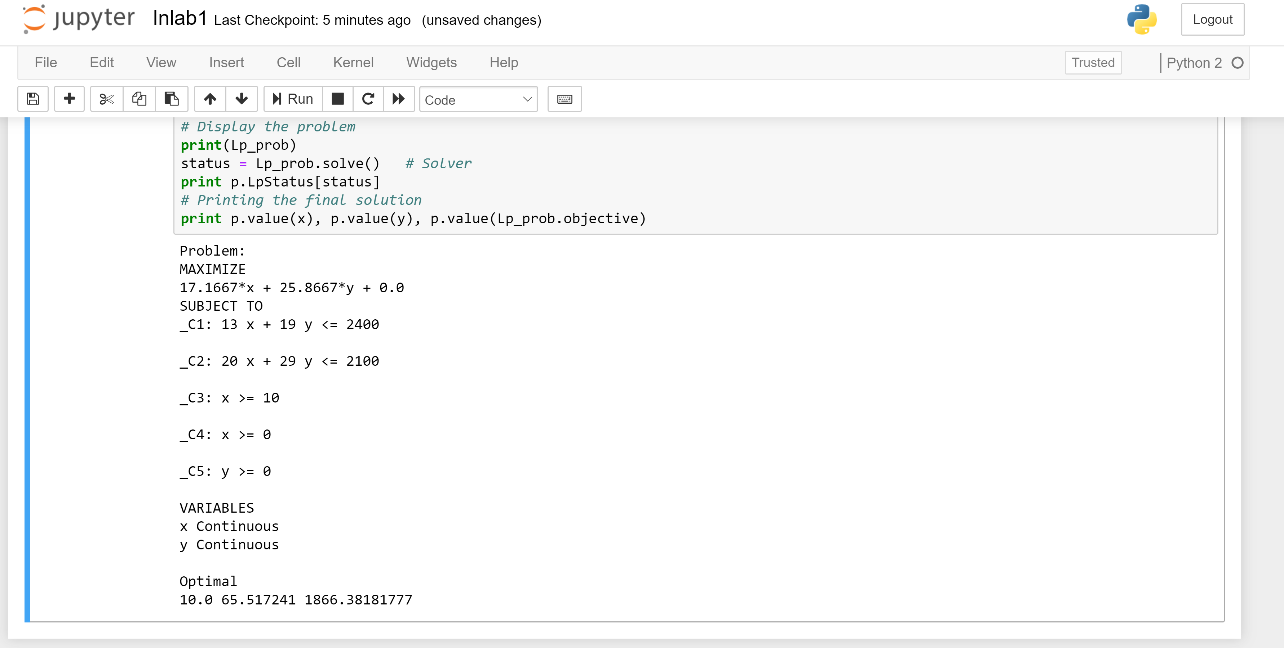

1. An Industry makes two items of P and Q by using two devices X and Y. Processing time requires 50hrs for item P on device X and 30hrs requires on device Y. Processing time requires 24hrs for item Q on device X and 33hrs requires on device Y. At starting of the current week, 30 pieces of A and 90 pieces of B are available. Processing time that is available on device X is predict to be 40hrs and on device Y is predict to be 35hrs. Demand for P in the current week is predict to be 75 pieces and for Q is predict to be 95 pieces. Industry policy is to maximize the combined sum of the pieces of P and the pieces of Q in stock at the end of the week. Formulate the problem of deciding how much of each item to make in the current week as a linear program. Solve this linear program graphically.

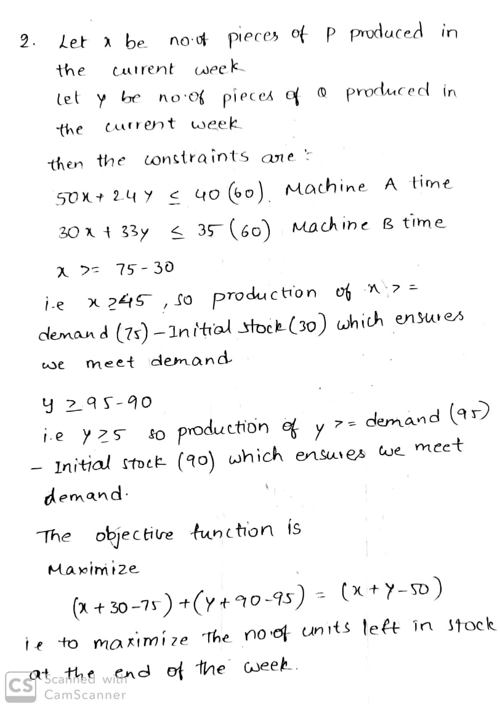

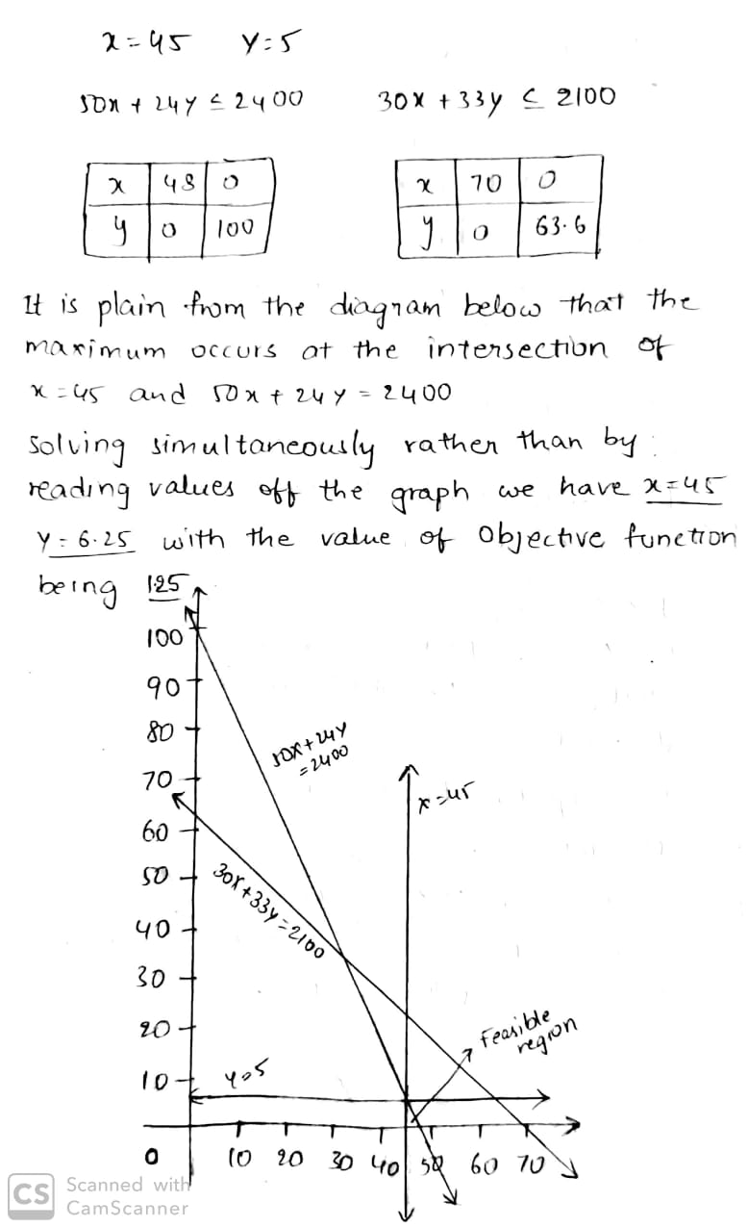

**POSTLAB**

1. Maximize

Z=4x+3yZ=4x+3y

Subject TO:

x≥0

y≥2

2y≤25–x

4y≥2x–8

y≤2x−5

Solve LP graphically using python

**Code:**

**import numpy as np**

**import matplotlib.pyplot as plt**

**%matplotlib inline**

**# Construct lines**

**# x > 0**

**x = np.linspace(0, 20, 2000)**

**# y >= 2**

**y1 = (x*0) + 2**

**# 2y <= 25 - x**

**y2 = (25-x)/2.0**

**# 4y >= 2x - 8**

**y3 = (2*x-8)/4.0**

**# y <= 2x - 5**

**y4 = 2 * x -5**

**# Make plot**

**plt.plot(x, y1, label=r'$y\geq2$')**

**plt.plot(x, y2, label=r'$2y\leq25-x$')**

**plt.plot(x, y3, label=r'$4y\geq 2x - 8$')**

**plt.plot(x, y4, label=r'$y\leq 2x-5$')**

**plt.xlim((0, 16))**

**plt.ylim((0, 11))**

**plt.xlabel(r'$x$')**

**plt.ylabel(r'$y$')**

**# Fill feasible region**

**y5 = np.minimum(y2, y4)**

**y6 = np.maximum(y1, y3)**

**plt.fill_between(x, y5, y6, where=y5>y6, color='grey', alpha=0.5)**

**plt.legend(bbox_to_anchor=(1.05, 1), loc=2, borderaxespad=0.)**

**OUTPUT**

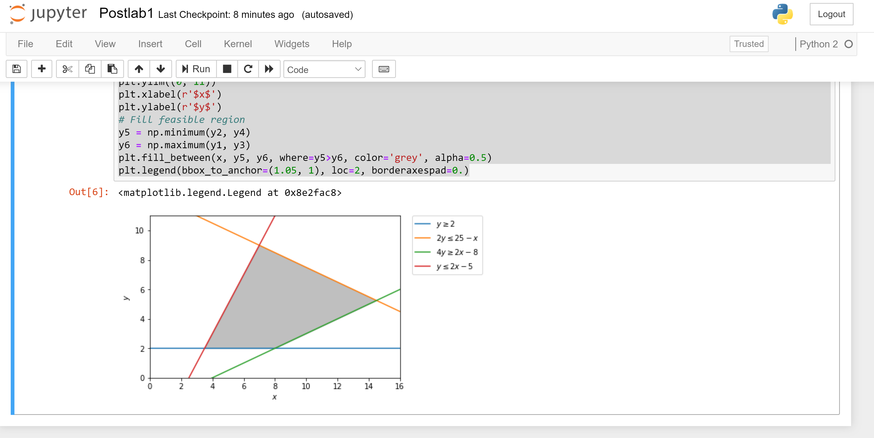

1. A cabinetmaker makes benches and desks. Each bench can be sold for a profit of $30 and each desk for a profit of $10. The cabinetmaker can afford to spend up to 40 hrs per week working and takes 6 hrs to make a bench and 3 hrs to make a desk. Customer demand requires that he makes at least 3 times as many desks as benches. Benches take up 4 times as much storage space as desks and there is room for at most four benches each week. Formulate this problem as a linear programming problem and solve it graphically.

