**MP-1 TUTORIAL-2**

**PRELAB**

1. Write the algorithm to solve the simple simplex method. What is the usage of slack variables

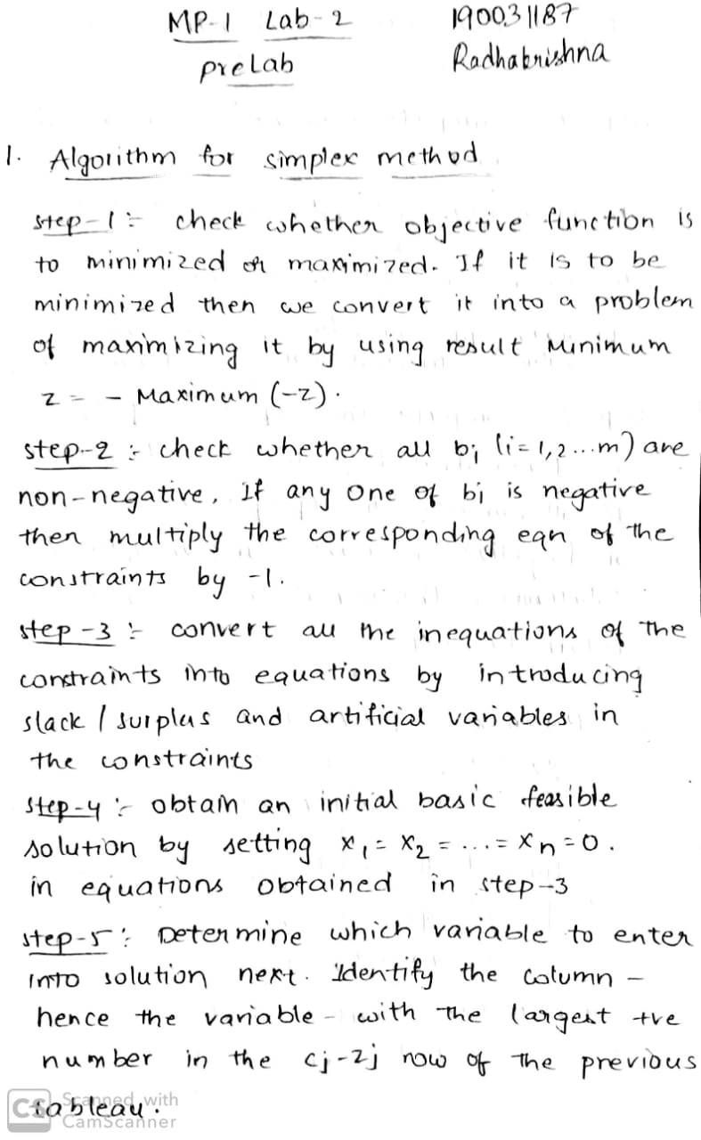

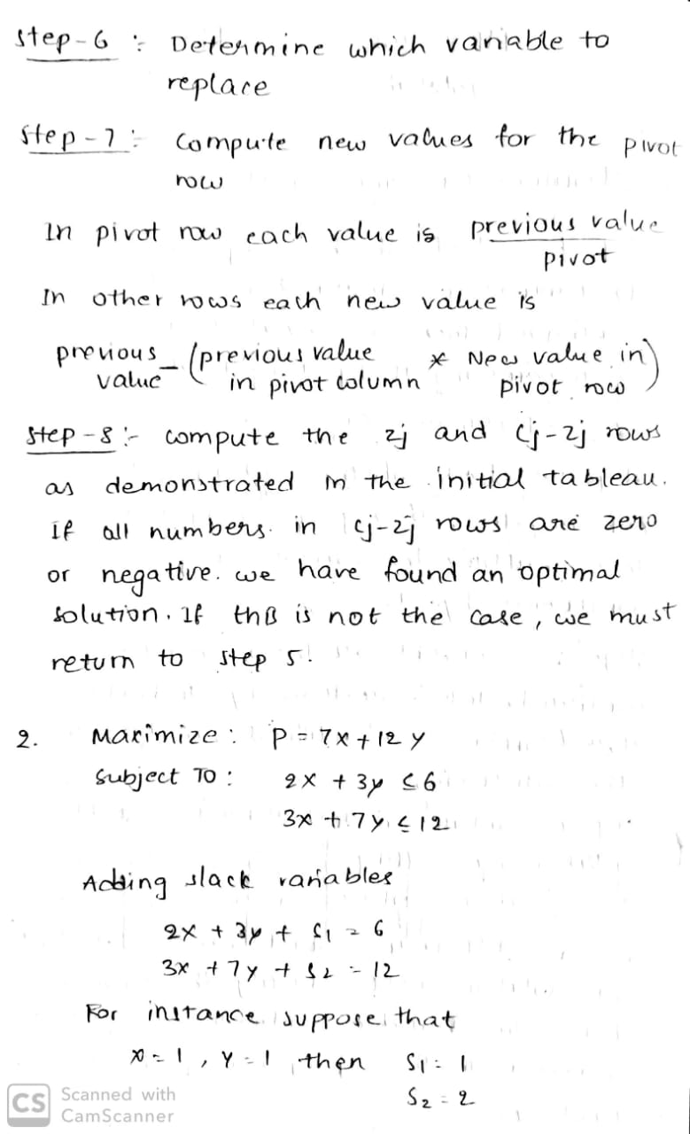

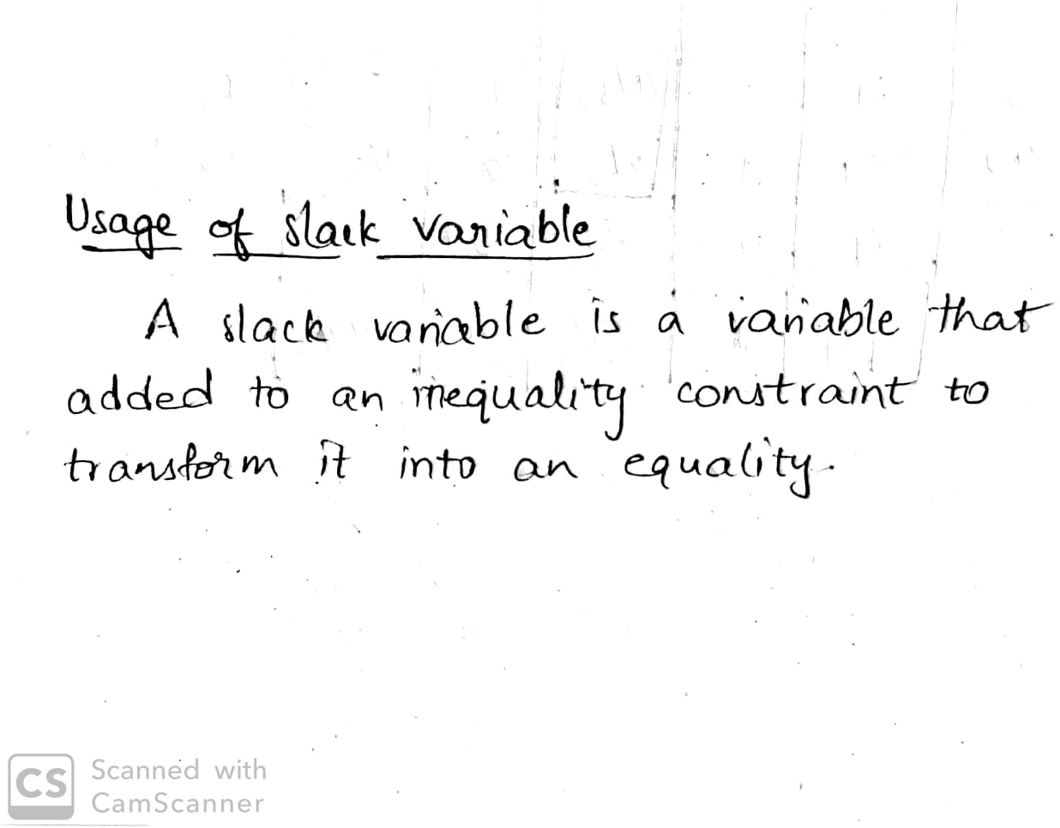

1. Consider the following linear programming problem

Maximize:

*P* = 7*x* + 12*y*

Subject to:

2*x* + 3*y* ≤ 6

3*x* + 7*y* ≤12

SetUp the Initial Simplex Tableau.

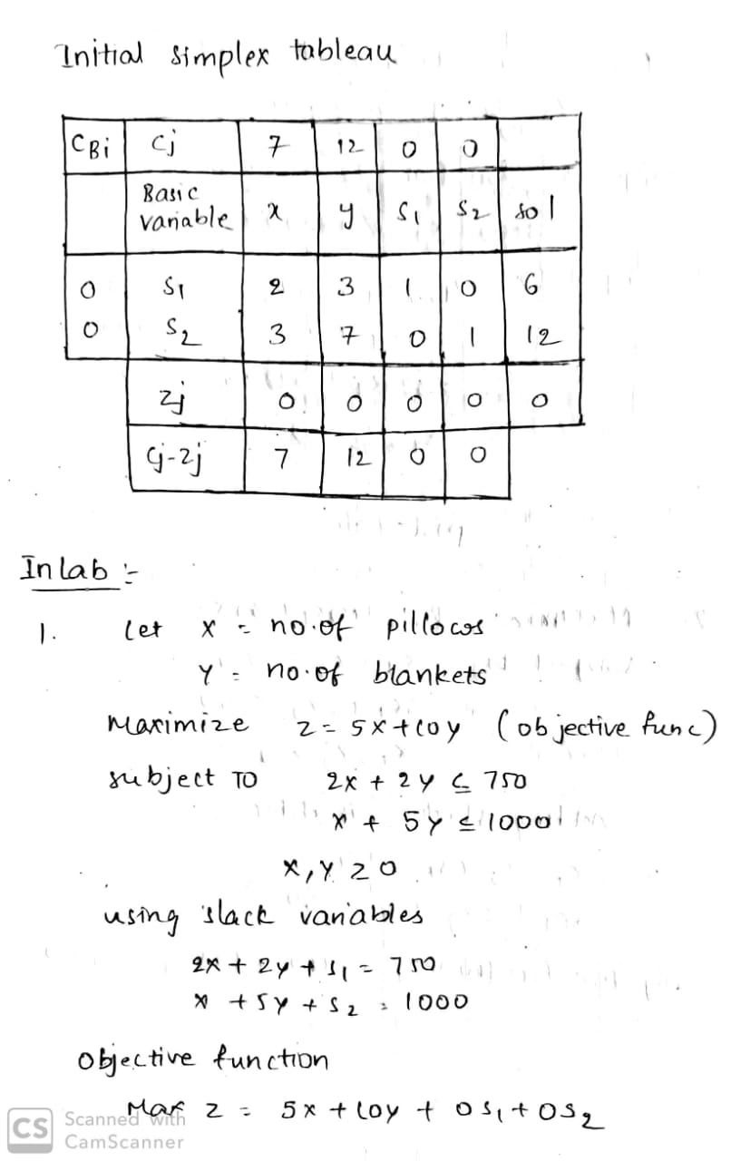

**INLAB**

1. A hotel has requested a manufacturer to produce pillows and blanketsfor their room service. For materials, the manufacturer has 750 m² of cotton textile and 1,000 m² of silk. Every pillow needs 2 m² of cotton and 1 m² of silk. Every blanket needs 2 m² of cotton and 5 m² of silk. The price of the pillow is fixed at $5 and the blanket is fixed at $10.What is the number of pillows and blankets that the manufacturer must give to the hotel so that these items obtain a maximum sale? Formulate and Solve using Python.



**Code:**

**import numpy as np**

**import scipy as sp**

**#create the matrix for objective function and constraints**

**z=np.array([-5,-10])**

**a=np.array([[2,2],[1,5]])**

**b=np.array([750,1000])**

**x1_bound=(0,None)**

**x2_bound=(0,None)**

**from scipy.optimize import linprog**

**#Required command to get result**

**result=linprog(z,A_ub=a,b_ub=b,bounds=[x1_bound,x2_bound])**

**print result**

**OUTPUT**

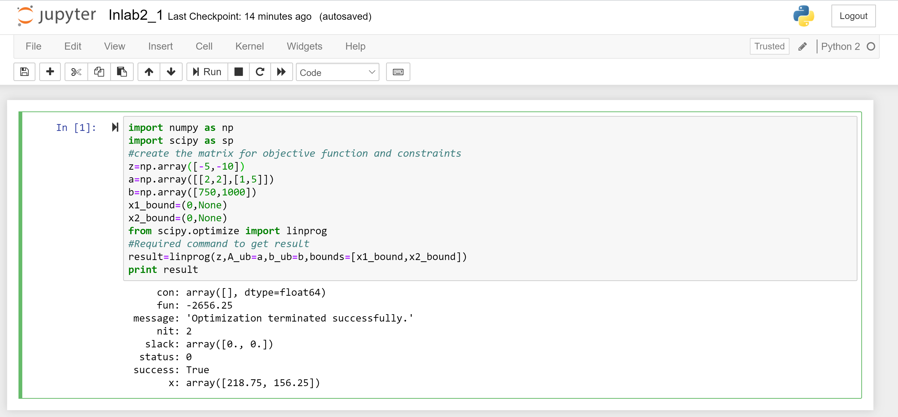

1. Kiran owns a petroleum company, which consists of two refineries.Refinery 1 costs $32,000 per day to operate, and it can produce 455 barrels of high-grade oil, 280 barrels of medium-grade oil, and 232 barrels of low-grade oil each day. Refinery 2 is newer and more modern. It costs $40,000 per day to operate, and it can produce 350 barrels of high-grade oil, 438 barrels of medium-grade oil, and 522 barrels of low-grade oil each day. The company has orders totaling 25,625 barrels of high-grade oil, 24,992 barrels of medium-grade oil, and 29,568 barrels of low-grade oil. How many days should it run each refinery to minimize its costs and still refine enough oil to meet its orders? Formulate the problem and solve using Python.

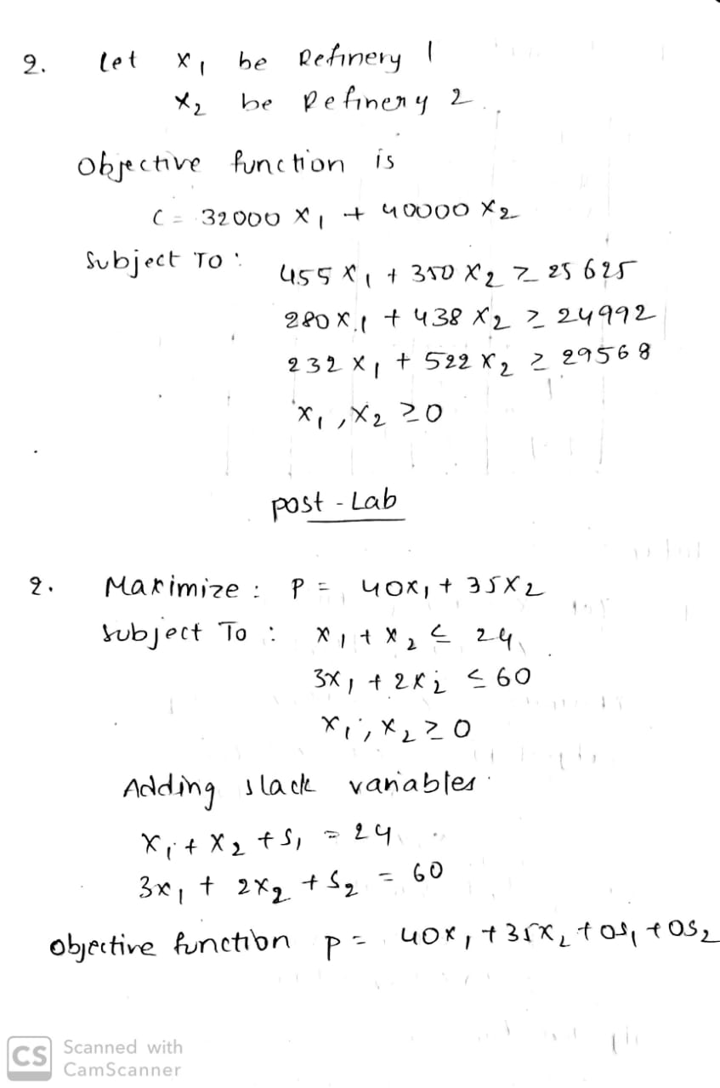

**Code:**

**import numpy as np**

**import scipy as sp**

**c = [-32000,-40000]**

**A = [[455,350], [280,438], [232,522]]**

**b = [25625,24992,29568]**

**x0_bounds = (0, None)**

**x1_bounds = (0, None)**

**from scipy.optimize import linprog**

**# Solve the problem by Simplex method in Optimization**

**res = linprog(c, A_ub=A, b_ub=b, bounds=(x0_bounds, x1_bounds), method='simplex', options={"disp": True})**

**print res**

**OUTPUT**

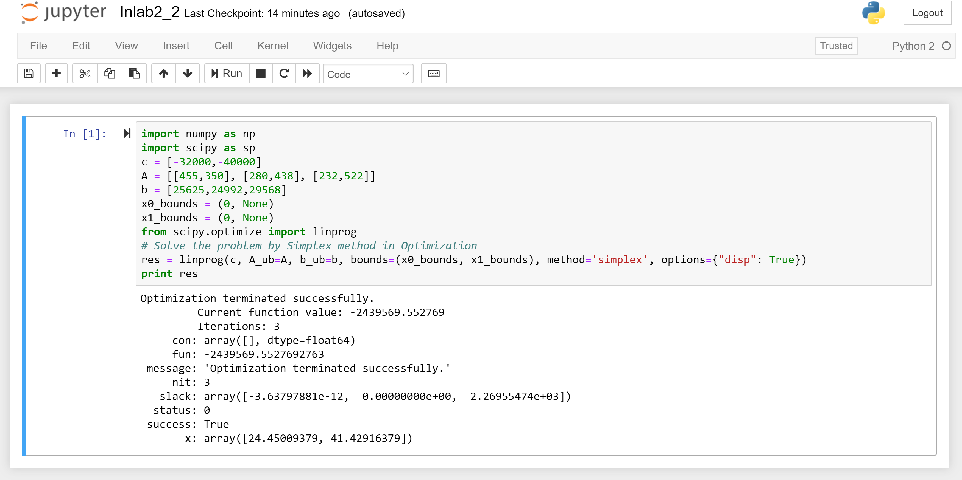

**POSTLAB**

1. Maximize Z=3 x1 + 5 x2

Subject TO:

3 x1 + 2 x2 =18

X1 <= 4

2 x2 <= 12

X1 >=0

X2 >= 0

Solve LP using simplex method using Python

**Code:**

**import numpy as np**

**import scipy as sp**

**c = [-3, -5]**

**A = [[1, 0], [0, 2], [3, 2]]**

**b = [4, 12, 18]**

**x0_bounds = (0, None)**

**x1_bounds = (0, None)**

**from scipy.optimize import linprog**

**# Solve the problem by Simplex method in Optimization**

**res = linprog(c, A_ub=A, b_ub=b, bounds=(x0_bounds, x1_bounds), method='simplex', options={"disp": True})**

**print res**

**OUTPUT**

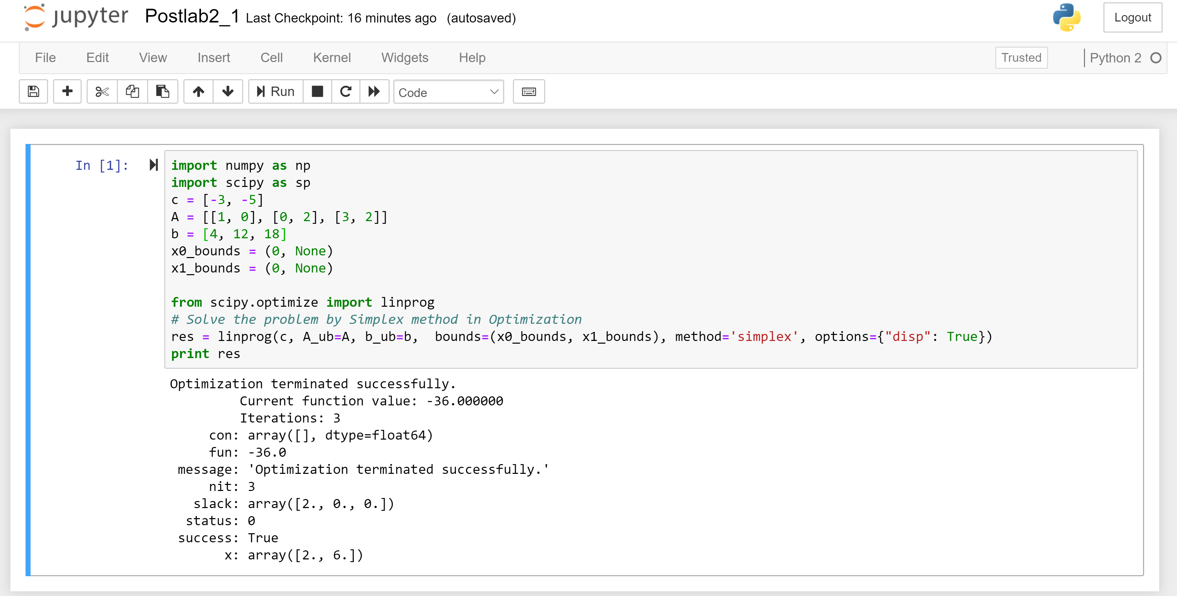

2. Solve Linear Programming Model Using Simplex Method

Maximize: P=40x1+35x2

Subject To: x1 +x2 <=24

3x1 +2x2<=60

X1,x2 >=0



