**MP-1 TUTORIAL-3**

**PRELAB**

1. Differentiate Simplex and two-phase simplex method.

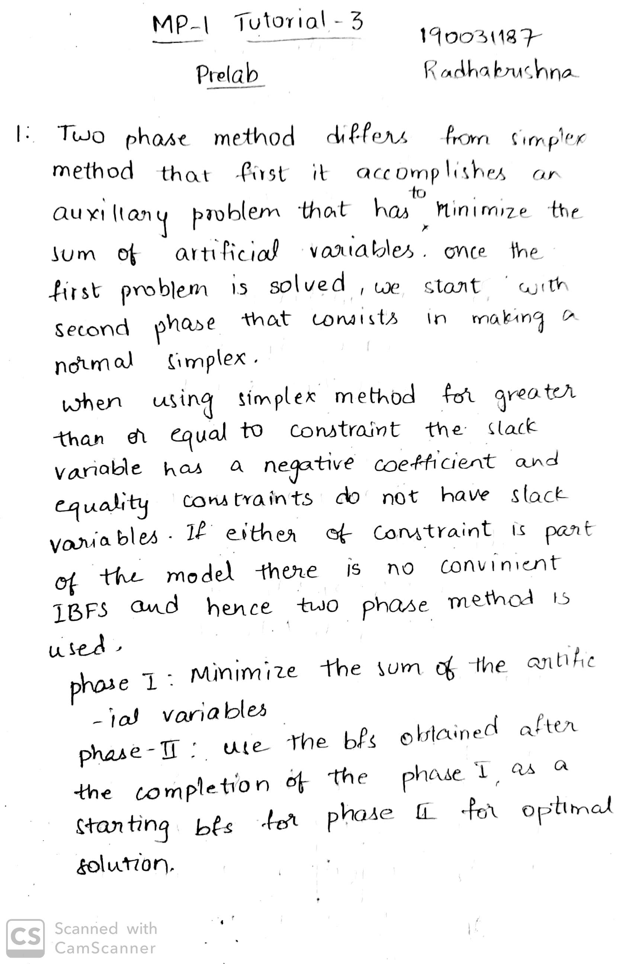

1. Minimum Z=x1+x2

Subject to:

2x1 + x2 >=4

X1 + 7x2 >=7

And x1, x2>=0

Solve using Two-phase method

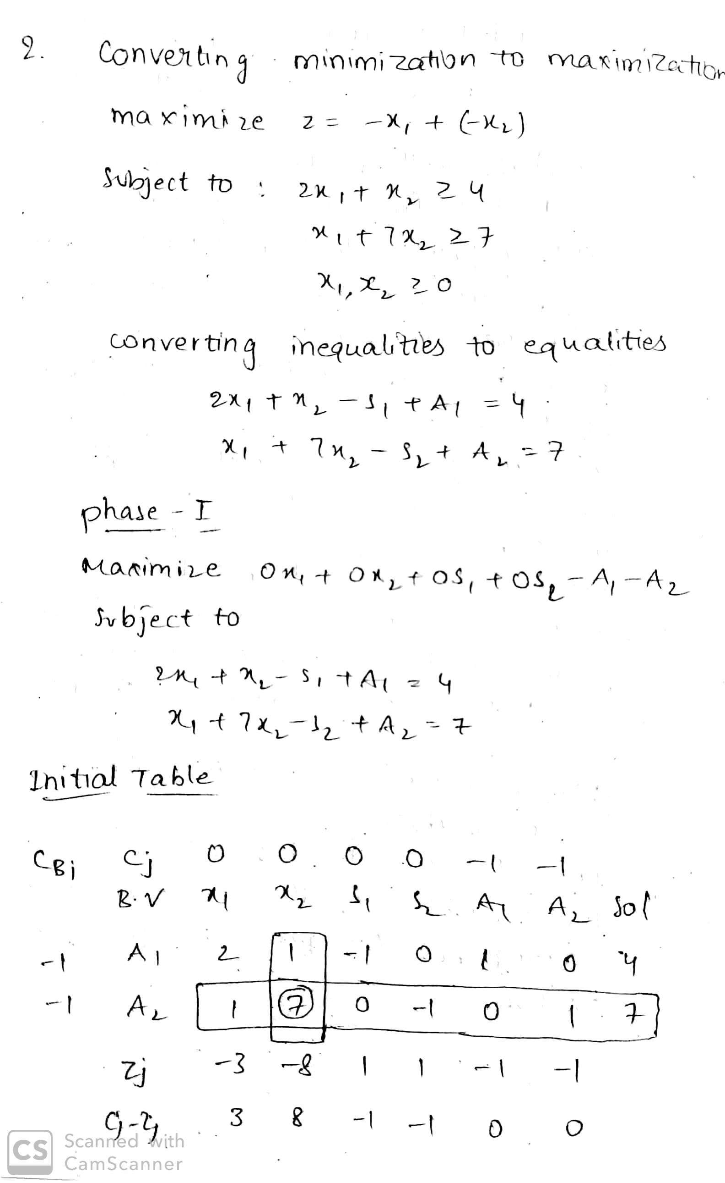

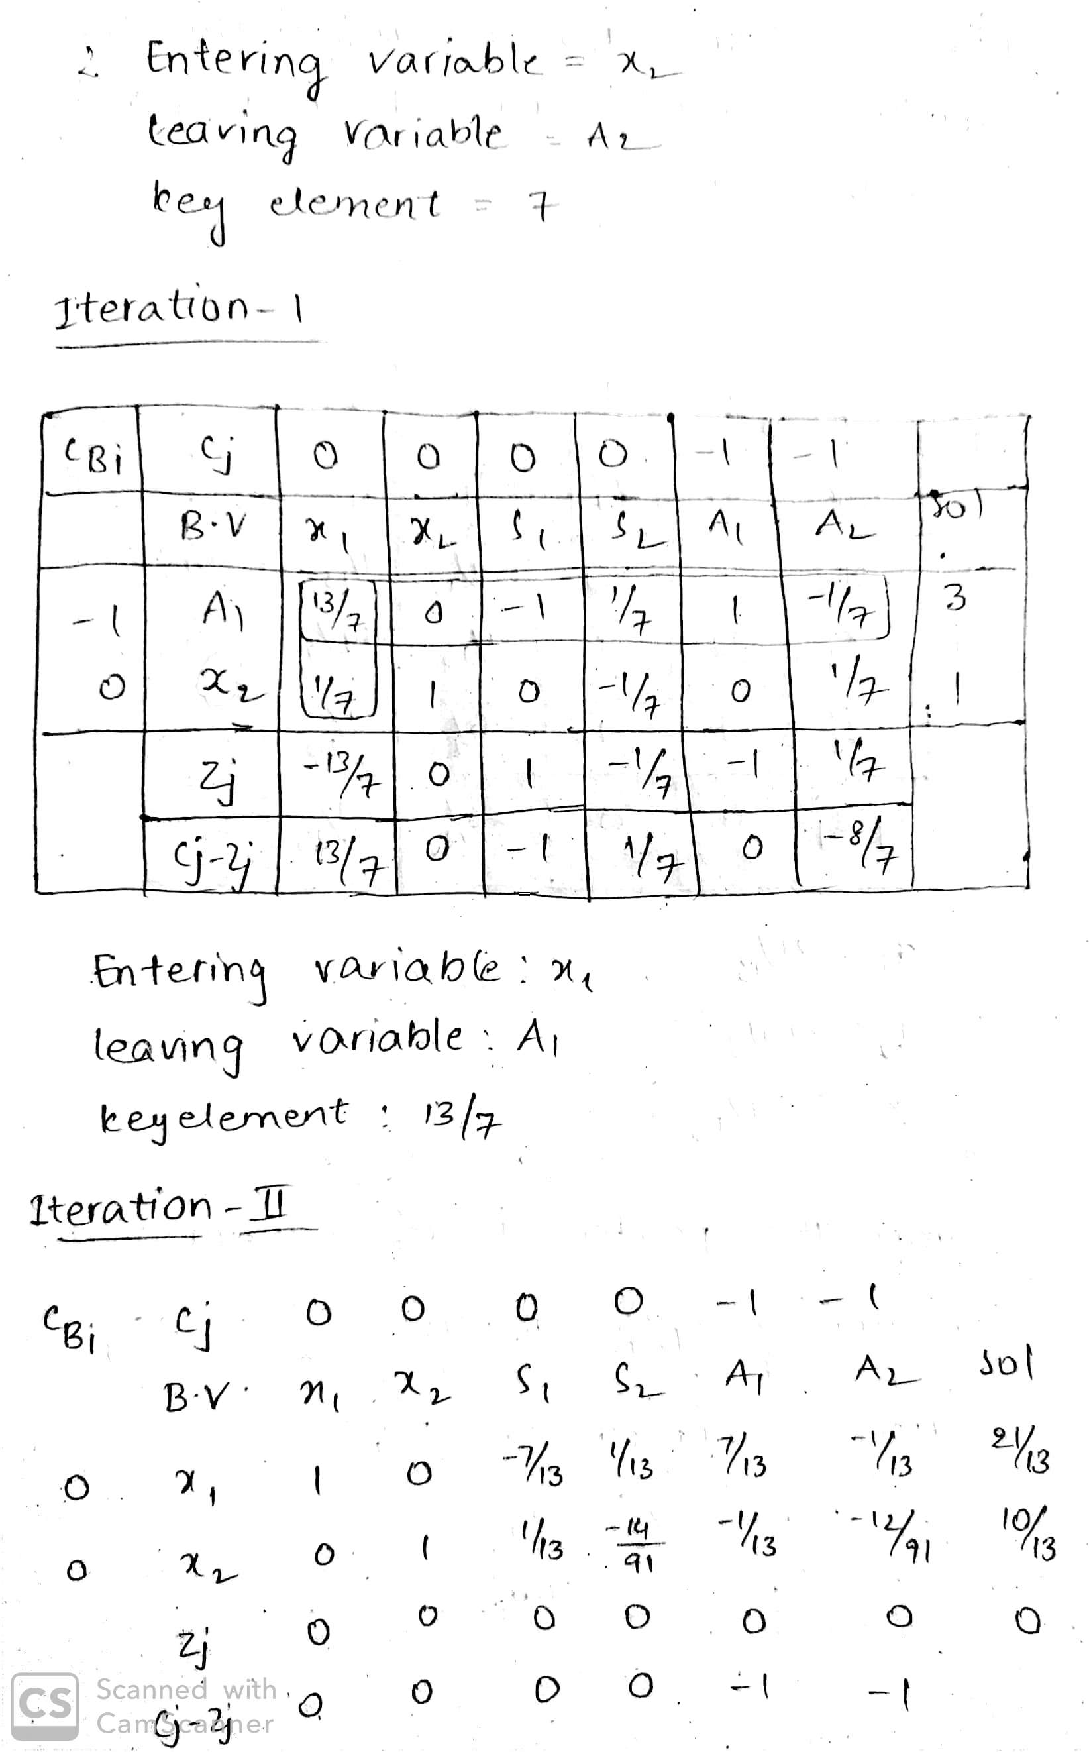

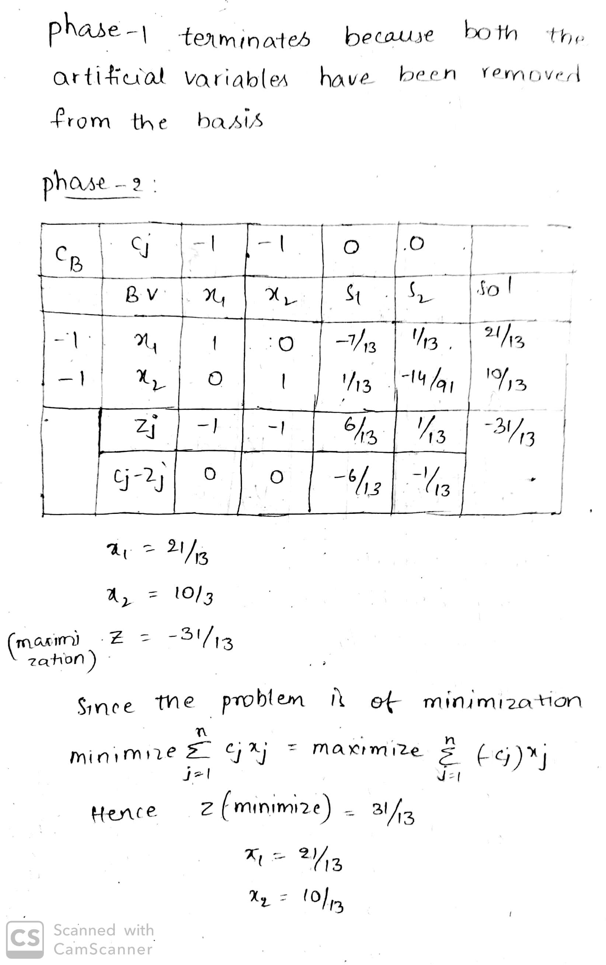

**INLAB**

1.Minimize: z = x1 + x2 + x3 + x4 + x5  
Subject to:

3x1 + 2x2 + x3               = 1  
                 5x1 +  x2 +  x3 + x4        = 3  
                 2x1 + 5x2 + x3 +       x5  = 4

Solve using two-phase simplex method in python.

def printTableu(tableu):

print '----------------------'

for row in tableu:

print row

print '----------------------'

return

def pivotOn(tableu, row, col):

j = 0

pivot = tableu[row][col]

for x in tableu[row]:

tableu[row][j] = tableu[row][j] / pivot

j += 1

i = 0

for xi in tableu:

if i != row:

ratio = xi[col]

j = 0

for xij in xi:

xij -= ratio * tableu[row][j]

tableu[i][j] = xij

j += 1

i += 1

return tableu

# assuming tablue in standard form with basis formed in last m columns

def phase_1_simplex(tableu):

THETA_INFINITE = -1

opt = False

unbounded = False

n = len(tableu[0])

m = len(tableu) - 2

while ((not opt) and (not unbounded)):

min = 0.0

pivotCol = j = 1

while(j < (n-m)):

cj = tableu[1][j]

if (cj < min):

min = cj

pivotCol = j

j += 1

if min == 0.0:

opt = True

continue

pivotRow = i = 0

minTheta = THETA_INFINITE

for xi in tableu:

if (i > 1):

xij = xi[pivotCol]

if xij > 0:

theta = (xi[0] / xij)

if (theta < minTheta) or (minTheta == THETA_INFINITE):

minTheta = theta

pivotRow = i

i += 1

if minTheta == THETA_INFINITE:

unbounded = True

continue

tableu = pivotOn(tableu, pivotRow, pivotCol)

return tableu

def simplex(tableu):

THETA_INFINITE = -1

opt = False

unbounded = False

n = len(tableu[0])

m = len(tableu) - 1

while ((not opt) and (not unbounded)):

min = 0.0

pivotCol = j = 0

while(j < (n-m)):

cj = tableu[0][j]

if (cj < min) and (j > 0):

min = cj

pivotCol = j

j += 1

if min == 0.0:

opt = True

continue

pivotRow = i = 0

minTheta = THETA_INFINITE

for xi in tableu:

if (i > 0):

xij = xi[pivotCol]

if xij > 0:

theta = (xi[0] / xij)

if (theta < minTheta) or (minTheta == THETA_INFINITE):

minTheta = theta

pivotRow = i

i += 1

if minTheta == THETA_INFINITE:

unbounded = True

continue

tableu = pivotOn(tableu, pivotRow, pivotCol)

return tableu

def drive_out_artificial_basis(tableu):

n = len(tableu[0])

j = n - 1

isbasis = True

while(j > 0):

found = False

i = -1

row = 0

for xi in tableu:

i += 1

if (xi[j] == 1):

if (found):

isbasis = False

continue

elif (i > 1):

row = i

found = True

elif (xi[0] != 0):

isbasis = False

continue

if (isbasis and found):

if (j >= n):

tableu = pivotOn(tableu, row, j)

else:

return tableu

j -= 1

return tableu

def two_phase_simpelx(tableu):

infeasible = False

tableu = phase_1_simplex(tableu)

sigma = tableu[1][0]

if (sigma > 0):

infeasible = True

print 'infeasible'

else:

#sigma is equals to zero

tableu = drive_out_artificial_basis(tableu)

m = len(tableu) - 2

n = len(tableu[0])

n -= m

tableu.pop(1)

i = 0

while (i < len(tableu)):

tableu[i] = tableu[i][:n]

i += 1

tableu = simplex(tableu)

return tableu

def getTableu(c, eqs, b):

#assume b >= 0 so if there is any b[i] negative make sure to enter

#it possitive by multiplying (-1 * eqs[i]) and (-1 * b[i]) for all i

tableu = []

m = len(eqs)

n = len(c)

c.insert(0, 0.0)

artificial = []

sigma = [0.0]

i = 0

while (i < n):

sigma.append(0.0)

i += 1

i = 0

while (i < m):

artificial.append(0.0)

sigma.append(1.0)

i += 1

c.extend(artificial)

tableu.append(c)

tableu.append(sigma)

i = 0

for eq in eqs:

eq.insert(0, b[i])

eq.extend(artificial)

eq[n+1+i] = 1.0

tableu.append(eq)

i += 1

i = 0

for xi in tableu:

if (i > 1):

j = 0

for xij in xi:

tableu[1][j] -= xij

j += 1

i += 1

return tableu

c = [ 1.0, 1.0, 1.0, 1.0, 1.0,]

eq1 = [ 3.0 , 2.0 , 1.0 , 0.0, 0.0]

eq2 = [ 5.0 , 1.0 , 1.0 , 1.0, 0.0]

eq3 = [ 2.0 , 5.0 , 1.0 , 0.0, 1.0]

b = [1.0 , 3.0 , 4.0]

eqs = []

eqs.append(eq1)

eqs.append(eq2)

eqs.append(eq3)

tableu = getTableu(c,eqs,b)

printTableu(tableu)

tableu = two_phase_simpelx(tableu)

printTableu(tableu)

print 'minimum cost is = {}'.format( -tableu[0][0])

Output :

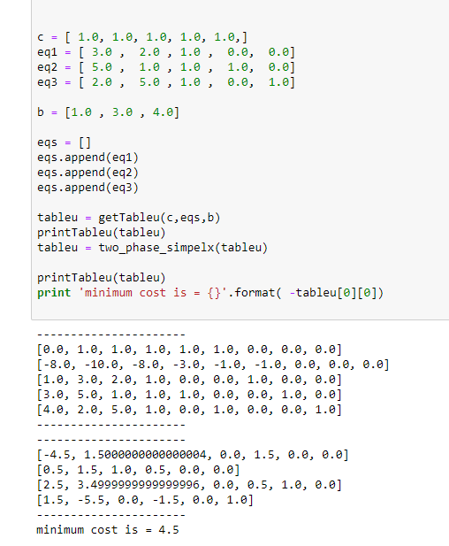

2. Minimize z = -3p1 + p2 – 2p3

subject to

p1 + 3p2 + p3 ≤ 5  
2p1 – p2 + p3 ≥ 2  
4p1 + 3p2 – 2p3 = 5

x1, x2, x3 ≥ 0

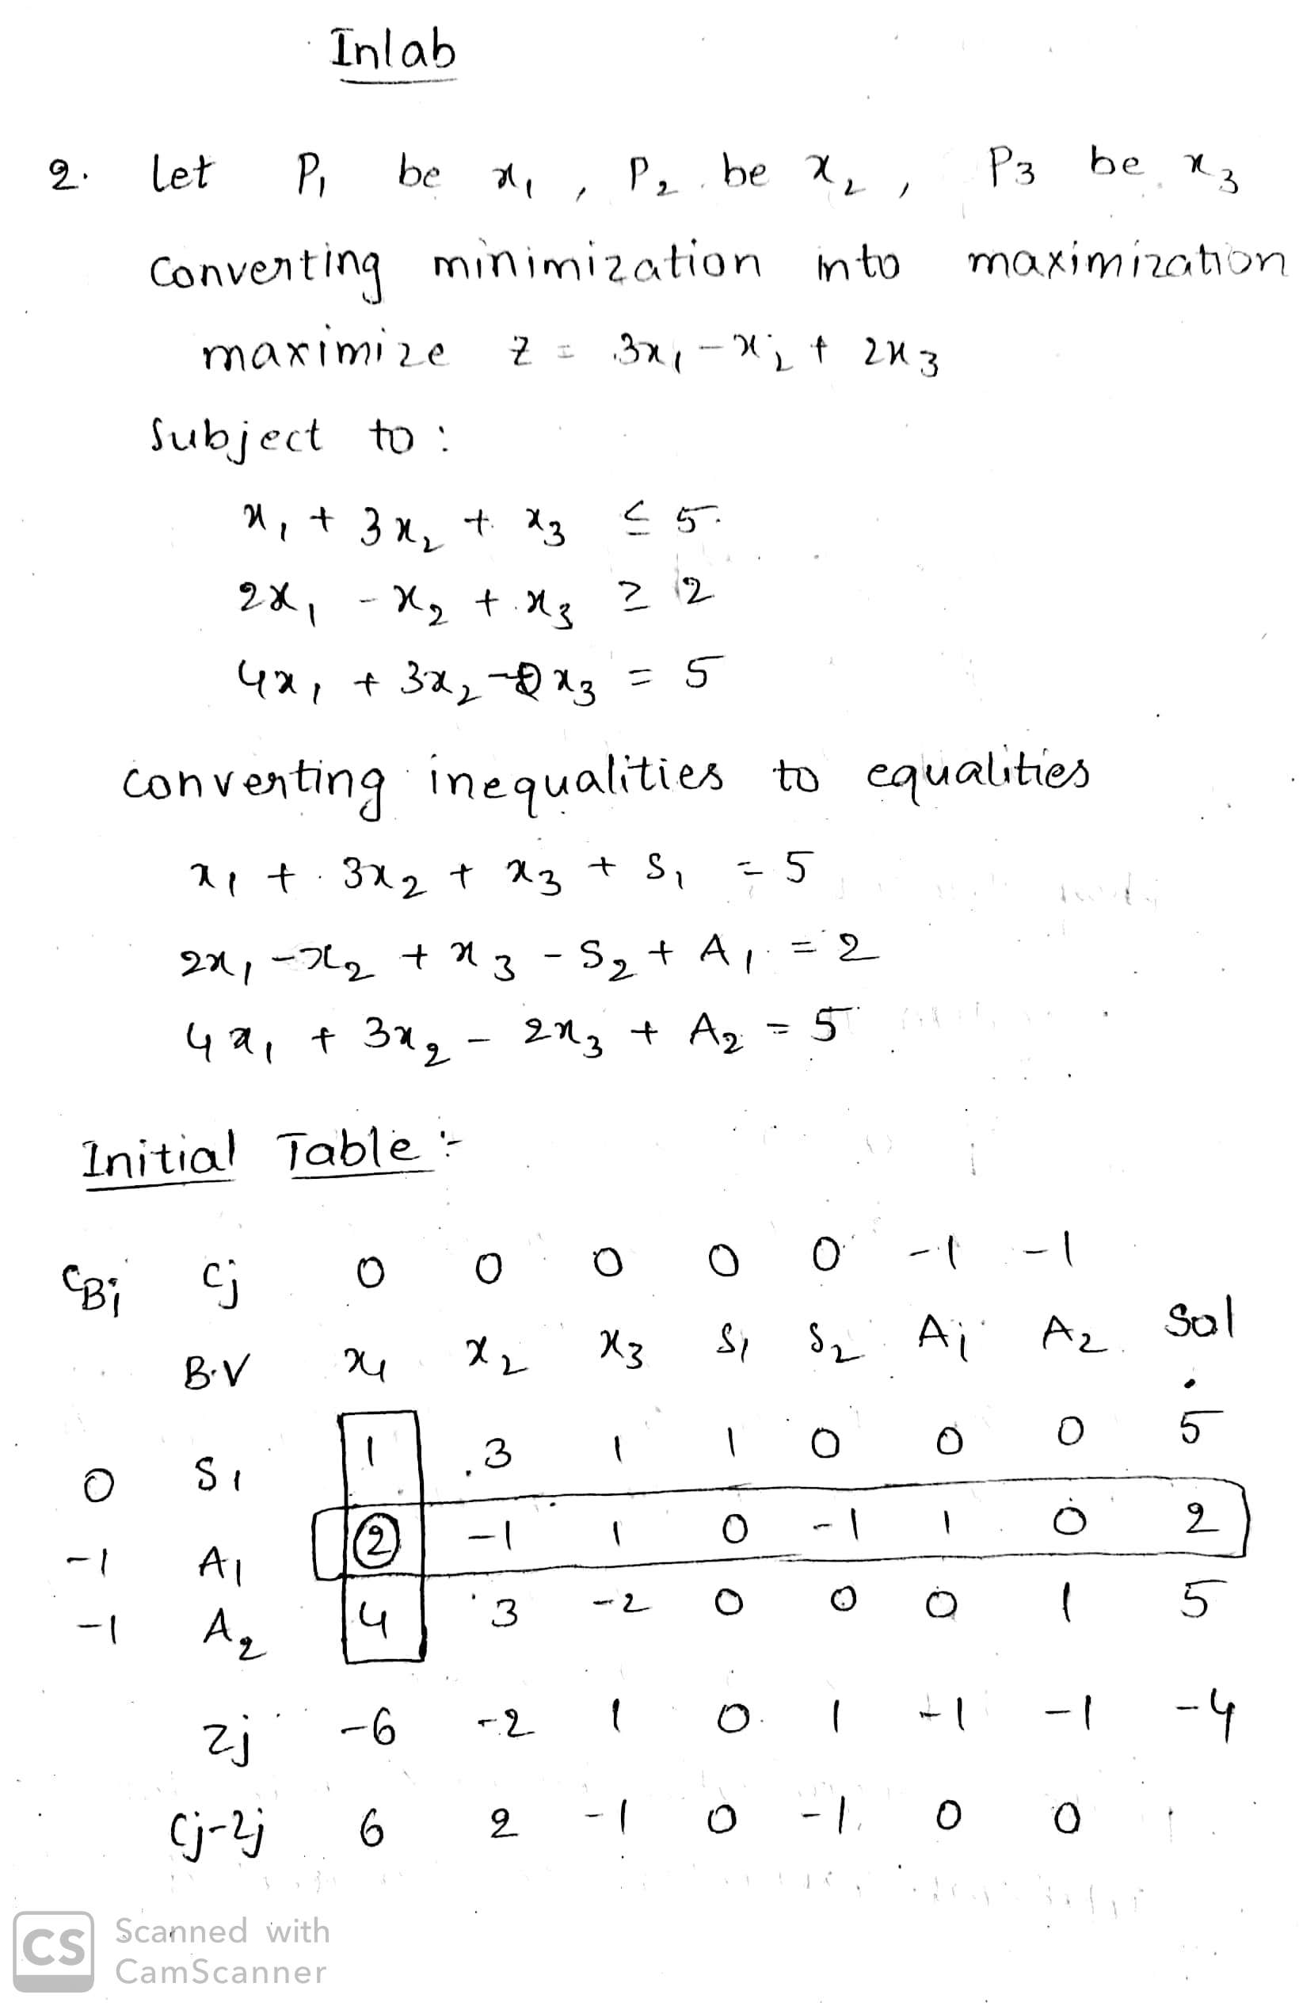

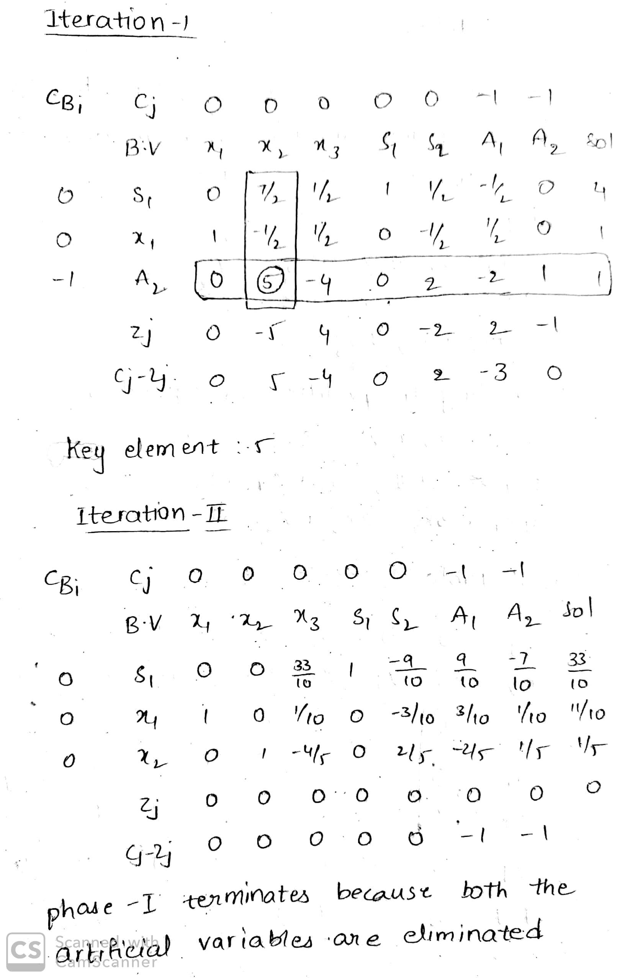

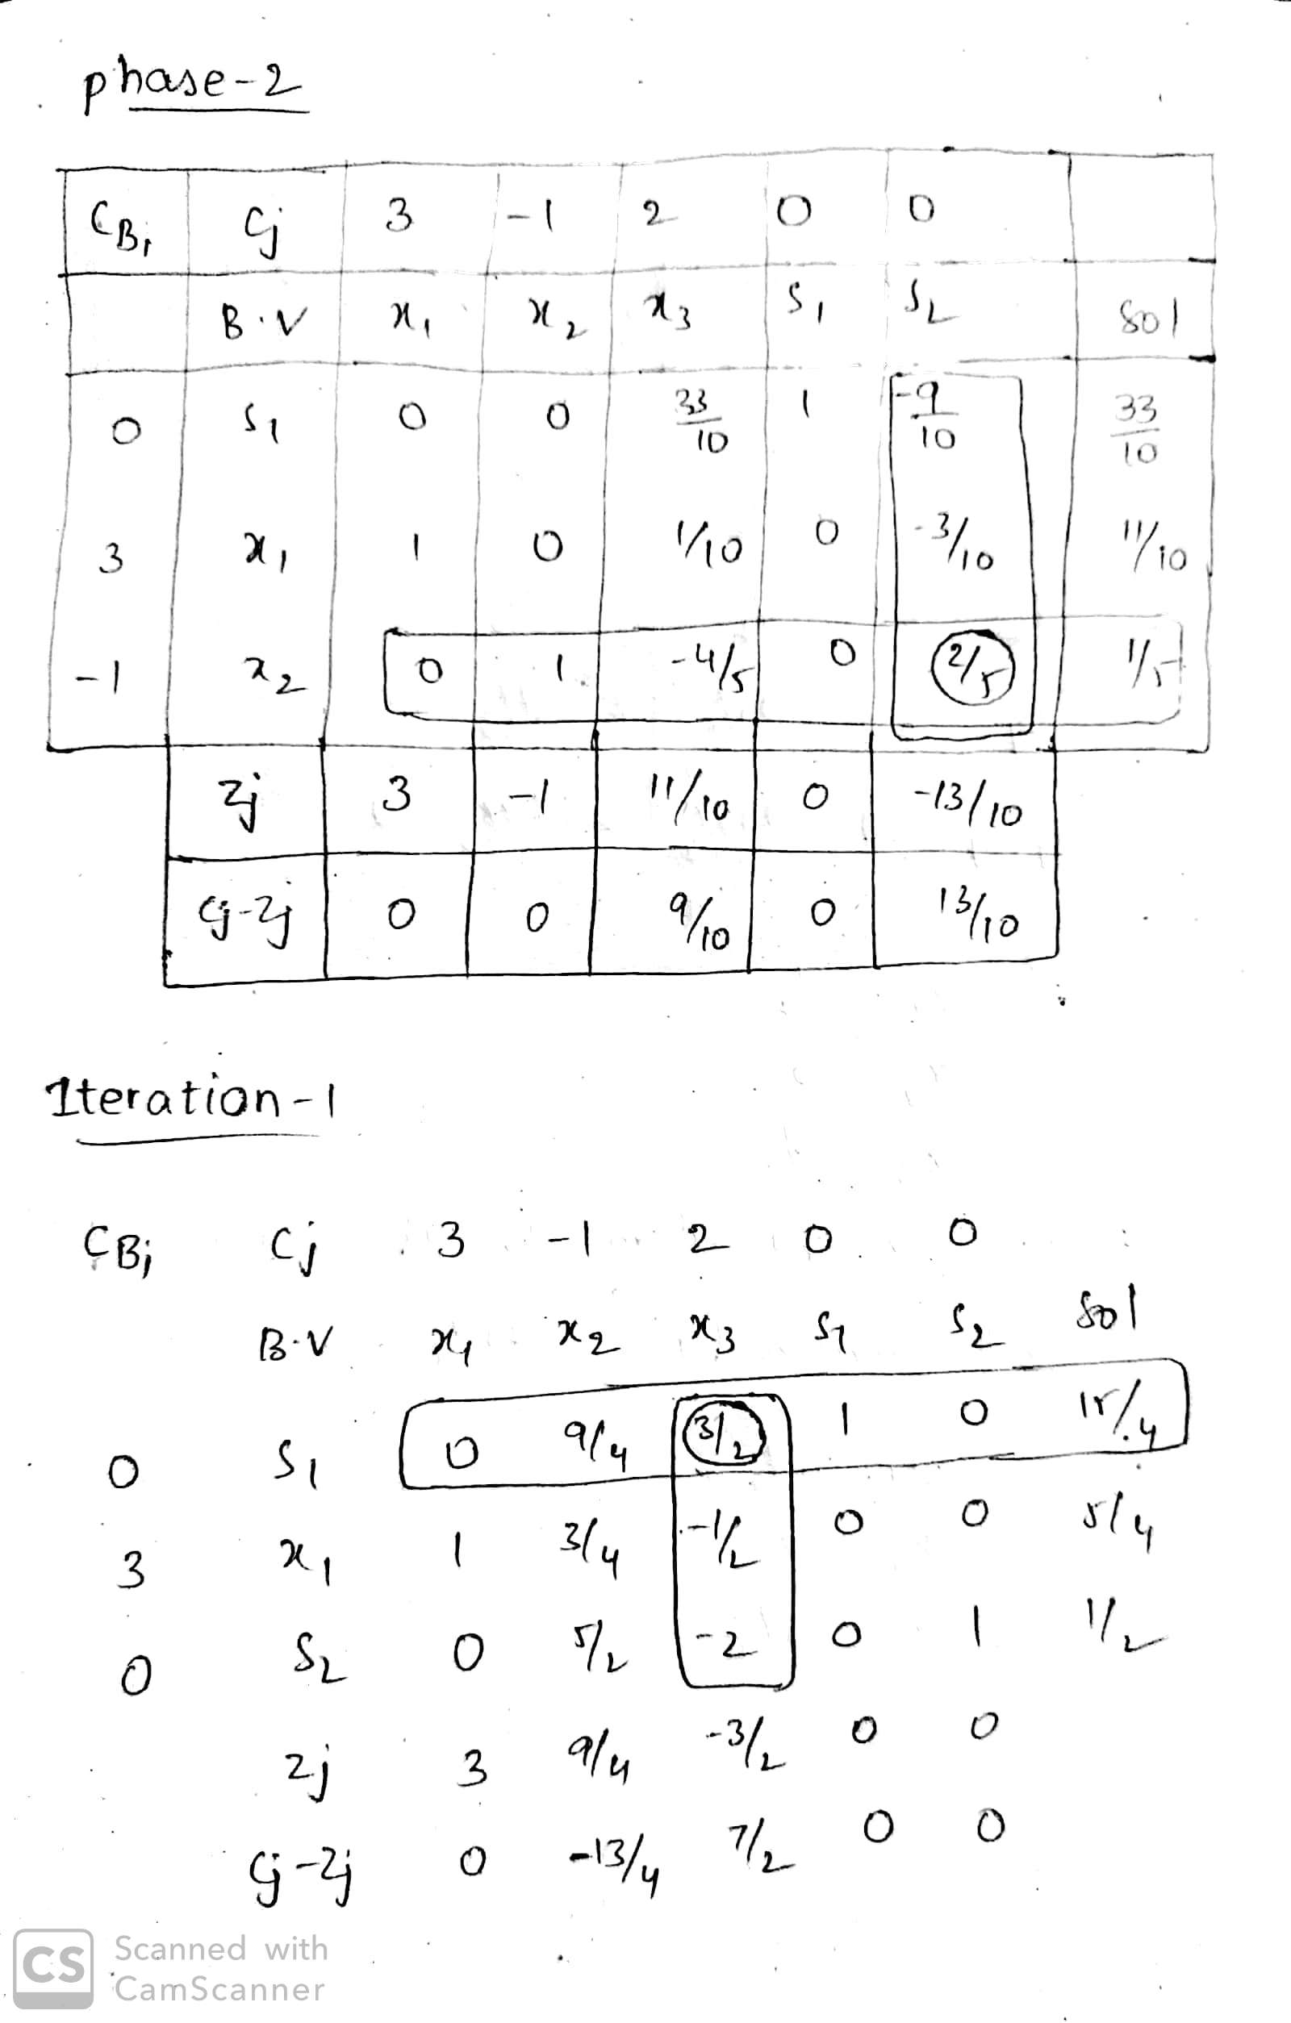

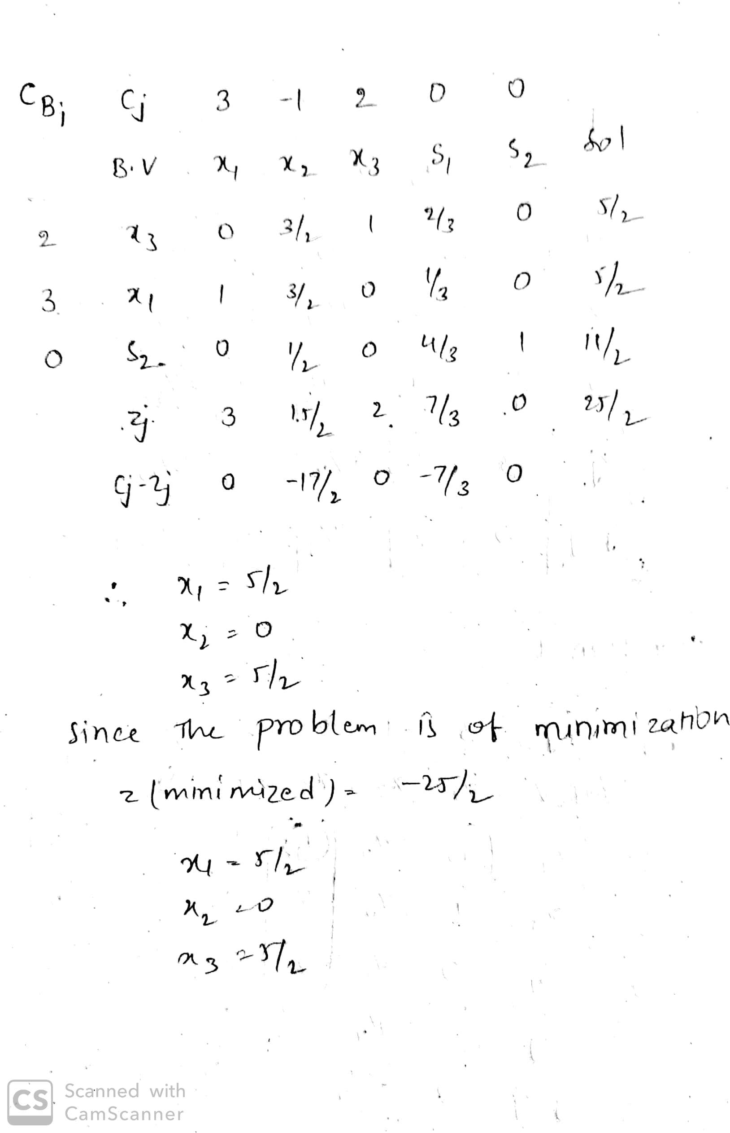

**POSTLAB**

1. Minimize Z =5 x1 + 2x2 +10 x3

Subject to :

X1 – x3 <=10

X2 + x3 >=10

And x1,x2,x3 >=0

Solve using two-phase simplex method.

`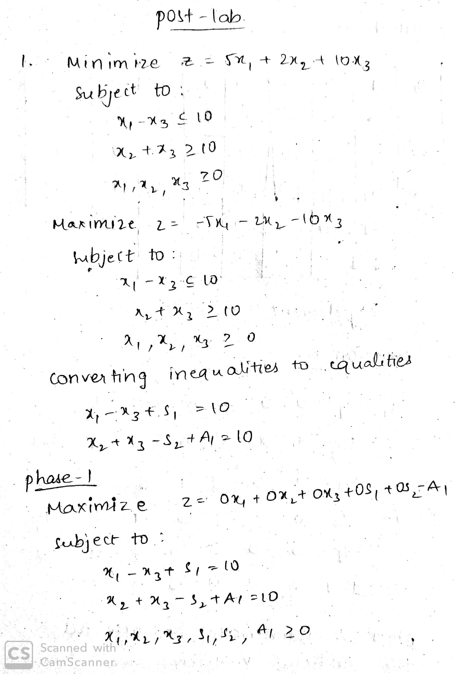

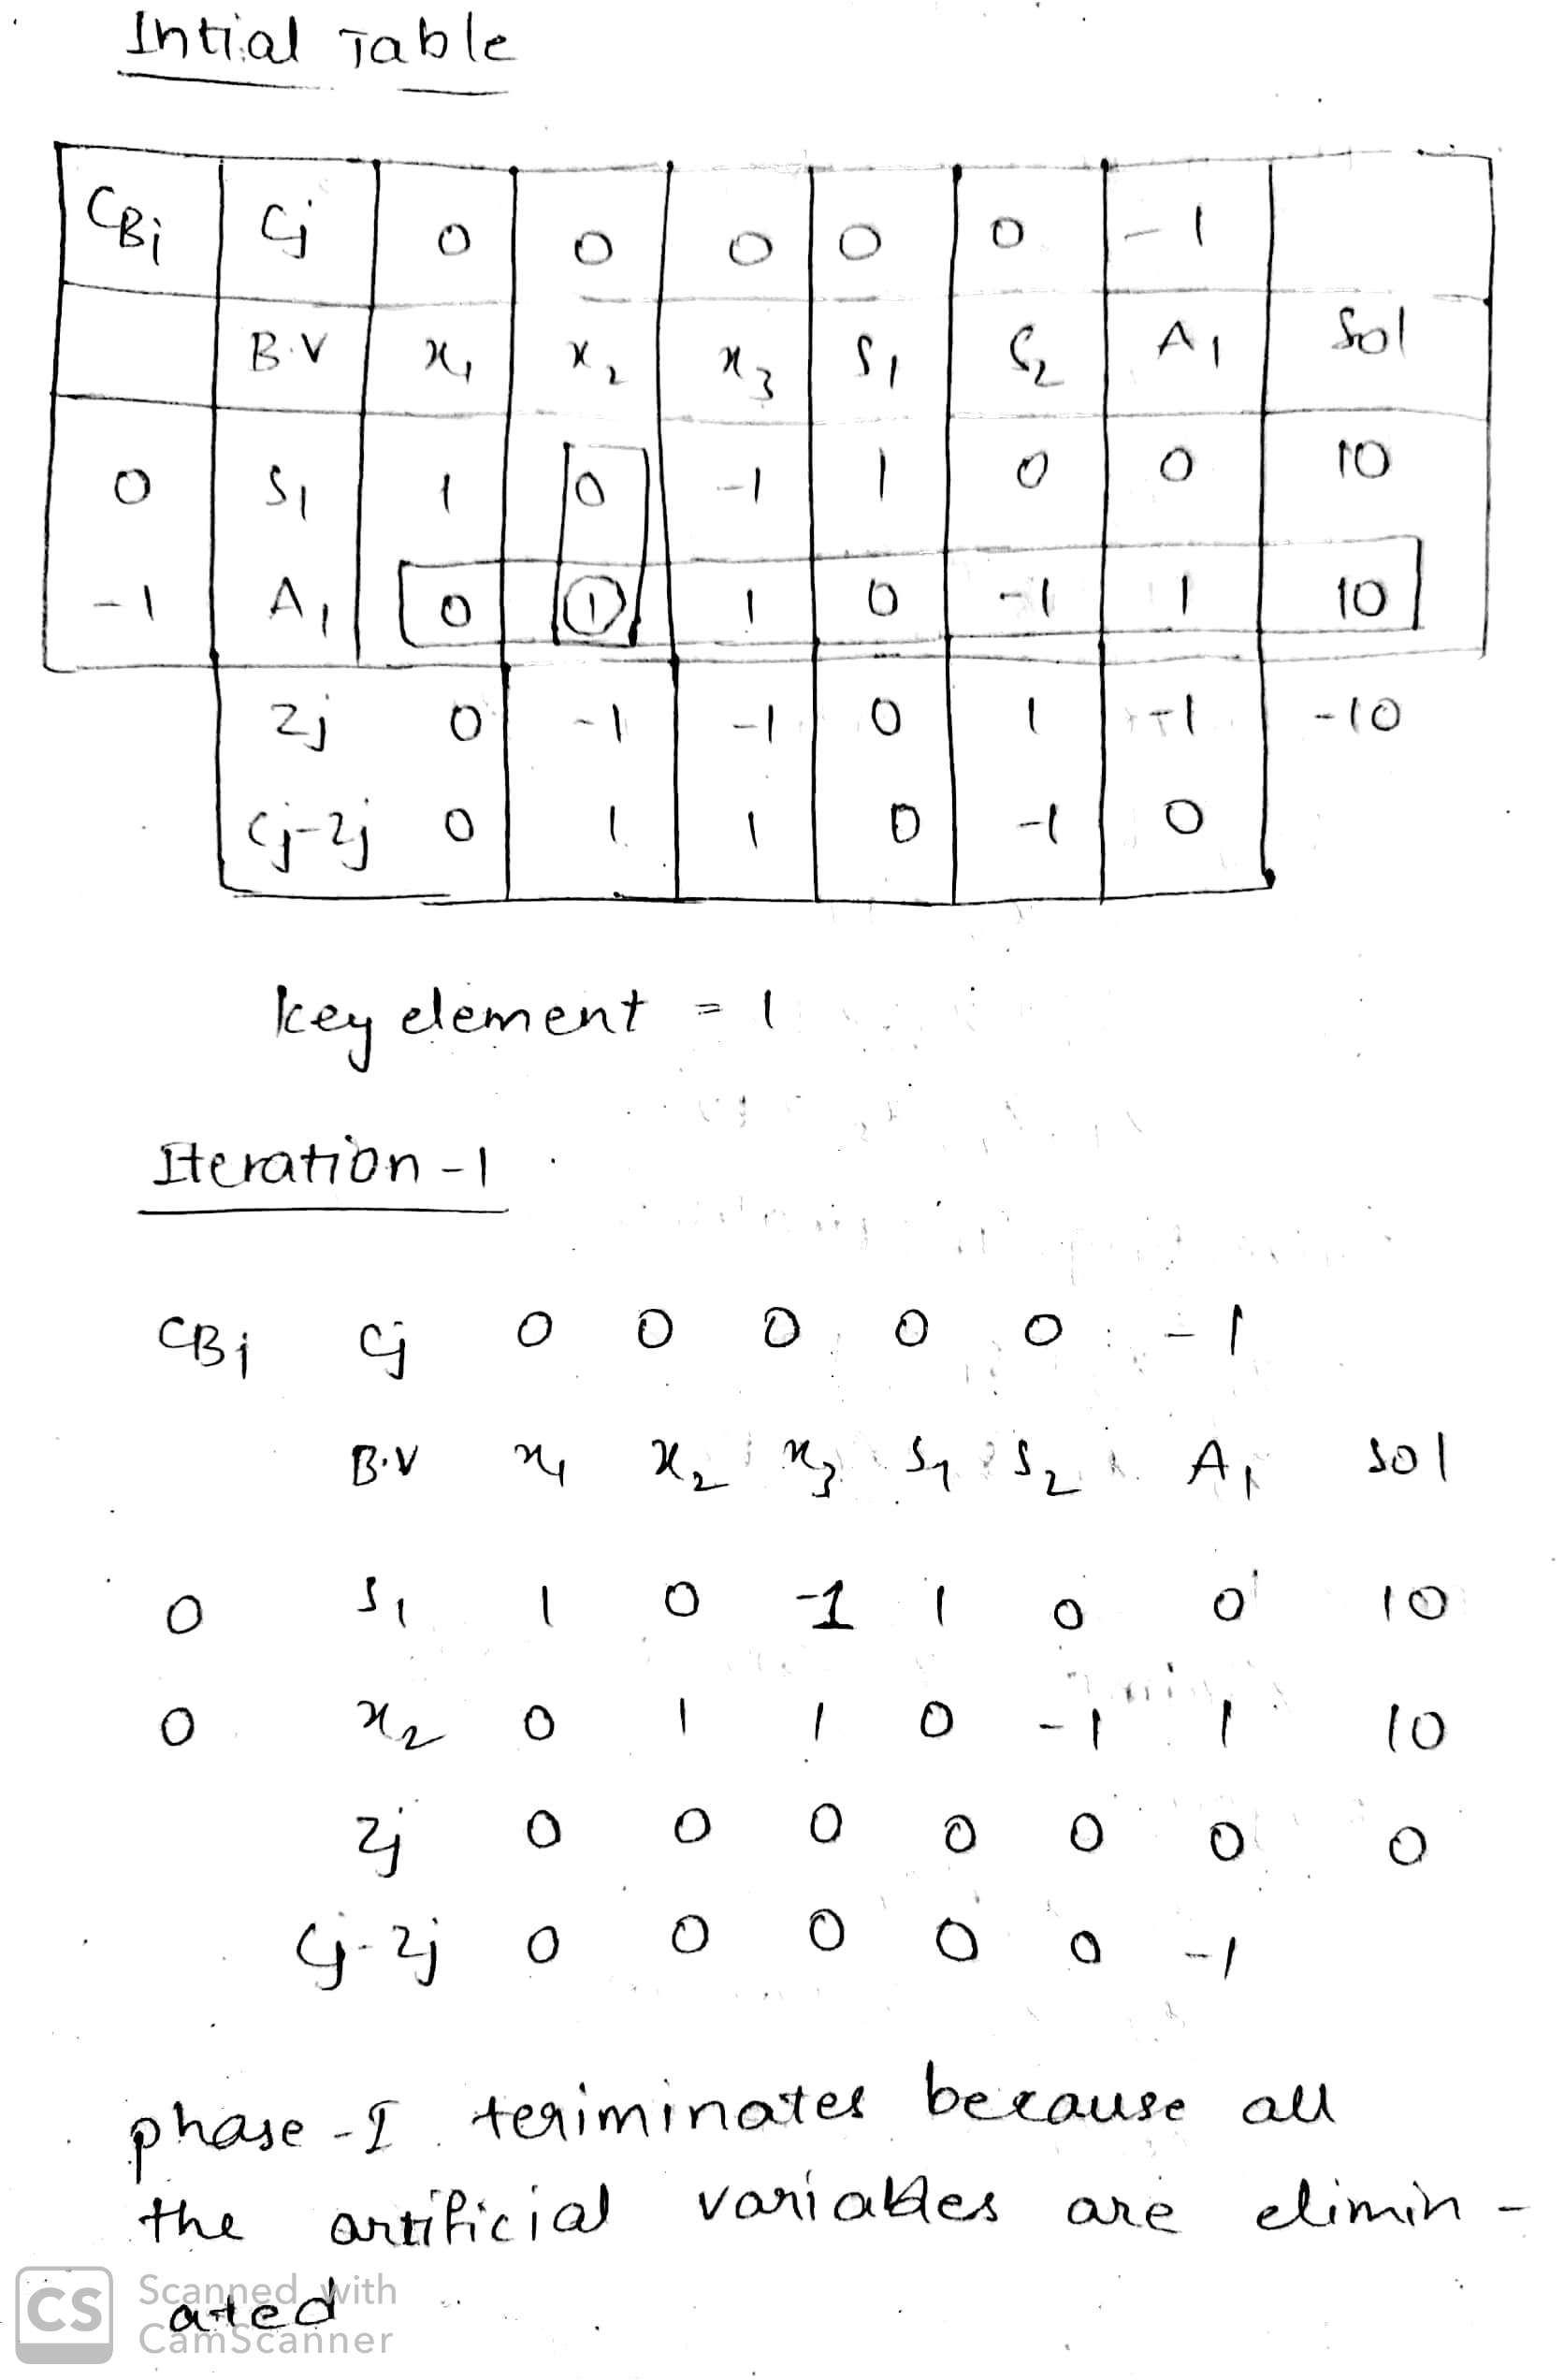

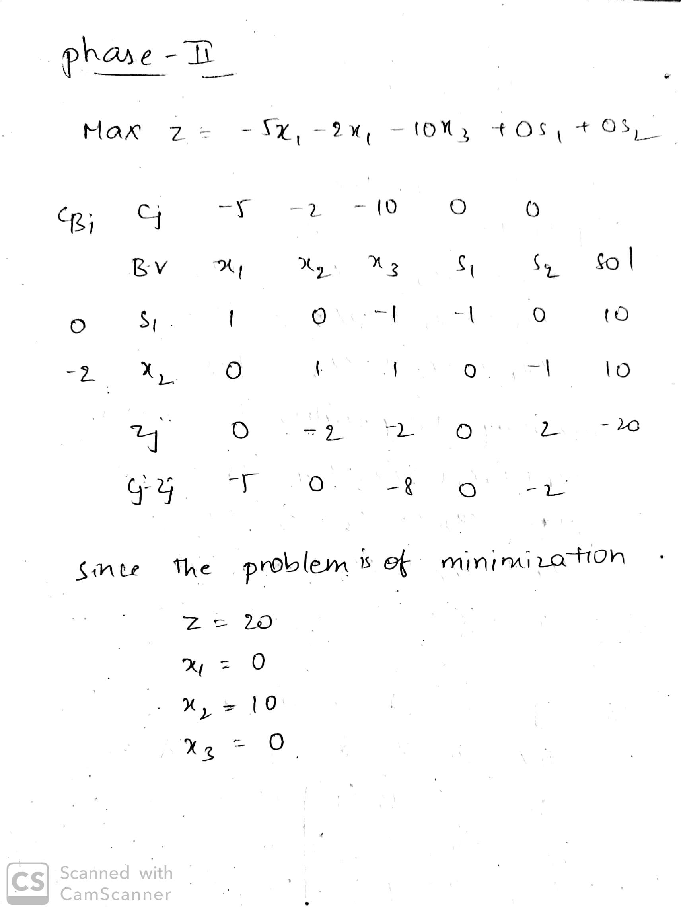

1. Maximize z = 12a1 + 15a2 + 9a3

subject to

8a1 + 16a2 + 12a3 ≤ 250  
4a1 + 8a2 + 10a3 ≥ 80  
7a1 + 9a2 + 8a3 = 105

a1, a2, a3 ≥ 0

