**MP-1 TUTORIAL-4**

**PRE-LAB**

1. State the general rules for formulating a dual LP problem from its primal?

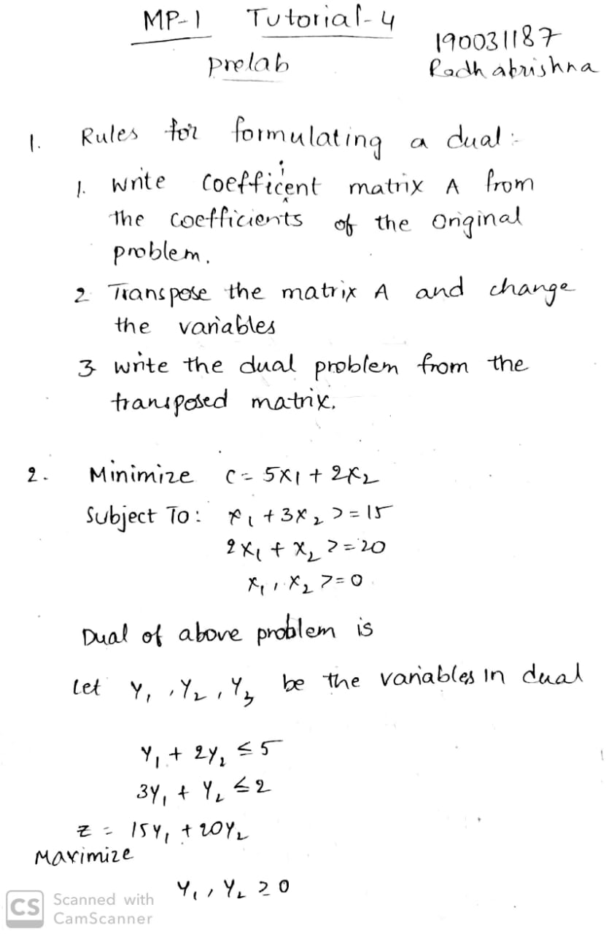

1. Minimize C=5x1+2x2

X1+3x2 >=15

Subject To: 2x1 + x2 >= 20

X1,x2 >=0

Find the dual problem for the above LP model.



1. Construct dual problem from primal problem.

Minimize C = 16 x1 + 45 x2

Subject to 2x1 + 5x2 ≥ 50

x1 + 3x2 ≥ 27

x1, x2 ≥ 0

Construct dual from Primal problem.

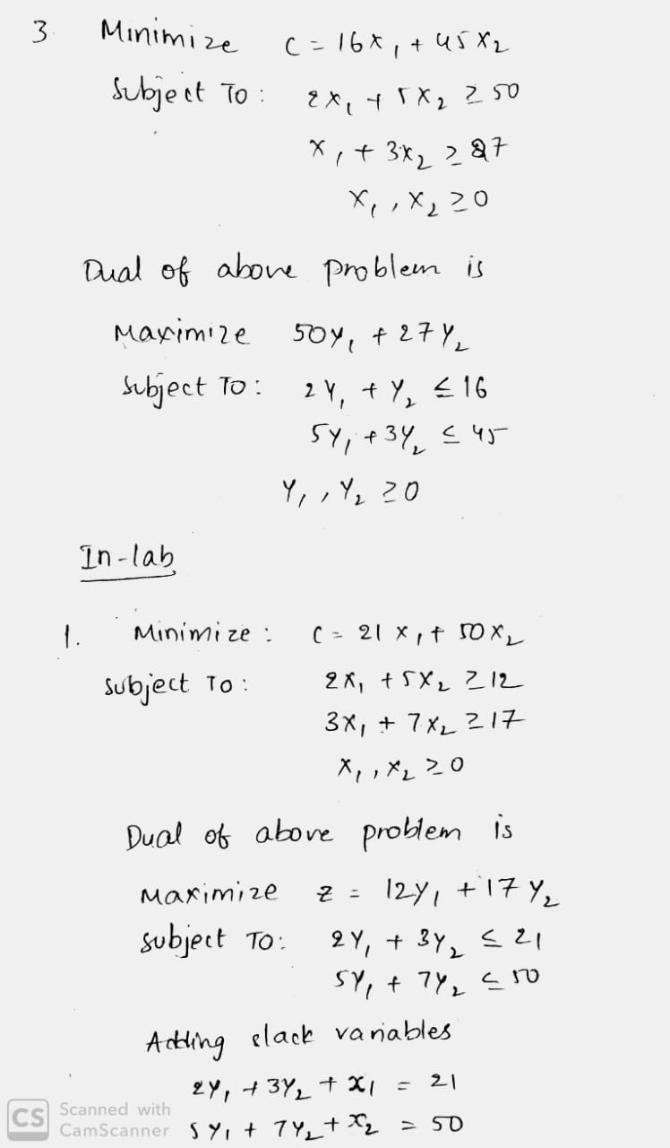

**INLAB**

**1.** Minimize : C=21x1 + 50x2

Subject To:

2x1 + 5x2 >=12

3x1 +7x2 >=17

X1,x2 >=0

A.Formulate Linear programming model.



B. Solve Dual LP model using Python.

**Code:**

**from pulp import \***

**from fractions import Fraction**

**prob = LpProblem("Dual problem",LpMinimize)**

**# nonnegativity constraints**

**x1=LpVariable("x1",0)**

**x2=LpVariable("x2",0)**

**# objective function**

**prob += 21*x1 + 50*x2, "Minimum value of 21*x1 + 50*x2"**

**# main constraints**

**prob += 2 * x1 + 5* x2 >= 12, "constraint 1"**

**prob += 3 * x1 + 7 * x2 >= 17, "constraint 2"**

**# The problem is solved using PuLP's choice of Solver**

**prob.solve()**

**print pulp.LpStatus[prob.status]**

**for i in prob.variables():**

**print "Variable {0} = {1}".format(i.name, i.varValue)**

**print "Objective function z = {0}".format(pulp.value(prob.objective))**

**OUTPUT**

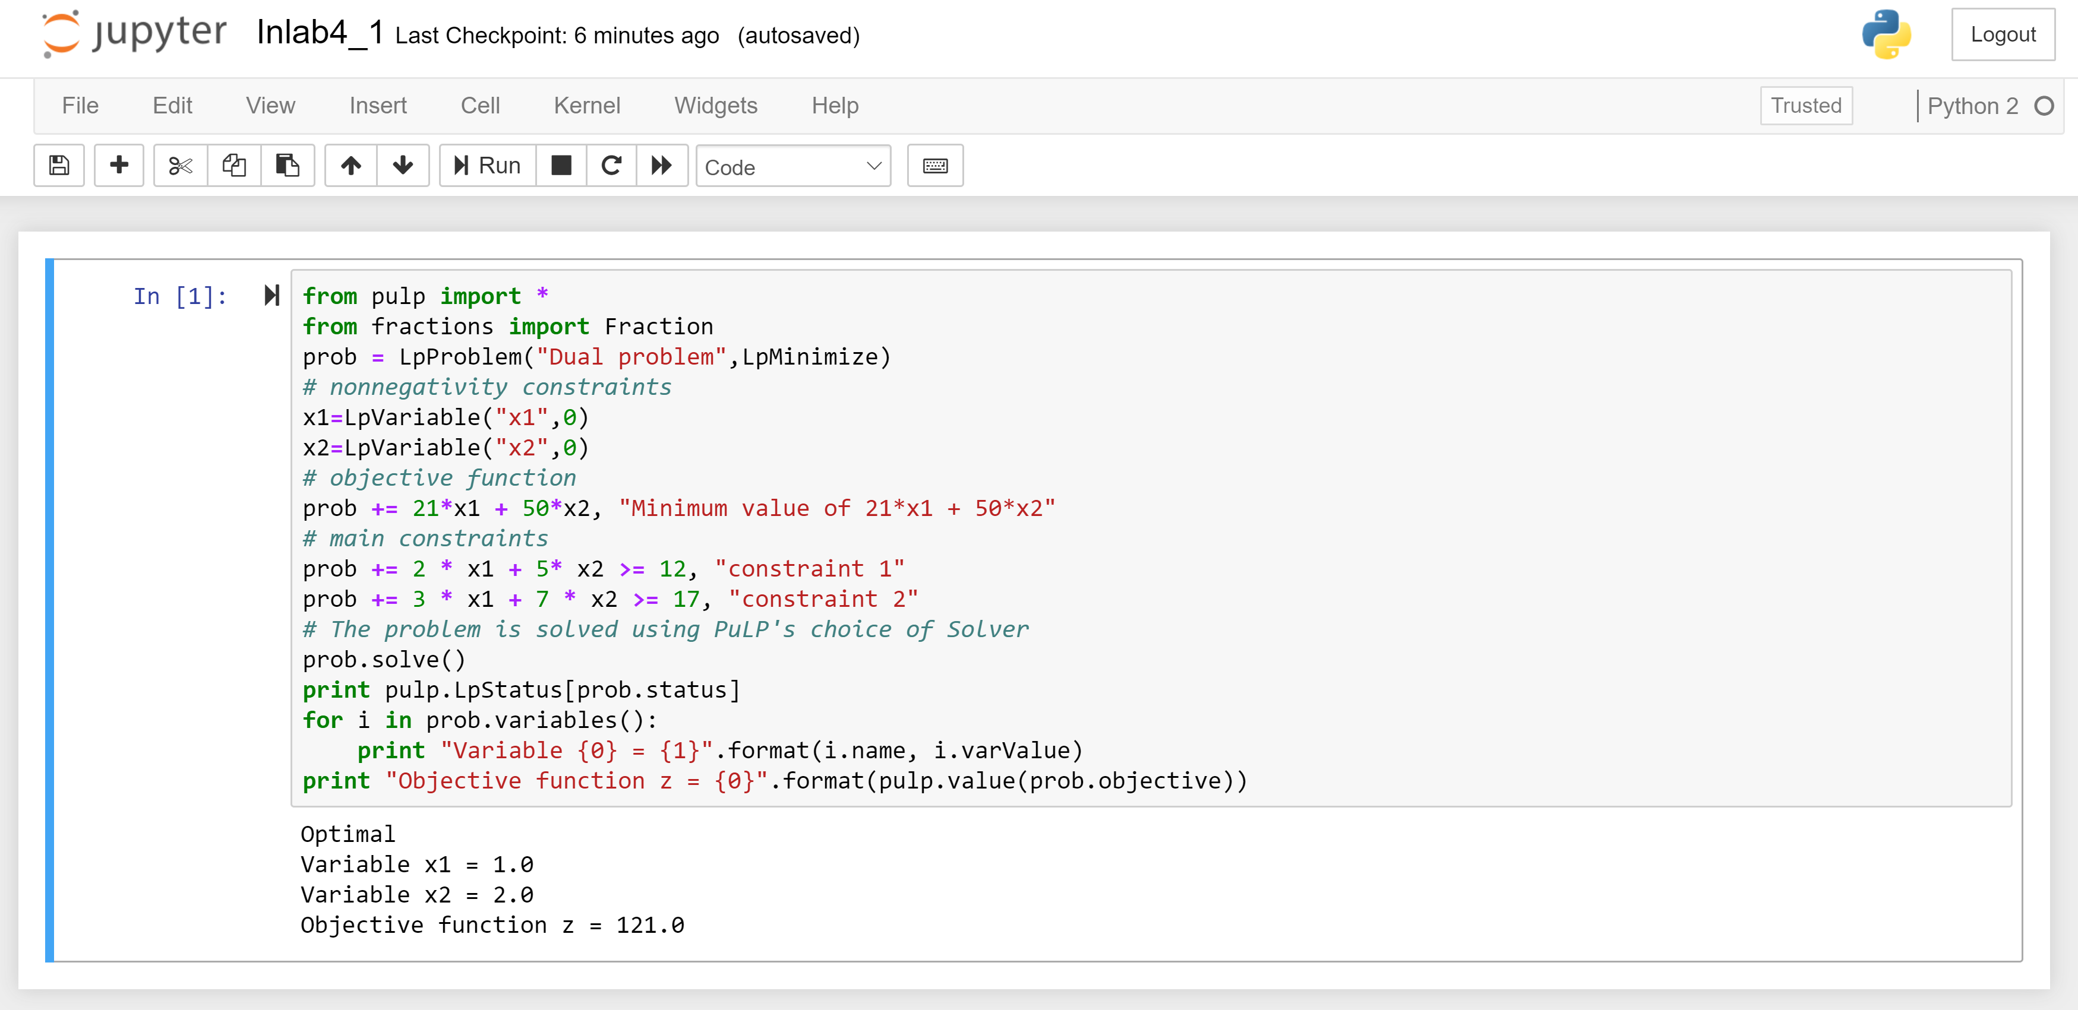

**2.** A XYZ company is hired by a retailer to transport goods from its store room in A and B to its outlets stores in C and D. The XYZ company is contracted to deliver 30 vehicles each month to deliver goods. The company determines that it will need to send at least 12 of the vehicles to the ‘C’ location and at least 13 vehicles to the “D” location. At least 15 vehicles can come from the A storeroom and at least 20 vehicles can come from the “B”. The truck company wants to minimize the number of miles placed on its trucks. How many trucks should the send out from each location and to which outlets should they send them?

A B

C 22ml 31ml

D 20ml 38ml

A.Formulate Linear programming model.

B. Solve Dual LP model using Python.

**Code:**

**from pulp import \***

**prob = LpProblem("Dual problem",LpMinimize)**

**# nonnegativity constraints**

**x1=LpVariable("x1",0)**

**x2=LpVariable("x2",0)**

**x3=LpVariable("x3",0)**

**x4=LpVariable("x4",0)**

**# objective function**

**prob += 900 * x1 + 2200 * x2 + 800 * x3, "Minimum value of 44 * x1 + 40 * x2 + 62 * x3 + 76 * x4"**

**# main constraints**

**prob += 300*x1 + 400*x2+100*x3<= 2, "constraint 1"**

**prob += 100*x1 + 300*x2+200*x3>= 1.25, "constraint 2"**

**prob += x1>= 0, "constraint 3"**

**prob += x2>= 0, "constraint 4"**

**prob += x3>= 0, "constraint 5"**

**# The problem is solved using PuLP's choice of Solver**

**prob.solve()**

**print pulp.LpStatus[prob.status]**

**for i in prob.variables():**

**print "Variable {0} = {1}".format(i.name, i.varValue)**

**print "Objective function z = {0}".format(pulp.value(prob.objective))**

**OUTPUT**

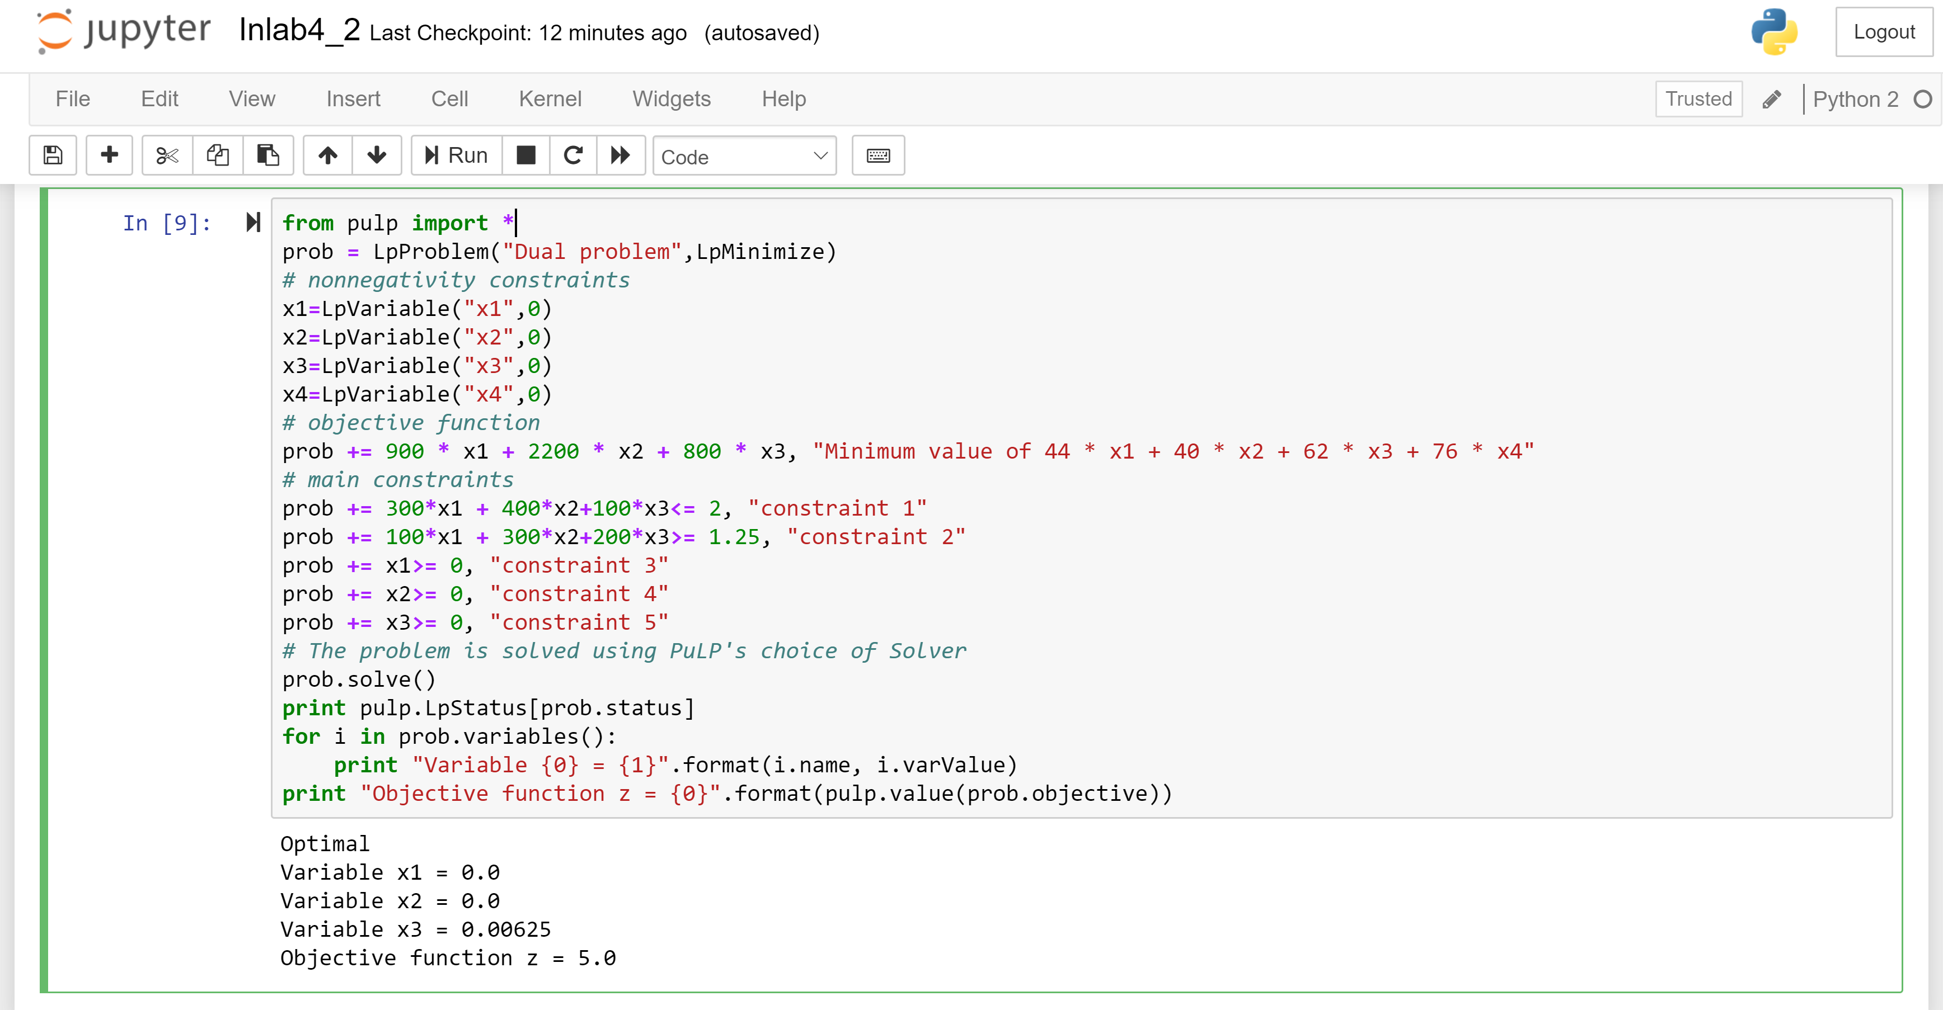

**POSTLAB**

1**.** Minimize : C= 16x1+8x2+4x2

Subject To: 3x1 + 2x2 +2x3 >=16

4x1 +3x2 + x3 >=14

5x1 + 3x2 + x3 >=12

X1,x2,x3 >=0

Apply dual method and find the optimal solution for minimization problem

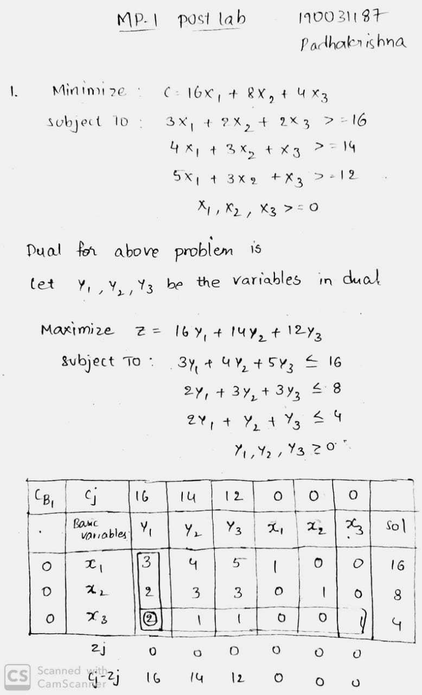

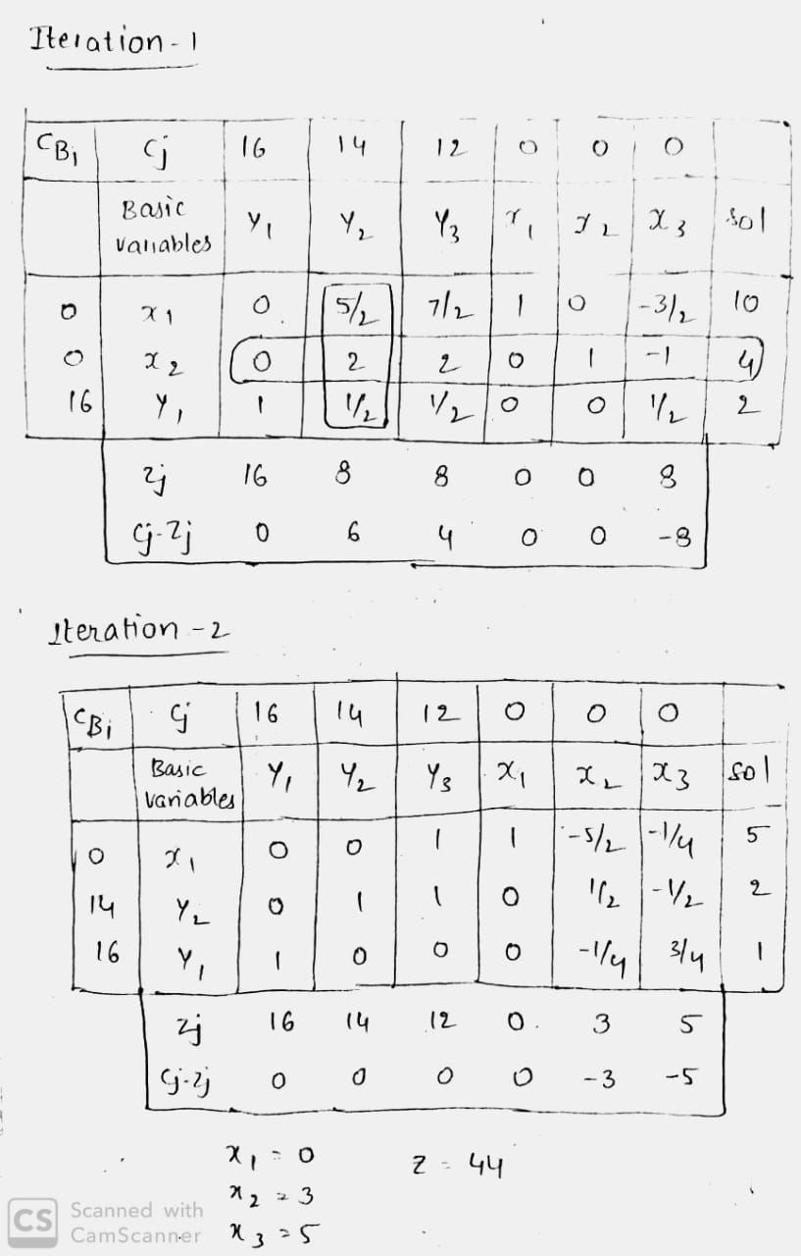

2. A producer of Healthy food makes two important and secret ingredients that goes into their humanfood, named as a HealthyMan and CommonMan. Each kg of HealhyMan contains 300 g of vitamins, 400 g of protein, and 100 g of carbs. Each kg of commonMan contains 100 g of vitamins, 300 g of protein, and 200 g of carbs. Guidelines for minimum nutritional that require a mixture made from these ingredients contain at least 900 g of vitamins, 2200 g of protein, and 800 g of carbs. HealthyMan costs $2.00 per kg to produce and CommonMan costs $1.25 per kg to produce. Find the number of kgs of each ingredient that should be produced in order to minimize cost.

Solve LPP by using Dual method.

