**MP-1 TUTORIAL-5**

**PRELAB**

**Problem 1:**

The Amulya Milk Company has three plants located throughout a state with production capacity 50, 75 and 25 gallons. Each day the firm must furnish its four retail shops R1, R2, R3& R4 with at least 20, 20, 50, and 60 gallons respectively. The transportation costs (in Rs.) are given below.

|  |  |  |  |  |  |
| --- | --- | --- | --- | --- | --- |
| **Plant** | **Retail Shop** | | | | **Supply** |
| **R1** | **R2** | **R3** | **R4** |
| **P1** | 3 | 5 | 7 | 6 | 50 |
| **P2** | 2 | 5 | 8 | 2 | 75 |
| **P3** | 3 | 6 | 9 | 2 | 25 |
| **Demand** | 20 | 20 | 50 | 60 |  |

The economic problem is to distribute the avaiSESSIONle product to different retail shops in such a way so that the total transportation cost is minimum.

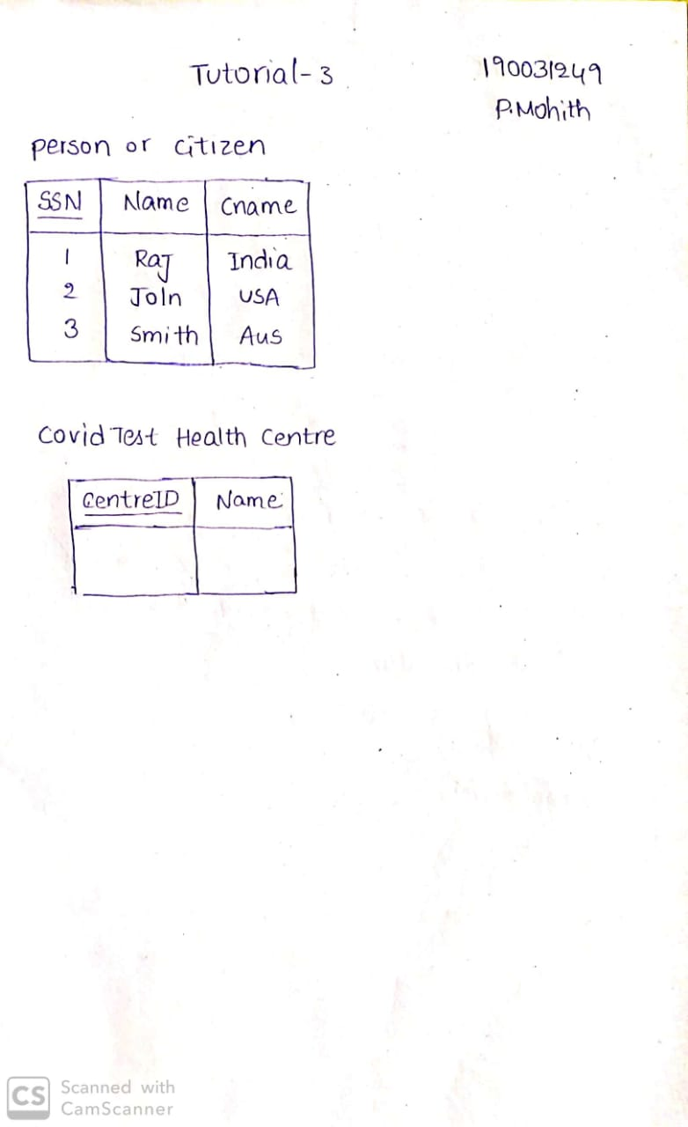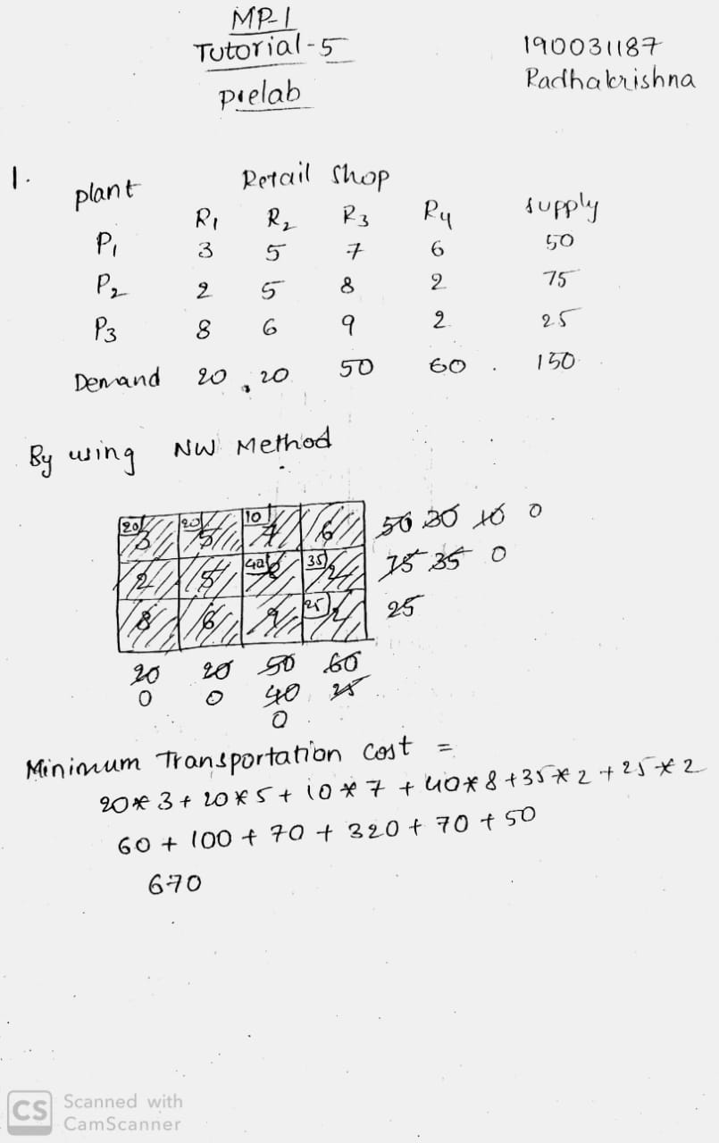

**INLAB**

**Problem 1:**

Luminous lamps have three factories - F1, F2, and F3 with production capacity 30, 50, and 20 units per week respectively. These units are to be shipped to four warehouses W1, W2, W3, and W4 with requirement of 20, 40, 30, and 10 units per week respectively. The transportation

costs (in Rs.) per unit between factories and warehouses are given below.

|  |  |  |  |  |  |
| --- | --- | --- | --- | --- | --- |
| **Factory** | **Warehouse** | | | | **Supply** |
| **W1** | **W2** | **W3** | **W4** |
| **F1** | 1 | 2 | 1 | 4 | 30 |
| **F2** | 3 | 3 | 2 | 1 | 50 |
| **F3** | 4 | 2 | 5 | 9 | 20 |
| **Demand** | 20 | 40 | 30 | 10 |  |

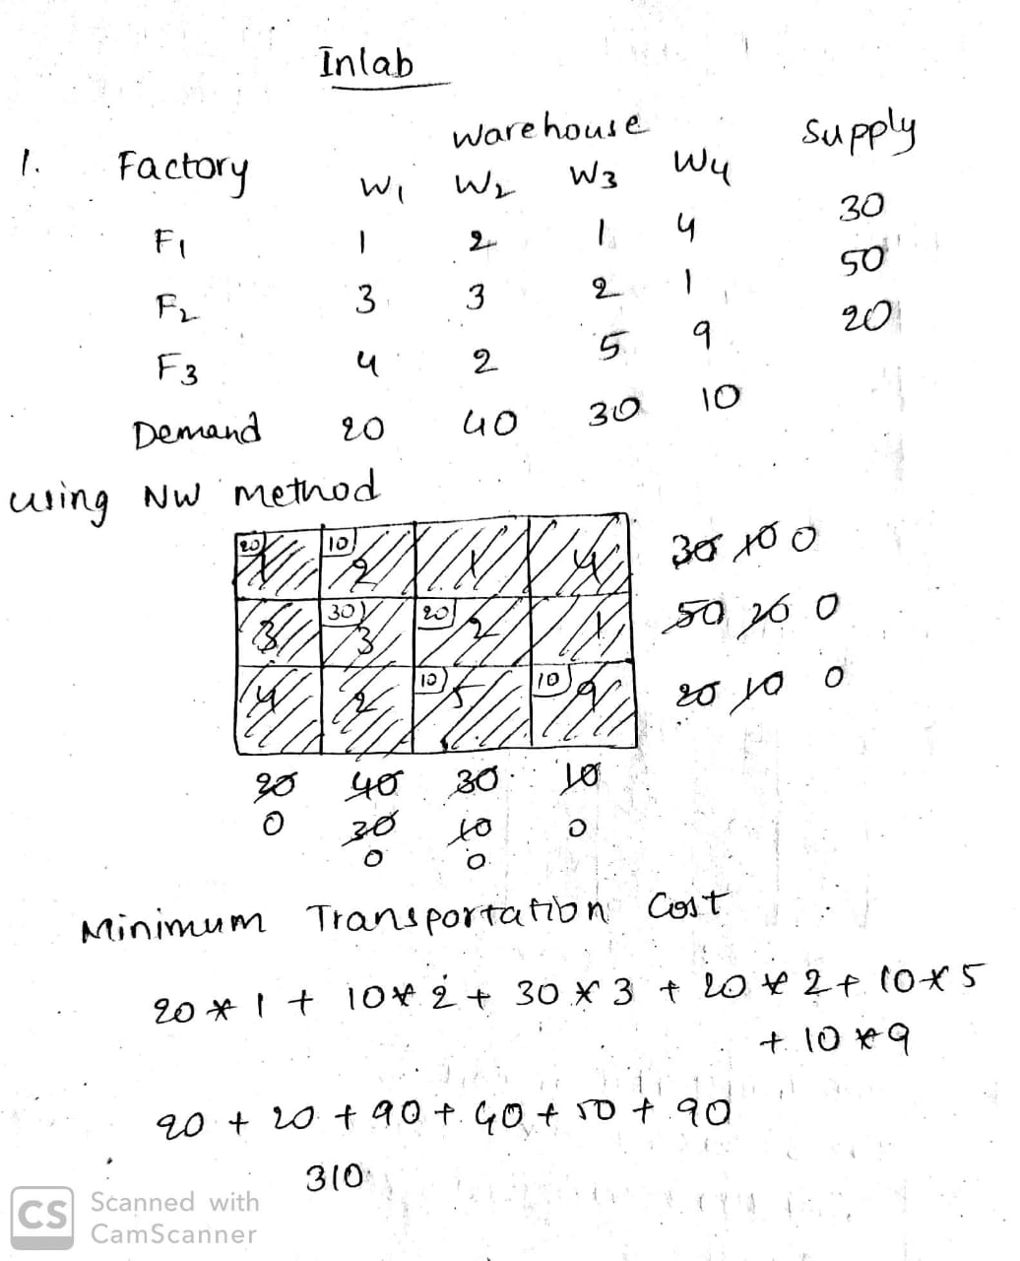

**POSTLAB**

**Problem 1:**

GM Textiles units located at Chennai, Coimbatore and Madurai. GM Textiles produces ready-made garments at these locations with capacities 6000, 5000 and 4000 units per week at Chennai, Coimbatore and Madurai respectively. The textile unit distributes its ready-made garments through four of its wholesale distributors situated at four locations Bangalore, Hyderabad, Cochin and Goa. The weekly demand of the distributors is 5000, 4000, 2000 and 4000 units for Bangalore, Hyderabad, Cochin and Goa respectively.

The cost of transportation per unit varies between different supply points and destination points. The transportation costs are given in the network diagram.

The management of GM Textiles would like to determine the number of units to be shipped from each textile unit to satisfy the demand of each wholesale distributor. The supply, demand and transportation cost are as follows:

**Production Capacities**

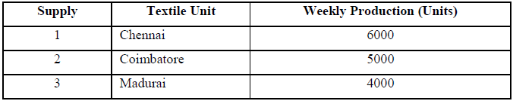**Demand Requirements**

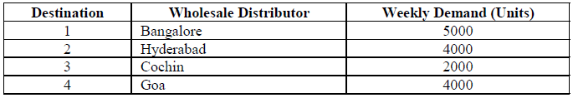

**Transportation cost per unit**

