**MP-1 TUTORIAL-6**

**PRELAB**

**Problem 1:**

Consider the transportation problem presented in the following table:

|  |  |  |  |  |
| --- | --- | --- | --- | --- |
| **Factory** | **Warehouse** | | | **Supply** |
| **W1** | **W2** | **W3** |
| **F1** | 16 | 20 | 12 | 200 |
| **F2** | 14 | 8 | 18 | 160 |
| **F3** | 26 | 24 | 16 | 90 |
| **Demand** | 180 | 120 | 150 | 450 |

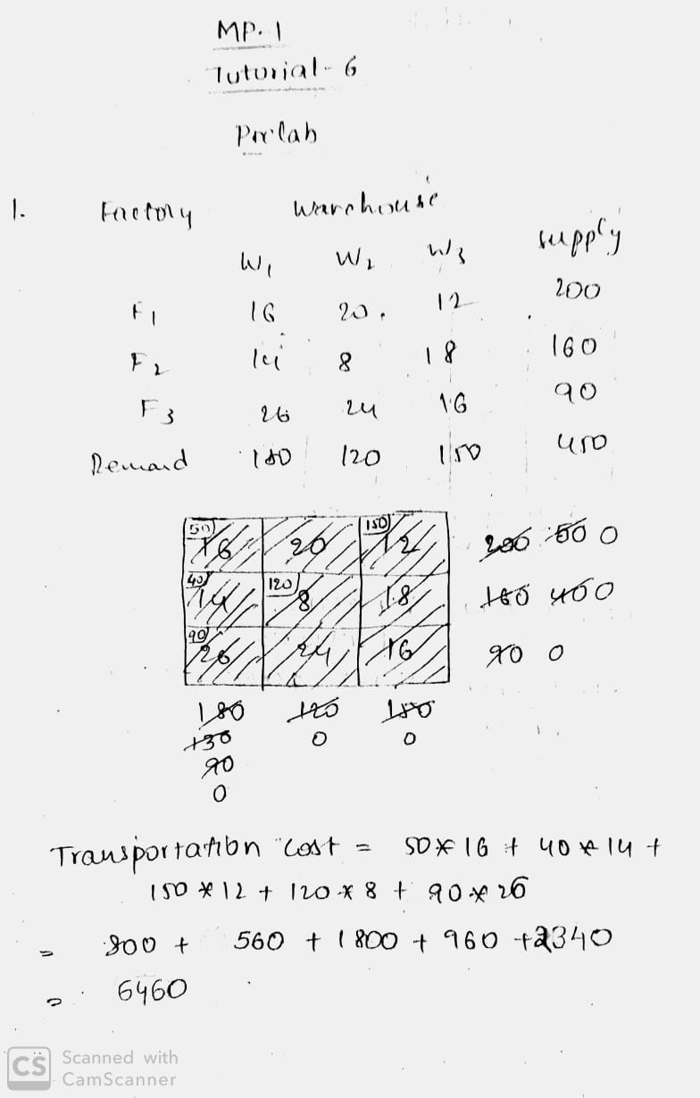

**Code:**

**def minimum(a,n):**

**minpos = a.index(min(i for i in a if i>0))**

**return minpos**

**def Row_Minima(supply,demand,costs):**

**r=len(costs)**

**c=len(costs[0])**

**i=0**

**j=0**

**bfs=[]**

**total=0**

**while i<r:**

**j=0**

**while j<c and supply[i]!=0:**

**m=minimum(costs[i],len(costs[i]))**

**if(supply[i]>=demand[m] and demand[m]!=0):**

**total = total+demand[m]*costs[i][m]**

**bfs.append(((i,m),demand[m]))**

**supply[i]=supply[i]-demand[m]**

**demand[m]=0**

**for k in range(i,r):**

**costs[k][m]=0**

**elif(supply[i]<=demand[m]and demand[m]!=0):**

**total = total+supply[i]*costs[i][m]**

**bfs.append(((i,m),supply[i]))**

**demand[m]=demand[m]-supply[i]**

**supply[i]=0**

**costs[i][m]=0**

**j=j+1**

**i=i+1**

**print "Basic Feasible solution is ",bfs**

**print "Total cost=",total**

**return**

**supply=[200,160,90]**

**demand=[180,120,150]**

**costs=[[16,20,12],[14,8,18],[26,24,16]]**

**Row_Minima(supply,demand,costs)**

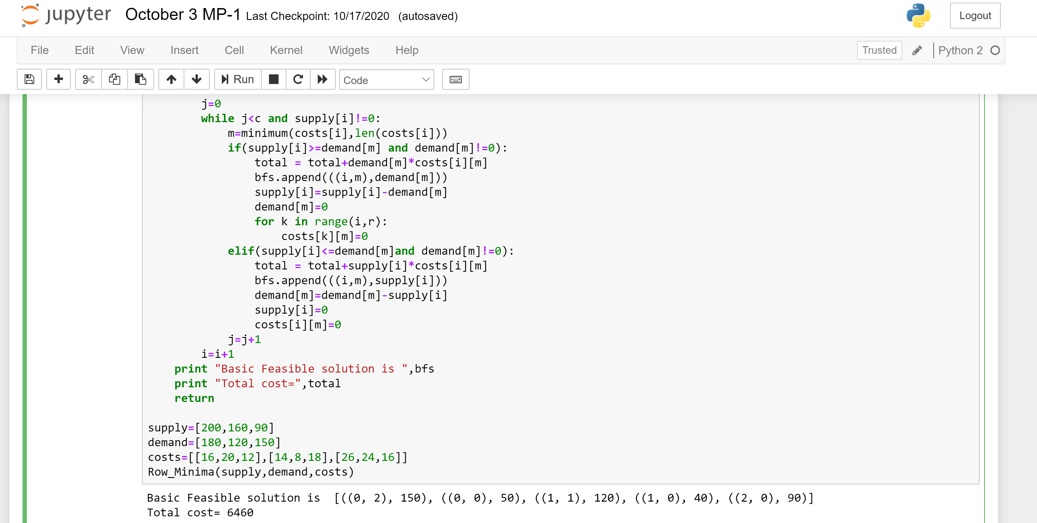

**INLAB**

**Problem 1:**

The Ushodaya departmental store has three plants located throughout a state with production capacity 80, 60 and 70 kilo grams of rice. Each day the firm must furnish its four retail shops R1, R2, R3, & R4 with at least 40, 60, 50, and 60 gallons respectively. The transportation costs (in Rs.) are given below.

|  |  |  |  |  |  |
| --- | --- | --- | --- | --- | --- |
| **Store** | **Retail Shop** | | | | **Supply** |
| **1** | **2** | **3** | **4** |
| **1** | 3 | 5 | 7 | 6 | 80 |
| **2** | 2 | 5 | 8 | 2 | 60 |
| **3** | 3 | 6 | 9 | 2 | 70 |
| **Demand** | 40 | 60 | 50 | 60 |  |

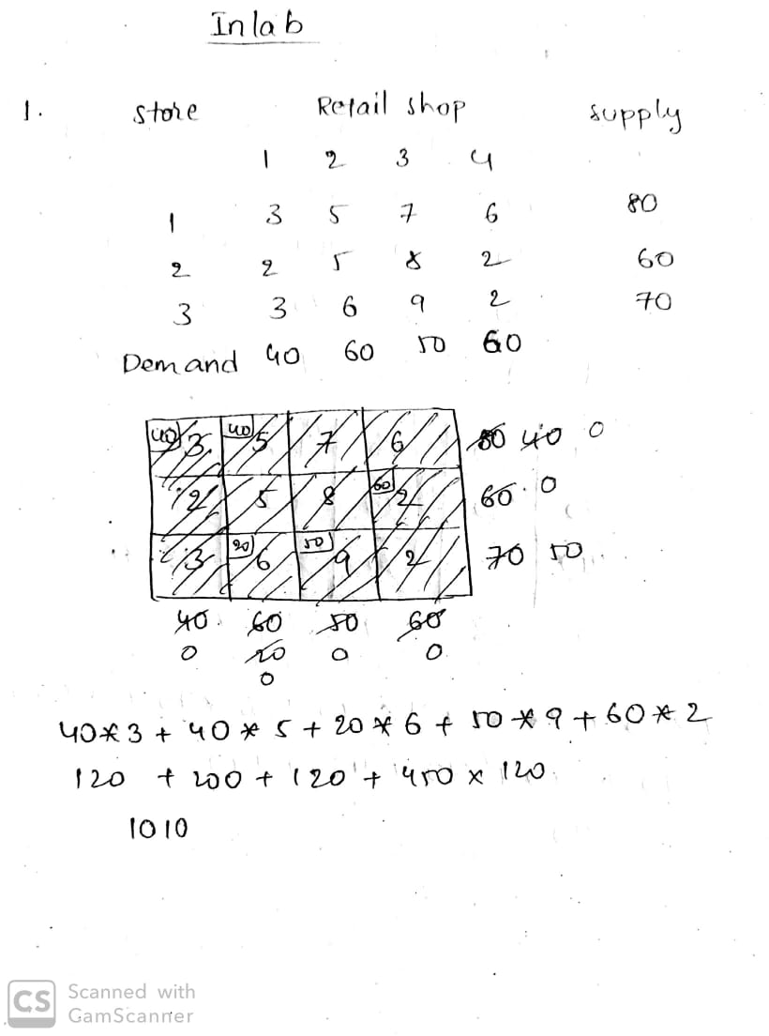

**Code:**

**def minimum(a,n):**

**minpos = a.index(min(i for i in a if i>0))**

**return minpos**

**def Row_Minima(supply,demand,costs):**

**r=len(costs)**

**c=len(costs[0])**

**i=0**

**j=0**

**bfs=[]**

**total=0**

**while i<r:**

**j=0**

**while j<c and supply[i]!=0:**

**m=minimum(costs[i],len(costs[i]))**

**if(supply[i]>=demand[m] and demand[m]!=0):**

**total = total+demand[m]*costs[i][m]**

**bfs.append(((i,m),demand[m]))**

**supply[i]=supply[i]-demand[m]**

**demand[m]=0**

**for k in range(i,r):**

**costs[k][m]=0**

**elif(supply[i]<=demand[m]and demand[m]!=0):**

**total = total+supply[i]*costs[i][m]**

**bfs.append(((i,m),supply[i]))**

**demand[m]=demand[m]-supply[i]**

**supply[i]=0**

**costs[i][m]=0**

**j=j+1**

**i=i+1**

**print "Basic Feasible solution is ",bfs**

**print "Total cost=",total**

**return**

**supply=[80,60,70]**

**demand=[40,60,50,60]**

**costs=[[3,5,7,6],[2,5,8,2],[3,6,9,2]]**

**Row_Minima(supply,demand,costs)**

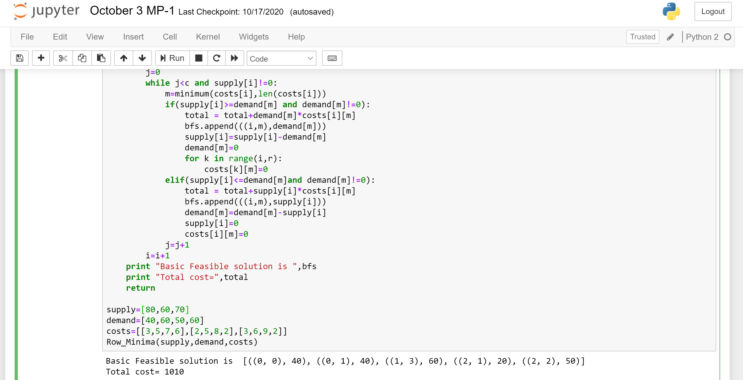

**POSTLAB**

**Problem 1:**

The distribution manager of a company needs to minimize global transport costs between a set of three factories (supply points) S1, S2, and S3, and a set of four distributors (demand points) D1, D2, D3, and D4. The following table shows the transportation cost from each supply point to every demand point, the supply of the product at the supply points, and the demand of the product at the demand points

|  |  |  |  |  |  |
| --- | --- | --- | --- | --- | --- |
| F/D | D1 | D2 | D3 | D4 | Supply |
| S1 | 19 | 30 | 50 | 10 | 7 |
| S2 | 70 | 30 | 40 | 60 | 9 |
| S3 | 40 | 8 | 70 | 20 | 18 |
| Demand | 5 | 8 | 7 | 14 | 34 |

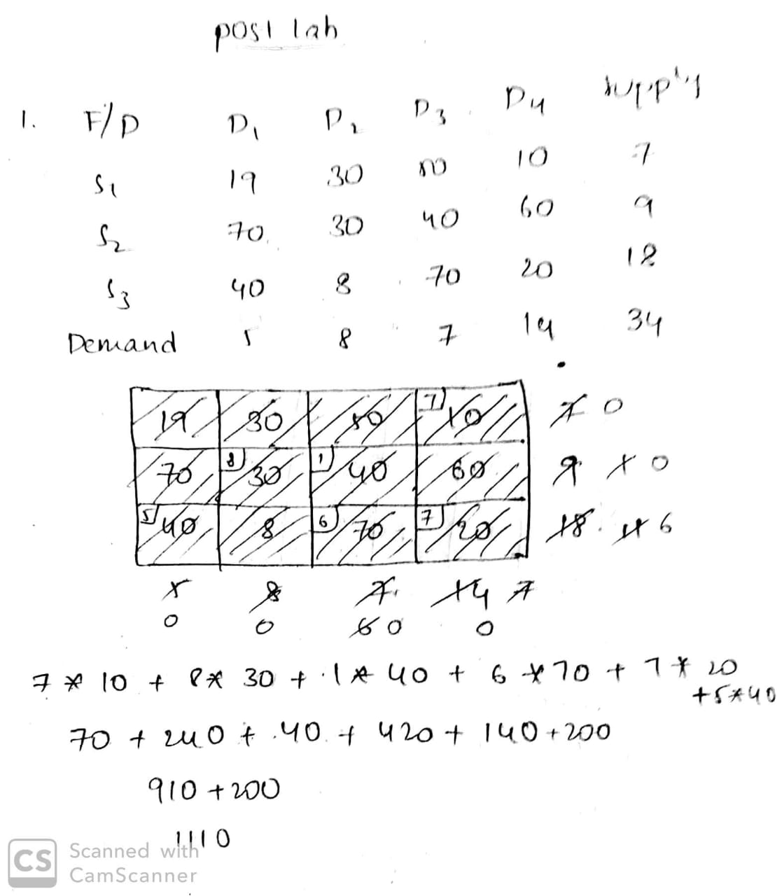

**Code:**

**def minimum(a,n):**

**minpos = a.index(min(i for i in a if i>0))**

**return minpos**

**def Row_Minima(supply,demand,costs):**

**r=len(costs)**

**c=len(costs[0])**

**i=0**

**j=0**

**bfs=[]**

**total=0**

**while i<r:**

**j=0**

**while j<c and supply[i]!=0:**

**m=minimum(costs[i],len(costs[i]))**

**if(supply[i]>=demand[m] and demand[m]!=0):**

**total = total+demand[m]*costs[i][m]**

**bfs.append(((i,m),demand[m]))**

**supply[i]=supply[i]-demand[m]**

**demand[m]=0**

**for k in range(i,r):**

**costs[k][m]=0**

**elif(supply[i]<=demand[m]and demand[m]!=0):**

**total = total+supply[i]*costs[i][m]**

**bfs.append(((i,m),supply[i]))**

**demand[m]=demand[m]-supply[i]**

**supply[i]=0**

**costs[i][m]=0**

**j=j+1**

**i=i+1**

**print "Basic Feasible solution is ",bfs**

**print "Total cost=",total**

**return**

**supply=[7,9,18]**

**demand=[5,8,7,14]**

**costs=[[19,30,50,10],[70,30,40,60],[40,8,70,20]]**

**Row_Minima(supply,demand,costs)**

