**PRELAB-1**

Write the description for the following system calls: open, close, read, write, fork, wait, exit, sleep, File descriptor values for standard I/O channels. 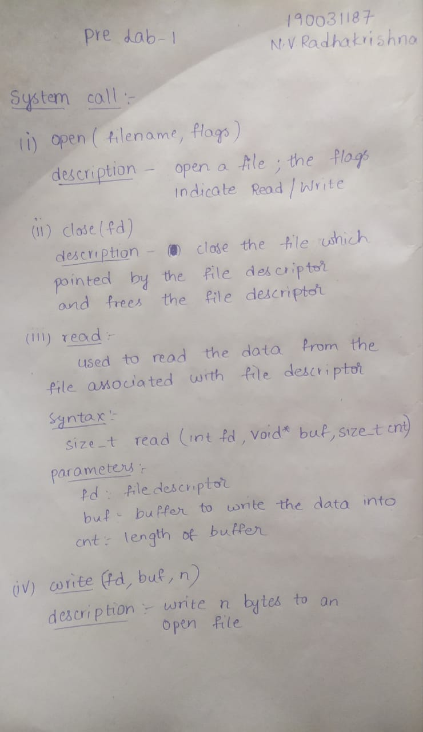

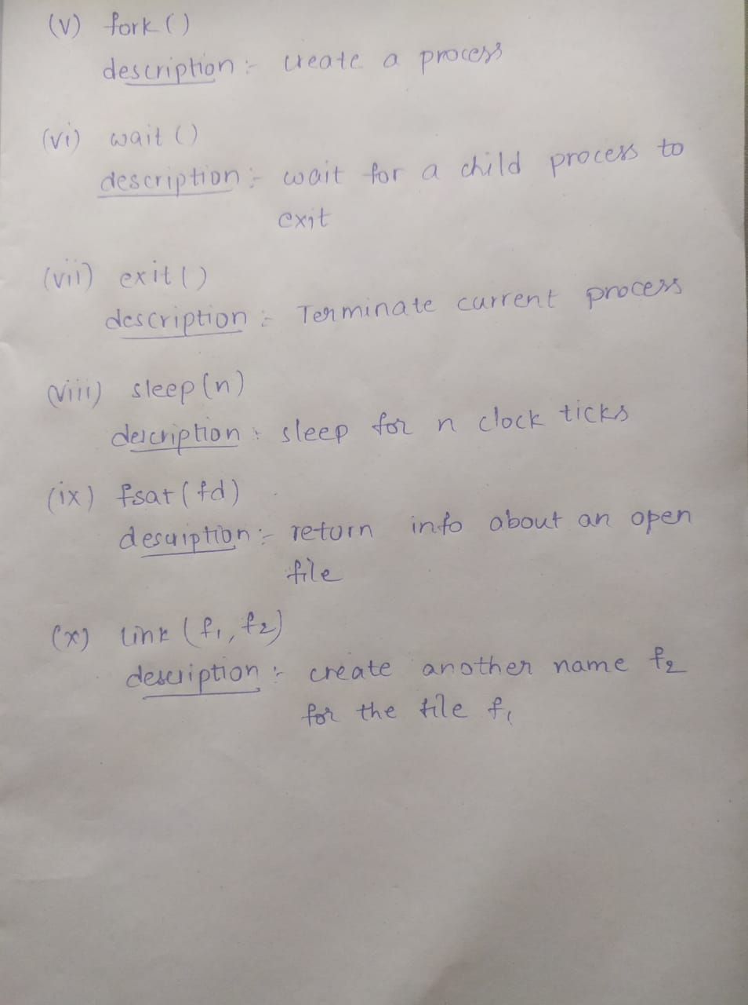

**INLAB-1**

Write a system program for implementing cat.c: which forms the essence of cat copies data from its standard input to its standard output. If an error occurs, it writes a message to the standard error. fork.c: A Simple Child Creation Program.

Solution)

Stepwise Procedure:

1) Login to putty and write cd xv6

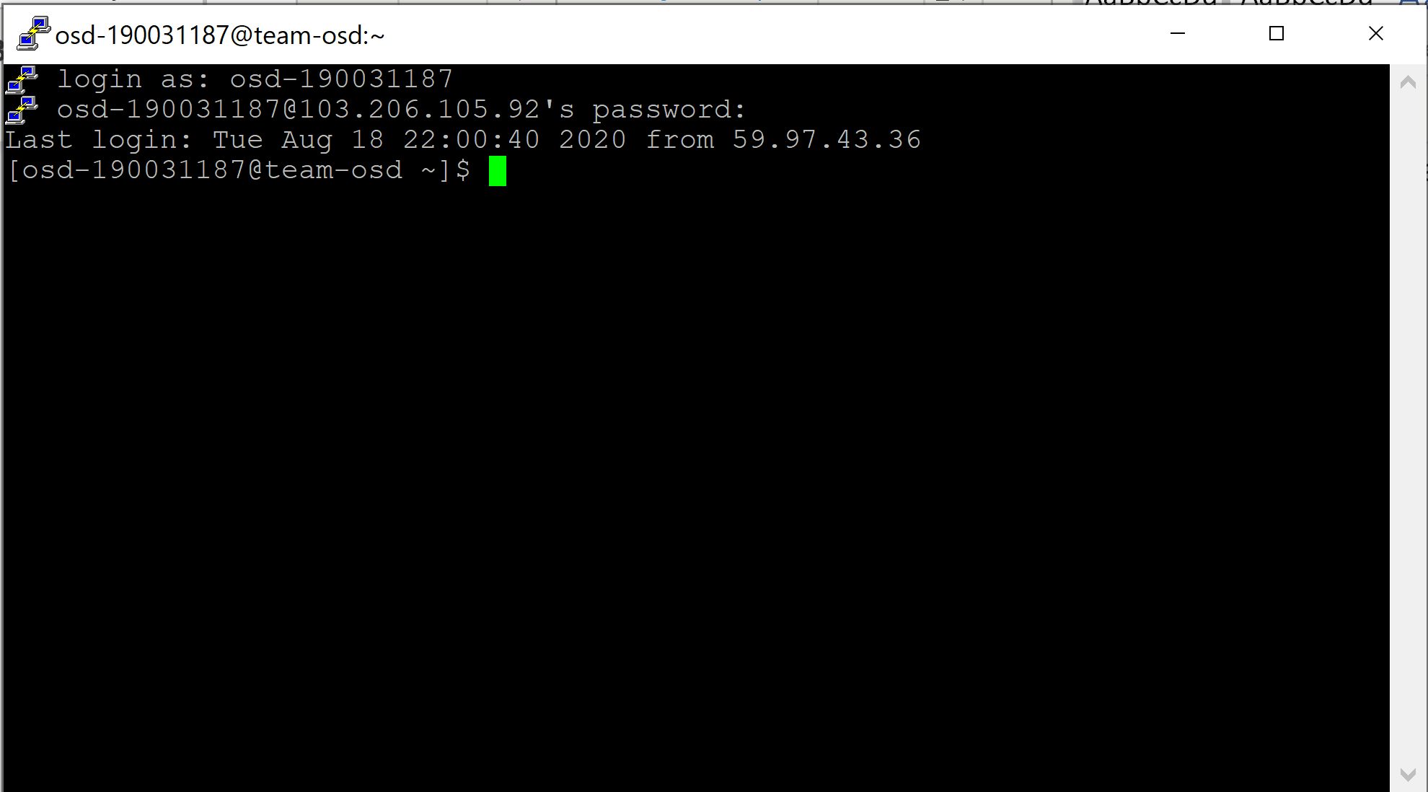

2) next type cd xv6

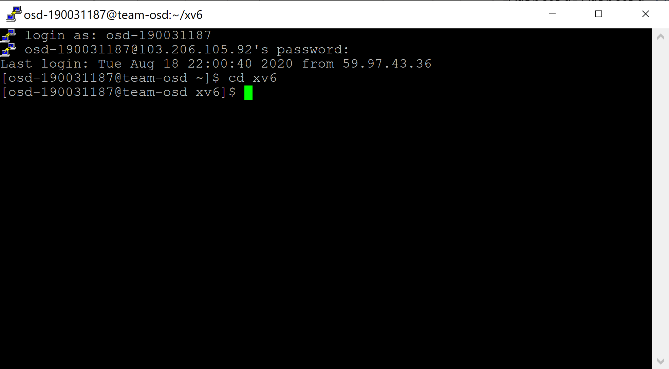

3) Type nano fork1.c and enter the code and save

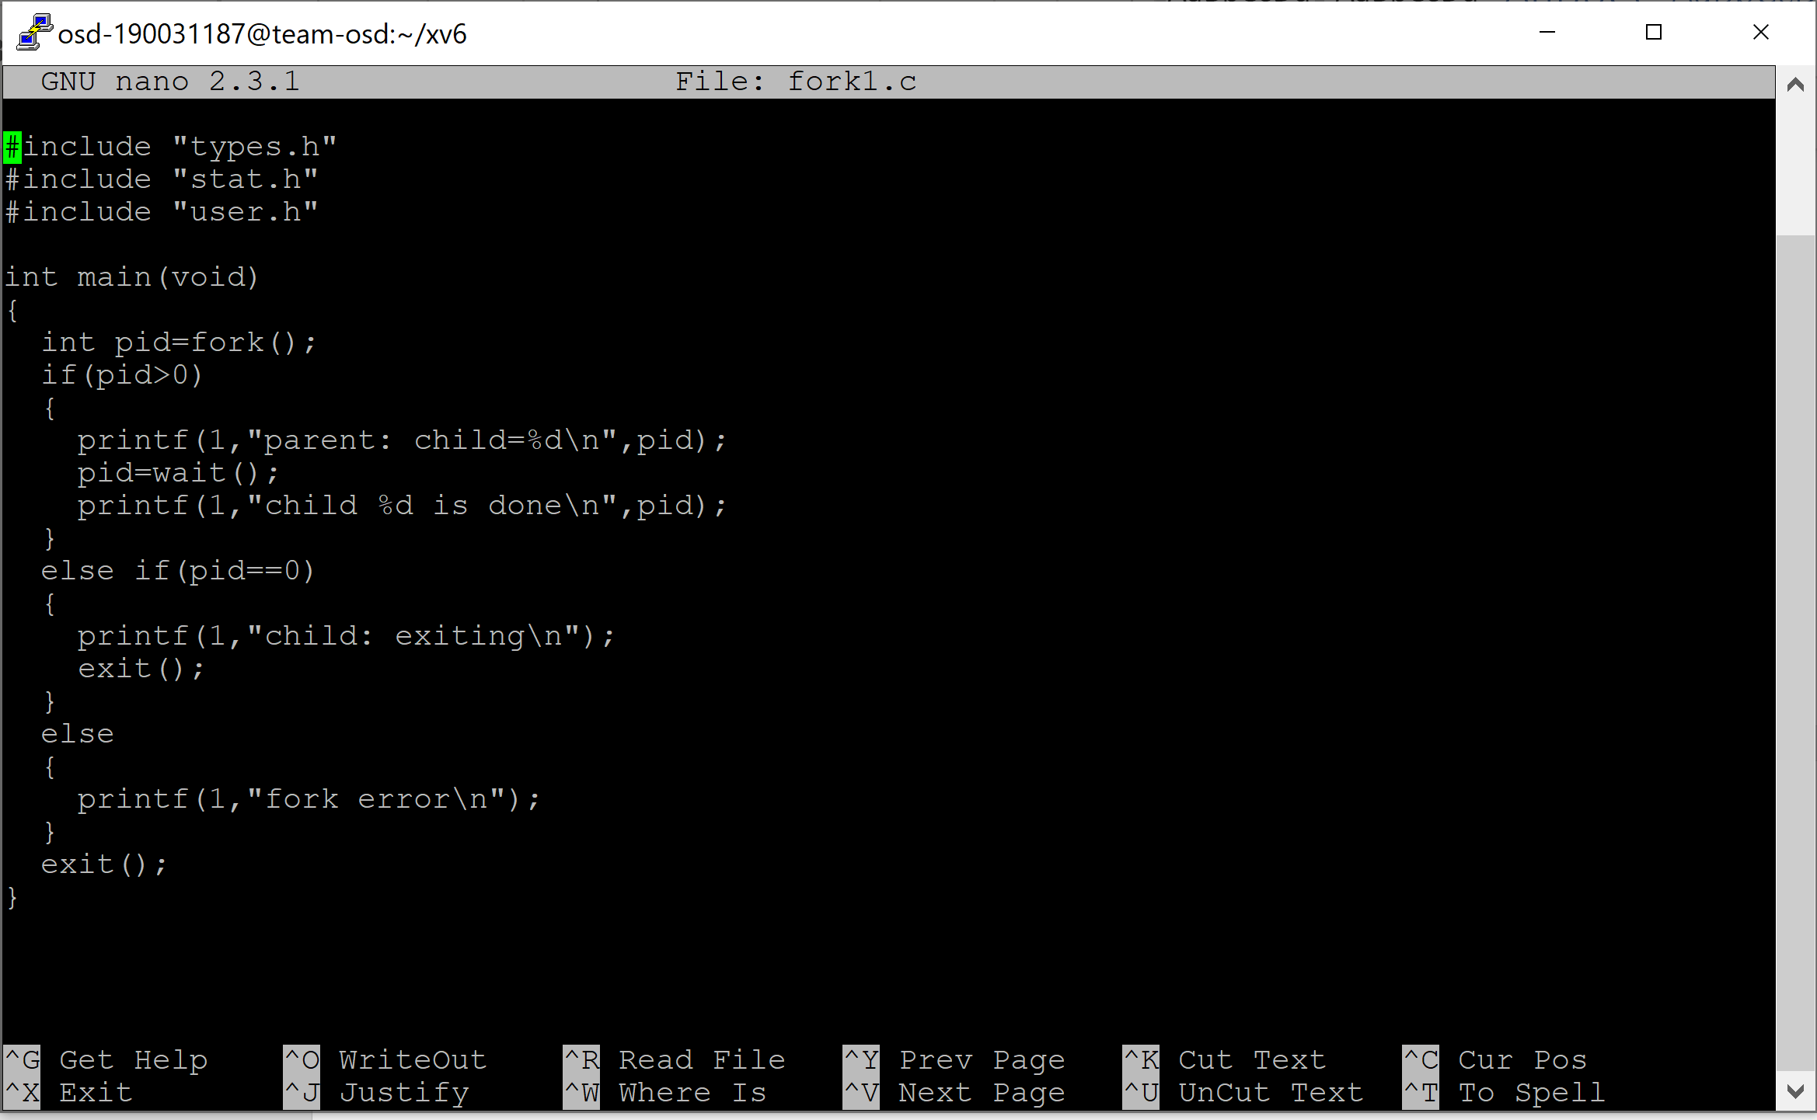

4) next type nano Makefile Under UPROGS add the file

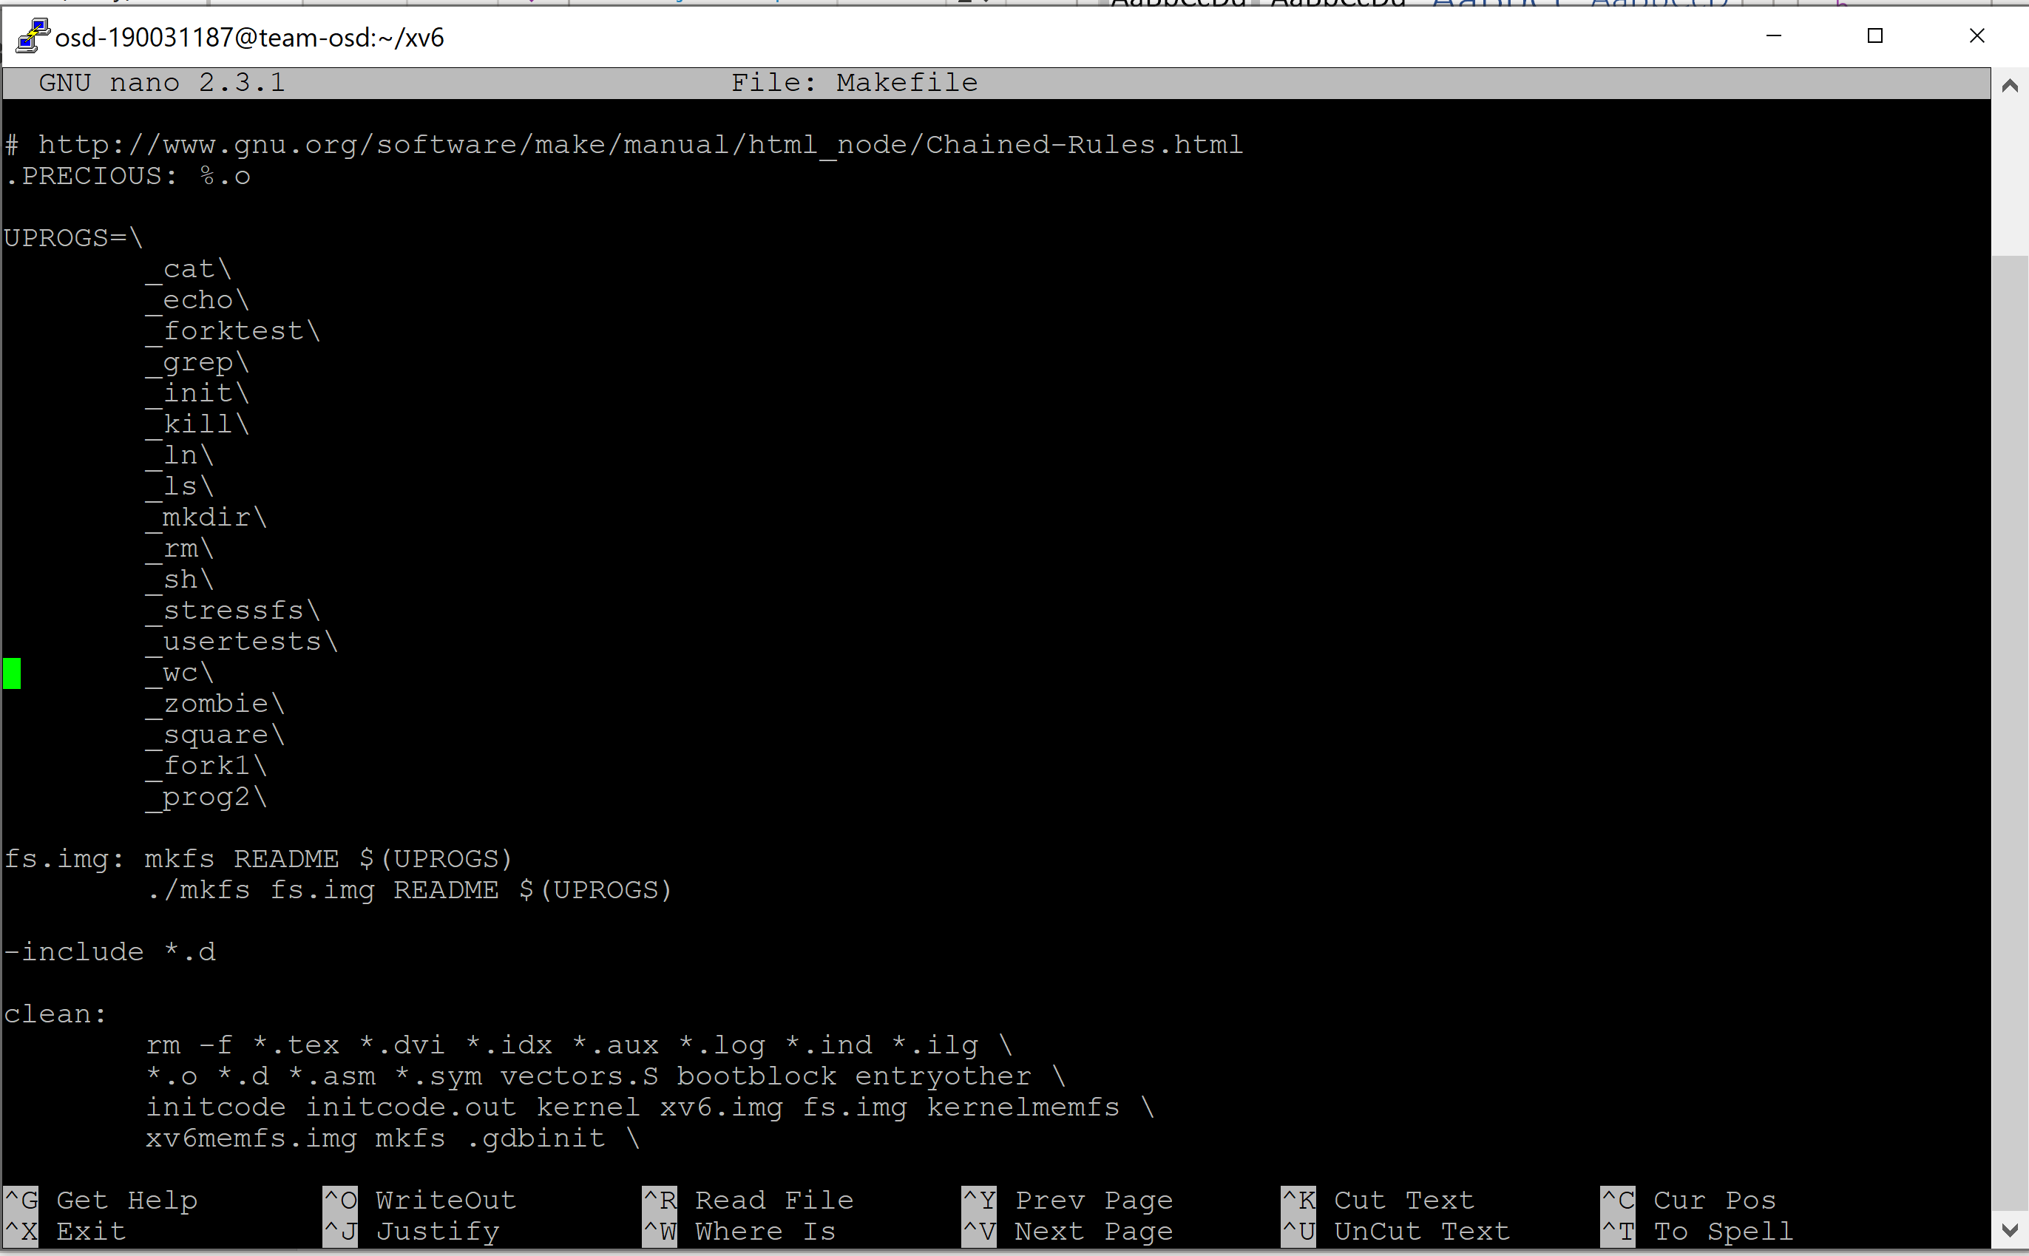

4.2) Also Under EXTRA add the file and SAVE

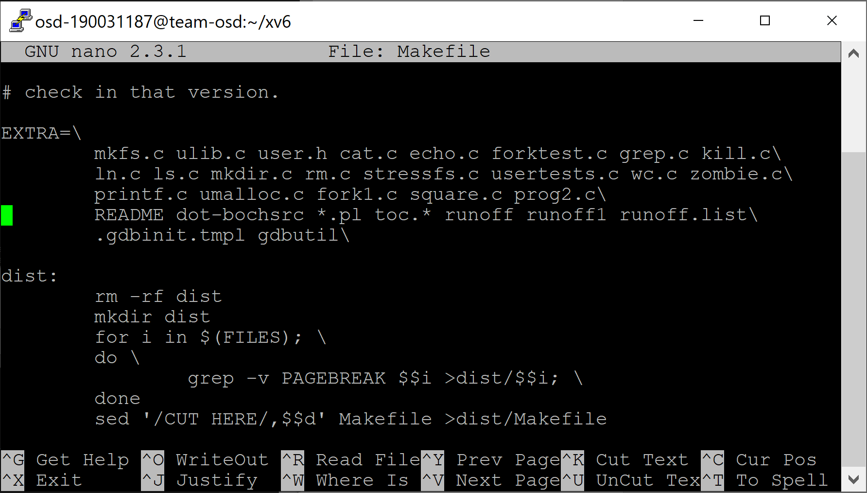

5) write make clean

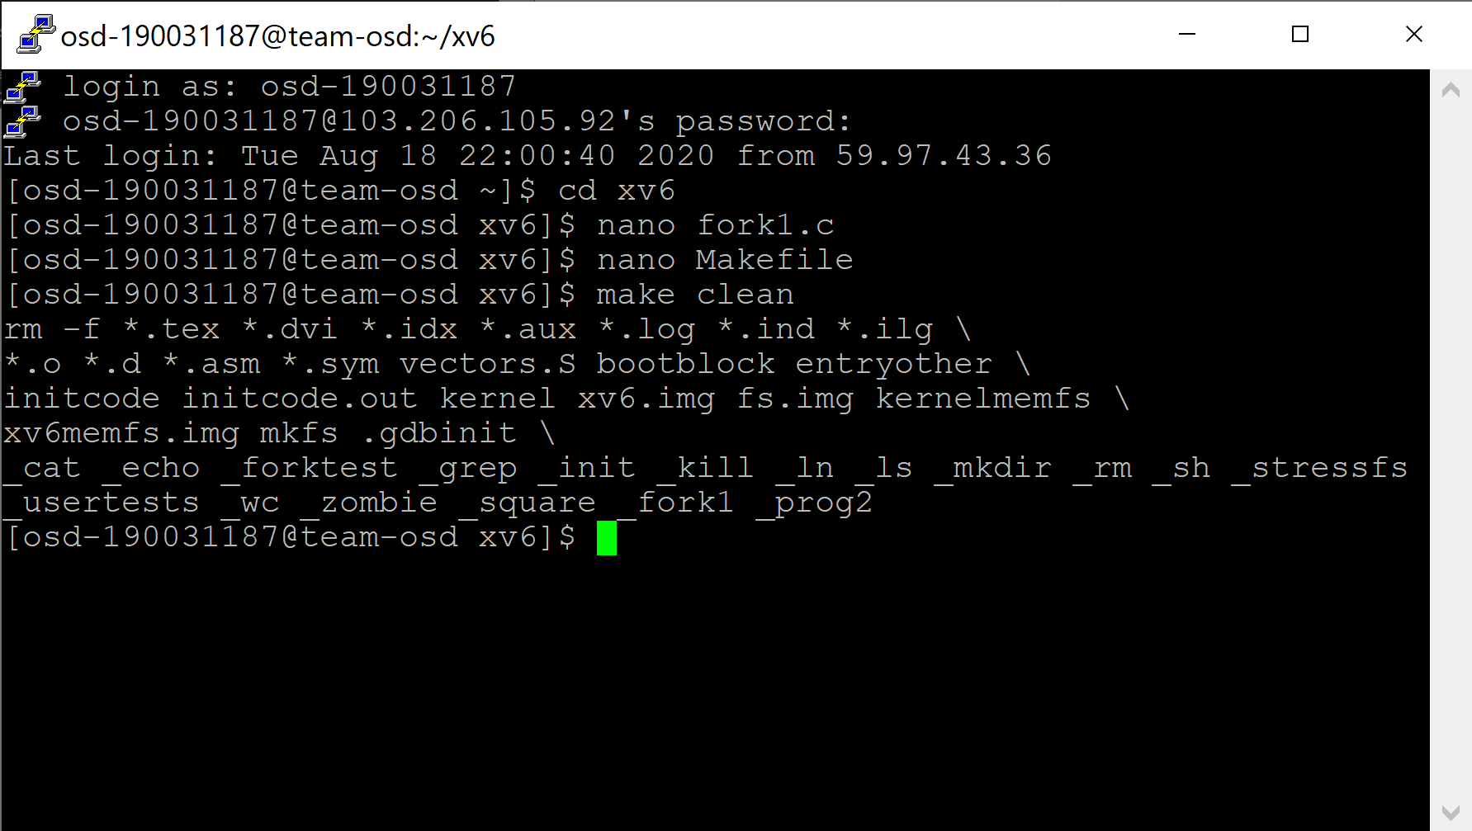  
7) next write make command and next write make qemu-nox

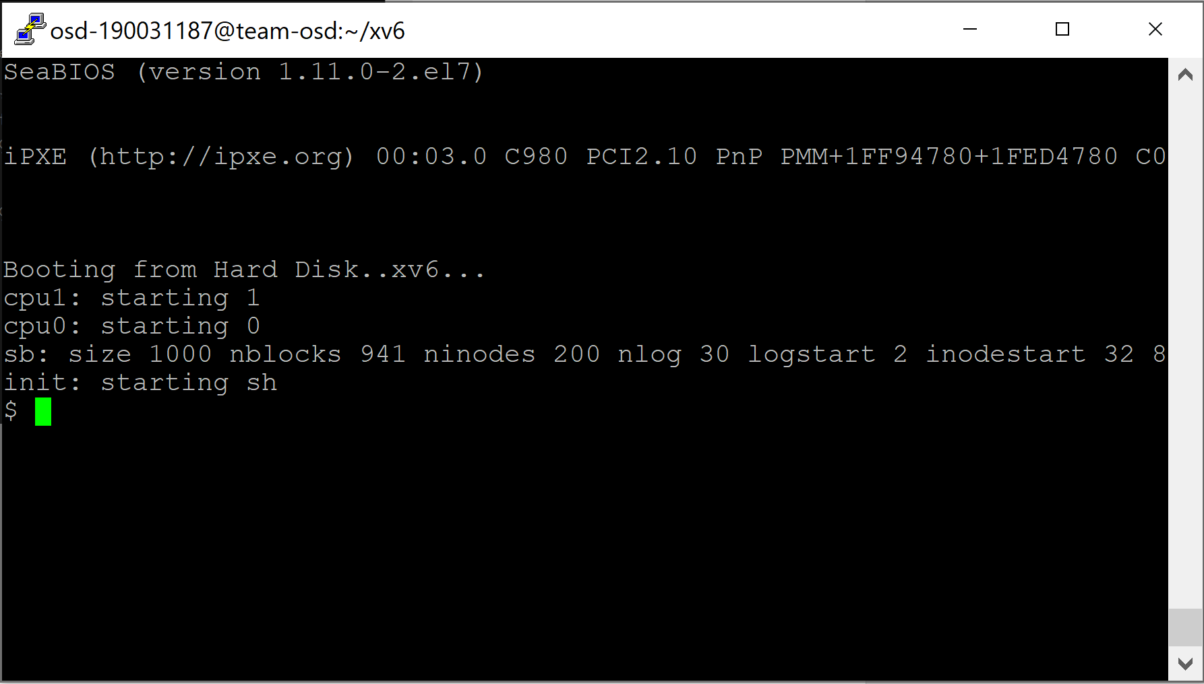

9) type your file name the ouput will execute

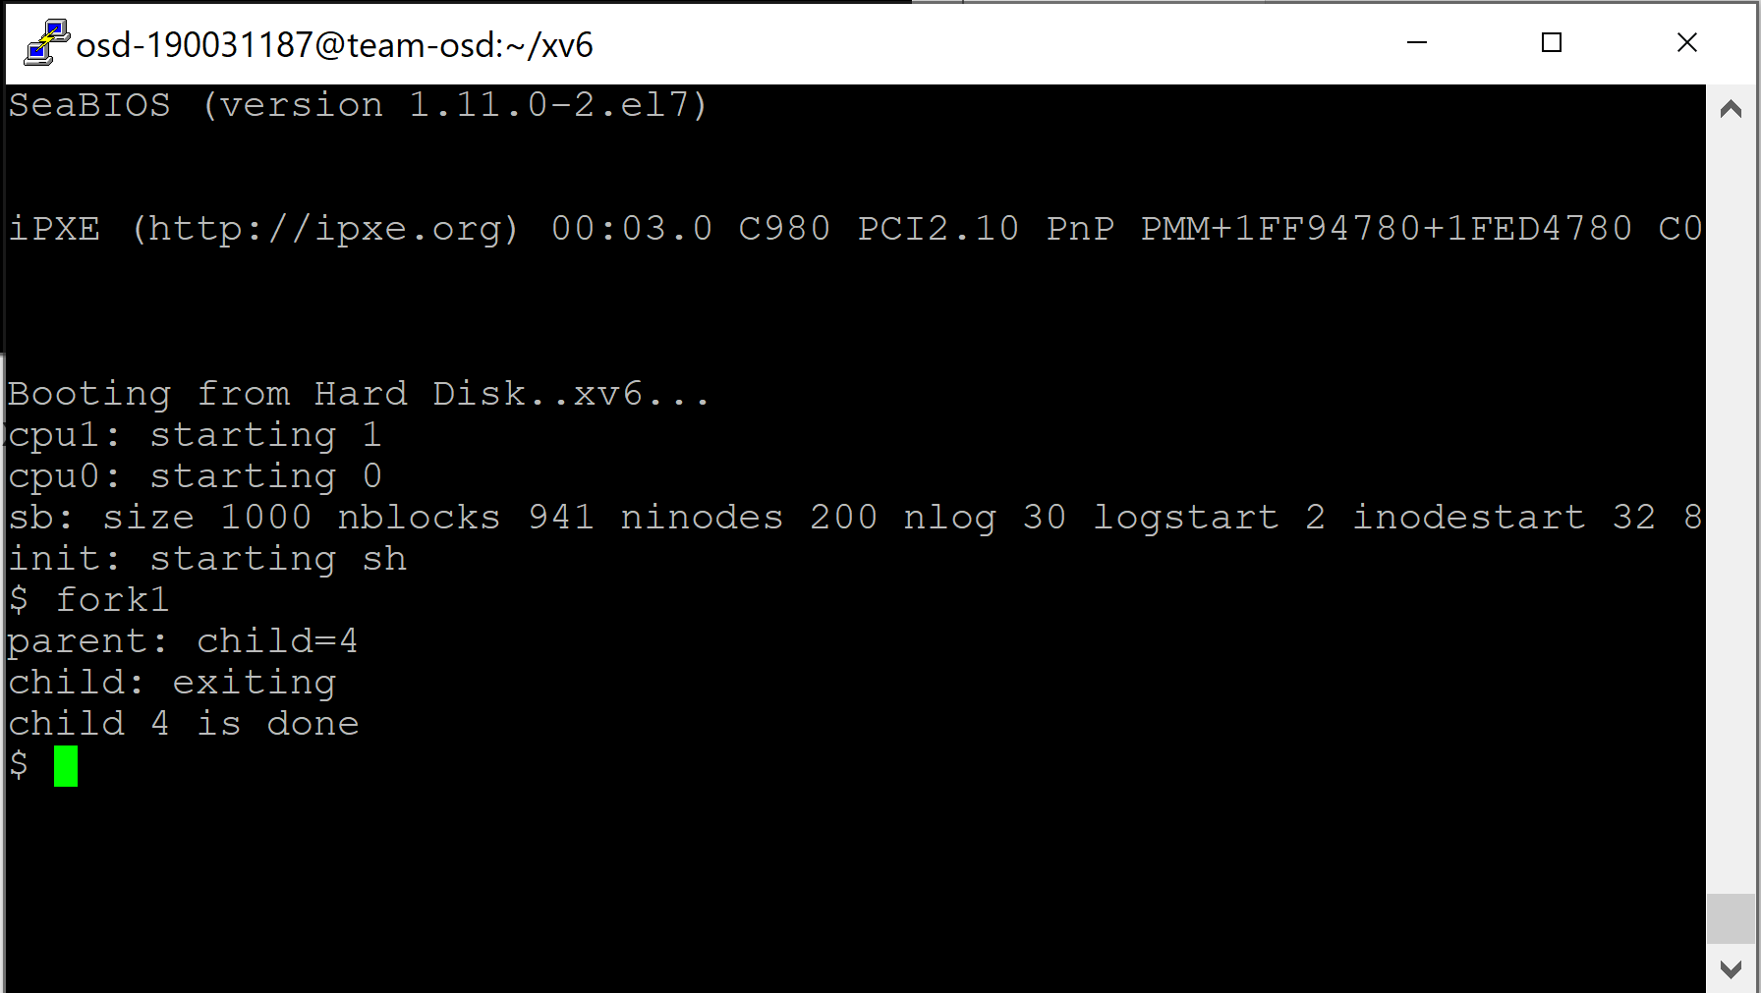

**POSTLAB-1**

Write a program using C library functions for file handling Standard I/O library that will copy data from one file to another file. io.c : A Program That Does I/O operations.

Solution)

Stepwise Procedure:

1) Login to putty and write cd xv6



2) next type cd xv6



3) Write code for i/o

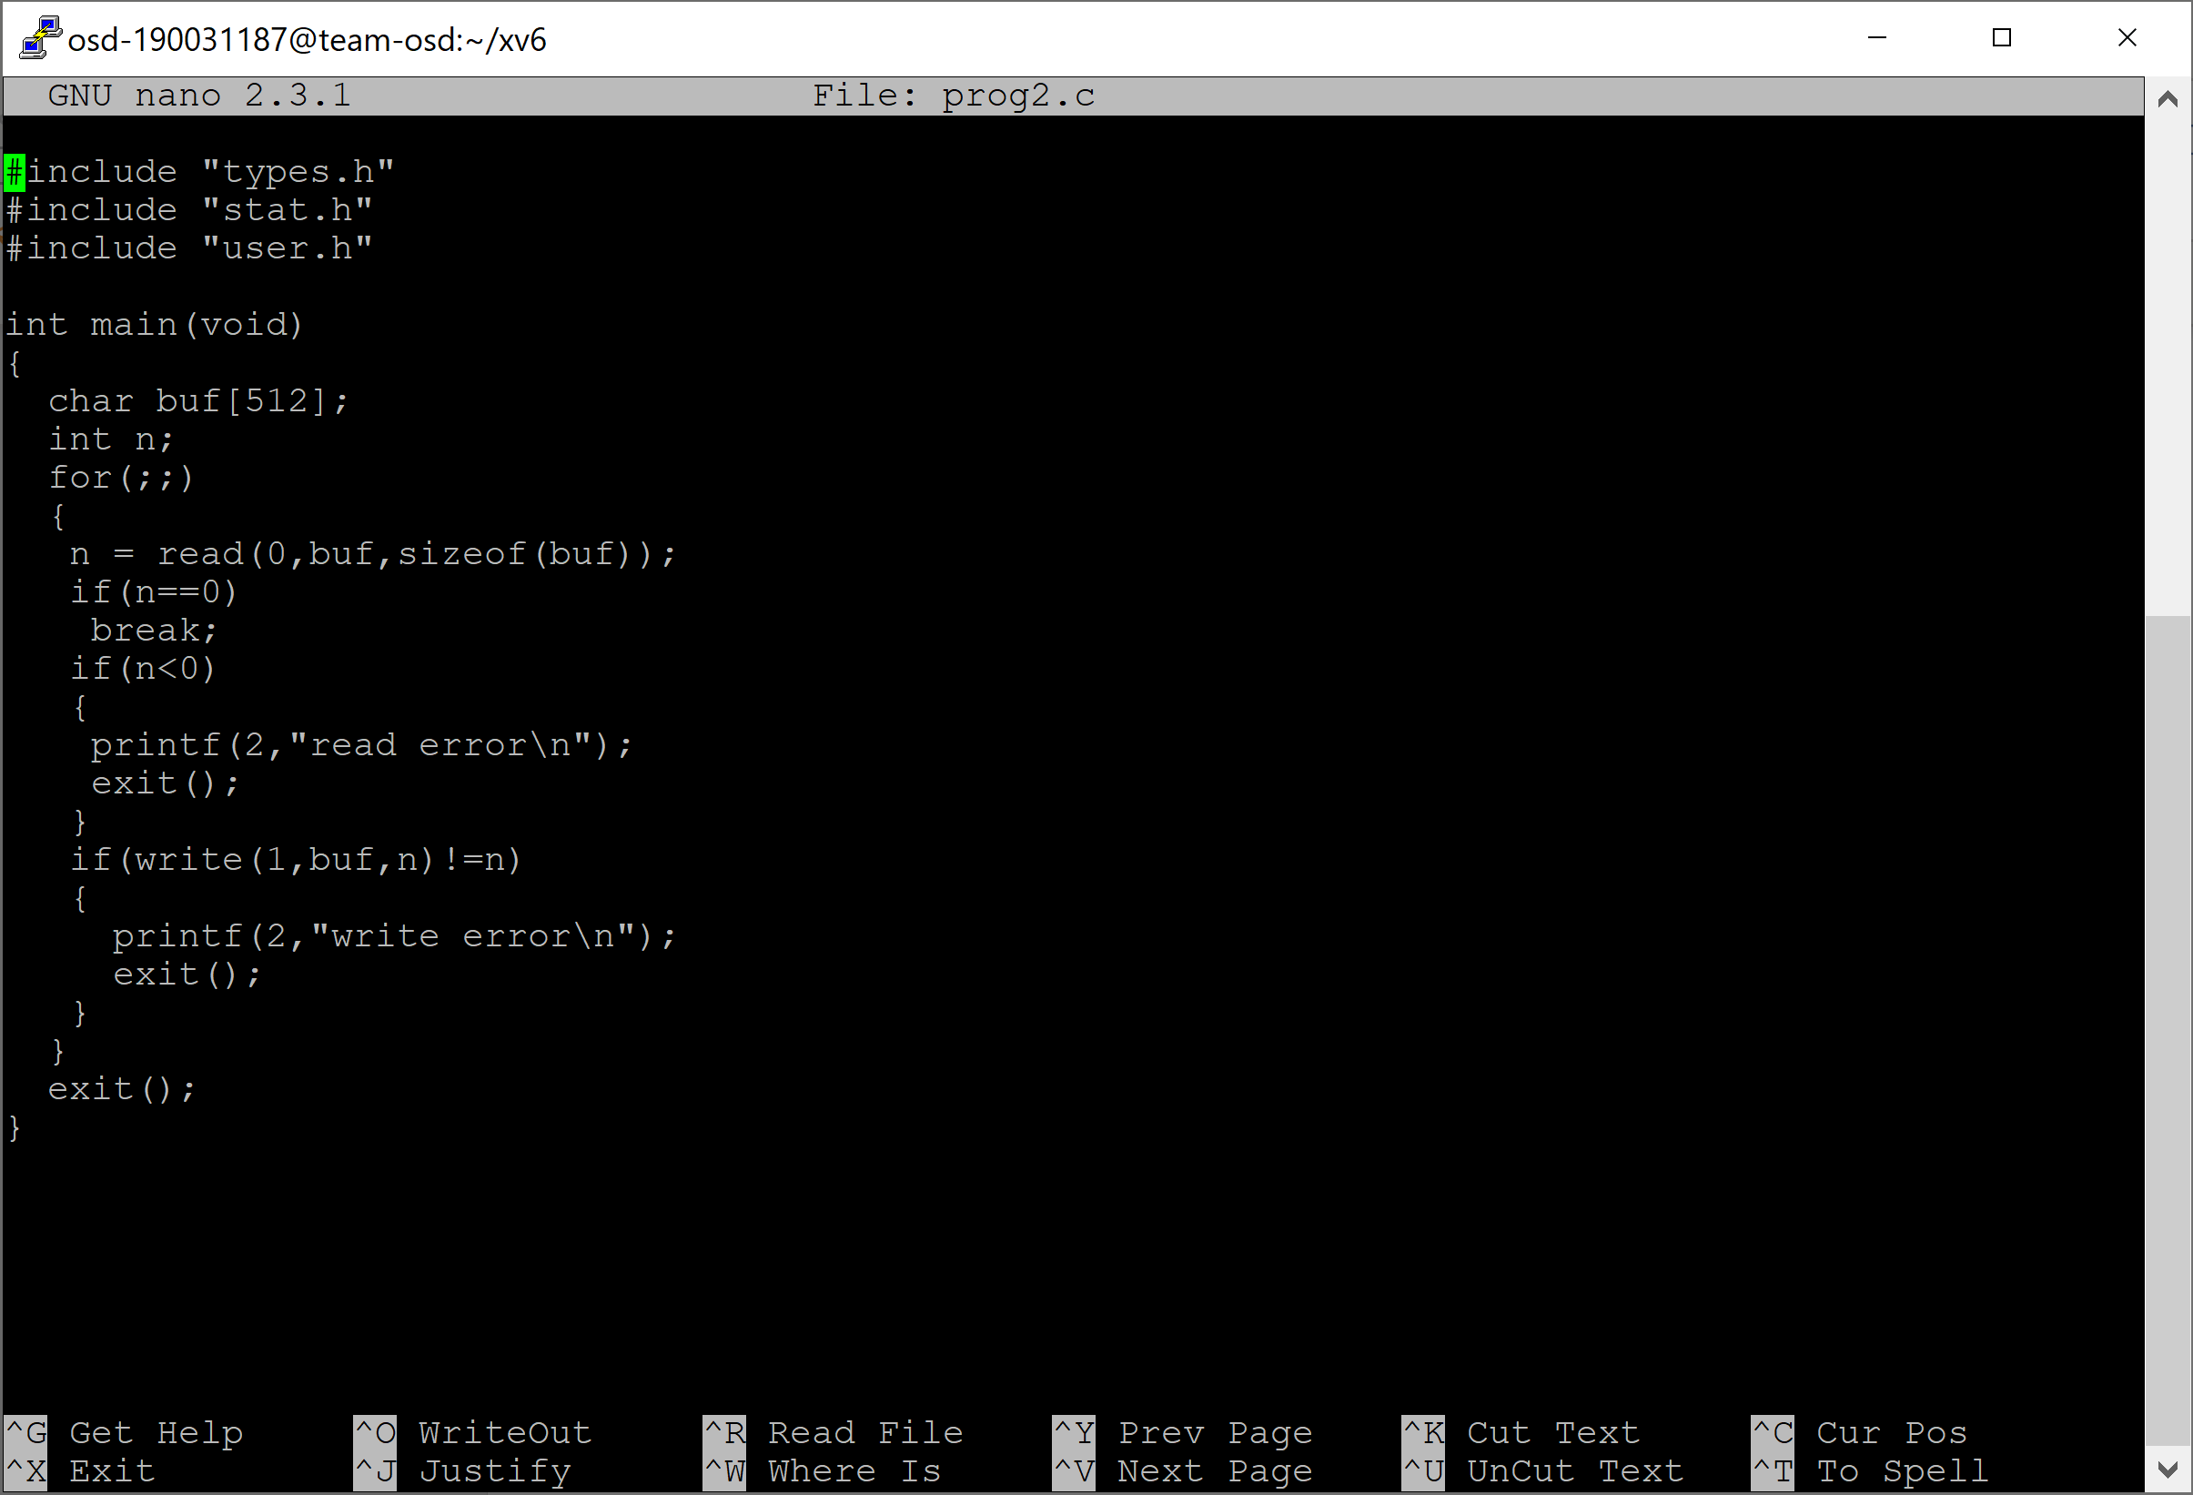

4) next type nano Makefile Under UPROGS add the file



4.2) Also Under EXTRA add the file and SAVE



5) write make clean

  
7) next write make command and next write make qemu-nox



9) type your file name

input:radha

output:radha

