**Operating System and Design (19CS2106S)**

**Lab- 10**

**Pre-Lab**

**shmat(**): Attach the process to the already created shared memory segment **shmdt() :** Detach the process from the already attached shared memory segment **shmctl():** Control operations on the shared memory segment

1. pthread_create() :- create a new thread

Description : The pthread_create() function starts a new thread in the calling process. The new thread starts execution by invoking start_routine(); arg is passed as the sole argument of start_routine().

1. pthread_exit() :-terminate calling thread

Description : The pthread_exit() function terminates the calling thread and returns a value via retval that (if the thread is joinable) is available to another thread in the same process that calls pthread_join.

3.pthread_join() :-join with a terminated thread

Description : The pthread_join() function waits for the thread specified by thread to terminate. If that thread has already terminated, then pthread_join() returns immediately. The thread specified by thread must be joinable

1. pthread_self() :-obtain ID of the calling thread

Description : The pthread_self() function returns the ID of the calling thread. This is the same value that is returned in *thread in the pthread_create(3) call that created this thread.

1. pthread_cancel() :-send a cancellation request to a thread

Description : The pthread_cancel() function sends a cancellation request to the thread thread. Whether and when the target thread reacts to the cancellation request depends on two attributes that are under the control of that thread: its cancelability state and type.

1. pthread_detach( ):-detach a thread

Description : The pthread_detach() function marks the thread identified by thread as detached. When a detached thread terminates, its resources are automatically released back to the system without the need for another thread to join with the terminated thread.

1. pthread_equal() :-compare thread IDs

Description : The pthread_equal() function compares two thread identifiers.

1. pthread_mutex_init() :- initialise or destroy a mutex

Description : The pthread_mutex_init() function initialises the mutex referenced by mutex with attributes specified by attr . If attr is NULL, the default mutex attributes are used; the effect is the same as passing the address of a default mutex attributes object. Upon successful initialisation, the state of the mutex becomes initialised and unlocked.

1. pthread_mutex_destroy() :- destroy and initialize a mutex

Description : The pthread_mutex_destroy () function shall destroy the mutex object referenced by mutex ; the mutex object becomes, in effect, uninitialized. An implementation may cause pthread_mutex_destroy () to set the object referenced by mutex to an invalid value. A destroyed mutex object can be reinitialized using pthread_mutex_init (); the results of otherwise referencing the object after it has been destroyed are undefined.

10.pthread_mutex_lock() :- Lock a mutex

Description : The pthread_mutex_lock() function locks the mutex object referenced by mutex . If the mutex is already locked, then the calling thread blocks until it has acquired the mutex. When the function returns, the mutex object is locked and owned by the calling thread.

11. pthread_mutex_trylock() :- Attempt to lock a mutex

Description : The pthread_mutex_trylock() function attempts to lock the mutex mutex , but doesn't block the calling thread if the mutex is already locked.

12.pthread_mutex_unlock() :- Unlock a mutex

Description : The pthread_mutex_unlock() function unlocks the mutex mutex . The mutex should be owned by the calling thread. If there are threads blocked on the mutex then the highest priority waiting thread is unblocked and becomes the next owner of the mutex.

**In-Lab**

1. **System V shared memory.**

#include <stdio.h>

#include <stdlib.h>

#include <string.h>

#include <sys/types.h>

#include <sys/ipc.h>

#include <sys/shm.h>

#define SHM_SIZE 1024 /* make it a 1K shared memory segment */

int main(int argc, char *argv[])

{

key_t key;

int shmid;

char *data;

int mode;

if (argc > 2) {

fprintf(stderr,"usage: shmdemo [data_to_write]\n");

exit(1);

}

/* make the key: */

if ((key = ftok("shm.c", 'R')) == -1)

{

perror("ftok");

exit(1);

}

/* connect to (and possibly create) the segment: */

if ((shmid = shmget(key, SHM_SIZE, 0644 | IPC_CREAT)) == -1)

{

perror("shmget");

exit(1);

}

/* attach to the segment to get a pointer to it:*/

data = shmat(shmid, (void *)0, 0);

if (data == (char *)(-1))

{ perror("shmat");

exit(1);

}

/* read or modify the segment, based on the command line: */

if (argc == 2)

{

printf("writing to segment: \"%s\"\n", argv[1]);

strncpy(data, argv[1], SHM_SIZE);

} else

{

printf("segment contains: \"%s\"\n", data);

/* detach from the segment: */

shmctl(shmid, IPC_RMID, NULL);

}

if (shmdt(data) == -1) {

perror("shmdt");

exit(1);

}

}

**OUTPUT**

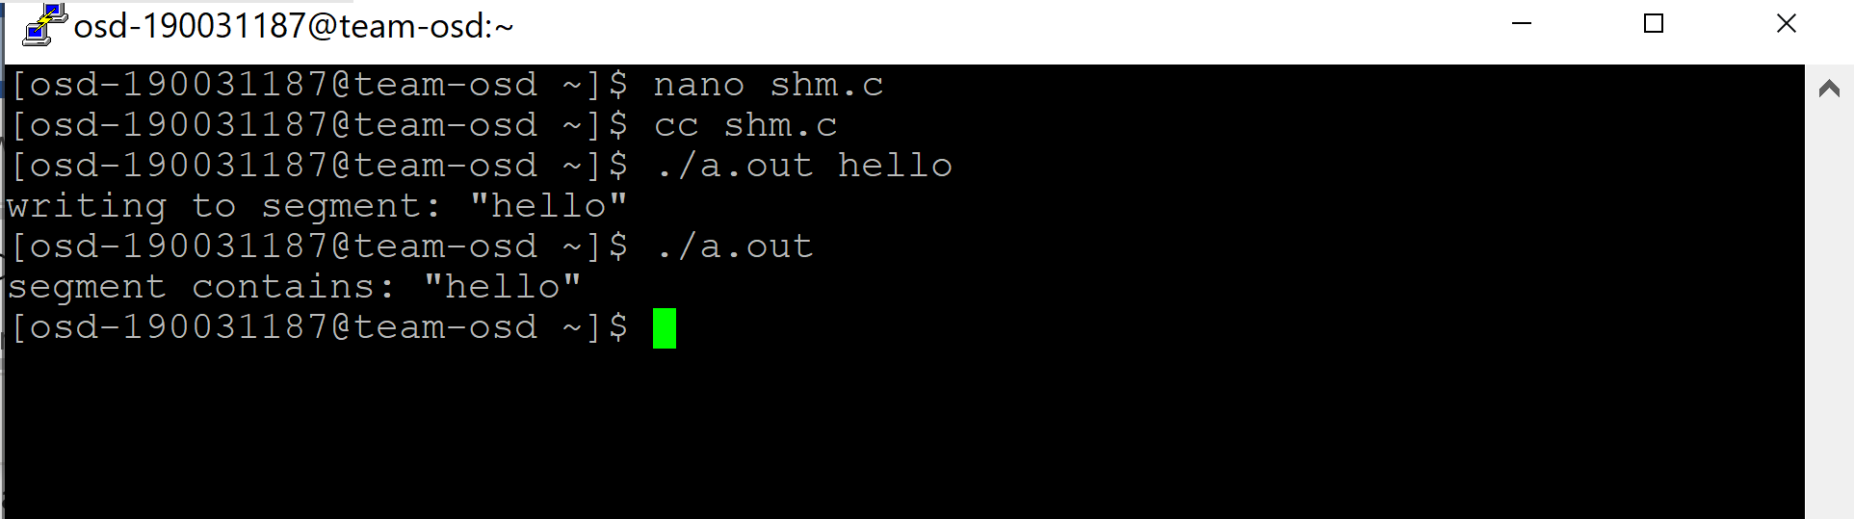

1. Write a program to create 5 pthreads and display Hello world. Main thread should wait until all new threads are terminated. Use Simpler Argument Passing to a Thread.

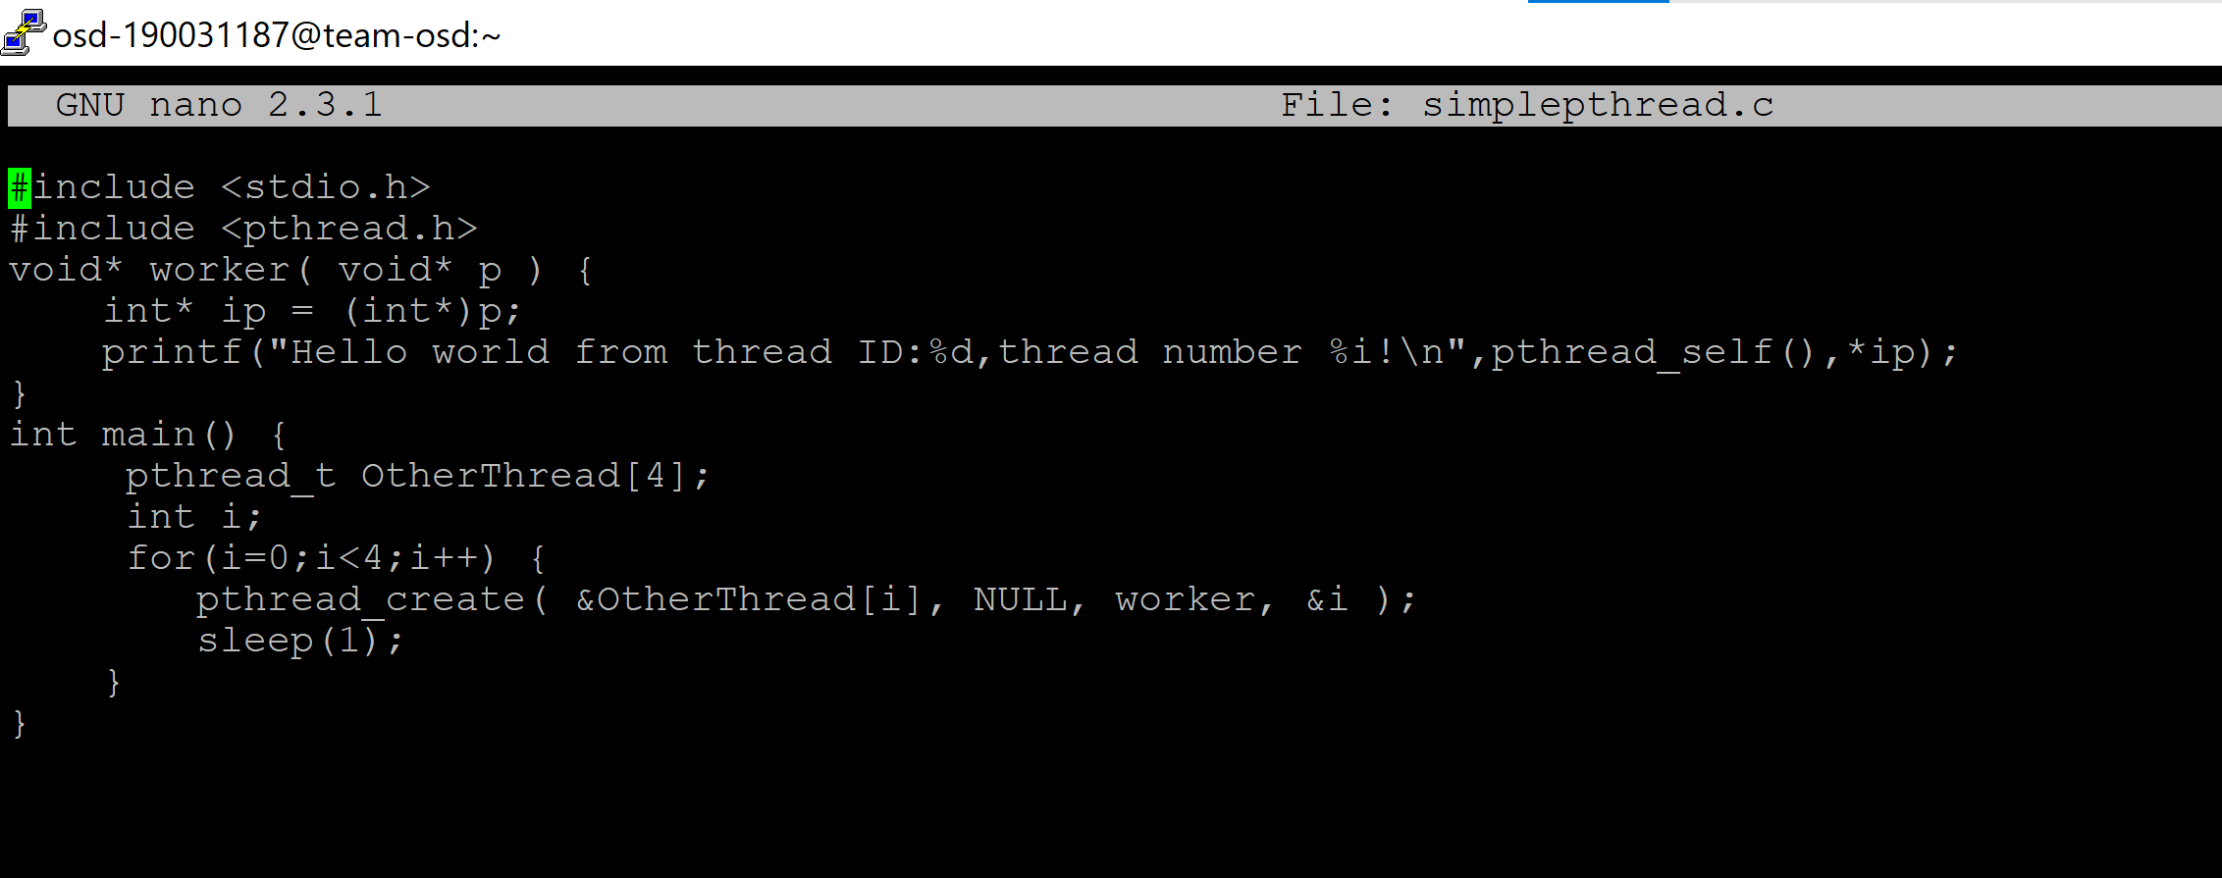

**OUTPUT**

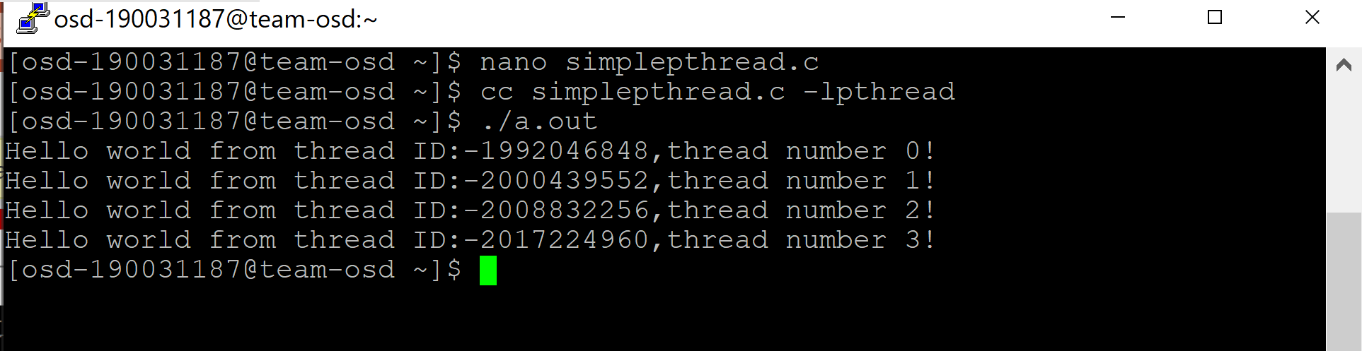

**Post-Lab**

1. **System V message queues.**

Message queues:

Message queues are one of the interprocess communication mechanisms available under Linux. Message queues, shared memory and semaphores are normally listed as the three interprocess communication mechanisms under Linux. Semaphores, though, are really for process synchronization. In practice, shared memory, aided by semaphores, makes an interprocess communication mechanism. Message queues is the other interprocess communication mechanism.

System V and POSIX Message queues:

There are two varieties of message queues, System V message queues and POSIX message queues. Both provide almost the same functionality but system calls for the two are different. System V message queues have been around for a long time, since the UNIX systems of 1980s and are a mandatory requirement of Unix-certified systems. POSIX message queues (and the complete POSIX IPC calls) were introduced in 1993 and are still an optional requirement of Unix-certified systems. This tutorial is for System V message queues.